# 听说模拟1答案

## 朗读句子

1. The main foods of a country depend on what grows best there.

2. Among their findings was that as Venus moved through the night sky over a period of months, it seemed to disappear, stop and change direction.

## 朗读段落

Advocates of homeschooling believe that children learn better when they are in a secure, loving environment. Many psychologists see the home as the most natural learning environment, and originally the home was the classroom, long before schools were established. Parents who homeschool argue that they can monitor their children’s education and give them the attention that is lacking in a traditional school setting. Students can also pick and choose what to study and when to study, thus enabling them to learn at their own pace.

## 情景提问

**Questions 1~2** Your deskmate has been absent from class for two days. So you call him and ask him two questions to show your concern.

* What happened to you? Do you meet any trouble?
* Is there anything I can do for you? How is everything going?
* What’s wrong with you? Do you encounter any difficulties?

Keywords: What happened Do meet trouble|Is there anything do How everything going|What’s wrong Do encounter difficulties

**Questions 3~4** Your cousin is going to graduate from university. You ask him two questions about his plan.

* How would you like to celebrate your graduation? Have you found a job?
* What kind of work do you want to do after graduation? Will you feel reluctant to leave the campus?
* How would you like to celebrate your graduation? Will your parents come to attend your graduation ceremony?

Keywords: How celebrate graduation Have found job|What kind work want graduation Will feel reluctant leave campus|How celebrate graduation Will parents come attend graduation ceremony

## 情景描述

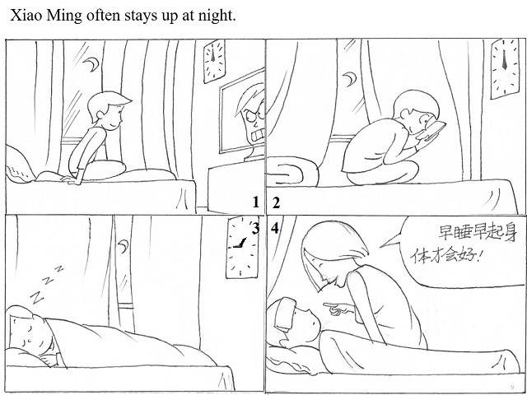

* Xiao Ming often stays up at night. He likes to watch TV at night and often forgets the time. The TV programme is sometimes about violence and blood, which is not good for his mental health. When the programme ends, he still doesn’t go to sleep, and he usually takes out his smart phone to read online novels. Under the dim light, he can’t see the small characters unless he gets close to the mobile phone. That makes his sight weaker. He doesn’t go to bed until it’s very late at night. One day, he felt ill and had a headache. His mother told him that going to bed early and getting up early could make him better, and that a good rest is very important for one’s health.
* Xiao Ming often stays up at night. There is a TV set in his bedroom. Every night at the time when he should go to bed, he opens the TV and watches the violent movie, which makes him excited and stimulated. When the movie is over, he still doesn’t want to sleep because of the fierce plots in the programme. He usually takes out his mobile phone to read the e-novels. Since the light is dim, he must get so close to the screen to see the lines, which makes his sight weaker and weaker. He goes to bed very late at night and cannot get up early in the next morning. Finally, he gets ill and has to stay in bed. His mother tells him that only sleeping early at night and getting up early in the morning can make him healthy.
* Xiao Ming often stays up at night. Usually, he watches television for quite a long time at night. He thinks it is so much fun because he really enjoys the characters in the program as well as the plots. Very often, he doesn’t go to bed until mid-night. He spends all night on the online games in his phone. He likes the game Minecraft best mainly because of its open-minded design. Of course, he considers online novels as his another choice to enjoy himself at midnight. All these TV shows and games make him forget the time. When it is nearly dawn, exhaustion puts him to bed. As a result, he gets sick. While looking after Xiao Ming, his mum keeps telling him “early to go to bed and early to rise makes a man healthy, wealthy and wise”. There is no doubt that having enough sleep is the best way to stay healthy.

## 快速应答

**1.** How do you like your maths teacher?

* I love him very much.
* He is interesting and ready to answer all the difficult questions.
* I appreciate him very much. He is so smart and can solve any questions that I cannot.

Keywords: love|interesting ready answer questions|appreciate smart solve questions

**2.** Can you speak a little louder please?

* Oh, of course. Could you hear me now?
* Sure. Can you hear clearly now?
* OK, what about the voice now?

Keywords: of course|Sure|OK

**3.** Your speech is very informative.

* Thank you. I am flattered.
* Thank you. I hope it can be useful to you.
* Thanks. I hope my speech can also help you.

Keywords: Thank you flattered|Thank you hope useful|Thanks hope help

**4.** I’m sorry that I’ve taken your umbrella by mistake.

* It’s OK.
* That’s all right!
* It doesn’t matter.

Keywords: OK|all right|doesn’t matter

## 简述和回答

**Listen to the following speaker talking about how to be media literate.**In today’s multimedia world, it is not enough to be able to read and write text. To grasp meaning from a range of media forms, it is vital to be media literate. This means that one must be able to question and assess the content of many media forms. One method that can help a person to improve this skill is to record a single television advertisement and view it over and over.With each viewing, a person should pay attention to a single different technique used by the makers of the advertisement. For the first viewing, turn off the sound and watch the picture closely. Focus on techniques used to construct the images. These include lighting, color, close-ups and camera angles. Next, listen to the sound without looking at the picture. Note the types of sounds and any music used. Then think about the type of mood or scene these sounds and images create.In later viewings, focus on who or what is included in the advertisement. Listen to the dialogue and note what words are used. Do any of them lead to a particular response? Answering these questions will help to identify the message and values that the developers of the advertisement are trying to convey. Reacting to all media messages in this way will help make a person truly media literate.

**1.** What does “being media literate” mean and what does the speaker suggest we do to improve our media literacy?

* It means that one must be able to question and assess the content of many media forms. We should record a single television ad and view it over and over.
* Being media literate means one must be able to question and assess the content of many media forms. One method that can help a person to improve this skill is to record a single television advertisement and view it over and over.
* The meaning of being media literate is to have the ability to question and assess the content of many media forms. To improve this skill, the speaker suggest we record a single television advertisement and view it over and over.

Keywords: question assess content media forms record single television advertisement view

**2.** Which television advertisement impresses you most? Why?

* When it comes to the most attractive advertisement I have ever seen, the one called “I love Shanghai” comes across my mind in the first place. It impresses me not just because it has beautiful images and exciting background music, but also because of its cheerful and high spirits. I also can feel the warmness, strong will as well as hospitality of Shanghainese.
* The most impressive ad for me is a noncommercial one. The ad starts with a plot that a mother is washing the feet for her elder mother. At this time, her son sees the scene. After a while, the little son who is less than five years old takes a foot basin full of water and comes to his mother. He wants to wash the feet for his mum! This ad is so meaningful. It tells us that adults should set a good example for their children to be filial to the elder.
* The most impressive advertisement for me is a story about an old man who gradually gets the dementia. He could even hardly recognize his son. However, when he sees the dumplings at a dinner table, he uses his hands directly to fetch the dumplings and says “That’s my son’s favourite food!” Seeing that, his son cannot say a word but is greatly touched. And I believe all the audience before the TV set are also touched. We know that the disease can make the father lose his memory, but it cannot take his love for his son away!

Keywords: The Most Impressive Advertisement