# 听说模拟10答案

## 朗读句子

1. Metal or plastic containers are best, as wooden ones leak.

2. Leading the push for organic farming in countries that once abandoned it are people who think that many agricultural chemicals are unnecessary.

## 朗读段落

The number of parents choosing to have only one child is increasing in many parts of the world. In the U.S., for example, 14 percent of women between 18 and 34 plan to have just one child, and this percentage is expected to rise. In Japan, the average number of children born per family had declined to 1.42 by 1996. This has led to government concerns about supporting an increasing population of elderly people in the future; it is predicted that, by 2020, a third of the population in Japan will be aged 65 or over.

## 情景提问

**Questions 1~2** Your friend, Mary, has just come back from a concert by a popular band. Ask her two questions about it.

* Is the concert worth such a high price? How do you feel about the concert?
* How do you feel about the concert? How many songs did the band perform?
* How many songs did the band perform? Do you feel satisfied with the performance?

Keywords: concert worth high price How feel concert|How feel concert How many songs band perform|How many songs band perform feel satisfied performance

**Questions 3~4** You are going to give your mom a gift for her birthday, but you don’t know what she likes. So you turn to your father for suggestions.

* Dad, what should I buy for Mom’s birthday? What about a handbag?
* Daddy, what do you think Mom wants for her birthday? Is it a good idea if I send flowers to her?
* Dad, what should I buy for Mom’s birthday? Do you think a necklace would be a good choice?

Keywords: what should buy birthday what about|what think wants birthday good idea if|what should buy birthday think be good choice

## 情景描述

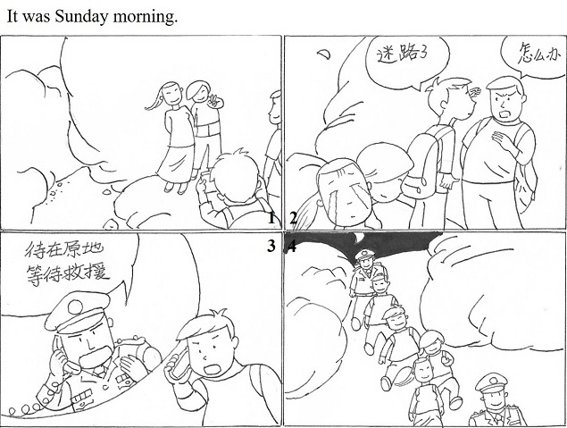

* It was Sunday morning. My friends and I went hiking on a mountain. We enjoyed the landscape along the way and took a lot of pictures. We really felt happy and relaxed. However, after a while, we got lost. What’s worse, no device was available to locate ourselves. “We got lost!” someone shouted. One of us even began to cry. I tried to calm down myself and called the police. I told the policeman the situation. He told us to stay in the same place and wait for their help. One hour later, two policemen came and helped us to find the way out. We all felt relieved.
* It was Sunday morning. My friends asked me to go climbing with them, and I felt happy to go. Along the way, we took a number of pictures to record the beautiful moments. But since it was the first time for each of us to climb the mountain, we soon found that we had lost our way. Feeling frightened and desperate, some of my friends cried and didn’t know what we should do. At that moment, I knew we must call the police. So I calmed down and made a phone call to the police. The police told us to stay in the same place and wait for their help. Luckily, we were all saved by the police in less than an hour. We felt grateful to these public servants!
* It was Sunday morning. I went hiking with my friends to release the high pressure from our daily studies. We had a lot of fun enjoying the beautiful scenery and taking photos. However, when we were about to go back, we found we lost our way. None of us knew where we were and which way we should choose. Being deeply desperate, some of us began to cry and some only repeated “What should we do?” I tried hard to calm down and recall what we had learned from the media. Then I made a phone call to the police and told the policeman our general direction. He told me to stay in the same place and wait for the police. After about 40 minutes, a team of policemen came to save us!

## 快速应答

**1.** What’s the final score of last week’s football match?

* Three to zero.
* It was one to four.
* The score was tied zero to zero.

Keywords: to|score to

**2.** Have you heard that Mike is coming back next week?

* No, I haven’t. Really?
* Yes, I feel glad to hear that!
* No. So why does he come back so early?

Keywords: No|Yes|Really

**3.** Sorry, but I didn’t quite catch what you said.

* Sorry. I will speak slower.
* Sorry. I will say that again.
* I’m sorry. I’ll speak louder.

Keywords: sorry

**4.** The cake you baked tastes really good.

* Thanks.
* Thanks a lot. Would you like some more?
* Thank you. I am so happy that you like it.

Keywords: Thanks|thank you happy like|thank you

## 简述和回答

**Listen to the following speaker talking about lightning.**Lightning strikes in many parts of the world. Lightning is an electric charge in a thunderstorm that is powerful enough to hurt or kill people. Here are a few basic safety rules to follow if you find yourself in a thunderstorm.First, find shelter. Get inside a building or a car. Don’t stand under a tree. If you’re in a car, stay away from metal surfaces that can conduct electricity. Lightning can strike as far away as 16 kilometers from the center of the storm. Just because lightning and thunder seem far away, you should not assume that there is no danger. Remember that lightning will generally strike the highest place in an area. Don’t climb trees or play outside during a thunderstorm.If you’re inside, don’t talk on the phone. Lightning can travel through the telephone wires and strike you while you’re talking. Turn off TVs, computers, and other appliances and stay away from them. Water is also a conductor of electricity. Don’t take a shower and stay away from sinks. Practice these safety rules and use your common sense to stay safe.

**1.** List two of the things mentioned in the passage that we should avoid doing in a thunderstorm.

* Standing under a tree and climbing trees.
* Playing outside and talking on the phone.
* Staying near the sink and turning on TVs.

Keywords: Standing under tree climbing trees|playing outside talking phone|staying near sink turning on TVs

**2.** What kind of weather do you like most? Why?

* I like rainy days best. There are mainly two reasons. First, the air in the city is badly polluted. Sometimes the dirty air invaded us and we could hardly breathe. Some people even get diseases because of the polluted air. Thanks to the rain, the air is fresh again. Second, when it is raining outside, I always come up with some poetic ideas, which cannot be found on hot and sunny days. I would write something to express my feeling at that time. And I really enjoy the coolness brought by the rain.
* I like snowy days most. Several factors are responsible for it. First, winter is my favourite season. When winter comes, our Spring Festival is approaching, and all the family can get together and play in the snow-covered field. Second, snow can bring us a lot of fun. I like making the snowman and play snowballs as well as fighting with my cousins. Since we are not in the same city, we seldom have the chance to play together. Lastly, I like the view of a vast expanse of whiteness, bringing me the feel of tranquility, which can purify people’s hearts.
* I love windy days best. To begin with, I like flying kites very much. On windy days, I can go to fly kites with my friends. That will bring me a lot of fun. Secondly, on windy days, I can see leaves moving. It makes me feel that everything is living, which gives me power and energy to face the difficulties in my life.

Keywords: rainy days best|snowy days most|windy days best