# 听说模拟11答案

## 朗读句子

1. Gardening is caring for and growing plants, both outdoors and indoors.

2. As scientists have learned more about the way dinosaurs moved, they have disproved some long-held theories about dinosaurs.

## 朗读段落

Space Travel used to be a young man’s game, but when John Glenn went into space aboard Discovery, four generations of men and women could gaze into the sky and think, “That could be me someday.” At the same time, Glenn was looking down and doing some thinking of his own. “It’s quite something,” he said, “to look down on this blue planet, seeing that little film of air that surrounds it. You wonder why in the world humans can’t solve all the problems they’ve created and left uncertain for centuries.”

## 情景提问

**Questions 1~2** You are in a coffee shop but you don’t know which one to order. You ask the waiter two questions.

* What is the best coffee in your shop? Could you give me some suggestions about the order?
* What types of coffee are less bitter? Could you please recommend some coffee without too much caffeine?
* Which type of coffee is the best selling in your shop? Do you have any advice about the order?

Keywords: what best coffee shop could give suggestions order|what types coffee less bitter could recommend coffee without caffeine|Which type coffee best selling shop have advice order

**Questions 3~4** Your classmate is looking for his mobile phone. You offer to help and ask him two questions about his mobile phone.

* Do you remember the last time you used it? What’s your phone number?
* What’s your phone number? I will call it to make it ring. Have you left your mobile phone at home?
* Where did you last see your mobile phone? Do you remember the last time you used it?

Keywords: Do remember last time used What’s phone number|What’s phone number call make ring left mobile phone home|Where last see mobile phone remember last time used

## 情景描述

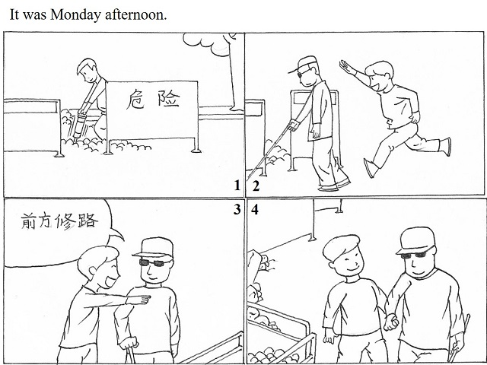

* It was Monday afternoon. I was wandering on the street. A worker was repairing the road on one side of the street. There are some barriers and obstacles near the construction site and a sign beside saying “Danger Here”. Then I saw a man with a cane and a pair of dark glasses walking towards the site, and he was approaching to the stones and sand. “Oh, he is blind.” I said to myself and quickly ran to stop him. I told him that the road was under construction and I was willing to give him a hand. He said thanks to me and held my hands. I guided him to the right way and I felt proud of myself.
* It was Monday afternoon. A worker was repairing the road on the street. Some fences and a sign saying “Danger Here” were around the construction site. A man with a walking stick and a pair of dark glasses was walking slowly towards the obstacles. He is a blind man! And he was about to hit the barriers! Suddenly a boy hurried to him and stopped him walking on. The boy told him the road was under construction and he was glad to help him. The blind man really appreciated what the boy said and took his hands. Then the boy led him to walk in the safe part of the road and he felt satisfied with himself.
* It was Monday afternoon. I was walking on the street. Suddenly I saw one side of the road was under construction. A sign which reads “Danger!” was beside the site. But at the moment, a man wearing a pair of dark glasses and holding a walking stick was heading for the construction site. I thought the man must be blind and decided to help him. So I quickened my steps and caught up with him. When I reached him, I said, “Sorry, sir, the road in front of you is being constructed and you cannot pass across here. If you don’t mind, I’d like to give you a hand and lead you to the right way.” Hearing this, the blind man held my hands tightly and felt very grateful to me. I was also very happy because I really did something good!

## 快速应答

**1.** How many English lessons do you have every week?

* Six lessons.
* I have six English lessons every week.
* I don’t have any English lessons every week.

Keywords: six|don’t have English lessons

**2.** Would you please fetch me a glass of water?

* OK, here you are.
* Sure, with pleasure.
* No, why not do it by yourself?

Keywords: OK here you are|Sure pleasure|No why not do it by yourself

**3.** Keep off the grass, please.

* Oh! I’m sorry.
* Sorry, I’m not on purpose.
* Sorry, I’ll never do such a thing again.

Keywords: sorry|sorry not on purpose|sorry never do thing

**4.** Help yourself to some fish.

* Thank you!
* Thank you very much.
* Thank you. I like it very much!

Keywords: thank you

## 简述和回答

**Listen to the following speaker talking about the kindergarten graduation in Japan.**In Japan an important event in every child’s life is the kindergarten graduation. Known as the “great transformation”, this ceremony marks a child’s passage from playful youngster to serious student.Kindergarten in Japan is a time for children to learn through play. This style of active learning cultivates their minds and bodies. Teachers design programs that develop social skills, the use of language, the expression of thoughts and feelings, and an awareness of the natural world. Teachers also help to prepare children for the next level of study. Although children have a great deal of playtime in kindergarten, they learn to settle down quickly and focus when it is time for a lesson.The great transformation represents this passage in the youngster’s life. The children behave themselves with politeness during this formal event. They march into the room in single file with their arms held against their sides. When they reach the row of chairs in the center of the room, they take a bow all together. They then sit down silently. A number of adults give short speeches, and then the dean awards each student a certificate. After the children recite a farewell speech or sing a song, the ceremony closes. The seriousness of the great transformation helps to prepare children for the intense learning that lies ahead.

**1.** List two things that kindergarten students in Japan learn from the programs designed by teachers.

* Social skills and the use of language.
* Social skills and the expression of thoughts and feelings.
* Social skills and an awareness of the natural world.

Keywords: social skills use language|social skills expression thoughts feelings

**2.** Describe an event that happened when you were in kindergarten or primary school.

* When I was in Grade Five, my English was average and I always felt unconfident when I opened my mouth to speak. Luckily I had a nice and patient English teacher, and she thought I have the potential to learn English well. She encouraged me to express myself in the English competition. And she also asked a foreign teacher to help me with my oral English. So a month later, when I was standing on the stage of the competition, I was confident to show my spoken English and I won the first place in this contest.
* The thing that impresses me the most in kindergarten is a stupid thing I did when I was four. One of my classmates suffered nosebleeds. He felt very bad, and then the teacher called his parents to pick him up. So he could go back home. After seeing this, I came up with an idea. I nipped my nose again and again to make it bleed. Finally, I succeeded and showed it to my teacher. But the teacher laughed and didn’t call my parents. She knew what I did! She told me to stay in school and be honest.
* The event which leaves the deepest impression on me is a warm story about my classmate Mary happened in my primary school. The place where I lived was a little bit far away from where Mary lived. One day, it was raining outside when we got ready to go home. Unfortunately, I didn’t carry an umbrella with me that day. However, Mary did. I planned to stay at school until the rain stopped. But Mary said we should help each other. At the end, she took me home first, and then she went back to her home.

Keywords: The Most Impressive Event