# 综合模拟10答案

## 朗读句子

1. The forgotten men and women of our country will be forgotten no longer.

2. January twentieth two thousand seventeen, will be remembered as the day the people became the rulers of this nation again.

## 朗读段落

Taobao is now used by many people every day. Whether the entire online shopping market is healthy or not has become very important. A healthy market environment refers not only to the quality of the goods themselves, but also operators’ development state of this market. Taobao provides good services to the sellers, so the sellers can provide a good service to buyers, and then the buyers can in turn continue to promote the development of Taobao. An environment like this is necessary to maintain the healthy development of the online shopping market. Even with such rapid growth, the online shopping market still has some problems such as credit card fraud and ID theft.

## 情景提问

**Questions 1~2** Imagine the famous sportsman Sun Yang has made a speech in your school. You ask him two questions.

* What has made you so successful? Do you find it happy to be a celebrity in daily life?
* Why do you want to be a sportsman? How old were you when you began training?
* How did you become a sportsman? How do you usually spend a day?
* Are you nervous when you take part in a sports game? How do you calm yourself down before a sports game?
* What did you think when you won a champion in the 2016 Olympic Games? What’s your future plan?
* What difficulties have you met in your sports career? How do you overcome the difficulties?
* How do you usually spend a day? What do you like to do in your spare time?
* What did you think when you won a champion in the 2016 Olympic Games? Do you have any words to encourage us students?
* How long do you take training every day? What do you like to do in your spare time?
* What has made you so successful? How did you become a sportsman?

Keywords: What made successful find happy be celebrity|why want be sportsman how old began training|how become sportsman how spend a day|nervous take part in sports game how calm down before sports game|what think when won champion what’s future plan|what difficulties met sports career how overcome difficulties|how spend a day what like do spare time|what think when won champion have words encourage students|how long take training every day what like do spare time|what made successful how become sportsman

**Questions 3~4** You want to apply for a library card. You ask the librarian two questions.

* Can I apply for a library card here? How much should I pay for the library card?
* What should I bring to apply for a library card? When can I get my library card after applying for it?
* Does the library card have time limit? What do I need to apply for a library card?
* Can I apply for a library card here? How much does it cost?
* Excuse me, how can I apply for a library card here? Does the library card have time limit?
* What should I bring to apply for a library card? How many books can I borrow if I have a library card?
* When can I get my library card after applying for it? Does the library card have time limit?
* What do I need to apply for a library card? How much does it cost?
* Excuse me, how can I apply for a library card here? When can I get my library card after applying for it?
* How many books can I borrow if I have a library card? Does the library card have time limit?

Keywords: Can apply for library card how much pay for library card|what bring apply for library card when I get library card|library card have time limit what I need apply for library card|can apply for library card how much it cost|how apply for library card library card have time limit|what bring apply for library card how many books borrow|when get library card library card have time limit|what need apply for library card how much it cost|how apply for library card when get library card|how many books borrow library card have time limit

## 情景描述

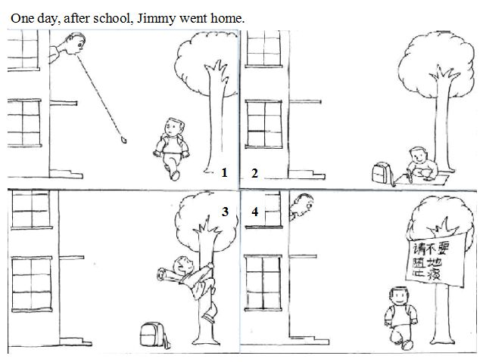

* One day, after school, Jimmy went home. When he walked past a tall building, he saw a man upstairs spit and he narrowly escaped from the spit attacking. Jimmy felt very angry and decided to do something to stop such bad behavior. He wrote a slogan “Please don’t spit everywhere!” on a board and then he stuck the board on the tree. When the man saw the slogan he felt ashamed and said sorry to Jimmy. He promised that he would not do that again.
* One day, after school, Jimmy went home. When passing by a building, a man spit from an upstairs window. He thought this was a bad behavior and he must do something. So he wrote something on a big piece of paper. Then he climbed up to the tree near the building, and nailed the paper on it. When the man on the second floor looked out from the window, he saw “Please don’t spit everywhere!” on the paper. He felt ashamed and said sorry to Jimmy.
* One day, after school, Jimmy went home. A man in a tall building spit down from the window and it almost fell on Jimmy’s head. Jimmy was very angry. He decided to do something to let the man realize his bad behavior. He wrote “Please don’t spit everywhere!” on a big piece of paper. Then he stuck it on the tree opposite the man’s home. When the man saw the paper, he felt so sorry and he promised he would not do that again.

## 快速应答

**1.** Would you like something to drink? Tea or coffee?

* Tea, please.
* I’d like some coffee, please.
* No, thanks.
* Coffee, please.
* I’d like some tea, please.
* I would like some coffee.
* I would like some tea.

Keywords: tea|coffee|no thanks

**2.** It’s nice of you to show me around your school.

* My pleasure.
* You are welcome.
* It’s my pleasure.
* It is my pleasure.
* You’re welcome.

Keywords: pleasure|welcome

**3.** Aunt Lily had an accident and she broke her leg.

* I’m so sorry to hear that.
* Sorry to hear that. Maybe we can visit her later.
* I’m sorry to hear that. Is it serious?

Keywords: Sorry

**4.** How did you enjoy the concert last night?

* It was wonderful.
* I like it very much.
* It was so great!
* I think it was a little bit boring.
* I enjoyed it very much.
* Oh, it was impressive. I like it very much.
* Oh, it’s terrible.

Keywords: wonderful|like|great|boring|enjoyed|impressive|terrible

## 简述和回答

**Listen to the following speaker talking about why people keep a dog.**When you take a walk in any of the cities in the West, you often see a lot of people walking with dogs. It is still true that the dog is the most useful and faithful animal in the world. But the reasons why people keep a dog have changed. In the old days people used to train dogs to protect themselves against attacks by other beasts. And later they came to realize that a dog was not only useful for a protection but willing to obey his master. For example, when people used dogs for hunting, the dogs wouldn’t eat what was caught without permission. But now people in a city need not protect themselves against attacks from animals. Why do they keep dogs then? Some people keep dogs to protect themselves from thieves. But the most important reason is for companionship. For a child, a dog is his best friend when he has no friends to play with. For young couples, a dog is their child when they have no children. For old couples, a dog is also their child when their real children have grown up. So the main reason why people keep dogs has changed from protection to friendship.

**1.** What’s the most important reason for people to keep dogs nowadays?

* For companionship.
* The most important reason is for companionship.
* The most important reason for people to keep dogs nowadays is for companionship.
* It is for companionship.
* It’s for companionship.

Keywords: companionship

**2.** Which pet do you want to keep? Why?

* I want to keep a cat, especially a white cat. Because cats are cute. Their fur is soft. I want to fall asleep touching their fur. Besides, I’d like to take a lot of lovely photos with my cat and then put them on the Internet. Many people like to see lovely photos about cats nowadays on the Internet.
* I’d like to keep a dog. Dogs are loyal and they always obey the master’s order. Also, they are good companions. I am the only child in my family. When I am not at home, I hope a dog can accompany my parents so that they may not feel lonely. These are the reasons why I want to keep a dog.
* I want to keep some goldfish as pets if possible. My parents don’t allow me to keep dogs or cats because they think keeping them is a trouble. But keeping goldfish is very easy. I just need to provide them with clean water and feed them every day. And it won’t cost too much to keep goldfish. Besides, goldfish are beautiful so they may be a good decoration in my house.

Keywords: The Pets I Want to Keep