# 综合模拟12答案

## 朗读句子

1. I know a special shortcut to that address.

2. There are a number of challenges that any city will face when hosting the Olympic games.

## 朗读段落

Recently Jennifer Lawrence, one of the highest paid female actresses, voiced online that female actresses make much less money than males do in Hollywood. In fact, women today only make about as much money as men made ten years ago. Although gender equality has improved in some aspects like education, females may find things are still difficult in workplace. Of the 145 countries and areas surveyed in the WEF report, 97 have more female students than male students in universities. But only four of those countries have a majority of women leaders in the workplace. “Women tend to be viewed on the basis of their performance, while men are often promoted for their potential,” The Washington Post wrote.

## 情景提问

**Questions 1~2** Your friend Li Ming has just come back from the English summer camp in Canada. Ask him two questions about it.

* What do you think of the life in the summer camp in Canada? How long did the summer camp last?
* What have you learned from the summer camp? Do you any special experience during the summer camp?
* Did you have a good time? What kind of activities did you take part in during the summer camp?
* Whom did you go with? Have you visited any places of interest in Canada?
* How do you like the life in the summer camp in Canada? Do you any special experience during the summer camp?
* How do you like the English summer camp? Did you visit any places of interest in Canada?
* What have you learned from the summer camp? Was the summer camp interesting?
* How much did you pay for the summer camp? What did you do in the summer camp?
* What do you think of this English summer camp? How much did the summer camp cost?
* Do you any special experience during the summer camp? How much did you pay for the camp?
* What kind of activities did you take part in during the summer camp? Did you visit any places of interest in Canada?
* What kind of activities did you take part in during the summer camp? Have you learned anything new?

Keywords: What think life summer camp? How long did camp last|What have learned camp Do any special experience|Did have good time What kind activities take part in|Whom go with Have visited places interest Canada|How do like life summer camp in Canada Do special experience|How like camp Did visit places interest Canada|What learned Was camp interesting|How much pay camp What do|What do think camp How much camp cost|Do special experience How much pay camp|What kind activities take part camp Did visit places Canada|What kind activities did take part camp Have learned anything new

**Questions 3~4** It is your mother’s birthday tomorrow and you have no idea about what to buy as a birthday gift. Ask your friend for advice.

* What kinds of gifts should I buy for my mother’s birthday tomorrow? Can you give me some advice?
* What do you think I should buy for my mother as a birthday gift? Could you give me some suggestions?
* What birthday present can I buy for my mother? Do you have any good ideas?
* What can I buy for my mother as a birthday gift? Can you give me some ideas?
* Do you have any good ideas on what to buy as a birthday gift for my mother? What do you think of some flowers?
* Can you give me some suggestions on buying gift for my mother’s birthday tomorrow? How can I make a surprise for her?
* Could you give me some suggestions on the birthday gift for my mother tomorrow? How about holding a birthday party for her?
* Do you have any good ideas on what to buy for my mother’s birthday tomorrow? What do you think of buying a handbag for her?

Keywords: What kinds birthday gifts should buy birthday Can you give some advice|What think should buy birthday gift Could give some suggestions|What birthday present can buy mother Do have any good ideas|What can buy for mother birthday gift Can give some ideas|Do have any good ideas What do think some flowers|Can give some suggestions buying gift mother’s birthday How can make surprise|Could give some suggestions How about holding birthday party|Do have any good ideas What do think buying handbag

## 情景描述

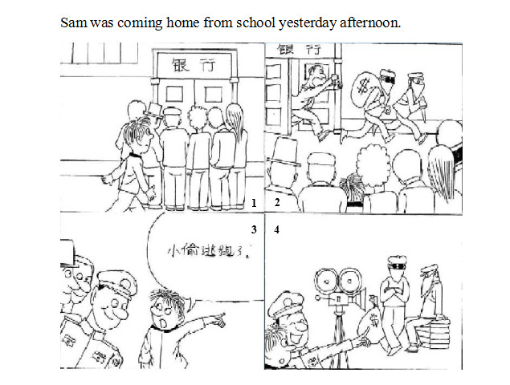

* Sam was coming home from school yesterday afternoon. He saw some people standing around a bank and watching something. Sam felt interested. Suddenly two robbers were running out of the bank with a large bag full of money. A man was running after the two robbers. They ran very fast and at that time some policemen came. Sam came up to them and showed them the direction where the robbers were running. But the policemen smiled at Sam and said, “They are making a movie. The two robbers are actors.”
* Sam was coming home from school yesterday afternoon. When passing by the bank, he found that several people gathered at the gate of the bank. He was wondering what had happened there. Just at that moment, Sam saw two robbers running out of the bank hurriedly. One of the robbers took a bag on his shoulder. Sam was so worried. Just then he saw the policemen. He immediately ran to the policemen and showed them the direction in which the robbers were running. But to his surprise, the policeman pointed to a big camera and told him, “Don’t worry. They are just making a film there. The two robbers are actors.”
* Sam was coming home from school yesterday afternoon. He saw a crowd of people near a bank. Sam was so curious that he joined the crowd. He was surprised to see two thieves running out of the bank. One of them held a bag which was full of money. The bank manager was running after them. Some policemen were standing among the crowd, but they didn’t do anything. Sam shouted to the policemen and showed them where the two robbers ran. But they just smiled. One of the policemen pointed to a big camera and told Sam that they were making a film. Actually those men weren’t real thieves. They were actors. What a joke!

## 快速应答

**1.** I did not sleep very well. I had a serious headache.

* I’m sorry to hear that.
* Oh, you’d better go to see a doctor.
* Sorry to hear that. I think you should take a good rest now.
* Oh, drink a cup of hot milk and take a good rest now.
* I’m sorry to hear that. You’d better go to see a doctor and have a good rest.
* Oh, I’m sorry to hear that. Hope you’ll be well soon.

Keywords: sorry hear|better see doctor|sorry hear take good rest|drink milk take good rest|sorry hear better see doctor have good rest|sorry hear hope well soon

**2.** I am terribly sorry to have kept you waiting.

* Never mind.
* Oh, nothing. Forget about it.
* That’s OK.
* That’s all right.
* You can forget about it.
* It doesn’t matter.
* It’s OK.
* Forget about it.

Keywords: Never mind|nothing Forget about it|That’s OK|That’s all right|You can forget it|It doesn’t matter|It’s OK|Forget about it

**3.** I don’t have any change with me. Will you pay the fare for me?

* No problem.
* Sure. I’d love to.
* Sorry, I’m afraid I can’t.
* With pleasure.
* Of course.
* That’s OK. I will pay for you.
* I’d love to.

Keywords: No problem|I’d love to|Sorry I’m afraid|With pleasure|Of course|That’s OK|I’d love to

**4.** What a good day today! Why don’t we go for a picnic in the park?

* Good idea.
* It sounds great.
* I couldn’t agree more.
* That’s a good idea.
* Why not?
* Sounds good.
* Let’s go.
* That’s a great idea.

Keywords: Good idea|It sounds great|I couldn’t agree more|That’s a good idea|Why not|Sounds good|Let’s go|That’s a great idea

## 简述和回答

**Listen to the following speaker talking about New York.**To many foreigners, New York is the United States. It is the commercial and cultural center of the country. A lot of people have seen pictures of its skyscrapers. There are more skyscrapers in New York than anywhere in the United States. The Empire State Building is well-known throughout the world. The city’s theatre district, Broadway, is very famous as well. Thousands of people go there to see the shows. There are different plays and musicals. One can always find something interesting to see. Every summer, high school students all over the United States tour around New York. They can take the bus or subway to visit famous sites such as the United Nations, the Statue of Liberty, the Metropolitan Museum and the Bronx Zoo. The bus and subway are very convenient. One can go almost anywhere on them.

**1.** How important is New York to the United States?

* It is the commercial and cultural center of the United States.
* New York is the commercial and cultural center of the United States.
* To the United States, New York is the commercial and cultural center of the country.

Keywords: commercial cultural center the United States

**2.** Describe a city you like best.

* I like Beijing best. Beijing is the center of politics, economy and culture of our country. And it is also a very beautiful and important city. There are many famous wonders and beautiful scenic spots in Beijing, such as the Great Wall, the Forbidden City, the Summer Palace, Beihai Park and so on. I love Beijing. I hope to travel there one day.
* I have traveled to many cities. Hangzhou is the one I like best. Hangzhou is a beautiful city. It is like a big garden. There are lots of places of interest worth visiting. The West Lake with mountains all around is the prettiest part. It takes on different looks with the change of seasons. Anyway I like Hangzhou better than any other city.
* The city I like best is Shanghai. Since I was born, I have been living here. Shanghai is situated in the east of our country. It is both a modern and traditional city with many famous places. Every year many people travel to Shanghai for sightseeing, shopping and fun. And the local snacks never let you down. Traveling in Shanghai is very convenient too, because there are many different kinds of transport for you to choose.

Keywords: The City I Like Best