# 综合模拟13答案

## 朗读句子

1. These children are trapped in poverty in backward areas of China.

2. The drugs have ruined too many families and robbed our country of so much material and financial resources.

## 朗读段落

Great inventions keep the world moving forward and make life easier. Time Magazine in the US made a list of the most important inventions of the year. Let’s take a look at a few of them.People seldom realize how great of an invention the pencil was. It can write at any angle. The harder you press, the darker the shades get. And marks can be erased. For years, computer engineers have been trying to create a digital pencil with the same functions. Finally, Apple made an exciting product called the Apple Pencil. It allows users to draw, paint or write on a screen, just as they would on a piece of paper.

## 情景提问

**Questions 1~2** Your friend has lost his way in the city center and he has phoned you for help. Ask your friend two questions about it.

* Can you describe the building you see around you? Why don’t you ask a policeman to help you?
* What’s the name of the building beside you? Can you describe the nearest building?
* What well-known building can you see? Can you see any bus station there?
* Is there any road sign around you? Why not ask a policeman for help?
* What special building can you see? Can you find a nearest bus stop or subway station?
* What’s the name of the building beside you? Do you see any landmarks around?

Keywords: can describe building why don’t ask policeman| what name building can describe building| what well known building can see station| road sign why not ask policeman|what special building can find bus stop | what name building see landmarks

**Questions 3~4** You have a toothache and you are seeing the doctor now. Ask the doctor two questions.

* Is it serious, Doctor? What’s wrong with my teeth?
* What’s the matter with my tooth? Could you tell me how to stop the pain?
* Is there anything wrong with my teeth? What should I do then?
* What’s wrong with my teeth? Is it a bad tooth problem?
* What’s wrong with my tooth? Is it serious?
* Is it serious? What should I do to ease the pain?
* What should I do about the teeth? Do I have to watch what I eat?
* What’s wrong with my tooth? Should I pull it out?
* Is it a bad tooth? What should I do next?
* What’s the matter with my tooth? How could I deal with it?
* Is it serious, doctor? How can I stop the pain?
* What’s wrong with me, doctor? Do I need to take some medicine?

Keywords: is serious what’s wrong teeth | what’s matter tooth how stop pain| anything wrong what should do | what’s wrong tooth is bad tooth problem | what’s wrong tooth is serious | is serious what should do ease pain | what should do watch what eat | what’s wrong tooth should pull out | is bad tooth what should do | what’s matter tooth how deal with| is serious how stop pain| What’s wrong do need take medicine

## 情景描述

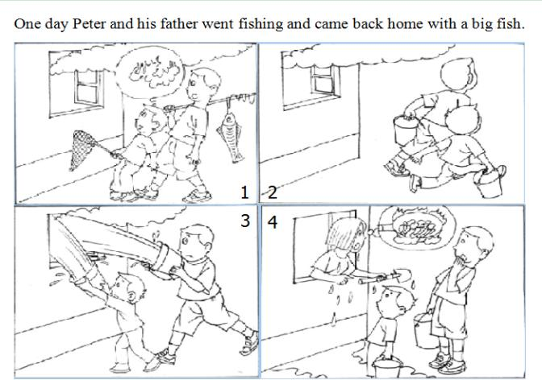

* One day Peter and his father went fishing and came back home with a big fish. When they passed a house, they found much smoke coming out of the window. They thought it was on fire. So they ran to the nearest river and got the buckets filled with water. They splashed the water into the window. To their great surprise, a woman glared at them and shouted, “What are you doing? I’m cooking dinner!” Peter and his father felt very embarrassed.
* One day Peter and his father went fishing and came back home with a big fish. When they approached their house, they saw some thick smoke coming out of the kitchen. The father and the son thought there was a fire. So they rushed to get water with the fishing buckets. Soon they came back and poured the water into the window. Surprisingly, Peter’s mother appeared by the window and shouted, “What on earth are you doing here? I am cooking!” Peter and his father were speechless.
* One day Peter and his father went fishing and came back home with a big fish. They saw much smoke coming from the kitchen window when they went past their house. They thought their house was on fire. Without hesitation, they ran to the nearest river to fetch water with the fishing buckets. When they came back, they quickly splashed the water into the kitchen. Before long, Peter’s mother came up, shouting angrily, “Ouch! What’s going on? I was cooking dinner, but I’m all wet now!”

## 快速应答

**1.** Don’t sit on that broken chair.

* Lucky you warned me.
* Thank goodness you reminded me.
* Thank you so much!
* Oh, thank you!
* Thank you very much for warning me.

Keywords: Warned me|thank reminded|thank you

**2.** What do you think of smoking?

* Smoking is a bad habit.
* It’s bad for our health. We cannot smoke in public places.
* Smoking can cause health problems.
* It’s unhealthy for us to smoke.
* It does harm to us.
* We should smoke in the smoking area.
* Smoking is harmful to our health.
* Smoking is no good.
* It’s bad for our health.
* It’s harmful to us and other people.
* Smoking is an unhealthy habit.

Keywords: Bad habit|bad for health|cause health problems|unhealthy|does harm|smoking area|harmful|no good|unhealthy habit

**3.** I’m sorry to have lost your pen.

* Never mind.
* It doesn’t matter, I have other pens.
* Oh, that’s OK. I have alternatives.
* It doesn’t matter. I have another one.
* Don’t worry. It’s OK.

Keywords: Never mind|doesn’t matter|have alternatives|don’t worry

**4.** I’m so grateful for your warm reception, but I really must go now.

* Goodbye.
* OK. Do you need to call a taxi?
* All right. Thank you for coming.
* OK. Welcome to my place next time!
* See you.
* OK. Do you need a drive home?
* All right. Let me call a taxi for you.
* OK. Would you like me to call a taxi for you?

Keywords: Goodbye|OK need call taxi|all right thank you coming|welcome next time|see you need drive home|all taxi

## 简述和回答

**Listen to the following speaker talking about the American graduation day .**In American high schools and colleges, the last day of the school year is the graduation day. The students who finish their last year in the school will graduate. The graduation ceremony is often in the school gymnasium. The people who come to watch the graduation are teachers, parents and friends of the graduates. The graduates will wear long robes and caps with square tops for the ceremony. The graduate who has the best record in school will make a speech. The school principal and some officials will also make speeches. Then each graduate will receive a piece of paper which has his name and the name of the school. The paper which the students receive in high school is a diploma. The paper which the students receive in college is a degree. After the ceremony, students often chat with their teachers, friends and relatives who come to congratulate them. They take pictures of each other. They will show each other these pictures a few nights later at the graduation prom. Graduation is a memorable event.

**1.** What do most graduates do on the graduation day?

* They wear long robes and caps, listen to speeches and receive diplomas or degrees at the graduation ceremony. After the ceremony, they often chat with their teachers, friends and relatives and take photos.
* They wear robes and caps for the ceremony. They listen to speeches by the best graduate, the principal and officials. Then they each will receive a diploma or a degree. After the ceremony, they often chat with those who come to congratulate them and take pictures of each other.
* On the day, they put on robes and caps for the graduation ceremony. They listen to the speeches of best student and school leaders and then receive diplomas or degrees. After that, they have a chat and take pictures with their teachers, families and friends.

Keywords: Wear robes caps listen speeches receive diplomas degrees chat take photos|Wear robes caps listen speeches receive diploma degree chat take pictures|put on robes and caps listen speeches receive diplomas degrees chat take pictures

**2.** What plans do you have after graduating from high school?

* I will go to one of the top 10 universities in China. And I won’t stop working hard in university. I also plan to join some school clubs or the Student Union. My campus life will be challenging and colorful. I’m looking forward to that.
* After graduating from high school, I will go to college to further my study. I’m going to choose English interpretation as my major. And to realize my dream of being an interpreter, I will devote my college life to English translation and interpretation. I believe that God help those who help themselves.
* I plan to find a job after graduation. Since my father broke his leg a month ago, we lost the main source of support for the family. I also have a little sister who is still in junior high school. She can’t quit school. So I have to work to support my family. After I get enough money, I will take some self-teaching courses and go to college.

Keywords: My Plan After Graduation