# 综合模拟14答案

## 朗读句子

1. To have a meaningful and happy life, we need friends.

2. Physical activity does the body good, and there's growing evidence that it helps the brain too.

## 朗读段落

Do you like eating tofu and drinking soy milk? They are both made from beans and are good for our health. Beans and peas are known as bean crops. They are getting international attention. Recently, the United Nations (UN) voted 2016 as the “International Year of Beans”. This action aims to make people notice the benefits of beans and improve their production. “The UN wants to encourage new and smarter uses of the beans”, said Xinhua. Beans are high in protein and vitamins. They are not only easy to cook but are good for reducing the risk of heart attacks and other diseases.

## 情景提问

**Questions 1~2** You are in your English teacher’s office. Ask the teacher two questions about English learning.

* How can I improve my English learning? What is the main problem in my English learning?
* Can you give me some advice on my English learning? How can I increase my vocabulary?
* What can I do to improve my pronunciation? Do you have any suggestions on improving my English?
* What can I do to remember all the grammars? Are there any ways to improve my writing?

Keywords: How improve English learning what main problem| Can give advice English how increase vocabulary|What do improve pronunciation do suggestions improving|What do remember grammars ways improve writing

**Questions 3~4** You have a new classmate Bob. You want to get to know him. Ask him two questions.

* May I know where you are from? What kind of sports do you like best?
* Which subject are you good at? What is your favourite subject?
* Do you want to be my partner in our English class? Who’s your favourite singer?
* Where do you live? How do you usually go to school?
* When is your birthday? Do you like to join the football club with me after school?

Keywords: where from what sports like|which subject good at what favourite subject|do want be partner who’s favourite singer|where live how go school|when birthday do like join club

## 情景描述

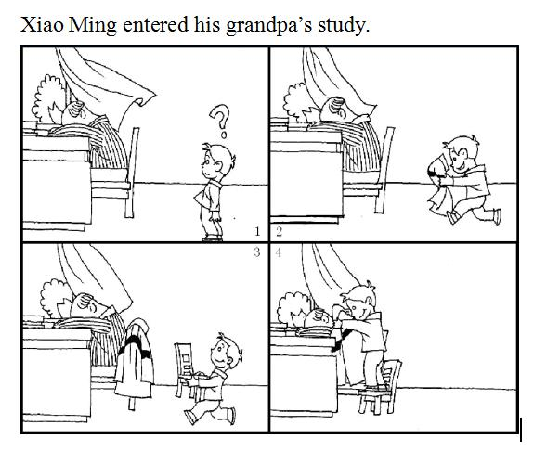

* Xiao Ming entered his grandpa’s study. He found that his grandpa was sleeping at the table with the window wide open. He thought he should do something to prevent his grandpa from getting sick. Soon he came up with an idea. Xiao Ming brought an overcoat and tried to put it on his grandpa. But he was not tall enough to do that. Then he put the overcoat on the chair, and went to bring a chair here. He put the chair beside his grandpa, and then he stood on the chair and he successfully covered the overcoat on his grandpa. What a good boy Xiao Ming was!
* Xiao Ming entered his grandpa’s study. He found that his grandpa was taking a nap at the table. He saw the window was wide open and the high wind blew into the room. Xiao Ming was worried that his grandpa may get a cold. He soon thought of an idea. He ran out to fetch a coat. But he realized that he couldn’t put it on his grandpa since he was not tall enough. Suddenly he came up with the idea that he could stand on a chair to do that. Then he went to bring a chair here. He stood on the chair and managed to cover the coat on his grandpa. He successfully did that. What a considerate boy he was!
* Xiao Ming entered his grandpa’s study. He saw his grandpa was sleeping at the table by the window, which was wide open. So he wondered what he could do to prevent his grandpa from getting sick. Suddenly he realized that he could put an overcoat on his grandpa. Then he went to fetch a coat. But he found himself too short to reach his grandpa. Soon he came up with an idea that standing on a chair can make him taller. He did that and successfully cover the coat on his grandpa. How clever he was!

## 快速应答

**1.** I like summer because I can wear skirts.

* So do I.
* I like winter because I can see the beautiful snow.
* I don’t like summer because the weather is too hot.
* I like spring because it’s getting warm.
* I like fall because it’s cool.
* Me too. I think we look beautiful when we wear skirts.
* I like autumn because it’s a harvest season.
* Oh, I don’t like summer at all. It’s too hot.
* But I like winter because I can make snowmen.
* But I don’t like summer. Winter is my favourite.
* The same with me.

Keywords: So do I |Like winter snow|Don’t like summer hot|Like spring warm|Like fall cool|Me too|Like autumn harvest|Like winter snowmen|Winter favourite|Same with

**2.** Will you join us for the dance party on Sunday?

* Of course.
* Oh, I’m sorry, I can not dance.
* Sorry, I’m afraid I can’t. I have an important meeting to attend.
* Yes, I’d like to.
* Sorry, my right leg was hurt this morning. I can not go.
* Of course. When and where will the dance be held?
* Why not? I love dancing a lot.
* Well, I’m not good at dancing. But I’ll go with you.

Keywords: Of course|Sorry can not dance|Sorry have meeting|Yes I’d like|Sorry leg hurt can not go|When dance be held| Why not love dancing|Not good at but go

**3.** Can you stop talking on your phone in the library?

* Sorry, I’ll stop right now.
* Sorry, it’s my fault. I’ll go outside to do that.
* I’m sorry. I didn’t notice that.
* Sorry, I’ll stop at once. Thank you for your reminding.
* I’m terribly sorry. I’ll stop talking at once.
* Oh, sorry. I didn’t notice that I was talking aloud. I’ll go outside.

Keywords: Sorry go right now|Sorry my fault|Sorry didn’t notice|Sorry stop thank you reminding|Sorry stop at once|Sorry go outside

**4.** Finally I’ve got two tickets of my favourite singer’s concert!

* That’s wonderful.
* That’s great. When will the concert be held?
* Congratulations. Who will go to the concert with you?
* Unbelievable. How did you get them?
* Great. Where will the concert be held?
* Congratulations. By the way, who is your favourite singer?
* Great. I’d like to go too. How can I get a ticket?

Keywords: Wonderful|great when be held|congratulations| how get|where be held|who favourite singer|I’d like go how get

## 简述和回答

**Listen to the following speaker talking about home computer industry.**The home computer industry has been growing rapidly in the United States for the last ten years. Computers used to be large, expensive machines that were very difficult to use. But scientists and technicians have been making them smaller and cheaper, while at the same time they have been made easier to use. As a result, their popularity has been increasing as more people have been buying computers for their homes and businesses. Computers have been designed to store information and compute complex problems. Some have voices that speak with the operators. Stores use computers to keep records of their inventories and to send bills to their customers. Offices use computers to type letters, record business and communicate with other offices. People have been using computers in their homes to keep track of expenses and turn appliances on and off. One important new use for computers is for entertainment. Many new games have been designed to be played on the computers. People of all ages have been playing these games. They have been going to Arcades where the computer games can be played for a small cost. People also have been buying home computers to play computer games at home. They have become very popular indeed.

**1.** Why have computers been getting more popular?

* Because they are made smaller and cheaper, while at the same time they are easier to use.
* Scientists and technicians have been making them smaller and cheaper, while at the same time they have been made easier to use.
* It is because they are smaller, cheaper and easier to use.
* Because they are now smaller, cheaper and easier to use.

Keywords: Smaller cheaper easier to use

**2.** How do computers change your life?

* Computers really change my life a lot. First, it changes the way I study. Now I often learn English online. Second, it changes the way my family communicate. My family members now chat on computers instead of making phone calls. What’s more, it changes our way of entertainment. We play games and watch TV dramas online.
* Computers make a big difference in my life. Nowadays, we students can search what we don’t know online to get knowledge instantly. And we can get in touch with our friends and families online. As an entertainment tool, A computer enables us to see movies, sing songs and play games on it.
* Computers make our life different from years ago. We use WeChat to chat with our friends instead of making phone calls. And we use Taobao to buy what we need instead of going to real shops. More importantly, we pay through the Internet banking account, such as Alipay and WeChat wallet, instead of paying the paper money.

Keywords: Computers Change Our Life