# 综合模拟16答案

## 朗读句子

1. Teenagers like playing and watching football.

2. Many of them love some football stars so much that they get the pictures of their favorite players on the walls of their rooms.

## 朗读段落

In the world, soccer or football is the most popular sport. This is because many countries have wonderful teams for the World Cup. The World Cup is held every four years. To remember 2002 FIFA World Cup, children from different countries and more than 60 children from Japanese schools came together and spent three weekends drawing a big picture called “Dream World Cups” in Japan. The children drew animals, flowers and people playing soccer under a blue bright sky. They wished each football team good luck by drawing the flags of all the countries that will take part in the World Cup in Japan and South Korea. The picture was put up in a park near a playground in Yokohama.

## 情景提问

**Questions 1~2** You missed a math lesson. Ask your classmate two questions about it.

* What was the homework for this lesson? Was it difficult?
* What did the teacher teach? How many key points did the teacher give?
* What was this lesson about? Did everyone attend the class?
* What did the teacher teach? What was the homework for this lesson?
* What did the teacher teach? What was the most important point of the lesson?
* What did the teacher teach? Was it difficult?
* What did the teacher teach? Did everyone attend the class?
* What was it about? How many key points did the teacher give?
* What was it about? What was the homework for this lesson?
* What was it about? What was the most important point of the lesson?
* What was it about? Was it difficult?
* What was it about? Did everyone attend the class?
* How many key points did the teacher give? What was the homework for this lesson?
* How many key points did the teacher give? What was the most important point of the lesson?
* How many key points did the teacher give? Was it difficult?
* How many key points did the teacher give? Did everyone attend the class?
* What was the homework for this lesson? What was the most important point of the lesson?
* What was the most important point of the lesson? Was it difficult?
* What was the most important point of the lesson? Did everyone attend the class?

Keywords: what homework was difficult|What teacher teach how many key points|what lesson about did everyone attend class|What teacher teach what homework|What teacher teach what most important point|What teacher teach was difficult|what teacher teach did everyone attend class|what about how many key points|what about what homework|what about what most important point|what about was difficult|what about did everyone attend class|how many key points what homework|how many key points what most important point|how many key points was difficult|how many key points did everyone attend class|what homework what most important point|what most important point was difficult|what most important point did everyone attend class

**Questions 3~4** You want to invite Mike to a concert on Saturday evening. You ask him two questions.

* Are you free on Saturday evening? How about going with me?
* Do you know the concert on Saturday evening? What about going with me?
* Are you free on Saturday evening? What about going to the concert with me?
* Are you free on Saturday evening? Why not go to the concert with me?
* Do you know the concert on Saturday evening? How about going to the concert with me?
* Do you know the concert on Saturday evening? Why not go to the concert with me?
* Are you available on Saturday? How about going to the concert with me?
* Would you like to go to the concert with me on Saturday night? When shall we meet?
* How about going to the concert with me? When and where shall we meet then?

Keywords: are free how about going|are free what about going concert|are free why not go concert|Do you know concert How about going concert|Do you know concert What about going|Do you know concert Why not go concert|are available how about going concert|would like go concert when meet|how about going concert when where meet

## 情景描述

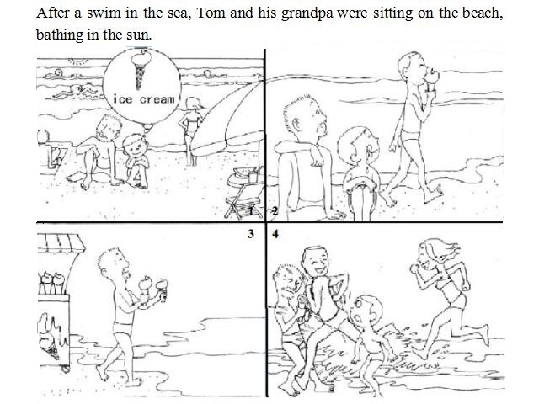

* After a swim in the sea, Tom and his grandpa were sitting on the beach, bathing in the sun. Tom felt thirsty and at that time he saw a man tasting an ice cream passing by. So Tom asked his grandpa to buy an ice cream for him. When his grandpa went back to Tom with two ice creams in both his hands, he was knocked down by a group of people who were running on the beach. What bad luck!
* After a swim in the sea, Tom and his grandpa were sitting on the beach, bathing in the sun. Tom was thirsty and he thought of a delicious ice cream. At the same time, someone passed by with an ice cream in his hand. It strengthened his desire to have an ice cream, so he asked his grandpa to buy one for him. Unluckily, when his grandpa came to him with two ice creams in his hands, a man running on the beach knocked down his grandpa. And the ice creams dropped on the beach.
* After a swim in the sea, Tom and his grandpa were sitting on the beach, bathing in the sun. Seeing the sun, Tom thought of an ice cream. Ice creams always match the hot weather. When he was thinking of this, a man passed by with an ice cream in his hand. The thirst for an ice cream increased, so he begged his grandpa to buy an ice cream for him. When his grandpa returned with two ice creams in his hands, he was knocked over by someone running on the beach. And the ice creams fell down from his hands. How unlucky they were!

## 快速应答

**1.** What day is it today?

* Monday.
* It’s Tuesday today.
* Wednesday.
* Thursday.
* Friday.
* Saturday.
* Sunday.

Keywords: Monday|Tuesday|Wednesday|Thursday|Friday|Saturday|Sunday

**2.** Would you mind turning down the music?

* Sorry, I will turn it down.
* Sorry to bother you. I’ll put on my earphone.
* No, I’m sorry to make trouble.
* No, not at all.

Keywords: No|sorry

**3.** What do you like reading in your spare time?

* Fiction.
* I like reading short stories.
* Fairy tales.
* Science fiction.
* Magazines.

Keywords: Fiction|short stories|fairy tales|magazines

**4.** I failed to catch what you have said. Can you repeat it?

* Sure. Now listen carefully.
* Of course. Now can you follow me?
* Yes, I will speak a bit more slowly.
* Sure. But you need to pay more attention this time.
* OK, listen carefully please.No problem.

Keywords: Sure|yes|of course|OK|No problem

## 简述和回答

**Listen to the following speaker talking about a picnic on weekend.**Henry’s family had a picnic over the weekend. They asked their friends, Nancy and her husband, to go with them. On Sunday morning, Henry’s wife, Kate, got up early to prepare sandwiches for the picnic. She asked Henry to get some soft drinks. Henry told her that they were in the refrigerator. Then Kate asked him to get the picnic basket ready. She also reminded him that he should put paper plates and napkins in it. At 10 o’clock in the morning, Nancy called Henry and told him that she would like to bring something to the picnic. Kate called her back and asked her to bring a bottle of wine. Nancy and her husband arrived at noon. The two families went to a nearby park. A small river ran through the park. There were tables and benches under the trees beside the river. The weather was cloudy but it didn’t rain. Everybody enjoyed the picnic and it was a very relaxing Sunday afternoon.

**1.** Who went on the picnic over the weekend?

* Henry’s family, Nancy and her husband.
* Henry’s family, Nancy and her husband went on the picnic over the weekend.
* Nancy’s family and Henry’s family.
* Henry, Kate, Nancy and her husband.
* Henry, Kate and Nancy’s family.
* Henry’s family and their friends.

Keywords: Henry’s family Nancy husband|Nancy’s family Henry’s family|Henry Kate Nancy husband|Henry Kate Nancy’s family|Henry’s family friends

**2.** What do you like doing best on your weekends? Why?

* I like doing sports best on weekends. It makes me healthy. As is known to us all, it is very important to stay healthy. Only when you stay healthy can you concentrate on your studies. And doing sports is also a good way to relieve stress.
* I like going camping with my family best on weekends. It is a good way to get close to nature. We may feel relaxed when we enjoy the beautiful scenery outside. And it is a good chance for the family to share happiness with each other in such a nice environment.
* I like reading books on weekends. It is my favorite activity on weekends. Reading can enrich our knowledge. By reading, we can know different kinds of things, how things happen and how to avoid bad things from happening. Books record a wide range of things about life. Through reading, we can know different aspects of life.

Keywords: Favorite Activity on Weekends