# 综合模拟17答案

## 朗读句子

1. Michael Jackson is considered as the “King of Pop”.

2. What surprises the foreign tourists is that great changes have taken place in Shanghai during the past decade.

## 朗读段落

Mr. Smith and his wife had their third child last year. So they decided to buy a van. A car with only four seats is not big enough for a family of five, because they will carry more suitcases than ever before when traveling. Americans call vans motor homes. A motor home is always used for holidays. When a family are traveling to the mountains or the seaside, they can live in their motor home for a few days or weeks. All the members of a big family can enjoy a happier life when they are traveling together. That is why motor homes have become so popular in America.

## 情景提问

**Questions 1~2** You are in the hospital visiting your friend Alan who broke his leg. So you ask him two questions.

* Are you feeling well? How did you break your leg?
* How do you feel now? When can you leave the hospital?
* How is your leg? How long have you been in hospital?
* Is your leg badly hurt? When will you recover?
* Do you still feel a pain in your leg? When will you recover from a broken leg?
* How do you feel now? How did you hurt your leg?
* Are you feeling well? When did you hurt your leg?
* How is your leg? When did you break your leg?
* Is your leg badly hurt? When will you be discharged from hospital?
* When were you admitted to hospital? How long will you stay in hospital?
* How is your leg? How many days have you been in hospital?
* How do you feel now? How long have you stayed in hospital?
* Is your leg badly hurt? How many days have you stayed in hospital?
* Are you feeling well? How long will you recover from a broken leg?
* How do you feel now? How many days will you stay in hospital?

Keywords: Are feeling well How break leg|How feel When leave hospital|How is leg How long hospital|Is leg badly hurt When recover|Do pain leg When recover broken leg|How feel How hurt leg|Are feeling well When hurt leg|How is leg When break leg|Is leg badly hurt When discharged hospital|When admitted hospital How long stay hospital|How is leg How many days hospital|How feel How long stayed hospital|Is leg badly hurt How many days stayed hospital|Are feeling well How long recover broken leg|How feel How many days stay hospital

**Questions 3~4** You are at the booking office of Shanghai Railway Station. Ask the office worker inside two questions.

* Do you have any tickets to Beijing for tomorrow? How much is a ticket to Beijing?
* Can I get a refund on this ticket? How much is the cancellation fee?
* Can I exchange this ticket? How can I exchange this ticket?
* Are there any tickets left to Chengdu today? How about for tomorrow?
* Can I return my ticket for a refund? How much is the cancellation fee?
* Can I buy a ticket for my friend? How much is a ticket to Xi’an?

Keywords: Do have tickets How much is ticket|Can get refund ticket How much is cancellation fee|Can exchange ticket How can exchange ticket|Are there tickets left How about|Can return ticket refund How much is cancellation fee|Can buy ticket friend How much is ticket

## 情景描述

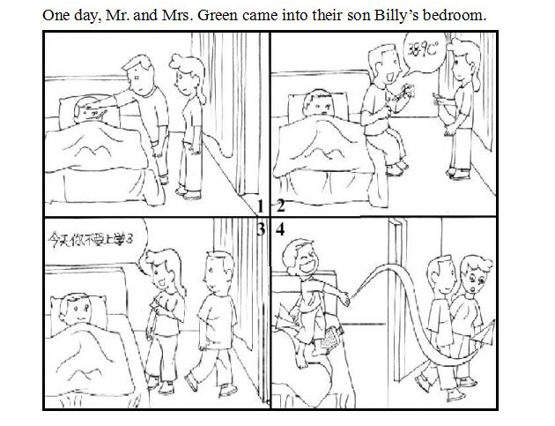

* One day, Mr. and Mrs. Green came into their son Billy’s bedroom. They found him still in bed. “What happened?” they thought. They were worried about their son very much. Then Mr. Green immediately took Billy’s temperature and found he had a fever. So Mrs. Green told Billy to stay at home and have a good rest. When they left the bedroom, Billy got up at once. Then he began to make paper planes and fly them happily.
* One day, Mr. and Mrs. Green came into their son Billy’s bedroom. It was a school day and Billy was supposed to be ready for school. However, he was still lying in bed. “What’s wrong with him?” Mr. and Mrs. Green thought. They were worried so much about him. Soon, Mr. Green checked Billy’s body temperature and it turned out that Billy had a fever. So Mrs. Green asked him to stay at home to have a good rest. But the moment they left the room, Billy got up quickly and flew paper planes happily.
* One day, Mr. and Mrs. Green came into their son Billy’s bedroom. They found their son was still sleeping. Mr. Green wondered whether his son was sick. Thus, he took Billy’s temperature and it was 38.9℃. He told his wife about it and soon Mrs. Green told Billy not to go to school today and to have a good rest at home. When Mr. and Mrs. Green left the room, Billy got up at once. He was so glad that he had successfully cheated his parents and started to have fun throwing paper planes.

## 快速应答

**1.** Congratulations! You won the 100-meter race.

* Thanks.
* Thank you.
* Thank you so much.
* Thank you very much.
* Thanks a lot.

Keywords: Thanks|thank you

**2.** What do you think of my new bicycle?

* It’s nice.
* Your new bicycle looks cool.
* It is beautiful.
* It is the latest one.
* It looks very cool.

Keywords: Nice|cool|beautiful|latest

**3.** Whom will you turn to for help if you are in trouble?

* My parents.
* I will turn to my teacher for help if I am in trouble.
* If I am in trouble, I will ask the police for help.
* My mother.
* My father.
* My mom.
* My dad.
* My mum.
* My father and mother.
* My mother and father.
* My dad and mum.
* My mum and dad.
* My grandmother.
* My grandfather.
* My grandma.
* My grandpa.
* My grandad.
* My grandparents.
* My sister.
* My brother.
* My uncle.
* My aunt.
* My best friend.
* My teacher.
* The police.

Keywords: Parents|teacher|police|mother|father|mom|dad|mum|father mother|mother father|dad mum|mum dad|grandmother|grandfather|grandma|grandpa|grandad|grandparents|sister|brother|uncle|aunt|friend

**4.** What’s your suggestion on speaking English well?

* Spend more time speaking English.
* You can talk with native speakers more often.
* Taking a Spoken English course may be helpful.
* Imitate the way of speaking of native speakers.
* Practise your spoken English more.
* Practice makes perfect.
* Do more listening.
* Do more reading.
* Spend more time studying conversational English.
* Watch English movies.
* Watch English films.
* Listen to English songs.
* Think in English.

Keywords: Spend time speaking English|talk native speakers|Taking Spoken English course helpful|Imitate way speaking native speakers|Practise spoken English|Practice makes perfect|Do listening|Do reading|Spend time studying conversational English|Watch English movies|Watch English films|Listen English songs|Think in English

## 简述和回答

**Listen to the following speaker talking about driving in the United States.** Driving in the United States is different from driving in Asia. Here are some general road rules you need to know when driving in the U.S. The most common one is the speed limit. The speed limit regulates how fast a car may go. The maximum speed limit in most states in America is sixty-five miles per hour. It is important to watch your speed, as it is strongly monitored by the speed radar. In most American states, sixteen is the minimum driving age, while in China, it is eighteen. Seat belt use is an important rule you should pay attention to. Forty-nine states have passed laws requiring seat belt use by at least all occupants of the front seat. In addition, most states require children to wear seat belts in the back seats. Last but not least, drunk driving is illegal in all American states. Although the penalties vary from state to state, some states require jail time and larger fines, even on a first offense.

**1.** What do we know about the general road rules in America?

* In America, the maximum speed limit is sixty-five miles per hour. The minimum driving age is sixteen. All occupants of the front seat need to wear seat belts. In addition, children in the back seats should wear seat belts too. Drunk driving is illegal.
* First, the maximum speed limit in most American states is sixty-five miles per hour. Second, the minimum driving age is sixteen. Third, drivers, front seat passengers and children in the back seats are all required to wear seat belts. Last but not least, drunk driving is illegal in America.
* In most states in America, the maximum speed limit is sixty-five miles per hour. Sixteen years old is the minimum driving age. Forty-nine American states have passed laws that require seat belt use by both drivers and front seat passengers. Besides, children in the back seats are required to wear seat belts as well. Last, drunk driving is not allowed by the law in all American states. Penalties in some states are severe.

Keywords: maximum speed limit sixty five miles per hour minimum driving age sixteen occupants front seat wear seat belts children back seats wear seat belts Drunk driving illegal|maximum speed limit sixty five miles per hour minimum driving age sixteen drivers front seat passengers children back seats required wear seat belts drunk driving illegal|maximum speed limit sixty five miles per hour Sixteen years old minimum driving age Forty nine American states passed laws require seat belt use drivers front seat passengers children back seats required wear seat belts drunk driving not allowed law Penalties severe

**2.** How can we be safe on the roads?

* First, we should cross the road through a subway, a footbridge or a zebra crossing. Besides, we should not cross the road when the red lights are on. Second, take public transportation, such as buses, subways, trains and so on, instead of those illegal. When taking a bus, stand firm. When sitting in a car, wear seat belts. Third, remember to walk on the sidewalk or pavement. Fourth, do not play games on the road.
* First of all, be careful when we cross the road. It will be safer to cross the road through a subway, a footbridge or a zebra crossing. Second, keep it in mind that walk on the sidewalk or pavement, and do not walk in the middle of the road or play games on the road. Third, we should stand firm on the bus or on the subway. When we are in a car, buckle up and keep our arms and heads inside.
* Firstly, when crossing the road, we should wait until the green light is on. If there aren’t any traffic lights, we should stop, watch and wait until it is safe to cross the road, or we should cross through a footbridge. Secondly, when traveling, we should take public transport. What’s more, we should keep our arms and heads inside when taking a bus or sitting in a car. Last but not least, when there is a traffic accident, call the police and the ambulance at once.

Keywords: Be Safe on the Road