# 综合模拟18答案

## 朗读句子

1. The ability to tolerate pain varies from person to person.

2. The presence or absence of clouds can have an important impact on heat transfer.

## 朗读段落

Mount Rainier is a large active volcano located in the Mount Rainier National Park in west central Washington. It is considered as one of the most dangerous volcanoes in the world. The 14,411-foot-high mountain is often said to create its own weather. It reaches into the atmosphere and interrupts the flow of moist air masses from the Pacific Ocean. This results in great amounts of rain and snowfall. During the winter from 1971 to 1972, 1,122 inches of snow fell on Mount Rainier, which was a world record.

## 情景提问

**Questions 1~2** You want to know something about posting a parcel to the U.S. Ask the postman two questions about it.

* How much is the postage? Do I need to pay any extra charges?
* How much do I need to pay for posting the parcel? How long does it take to get to the U.S.?
* Do I need to pay for the insurance? How will you deal with a lost parcel?
* How much do I need to pay for posting the parcel? Do I need to pay any extra charges?
* How much do I need to pay for posting the parcel? Is there an extra charge?
* How much do I need to pay in total? Do I need to pay any extra fees?
* How much do I need to pay in total? Is there an extra fee?
* What is your policy about overweight packages? Is there anything that is not allowed to be sent to America?
* How much do I need to pay for the insurance? What is your policy about cash on delivery?
* Can you tell me something about the policy of collect on delivery? What is forbidden to be sent to the U.S.?
* Can you tell me something about the policy of overweight parcels? What is prohibited to be sent to the United States?
* How much do I need to pay in total? How much time will it take to get to America?

Keywords: How much postage Do pay extra charges|How much pay posting parcel How long get U.S.|Do pay insurance How deal lost parcel|How much pay posting parcel Do pay extra charges|How much pay posting parcel Is extra charge|How much pay total Do pay extra fees|How much pay total Is extra fee|What policy overweight packages Is not allowed sent America|How much pay insurance What policy cash delivery|Can tell policy collect delivery What forbidden sent U.S.|Can tell policy overweight parcels What prohibited sent United States|How much pay total How much time get America

**Questions 3~4** You are invited to a party held by your friend Tom. Ask him two questions about the party.

* What is the party for? When will the party begin?
* Where will you hold the party? Who else will attend the party?
* Will your party offer food or drinks? What kinds of activities will there be at the party?
* What kind of party is it? Do I need to take anything to the party?
* What kind of party is it? What time will the party start?
* When will the party begin? When will the party end?
* What time will the party begin? What time will the party end?
* What is the party for? Where will you hold the party?
* What kind of party is it? Where will the party be held?
* Will the party be held at your home? When will the party begin?
* Will you hold the party at home? Who else will attend the party?
* Where will the party be held? Who else will go to the party?
* What is the party for? Will we have food or drinks at the party?
* Where will you hold the party? Will your party offer food or drinks?
* What kind of party is it? What kinds of activities will there be at the party?
* What is the party for? Will we have any special activities at the party?
* What is the party for? Should I bring anything to the party?
* How long will the party be? What kinds of activities will there be at the party?
* How long will the party last? Will your party offer food or drinks?

Keywords: What party When party begin|Where hold party Who attend party|Will party offer food drinks What activities party|What party Do take party|When party begin When party end|What time party begin What time party end|What party Where hold party|What party Where party held|Will party held home When party begin|Will hold party home Who attend party|Where party held Who go party|What party Will food drinks party|Where hold party Will party offer food drinks|What party What activities party|How long party last Will party offer food drinks

## 情景描述

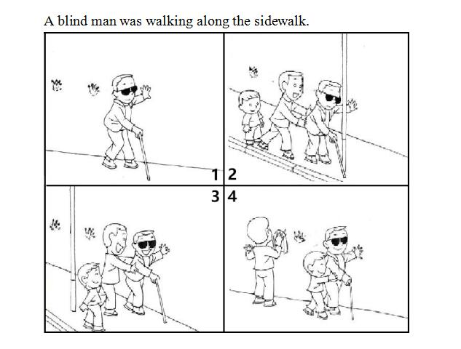

* A blind man was walking along the sidewalk. He was walking close to a pillar and nearly knocked on it. A little boy and his father saw this and they came up to help at once. The father helped move the blind man. And then, when the blind man was safe, the father asked his son to help the blind man move forward while he was cleaning the dirty handprints left by the blind man on the sidewall. How kind they are!
* A blind man was walking along the sidewalk. His hand was dirty, so he left some handprints on the sidewall behind him. As he was moving ahead, he nearly got knocked down by a pillar in front of him. At this moment, a father and his son saw this and they walked up to help. The father first moved the blind man to somewhere safe, and then he asked his son to help the blind man move forward so that he could clean the dirty handprints on the sidewall. How friendly they are!
* A blind man was walking along the sidewalk. His hand was so dirty that he left some handprints on the sidewall where he walked by. The moment he nearly knocked into a pillar, a father and his son came forward and offered help. The father immediately moved the blind man to a safe place. While the son was helping the blind man move forward, the father was cleaning the handprints the blind man left on the sidewall. What a good example the father has set to his son!

## 快速应答

**1.** You are late for school today.

* Sorry.
* I’m sorry and I’ll never be late for school again.
* I’m so sorry.
* Sorry, I’ll never be late for school again.

Keywords: Sorry|sorry never late school

**2.** Excuse me, how can I get to the train station?

* By bus.
* You can take a taxi there.
* You can go to the train station by subway.
* You can take the subway there.
* You can go there by underground.
* You can take the underground to go to the train station.
* You can go there on foot.
* You can walk there.
* You can walk to the train station.
* It’s just 5 minutes’ walk from here.
* You can take a bus there.
* You can go there by bus.

Keywords: By bus|take taxi|train station by subway|take subway|by underground|take underground train station|on foot|walk|walk train station|minutes’ walk|take bus

**3.** What will you do if you see someone get hurt at school?

* Call the ambulance at once.
* I will ask the teachers for help immediately.
* I will take him or her to the health center at once.
* I will call the ambulance at once.
* I will report to my teacher at once.
* I will take him or her to the school clinic.

Keywords: Call ambulance|ask teachers help|take him her health center|report teacher|take him her school clinic

**4.** Why do you love reading English novels?

* Because it is interesting.
* Because it is helpful to learn English well.
* Because I can learn a lot from them.
* Because I want to improve my English.
* Because it is good for my English study.

Keywords: Because interesting|Because helpful learn English well|Because learn them|Because improve English|Because good English study

## 简述和回答

**Listen to the following speaker talking about how roads were built in Rome in the past.** You may have heard the saying, “All roads lead to Rome.”, but do you know how roads were built in Rome in the past? Rome was the center of a huge empire. The Romans needed a way to move their large armies quickly so that they could protect their country. They also needed roads for land trade. Therefore, the emperor decided to build a net-work of roads.Beginning in 300 B.C., the Romans built roads in Europe, Asia and North Africa. By 200 A.D., they had built 50,000 miles of almost straight roads.To build their roads, the Romans moved away all soft soil. They dug until they reached the hard ground. Then they added layers of stone. The most important roads were paved with large flat stones. Main Roman roads were sometimes as wide as ours today. Sometimes, the Romans had to dig tunnels through mountains. But they didn’t have any machines to help them. So they heated the rock with fire and then threw cold water over it. When the rock cracked, they dug it out. It was hard work, but the roads were so well built that they were used for hundreds of years.

**1.** How did the Romans build roads in the past?

* They moved away all soft soil. And then, they dug until they reached the hard ground. Last, they added layers of stone.
* To build their roads, the Romans first cleared away all soft soil. Then, they dug until they reached the hard ground. And finally, they added layers of stone.
* There are mainly three steps for the Romans to build roads in the past. Firstly, they cleaned up all soft soil. Secondly, they dug until they reached the hard ground. Lastly, they paved the ground with stones.

Keywords: moved away soft soil dug until reached hard ground added layers stone|build roads Romans cleared away soft soil dug until reached hard ground added layers stone|three steps Romans build roads past cleaned up soft soil dug until reached hard ground paved ground stones

**2.** What is the most famous building in Shanghai and why is it famous?

* It is the Oriental Pearl Radio and TV Tower. It is very famous because it is the landmark of Shanghai. It is located in the Pudong New Area. It is 468 meters high and was open to the public in May, 1995. Every year, many people visit it.
* Oriental Pearl Radio and TV Tower is the most famous building in Shanghai because it is the landmark of Shanghai. It was open to the public in 1995, and was regarded as the National 5A-class Scenic Spot in 2007. It lies in Lujiazui in the Pudong New Area. It is 468 meters high and there is a history museum, a game city and several restaurants in it. Every year, people from different parts of the world come and visit it.
* The most famous building in Shanghai is the Oriental Pearl Radio and TV Tower. It is famous because it is the landmark of Shanghai. Located within the Pudong Park in Lujiazui in the Pudong New Area, the tower is an architectural heritage, and also a National 5A-class Scenic Spot. It is 468 meters high. There are restaurants, bars, sightseeing floors and even a roller coaster in it. It has become a must-go place for tourists when visiting Shanghai.

Keywords: The Most Famous Building in Shanghai