# 综合模拟20答案

## 朗读句子

1. Peter is the tallest tennis player in the team.

2. The United States is traditionally famous for its very solid and unchanging diet, chiefly made up of meat and potatoes.

## 朗读段落

I have the greatest job in the world. I travel to unusual places and work with people from all over the world. Sometimes working outdoors, sometimes in an office, sometimes using scientific equipment and sometimes meeting local people and tourists. I am never bored. Although my job is occasionally dangerous, I don’t mind because danger excites me and makes me feel alive. However, the most important thing about my job is that I help protect ordinary people from one of the most powerful forces on earth — the volcano.

## 情景提问

**Questions 1~2** Your friend has won first prize in an English speaking competition and he is very happy. Ask him two questions about it.

* How many people took part in the competition? Did your classmates took part in the competition, either?
* How did you prepare for the competition? Could you give me some suggestions about improving speaking English?
* What do you think made you succeed in the competition? Do you have any good suggestions about improving speaking English?
* What kind of competitions have you ever taken part in before? Were you nervous when standing on the stage?
* What kind of competitions have you ever taken part in before? Were you nervous when speaking English in front of many people?
* How many people participated in the competition? Did your classmates participate in the competition, either?
* What kind of competitions have you ever participate in before? Were you nervous when standing on the stage?
* What kind of competitions have you ever participate in before? Were you nervous when speaking English in front of many people?

Keywords: how many people took part competition classmates took part competition|how you prepare competition could you give me suggestions improving speaking English|what you think made you succeed competition you have suggestions improving speaking English|what competitions you taken part before were you nervous when standing stage|what competitions you taken part before were you nervous when speaking English front people|how many people participated competition classmates participate competition|what competitions you participate before were you nervous when standing stage|what competitions you participate before were you nervous when speaking English front people

**Questions 3~4** Your friend received a post card from an Australian teacher. Ask your friend two questions about the teacher.

* Where is he working now? Has he ever been to China?
* Is he your former English teacher? Where is he working now?
* How many years have you kept in touch with each other? Have you ever invited him to China?
* Is he your former English teacher? How many years have you kept in touch with each other?
* Is he your former English teacher? What subject did he teach you in the past?
* Is he your former English teacher? Which subject had he taught you before?
* Is he your former English teacher? What kind of teachers do you think he is?
* Is he your former English teacher? What do you think about him?
* How many years have you kept in touch with each other? Where is he working now?
* Where is he working now? Has he ever been to China?
* Where is he working now? Have you ever invited him to China?

Keywords: where he working now he been China|he your former teacher where he working now|how many years you kept touch each other you invited him China|he your former teacher how many years you kept touch each other|he your former teacher what subject he teach you past|he your former teacher which subject he taught you before|he your former teacher what kind teachers you think he|he your former teacher what you think him|how many years you kept touch each other where he working now|where he working now you invited him China

## 情景描述

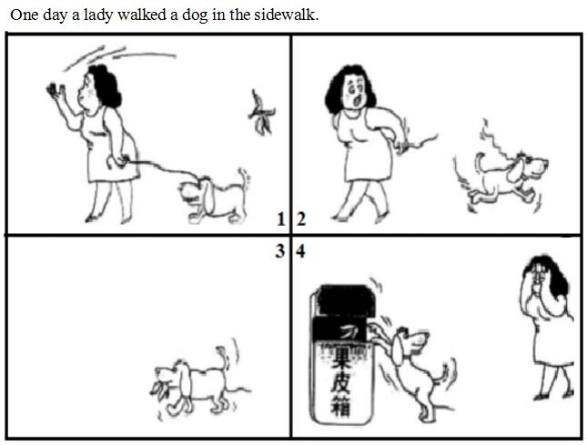

* One day a lady walked a dog in the sidewalk. She threw the banana skin on the sidewalk directly after finishing eating a banana. Suddenly, she was pulled back by a strong force and she found that it was her dog that was struggling to run back. Soon the dog got free and ran to the banana skin thrown by her. The dog held the banana skin with his mouth and then put it into the dustbin. Seeing what had happened, the lady was very ashamed.
* One day a lady walked a dog in the sidewalk. She was eating a banana happily. After finishing eating, she just threw the banana skin on the sidewalk. At that very moment she felt a strong force pulling her back. And she found that her dog was struggling to run back and finally the dog got free. He ran to the banana skin thrown by her. Then he held the skin with his mouth, and came to the dustbin to put the banana skin into it. When the lady saw this, she felt greatly ashamed.
* One day a lady walked a dog in the sidewalk. After finishing eating a banana, she just threw its skin on the sidewalk. At that very moment she felt a strong power pulling her back. Then she saw her dog was trying to run back and finally he got free. He ran to the banana skin which was thrown by her and hold it with his mouth. Then he came to a dustbin and put the banana skin into it. Seeing what her dog had done, the lady felt greatly ashamed.

## 快速应答

**1.** I am afraid you can’t take photos here.

* Sorry, I didn’t know that.
* Sorry, I won’t do it any more.
* Oh sorry, I didn’t see the sign.
* Oh sorry, I didn’t notice the sign.

Keywords: Sorry I didn’t know that|Sorry I won’t do it any more|sorry I didn’t see sign|sorry I didn’t notice sign

**2.** Excuse me, could you please help me take down the book on the top of the shelf?

* No problem.
* Sure, here you are.
* Sorry, I can’t reach it. You may ask someone else for help.
* Sorry, I’m not tall enough. You may ask the tall man over there.
* Yes, of course.
* Sorry, but I have to leave now.
* Of course, with pleasure.
* With pleasure.
* My pleasure.
* I am glad to.
* It’s my pleasure.
* Yes, with pleasure.
* Sure, with pleasure.
* Sure. I am glad to.
* Certainly. I am glad to.
* OK. I am glad to.
* Of course, here you are.

Keywords: no problem|sure|sorry|yes|of course|with pleasure|my pleasure|I am glad|certainly|OK

**3.** Here’s the medicine for your stomachache.

* Thanks a lot.
* Thank you very much.
* OK. Thank you very much.
* Thank you.
* OK. Thank you.
* OK. Thanks a lot.

Keywords: thanks|thank you|OK

**4.** Would you mind opening the air conditioner?

* All right.
* Sorry, but I have caught a cold.
* No problem.
* Of course. I feel hot, too.
* OK.
* Of course.
* I’m afraid not. I’ve got a cold.
* The air conditioner doesn’t work.
* Sorry. There is no air conditioner here.
* Sorry, but I am afraid you can’t.
* Sorry to tell you that the air conditioner is broken.

Keywords: all right|Sorry|no problem|of course|OK|I’m afraid not|the air conditioner doesn’t work|no air conditioner here|the air conditioner is broken

## 简述和回答

**Listen to the following speaker talking about the history of the United States.**Compared to the history of China, the history of the United States is quite short. It began little more than 200 years ago. In 1776, 13 colonies located on the eastern coast of North America declared independence and fought a revolution against the British. In 1783 the colonists won the revolution and gained their independence. After the revolution, the United States bought a large section of country from Napoleon of France. This purchase doubled the size of the United States. Napoleon needed money for his European wars. If he hadn’t needed that money, the United States might have stayed a small country. Texas and most of what is now the southwestern part of the United States belonged to Mexico. The people of Texas fought a revolution against Mexico. They became independent and joined the United States. Later, the United States and Mexico went to war. If Mexico had defeated the United States in that war, California and New Mexico would have been part of Mexico today.

**1.** After the revolution against the Britain, what did the United States do to make its land double size?

* The United States bought a large section of country from Napoleon of France, which doubled the size of the United States.
* After the revolution, the United States bought a large section of country from Napoleon of France. This purchase doubled the size of the United States.
* After the revolution with Britain, the United States bought a large section of country from Napoleon of France which made its land double size.

Keywords: United States bought large section country Napoleon France which doubled size United States|After revolution United States bought large section country Napoleon France purchase doubled size United States|After revolution Britain United States bought large section country Napoleon France which made its land double size

**2.** What else do you know about the United States? Please list at least 3 points.

* The United States comprises 50 states. Washington, D.C. is its capital. People from all over the world like to go to this country. For example, they can go to the fashion city New York for shopping or have a nice holiday in Hawaii.
* The United States is the fourth largest country in the world. New York is its biggest city. And as the capital of the USA, Washington, D.C. is much smaller than New York.
* The United States comprises 50 states. Washington, D.C. is its capital. There are fifty states in the United States, such as California, Texas and so on. The state with the largest in population is California, while the city with the largest population is New York.
* There are fifty states in the United States. The largest in area is Alaska. And it is the smallest in population. Alaska is also the coldest state. The most important city in the United States is Washington, D.C. It is the capital, but it is much smaller than New York which is the biggest city in this country.

Keywords: the United States