# 综合模拟3答案

## 朗读句子

1. Lady Liberty’s image represents hope and freedom.

2. People reacted to the announcement on social media, which made Lady Liberty a trending topic.

## 朗读段落

An estimated 68,000 people will visit the White House during the holiday season. There is no cost to enter. But, the very first people to see this year’s decorations were military members and their families. Michelle Obama welcomed them to the White House on Tuesday.The first lady said the gold ornaments on the official White House Christmas tree honor military heroes. The Christmas tree is almost six meters tall and stands in the Blue Room. This year’s theme is “The Gift of the Holidays”. Many of the decorations represent important gifts in America, including the “gift of a great education”, Michelle Obama said.

## 情景提问

**Questions 1~2** One of your friends asks you to go to a concert with him. Ask him two questions about the concert.

* How long will the concert last? Where is the concert?
* When does the concert start? Who will play at the concert?
* How much will the ticket cost? Are the performers famous?
* Who will sing at the concert? Where will the concert be held?
* Where will the concert be held? When will the concert end?
* How long will the concert last? Where will the concert be held?
* When does the concert start? How long will the concert last?
* How long will the concert last? How much will the ticket cost?
* Who will play at the concert? How long will the concert last?
* When does the concert start? How much will the ticket cost?
* When does the concert start? Who will sing at the concert?
* Where is the concert? Who will sing at the concert?
* When does the concert start? Are the performers famous?
* When will the concert end? Are the performers famous?
* How much will the ticket cost? When will the concert end?
* Are the performers famous? Where will the concert be held?

Keywords: How long concert last Where is concert|When concert start Who play concert|How much ticket cost Ar performers famous|Who sing concert Where concert held|Where concert held When concert end|How long concert last Where concert held|When concert start How long concert last|How long concert last How much ticket cost|Who play concert How long concert last|When concert start How much ticket cost|When concert start Who sing concert|Where is concert Who sing concert|When concert start Are performers famous|When concert end Are performers famous|How much ticket cost When concert end|Are performers famous Where concert held

**Questions 3~4** You have moved to a new residential area recently, and you are not familiar with the neighborhood. Ask your next-door neighbor two questions about your new neighborhood.

* Is it convenient to live here? How far is the supermarket?
* Are the people here easy to get along with? Where is the nearest bank?
* Can you tell me where the nearest bank is? How far is the supermarket?
* What are the people here like? Is it convenient to live here?
* What are the people here like? Is there a gymnasium near here?
* Can you tell me where the nearest bank is? What are the people here like?
* How far is the supermarket? Is there a gymnasium near here?
* How far is the supermarket? Are the people here easy to get along with?
* Can you tell me where the nearest bank is? What are the people here like?
* How far is the supermarket? What are the people here like?

Keywords: Is it convenient live How far supermarket|where nearest bank How far supermarket|Are people easy get along with Where nearest bank|What people like Is it convenient live|What people like Is there gymnasium|where nearest bank What people like|How far supermarket Is there gymnasium|How far supermarket Are people easy get along with|where nearest bank What people like|How far supermarket What people like

## 情景描述

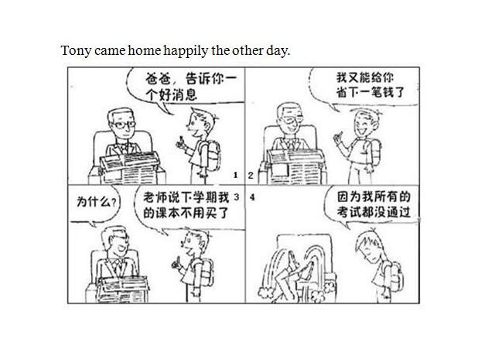

* Tony came home happily the other day. When he arrived home, his father was reading newspapers. He told his father excitedly that he had a piece of good news. “Dad, you can save lots of money this time. My teacher said that I wouldn’t have to buy the textbooks next term.” His father got surprised and asked what had happened. Tony lowered his head and said “Because I failed all the exams.” Hearing that, his father fell off the chair.
* Tony came home happily the other day. He went to the study and told his father there was some good news. His father wondered what it was. Tony said he could help his father save a large amount of money this time. And he further explained that his teacher said he could save the money from the textbooks for next term. This made his father even more surprised and he asked why. Tony looked sad and whispered that he didn’t pass any exams. His father fell off the chair on hearing the news.
* Tony came home happily the other day. He told his father he had a piece of good news to announce. His father stopped reading his newspapers and waited for Tony’s good news. Tony said in excitement that he would save some money this time because he wouldn’t have to pay for the textbooks for next term. His father was puzzled and asked why. Then Tony became sad and said he didn’t pass the exams. His father was so shocked that he fell off the chair.

## 快速应答

**1.** You shouldn’t smoke here, Sir.

* Sorry, I won’t do that next time.
* Sorry, I didn’t notice the sign here.
* I’m sorry. I’ll never do that again.
* Sorry, I won’t do it again.

Keywords: Sorry won’t do|Sorry didn’t notice sign|sorry never do

**2.** You’ve been doing a very good job in organizing the party.

* Thanks a lot.
* Thank you. I’m glad to hear that.
* Thank you.
* Thank you very much.
* It’s so nice of you to say that.

Keywords: Thank you|thanks a lot|it’s nice say that|thank you glad hear that

**3.** I don’t know how to use this fax machine.

* Don’t worry. Let me show you how to use it.
* That’s alright. I will teach you how to use it.
* Don’t worry. I will show you how to use it.
* Let me show you how to use it.
* Don’t worry. I can teach you how to use it.

Keywords: don’t worry show how use|that’s alright teach how use|let show how use|don’t worry teach how use

**4.** Can you tell me what time it is now?

* Eleven thirty.
* Sure. It’s five o’clock.
* It’s half past nine now.
* It’s three o five.
* It’s a quarter to ten.
* It’s ten past nine.
* It’s one o’clock.
* It’s two o’clock.
* It’s three o’clock.
* It’s four o’clock.
* It’s six o’clock.
* It’s seven o’clock.
* It’s eight o’clock.
* It’s nine o’clock.
* It’s ten o’clock.
* It’s eleven o’clock.
* It’s twelve o’clock.
* It’s two fifteen.

Keywords: eleven thirty|five|half past nine|three o five|a quarter to ten|ten past nine|one|two|three|four|seven|six|eight|nine|ten|eleven|twelve|two fifteen

## 简述和回答

**Listen to the following speaker talking about the health insurance programs in America.**American hospitals are the most modern and best equipped medical facilities in the world. But this degree of excellence has been expensive. Medical costs in the United States are very high. There is no national health plan for Americans. But there are many programs available for this purpose. Many people have health plans at the companies where they work. Under these plans, the company pays a fixed sum of money regularly into a fund. Then when the employee needs medical help, he can use money from the fund to pay for it. Other people have health insurance. They pay insurance premiums each month to insurance companies which then pay for medical expenses when they are needed. In some medical plans, the insurance company is also the medical institution. People regularly pay the hospital directly. Then when they need medical treatment, they go to the hospital without paying more money. The government has health insurance programs for older people, poor people and those with long-term illness.

**1.** How do Americans pay for health costs?

* With health plans or health insurance.
* They use the fund from their health plans or health insurance.
* People have health plans or health insurance to cover their health costs.

Keywords: health plans health insurance

**2.** Describe your ideas of a healthy life.

* How can we lead a healthy life? First, I think we should eat healthily. It’s important to have our daily meals on time and have more vegetables and fruits rather than meat. Second, we should exercise regularly because it can help control our weight and keep us from illness.
* In my opinion, a healthy life includes both physical and mental health. On the one hand, people should have a healthy diet and regular exercise to maintain a strong body. On the other hand, people should find ways to make themselves relaxed and keep a good mood every day.
* In order to have a healthy life, firstly I think we should not stay up late. It is vital that we have enough sleep, so that we can have enough energy for a day. Secondly, a lot of people are living under pressure now. People should learn to release their pressure in proper ways.

Keywords: My Opinion on a Healthy Life