# 综合模拟7答案

## 朗读句子

1. Today’s ceremony, however, has very special meaning.

2. Every four years we gather on these steps to carry out the orderly and peaceful transfer of power.

## 朗读段落

The Jordan family had the best berries in the neighborhood.So on a Friday summer night, we secretly went into the Jordans’ backyard and started picking their sweet, juicy berries. As we were enjoying the delicious berries, suddenly the Jordans’ backyard lights were turned on, and Mr. Jordan ran outside.“What are you boys doing out here?” he shouted as my friends ran off in all directions.All the boys ran away except me. Mr. Jordan shouted at me and told it to my mother. My friends laughed at me about it for days afterwards.

## 情景提问

**Questions 1~2** Your schoolmate is going to see a new film. He invites you to go with him. You ask him two questions about this.

* What kind of film are we going to see? What’s the name of this movie?
* When are we going to see this film? Where should we meet each other?
* When will the film start? How long does this film last?
* Where are we going to see the film? Does anyone else come with us?
* What kind of film are we going to see? Will anyone else come together?
* What’s the name of this movie? Do you also invite other people?
* Where should we meet each other? How long does this film last?
* Does anyone else come with us? Where should we meet each other?
* Do you also invite other people? Where are we going to see the film?
* Will anyone else come together? What kind of film are we going to see?
* How long does this film last? Where should we meet each other?

Keywords: What kind film we see what’s name|when we see film where we meet each other|when film start how long film last|where we see film anyone come|what kind film we see anyone come together|what’s name movie you invite other people|where we meet each other how long last|anyone come where we meet|you invite other people where we see film|anyone come together what kind film we see|how long film last where meet

**Questions 3~4** Your class has a new comer from another school this term. You ask the new comer two questions.

* What’s your name? Where are you from?
* What do you think of our school? Are you happy with the new class here?
* Is your home far away from our school? What do you like to do after school?
* How do you go to school? Do you think our school is beautiful?
* Why do you change school? Are you happy with the new class here?
* Is your home far away from our school? How do you go to school?
* Where are you from? Is your home far away from our school?
* What’s your name? What do you like to do after school?
* What do you think of our school? How do you go to school?
* How do you go to school? What do you like to do after school?

Keywords: What’s your name where you from|what you think our school you happy new class here|your home far away from our school what do you like do after school|How do you go to school our school beautiful|why you change school you happy with new class|Is your home far our school how you go school|where you from your home far our school|what’s your name what you like do after school|what do you think of our school how you go to school|how you go school what you do after school

## 情景描述

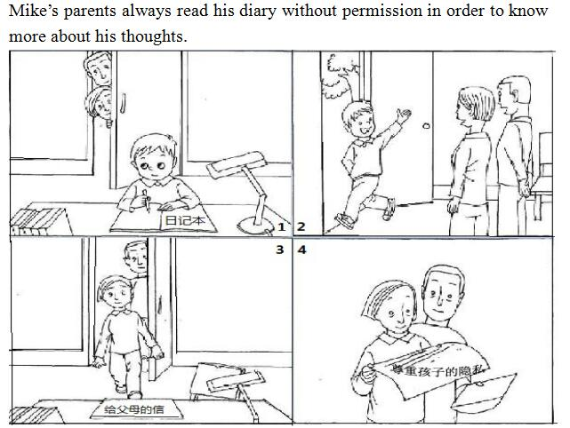

* Mike’s parents always read his diary without permission in order to know more about his thoughts. So Mike feels very upset. One day when he finished his diary writing, he found that his parents were standing outside his study and ready to come into his study to read his diary. He wrote something on the diary and then he said good-bye to his parents and went out of the room. His parents quickly came into the study and tried to read his son’s diary and they saw six big words on the paper. “Parents should respect your kids’ privacy.” When they read this, they felt guilty and decided never to read his diary without permission from then on.
* Mike’s parents always read his diary without permission in order to know more about his thoughts. Mike realizes that and he wants his parents to know it’s not right to do this. One day, when he was writing his diary, his parents were standing outside the room and watching him. After Mike finished his writing, he said goodbye to his parents and went outside. His parents quickly came into the room and picked up his diary. But they only found several words in it. “Please respect children’s privacy.” Seeing this, Mike’s parents felt guilty and swore not to read his diary any more.
* Mike’s parents always read his diary without permission in order to know more about his thoughts. Mike is not satisfied with it. One day, he found that his parents were standing outside his study room and prepared to read his diary secretly. He thought for a minute and wrote something on the diary. Then he said goodbye to his parents and went out of the room. His parents quickly came into the room and read his diary. To their surprise, there were only several words in it. “Parents should respect children’s privacy.” His parents felt guilty when they saw this, and they decided they would no longer read Mike’s diary.

## 快速应答

**1.** You’ve got a great ear for music.

* Thank you.
* Thanks. Music is my favorite.
* Oh. Thank you, it’s very sweet of you.
* Thank you, but there is still room for improvement.
* Oh, you are flattering me.

Keywords: Thank you|thanks music my favorite|thank you sweet you|thank you room improvement|flattering

**2.** Hello, is Peter there, please?

* Hold on please.
* This is Peter speaking.
* He is not available right now. Can I take a message?
* Yes. Go ahead, please.
* You’re speaking to him.
* One moment, please.
* Just a second, please.
* I’ll put him on.
* Hold the line, I’ll see if he is in.
* Wait a minute please. I’ll get him.
* Let me see if he’s here. Hang on. OK?
* He’s on another phone.
* He has not come yet. Could I take a message for you?
* He isn’t here right now. Would you like to leave a message?
* Sorry, he’s just gone out. Would you like to ring back later?
* I’m afraid you’ve got the wrong number.
* Peter? I’m sorry, but there’s nobody here by this name.

Keywords: Hold on|Peter speaking|He available right now can I take message|Yes go ahead|You’re speaking him|One moment|Just second please|I’ll put him on|Hold line I’ll see he in|Wait minute I’ll get him|Let me see he’s here Hang on OK|He another phone|He come yet could take message you|He isn’t here now Would you like leave message|Sorry he’s gone out would you like ring back later|I’m afraid you’ve got wrong number|Peter I’m sorry nobody here name

**3.** Make sure you lock the door when you leave.

* No problem.
* OK, I will.
* Sure.
* I will.
* You can count on me.
* I’ll lock the door. Don’t worry.
* Don’t worry about it.

Keywords: No problem|OK I will|Sure|I will|You can count me|I’ll lock the door Don’t worry|Don’t worry about it

**4.** This is nice, but it’s too expensive. I think 30 yuan may be better.

* OK, it’s a deal.
* Sorry, I’m afraid not.
* OK. Here you are.
* OK. You can take it.
* All right. I’ll sell it to you.
* I’d like to. But this is the lowest price we can offer.
* Sorry, this is out of our price range.
* Sorry, no discount.
* No bargain.
* Done.
* Deal!

Keywords: OK it’s deal|Sorry I’m afraid|OK here you are|OK you take it|All right I’ll sell it you|I’d like lowest price we can offer|Sorry out of our price range|Sorry no discount|No bargain|Done|Deal

## 简述和回答

**Listen to the following speaker talking about American families.**In the past, American families tended to be quite large. Parents raising five or more children were common. Over the years the size of the family has decreased. One reason for this is an increase in the cost of living. On average, children attend schools for more years than they used to, making them financially dependent on their families longer. Moreover, children nowadays are better dressed and have more money to spend on entertainment. The parents usually take the responsibility for all the expenses. Meanwhile, families are less close than they used to be. More and more American mothers work away from home. The break up of the family occurs when the parents get divorced. A lot of children in the U.S. live part of their young lives with only one parent. Broken families usually result in problems for children and parents alike. Children blame themselves when their parents separate. They grow up feeling unsettled as they are moved back and forth between parents. Usually one parent takes the responsibility for raising the children. These single parents must care for the children’s emotional and psychological needs while also supporting them financially.

**1.** Why have American families become smaller?

* It is because the cost of living has increased and the families are less close than before.
* Because there is an increase in the cost of living and meanwhile, the families are less close than they used to be.
* Because the cost of living is increasing and the families are less close than they used to be.
* The reason is that the cost of living is increasing and the families are less close than they used to be.
* Because the cost of living is increasing and the families are less close than they used to be.

Keywords: Cost living increased families less close than before|cost living increasing families less close than they used to be

**2.** Compared to the past, what are the changes of the families in China now?

* Compared to the past, there are many changes of the families in China nowadays. For those who live in the countryside, their families are becoming smaller and smaller. Young people move to the city for work and make a new family in the city. And the old people still stay in the countryside. As for the people live in the city, most families have only one child. The children feel lonely as they don’t have sisters or brothers to share their happiness and sadness.
* In the past, Chinese families were always poor. A lot of children suffered from hunger and couldn’t get enough education. Now, the situation is getting better and better. Most of the Chinese families have enough food, clothing and good health care. People don’t feel crowded or noisy at homes because most families have big houses. People’s life is getting much better, compared to the past.
* With the development of the whole country, Chinese families are changing in some ways compared to the past. First, most families have only one or two children nowadays. Children live with their parents only, not with their other relatives anymore. Family numbers become smaller and smaller. Second, people spend more time on entertainment. Many families would go traveling on weekends, but not stay at home. Third, women have the same rights as men in modern Chinese families.

Keywords: Families in the past and now