# 综合模拟8答案

## 朗读句子

1. This moment is your moment. It belongs to you.

2. What truly matters is not which party controls our government, but whether our government is controlled by the people.

## 朗读段落

Many years ago, I was fresh out of school and working in Denver. One day, I was driving to my parents’ home in Missouri for Christmas. Suddenly, I found black smoke pouring from the back of my car. I stopped and wondered what I was supposed to do. A car pulled up behind me. A couple came out. They said they would take me to my parents’ home. We chatted on the way into the city, and when I got out of the car, the husband gave me his business card.I wrote him and his wife a thank-you note for helping me. Soon afterwards, I received a Christmas present from them. A note in it said that helping me had made their holidays meaningful.

## 情景提问

**Questions 1~2** You’ve made some new friends from England. You want to know how they celebrate Christmas. You ask them two questions about it.

* How do you celebrate Christmas? What will you prepare for Christmas?
* Who will you invite to celebrate Christmas together? What would you do on Christmas Eve?
* How many days does this holiday last in your country? Will you celebrate it at home or outside?
* Will you prepare a big meal for Christmas? Is there any difference between English and people from other western countries to celebrate it?
* Where will you go to celebrate Christmas? Do all the family members get together on Christmas?
* How many days does this holiday last in your country? How do you celebrate Christmas?
* Do all the family members get together on Christmas? Will you prepare a big meal for Christmas?
* Who will you invite to celebrate Christmas together? Where will you go to celebrate Christmas?
* What will you prepare for Christmas? Will you celebrate it at home or outside?

Keywords: how you celebrate Christmas what you prepare|who you invite celebrate together what you do Eve|how many days holiday last your country will you celebrate home outside|will you prepare a big meal difference between English western countries celebrate|where will you go celebrate all family members get together|how many days holiday last your country how you celebrate|all family members together will you prepare big meal|who will invite celebrate where you go|what you prepare will you celebrate home outside

**Questions 3~4** You are in the supermarket and you want to buy an air conditioner. Ask the salesman two questions about it.

* Excuse me. I am looking for an air conditioner. Would you tell me where air conditioners are sold? Which air conditioner would you recommend?
* How can I find the air conditioner? I want to buy one. Which air conditioner is better?
* Hello, I’d like to buy an air conditioner. Can you help me? Which air conditioner would you recommend?
* Excuse me. I want to buy an air conditioner. Would you please show me the best one? What’s the difference between these two air conditioners?
* Could you please tell me where the air conditioner are? Is there any discount for the air conditioner?
* Why is this brand of air conditioner more expensive than others? What’s the difference between these two air conditioners?
* Is there any discount for the air conditioner? Which air conditioner would you recommend?
* Which brand of air conditioner is on sale? Which one is better?
* Hello, I’d like to buy an air conditioner. Can you help me? Which brand of air conditioner is on sale?
* Excuse me. I want to buy an air conditioner. Would you please show me the best one? Why is this brand of air conditioner more expensive than others?

Keywords: looking for air conditioner would tell where air conditioners sold which recommend|how I find air conditioner which better|I’d like buy air conditioner can help me which recommend|I want buy air conditioner would you show best what’s difference between these two|could tell where air conditioner discount|why this brand more expensive than others what’s difference between these two|discount for air conditioner which recommend|which brand air conditioner on sale which one better|I’d like buy air conditioner help which brand on sale

## 情景描述

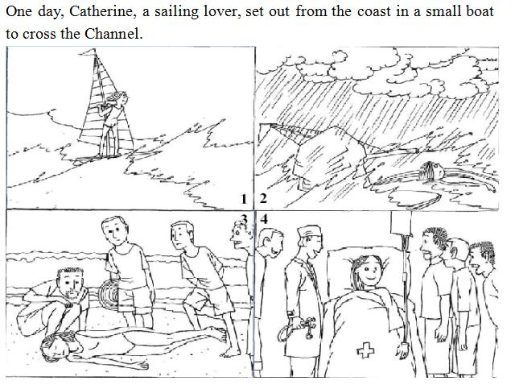

* One day, Catherine, a sailing lover, set out from the coast in a small boat to cross the Channel. But the weather changed. The storm came suddenly and the strong wind made her boat turn over and she fell into the water and got fainted. Fortunately, she was saved by several fishermen and she was sent to the hospital immediately. When she woke up, she found herself lying on the bed in the hospital with some people around her. The doctor told her that these men saved her life. Catherine sincerely thanked them for saving her life.
* One day, Catherine, a sailing lover, set out from the coast in a small boat to cross the Channel. Suddenly the weather became stormy. It rained heavily and her boat was turned over by the strong wind. Catherine fell into the water and lost her consciousness. It was lucky that she was found by some fishermen and sent to the hospital right away. Her life was saved. And when she woke up, she knew that it was the fisherman who sent her to the hospital. She felt very grateful. She thanked them from the bottom of her heart.
* One day, Catherine, a sailing lover, set out from the coast in a small boat to cross the Channel. The sea was calm at first but changed all of a sudden. Her boat was turned over by the big waves and she was drowned within a second. After the storm, she was found by some fishermen on the shore. When she woke up, she found herself lying on the bed in the hospital. The fishermen were there looking after her. She was told by the doctor that the fishermen saved her life. By hearing this, Catherine felt thankful to the fishermen.

## 快速应答

**1.** What you said yesterday really hurt me.

* Sorry, I didn’t mean it.
* Oh, I am so sorry.
* My apologies.
* Please accept my sincere apology.
* I owe you an apology for what I said.
* I really feel bad about it.
* I don’t know what to say but sorry.
* I’m sorry for what I’ve said. Would you please forgive me?
* It’s all my fault. I’ll try to make it up to you.
* Beg your pardon.
* Beg your forgiveness.

Keywords: sorry mean|sorry|my apologies|accept my sincere apology|I owe you apology for what I said|I really feel bad|I don’t know what say but sorry|I’m sorry what I’ve said would you forgive me|It’s my fault I’ll try make up|beg your pardon|beg your forgiveness

**2.** Would you mind not talking so loudly in class?

* My mistake. It won’t happen again.
* I am so sorry.
* No, I will stop talking in class.
* Sorry. I didn’t notice that.
* Sorry for that.
* It’s my fault.
* OK. I’ll keep my voice down.
* Sorry to bother you.

Keywords: my mistake it won’t happen|I am sorry|no I stop talking class|Sorry I didn’t notice|sorry that|It’s my fault|OK I’ll keep my voice down|sorry bother you

**3.** I failed the final examination and was scolded by my parents.

* I am sorry to hear that.
* How could that happened? You always perform well.
* Don’t be sad. You will do better next time.
* Everything will be fine.
* Don’t worry. Things will get better.
* Cheer up!
* Come on! Don’t let it beat you.
* Believe in yourself! You can do better.
* Study harder, and you can get better results next time.

Keywords: I am sorry to hear that|how that happened you perform well|don’t sad you do better next time|everything will fine|don’t worry things will better|cheer up|come on don’t it beat you|believe in yourself you do better|study harder you get better results next time

**4.** Lucy, you look nice with that blouse today.

* Thank you.
* Thank you, it’s very sweet of you.
* Oh, thanks. You look nice too. I like your dress.
* Thank you. it’s very kind of you to say so.
* Thank you for saying so.
* Really? I just bought it yesterday.
* I’m flattered.
* You are flattering me.

Keywords: Thank you|thank you it’s very sweet of you|oh thanks you look nice I like your dress|thank you it’s kind you say|thank you saying|really I bought yesterday|I’m flattered|you flattering me

## 简述和回答

**Listen to the following speaker talking about American women.**America has been called a democracy since its independence more than 200 years ago. However, at that time, only men were permitted to vote. Only men could own land and practice most professions. Women could not get a higher education or hold public office. The woman’s place was considered to be the home. Through the history of our country, many American women have worked to reduce the restrictions that society placed on them. They have met opposition. Slowly, however, the opportunities for women have increased. Colleges and universities were established for women. Later women were admitted to schools originally established only for men. In the early part of this century, American women were finally allowed to vote. Today, many women in America hold important positions or are pursuing careers that they could not pursue in the past. But many women are dissatisfied with the current situation. They point out that women are often paid less than men for the same work they do. The top positions in nearly all fields are still overwhelmingly held by men. In some places, a woman’s life is still dominated by her father or her husband.

**1.** How were American women restricted by the society?

* They were not permitted to vote. They couldn’t own land and practice most professions. They couldn’t get a higher education or hold public office.
* American women were restricted by the society in many ways. They couldn’t vote, own land, practice professions, and even couldn’t get a higher education nor hold public office.
* American women before didn’t have the right to vote. They couldn’t own land or practice most professions like men did. They didn’t received too much education or hold public office.

Keywords: They permitted vote they couldn’t own land practice most professions they get higher education hold public office|American women restricted society ways they couldn’t vote own land practice professions couldn’t get higher education hold public office|American women before have right vote they couldn’t own land practice most professions like men they didn’t received education hold public office

**2.** Say something to prove that the status of women has become better than before in China.

* There is no much difference between women and men in the society now. Women share the same rights with men. They can vote and receive education. Women in the past used to stay at home, but now with financial freedom, they can go travel and develop their own interests.
* The status of women in China nowadays has changed. People don’t pay too much attention to whether they would have a daughter or a son. Women can receive the best education and go abroad for further study as men do since they are very young. Women have the same rights as men in a family.
* Women now have more rights than before. In the past, only boys could received education and girls had to work for the family since they were very young. But now they can go to school and even receive better education than men. Their social position has improved and some of them even hold the top position in some fields.

Keywords: Women now