# 综合模拟9答案

## 朗读句子

1. Mary, did you see the special on TV last night?

2. My folks wouldn’t let me watch it. They wanted to watch something else.

## 朗读段落

Earlier this month, we had our first cultural orientation camp. We played some games to break the ice. The most exciting one was the Blinder Game. We were separated into eight groups, each with three people. One of them must close his or her eyes to act “blind ”. Then the other two must help him or her walk through obstacles and tasks.In my group, I was the “blind” one. When I couldn’t see anything, my fears came out. But my teammates gave me their hands and led me every step of the way. I began to trust them. Through this game, I learned trust itself is a process. I got closer to my teammates through this activity.

## 情景提问

**Questions 1~2** You plan to visit Tibet during your summer vacation and one of your classmates has been there. Ask him two questions.

* How was your trip in Tibet? Do you think it worth visiting Tibet?
* What do I need to take with me if I want to travel to Tibet? How much money should I take with me?
* Should I take a plane or a train to Tibet? How long do you think I should stay in Tibet?
* What do you think the life in Tibet? Do you think it worth visiting Tibet?
* What are the famous places of interest in Tibet? What’s the most famous food in Tibet?
* What places should I visit in Tibet? How can I plan the route to visit Tibet?
* Did you enjoy your trip in Tibet? Do you think it worth visiting Tibet?
* How do you like Tibet? Are there any taboos I should pay attention to in Tibet?
* Did you enjoy your trip in Tibet? Where would you recommend me to visit in Tibet?
* Do you have any special experiences in Tibet? What are the famous places of interest in Tibet?

Keywords: How trip Tibet worth visiting Tibet|what need take how much money take|take plane train Tibet how long stay Tibet|what life Tibet worth visiting Tibet|what famous places interest Tibet what’s famous food Tibet|what places visit Tibet how plan route Tibet|enjoy trip Tibet worth visiting Tibet|how like Tibet taboos pay attention to Tibet|enjoy trip Tibet where recommend visit Tibet|have special experiences Tibet what famous places interest Tibet

**Questions 3~4** Your friend Li Gang is going to write an article on space flight. Ask him two questions.

* Are you going to write an article on space flight? Why are you going to write an article on such a topic?
* What do you know about space flight? What will the readers learn from your article?
* Are you going to write an article on space flight? What are you going to write about it?
* What is the main idea of your article? How will you search the information about space flight?
* What are you going to write about space flight? Do you have any other articles for reference?
* Are you very interested in space flight? What do you know about space flight?
* Why are you going to write an article on space flight? What will the readers learn from your article?
* What are you going to write about space flight? How will you search the information about it?
* Why are you going to write an article on space flight? Are you very interested in space flight?
* How will you search the information about space flight? Do you have any other articles for reference?

Keywords: Write article space flight why write article topic|write article space flight what write|what know space flight what readers learn|what main idea how search information|what write space flight have reference|interested space flight what know space flight|why write article space flight what readers learn|what write space flight how search information|what write space flight interested space flight|how search information space flight have reference

## 情景描述

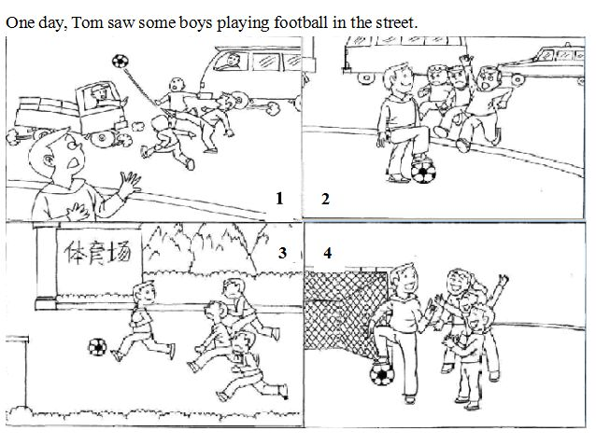

* One day, Tom saw some boys playing football in the street. The street was very busy with cars going and coming. It was unsafe playing football in this street. So he quickly ran to them and told them to stop playing there. He took them to the sports ground nearby and played football with these boys. They played happily together and the boys promised never to play football in the street again. Tom felt happy and he promised to play football with them again the next day.
* One day, Tom saw some boys playing football in the street. There were many cars in the street. It was very dangerous to play football there. Tom stopped them and picked up their football. The boys were angry and asked him to give back the football. But Tom just ran away. The boys followed him to the stadium. Then Tom played football with them. Later Tom told them playing football in the street was unsafe and they could play in the stadium. They felt very happy and promised never to play football in the street again.
* One day, Tom saw some boys playing football in the street. Cars are going and coming. It was very dangerous to play football there. So he quickly ran to them and told them to stop playing there. At first the boys felt angry. But after Tom took them to the sports ground nearby, they played football happily together. Tom told them they could play football in the sports ground instead of the street. Tom and these boys promised to play football again the next day.

## 快速应答

**1.** Would you mind opening the window? It’s too hot now.

* Never mind.
* No, I don’t mind.
* No, of course not.
* No, not at all.
* No, go ahead.
* No, certainly not.

Keywords: Never mind|don’t mind|of course not|not at all|go ahead|certainly not

**2.** Your dress is very beautiful! It looks good on you.

* Thank you.
* Thank you so much.
* Thanks a lot.
* Thanks.

Keywords: Thank you|thanks

**3.** How was your winter holiday?

* Wonderful.
* It was meaningful.
* I enjoyed it very much.
* Great.
* It was a busy holiday.
* I had a wonderful winter holiday.
* I had a bad winter holiday.
* It was bad.
* It was terribly bad.

Keywords: wonderful|meaningful|enjoyed|great|busy|bad

**4.** I’m so sorry that I forget to buy a hamburger for you.

* It’s OK.
* It doesn’t matter.
* That’s OK.
* Never mind.
* Forget about it.
* Nothing. Forget about it.
* That’s all right.

Keywords: OK|doesn’t matter|never mind|forget about it|that’s all right

## 简述和回答

**Listen to the following speaker talking about the television networks in the U.**S.The most common form of entertainment in the U.S. is television. Nearly everyone watches television at some regular time in their daily lives, whether in the morning, at night or on weekends. Most families have color televisions and many have more than one set. Since its beginning, the television industry in the U.S. has been controlled by three companies. Those companies have formed networks of television stations in cities across the country. Each station televises its company’s television programs. The three national networks are ABC, American Broadcasting Company, CBS, Columbia Broadcasting System and NBC, National Broadcasting Company. Each network has news features, dramatic presentations, comedies and sports events. Each network competes for a larger percentage of the television audience by trying to present programs with wide popular appeal. The programs are financed by advertising. Companies pay the television networks to display their products on television. The more popular a program is, the higher the network can charge a company for commercials during the program. There is also a public television network. It has no commercials. Instead it receives financial support from the government, some private corporations and individual donations.

**1.** What are the three major television networks in the U.S.?

* They are ABC, CBS and NBC.
* The three major television networks in the U.S. are ABC, CBS and NBC.
* The three national networks are ABC, American Broadcasting Company, CBS, Columbia Broadcasting System and NBC, National Broadcasting Company.
* They are ABC, American Broadcasting Company, CBS, Columbia Broadcasting System and NBC, National Broadcasting Company.

Keywords: ABC CBS NBC

**2.** What kind of TV program do you like best? Why?

* I like watching news best. I watch news every day. I can learn about what happens in our country and all over the world. It can open my eyes. Besides, I can know about the social hot spots. Every one needs to focus on our society.
* I like variety shows most, because they are so funny. I always laugh a lot when I watch variety shows. It can make me happy and get out of the bad mood. When I feel stressed because of my study, I watch variety shows for an hour. Then I become relaxed and I can go on my study.
* I like watching sports programs best! I love sports very much. I am a big fan of basketball. Every time I watch the basketball match on TV, I feel really excited. Besides, from the sports programs, I can learn a lot about the sportsmanship which is very valuable.

Keywords: The TV Programs Like Best