|  |  |
| --- | --- |
| C:\Users\User\AppData\Local\Microsoft\Windows\INetCache\Content.Word\CRONOS-Meraki-RGB-01.png | Examen HTML/CSS 7-11-2017  **Naam student:** **…………………………………………………**  **Behaald resultaat:** **…../100** |

**Opdracht:**

**Zet bijgevoegd grafisch ontwerp om in HTML en CSS. Maak gebruik van FLEXBOX en zorg voor een mooi ‘responsive’ alternatief…**

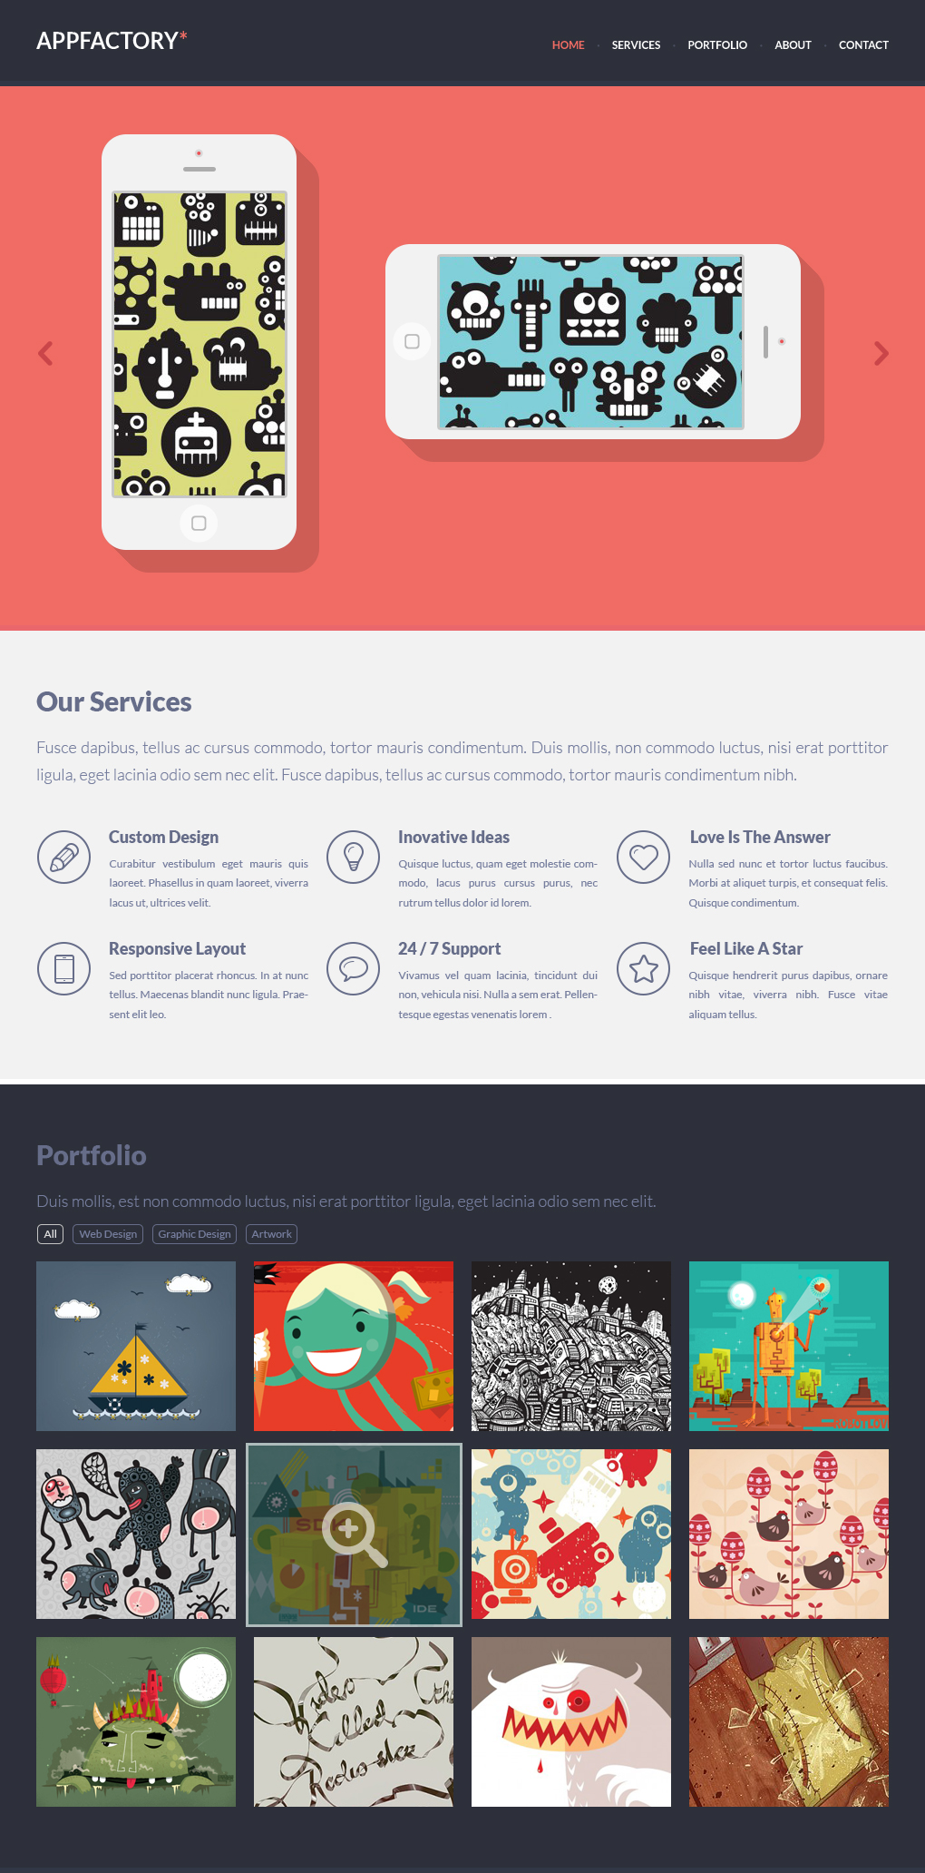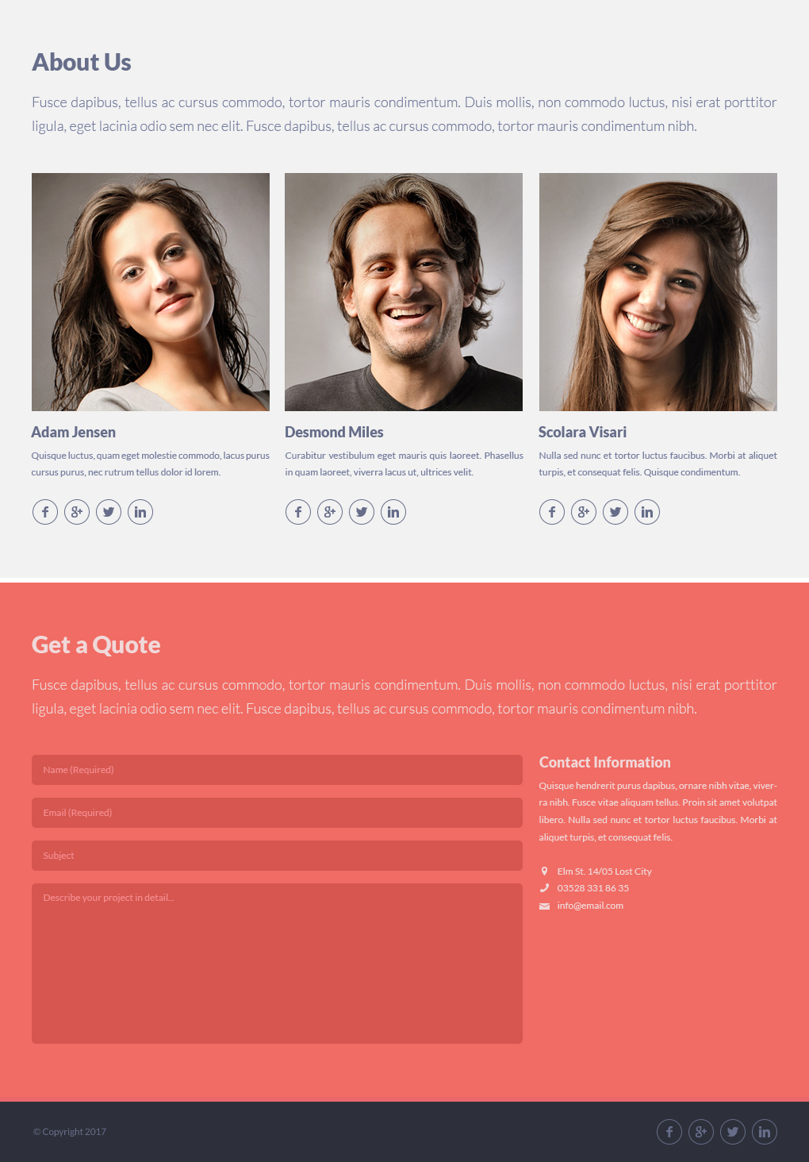

**Quotering:**

**Orde van html- en css-code, gebruik van semantisch correcte HTML5 elementen****…../20**

**………………………………………………………………………………………………………………………………………………………………………………………………………………………………………………………………………………………………………………………………………………………………………………………………………………………………………………………………………………………………………………………………………………**

**Pixelperfectie, respecteren van grafische witruimtes, grafisch ontwerp, lettertypes, kleuren** **…../35**

**………………………………………………………………………………………………………………………………………………………………………………………………………………………………………………………………………………………………………………………………………………………………………………………………………………………………………………………………………………………………………………………………………………**

**Animaties, hover-effecten** **…../10**

**………………………………………………………………………………………………………………………………………………………………………………………………………………………………………………………………………………………………………………………………………………………………………………………………………………………………………………………………………………………………………………………………………………**

**Performantie …../10**

**………………………………………………………………………………………………………………………………………………………………………………………………………………………………………………………………………………………………………………………………………………………………………………………………………………………………………………………………………………………………………………………………………………**

**Responsive …../25**

**………………………………………………………………………………………………………………………………………………………………………………………………………………………………………………………………………………………………………………………………………………………………………………………………………………………………………………………………………………………………………………………………………………**