PROJECT REPORT
Disk Scheduling Algorithm Visualizer
Operating Systems | Mini Project
Submitted by
2520080015 - V.Hari Priya
2520080068 - M.Sai Harika

Abstract
Disk scheduling is the operating system task of deciding the order in which pending read and write requests are served by a hard disk. Because moving the read/write head is the slowest part of a disk access, the chosen order directly affects performance. This project presents a web-based Disk Scheduling Algorithm Visualizer that lets a user enter a request queue, the initial head position and the disk size, select an algorithm, and watch the head movement animated on a cylinder track. The tool implements FCFS, SSTF, SCAN, C-SCAN, LOOK and C-LOOK, reports the total head movement and average seek per request, and compares all algorithms side by side.

1. Introduction
In a multiprogramming system, several processes issue I/O requests to different cylinders of the disk at the same time. The disk can serve only one request at a time, so the remaining requests wait in a queue. A disk scheduling algorithm chooses which request to serve next. A good algorithm reduces total seek time, improves throughput and avoids starving any request.
Reading about these algorithms in a textbook makes them hard to compare, because the difference lies in how the head moves over time. A visualizer turns the same data into a picture of the head path, which makes each strategy easier to understand and to compare.

2. Objectives
- Implement the six classic disk scheduling algorithms: FCFS, SSTF, SCAN, C-SCAN, LOOK and C-LOOK.
- Animate the head movement step by step over the cylinder range.
- Calculate and display total head movement, average seek per request and the service order.
- Compare all algorithms on the same input to show which performs best.
- Provide a simple interface that needs no installation and runs in any browser.

3. Background

3.1 Key terms
Term | Meaning
Seek time | Time taken to move the head to the target cylinder.
Rotational latency | Time for the required sector to rotate under the head.
Total head movement | Sum of cylinders crossed while serving all requests; the main metric used in this project.
Starvation | A request waiting indefinitely because other requests keep being served first.

3.2 Algorithms
Algorithm | How it works | Trade-off
FCFS | Serves requests in the order they arrive. | Fair, but causes long seeks.
SSTF | Serves the request nearest to the current head position. | Low seek time; far requests may starve.
SCAN | Head sweeps to one end of the disk, then reverses (elevator). | Good spread; waits are uneven at the edges.
C-SCAN | Head sweeps in one direction only, then jumps to the other end. | More uniform waiting time.
LOOK | Like SCAN, but reverses at the last request instead of the disk end. | Avoids unnecessary travel.
C-LOOK | Like C-SCAN, but jumps from the last request to the first. | Efficient and uniform.

4. System Design
The visualizer is a single-page web application written in HTML, CSS and JavaScript. Each algorithm is implemented as a function that takes the request queue, head position, disk size and direction, and returns the ordered list of cylinders visited, including the disk ends where the algorithm requires them. The same list drives the animation, the metrics and the comparison table, so all three always agree.

4.1 Workflow
- The user enters the request queue, head position, disk size, direction and algorithm.
- The input is parsed and validated.
- The selected algorithm returns the sequence of cylinders visited.
- The total head movement is the sum of absolute differences between consecutive cylinders; the average seek is this total divided by the number of requests.
- The path is drawn on a canvas one step at a time, with each served request labelled.
- All six algorithms are run on the same input to fill the comparison table, and the lowest total is highlighted.

4.2 Features
- Input panel for queue, head, disk size, direction and algorithm.
- Animated head path with Run & Animate; Compare All shows the final path instantly.
- Live metrics: total head movement, average seek and service order.
- Comparison table highlighting the best algorithm.

5. Implementation
The interface uses plain HTML form controls and a canvas element for the head path. The horizontal axis is the cylinder number and the vertical axis is the order of service, so the path reads from top to bottom. The starting head position is marked in orange and served requests in dark blue. The project runs entirely in the browser, so it needs no server or installation; opening the HTML file is enough.

6. Working Screenshot
Figure 1 shows the visualizer running the SCAN algorithm with the head at cylinder 53, a disk of 200 cylinders, the head moving towards 0 first, and the request queue 98, 183, 37, 122, 14, 124, 65, 67.
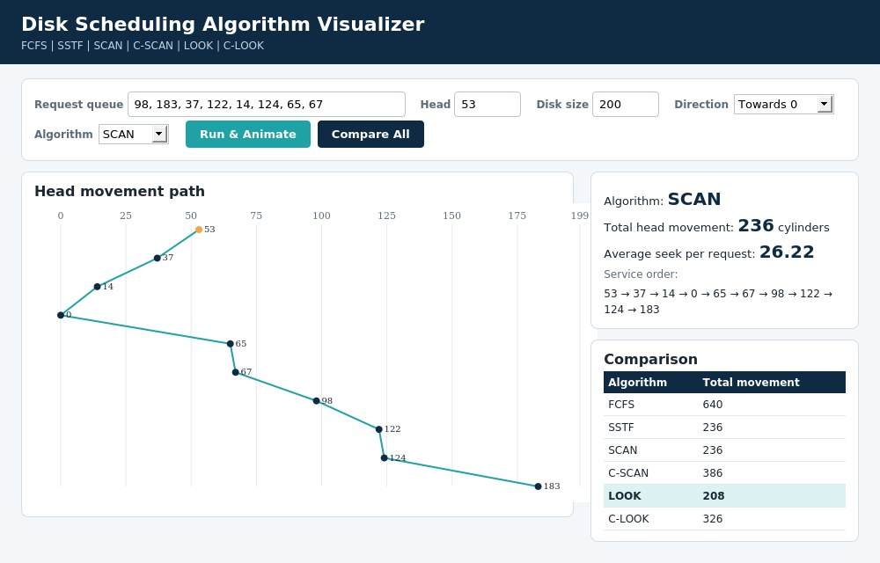
Figure 1: Disk Scheduling Algorithm Visualizer running SCAN
The path panel shows the head moving from 53 down to 0 and then up to 183. The metrics panel reports a total head movement of 236 cylinders and an average seek of 26.22 per request. The comparison table lists the totals of all six algorithms for the same input.

7. Results and Analysis
For the queue above (head at 53, disk of 200 cylinders, initial direction towards 0), the algorithms gave the following total head movement:
Algorithm | Total head movement (cylinders) | Average seek per request
FCFS | 640 | 80.00
SSTF | 236 | 29.50
SCAN | 236 | 26.22
C-SCAN | 386 | 38.60
LOOK | 208 | 26.00
C-LOOK | 326 | 40.75

FCFS is the worst here at 640 cylinders because it ignores the head position. LOOK is the best at 208, about 67% lower than FCFS, since it reverses at the last request rather than travelling to the disk end. SCAN and SSTF both give 236 for this input. The circular variants cost more in total because of the return jump, but they give more uniform waiting times, which is their purpose. Average seek divides the total by the number of head moves, which includes the stops at the disk ends for SCAN and C-SCAN.

8. Conclusion
The project shows that the choice of scheduling algorithm changes head movement a great deal for the same requests. The visualizer makes this visible through the animated head path and the side-by-side comparison. Lower seek time has to be weighed against fairness and starvation, so the best algorithm depends on the workload.

9. Future Scope
- Add SSD-oriented scheduling, where seek distance does not apply.
- Support request priorities and arrival times.
- Add random queue generation and adjustable animation speed.
- Export the results and chart as a report.

10. References
- Silberschatz, Galvin and Gagne, Operating System Concepts, Wiley.
- Tanenbaum and Bos, Modern Operating Systems, Pearson.
- Stallings, Operating Systems: Internals and Design Principles, Pearson.

