VPR User’s Manual
VPR 7.0 Full Release, November 08, 2026
Currently Active VPR Contributors:
Luu, Jason (jluu@eecg.toronto.edu)
Tim, Liu (tim_liu@yahoo.com)
Betz, Vaughn (vaughn@eecg.toronto.edu)
Anderson, Jason (anders@eecg.toronto.edu)
Rose, Jonathan (jayar@eecg.toronto.edu)

Overview
VPR (Versatile Place and Route) is an FPGA CAD tool that maps a technology mapped netlist (eg. a circuit expressed in look-up tables, flip-flops, memories, etc) to a hypothetical FPGA specified by the user.

VPR has two required and many optional parameters; it is invoked by entering:
> ./vpr architecture.xml circuit_name[.blif] [-options]
where items in square brackets are optional.
architecture.xml describes the architecture of the FPGA in which the circuit is to be realized. circuit_name is the name of the circuit that the user wants to map onto the FPGA. By default, VPR will perform packing, placement, and routing on the circuit to the architecture. If filenames are not explicitly specified, VPR reads in circuit_name.blif, and output three files to VPR’s parent directory: 1. The packed netlist to circuit_name.net, 2. The placement to circuit_name.place, and 3. The routing to circuit_name.route. VPR has options to select which parts of the flow to run, what parameters those algorithms should use, and as file naming options.
VPR can be run in one of two basic modes. In its default mode, VPR places a circuit on an FPGA and then repeatedly attempts to route it in order to find the minimum number of tracks required by the specified FPGA architecture to route this circuit. If a routing is unsuccessful, VPR increases the number of tracks in each routing channel and tries again; if a routing is successful, VPR decreases the number of tracks before trying to route it again. Once the minimum number of tracks required to route the circuit is found, VPR exits. The other mode of VPR is invoked when a user specifies a specific channel width for routing. In this case, VPR places a circuit and attempts to route it only once, with the specified channel width. If the circuit will not route at the specified channel width, VPR simply reports that it is unroutable.
Typing VPR with no parameters will print out a list of all the available command line parameters. By default, VPR will output text displayed to the terminal into a file called vpr_stdout.log.

Compiling and Running VPR

Compiling VPR on Linux, Solaris and Mac

If your compiler of choice is gcc and you are running a Unix-based system, you can compile VPR simply by typing make in the directory containing VPR’s source code and makefile. The makefile contains the following options located at the top of the makefile:

- ENABLE_GRAPHICS (default = true) enables or disables VPR’s X11-based graphics. If you do not have the X11 headers installed or you would prefer to compile VPR without graphics, set this to false.
- BUILD_TYPE (default = release) turns on optimization when set to release, and turns on debug information when set to debug.
- MAC_OS (default = false) changes the directory in which X11 is found to the default location for Mac when set to true. Irrelevant unless ENABLE_GRAPHICS is set to true.
- COMPILER (default = g++) sets the compiler.
- OPTIMIZATION_LEVEL_OF_RELEASE_BUILD (default = -O3) sets the level of optimi-zation for the release build. The possible levels are -O0 (no optimization), -O1, -O2,
-O3 (full optimization), -Os (optimize space usage). Only change this from -O3 if you are using a compiler other than gcc and you think you will get better optimization with another level.

If ENABLE_GRAPHICS is set to true, VPR requires X11 and Xft to compile. In Ubuntu, type make packages or sudo apt-get install libx11-dev libxft-dev to install. Please look online for information on how to install X11 on other Linux distributions. If you have the libraries installed in a non-default location on Linux, search the makefile for -L/usr/lib/X11 and and add/change the file path.
If, during compilation, you get an error that type XPointer is not defined, uncomment the “typedef char *XPointer” line in graphics.c (many X Windows implementations do not define the XPointer type).

Compiling VPR on Windows
A Visual Studio project file, VPR.vcxproj, is included in VPR’s parent directory. To input command-line arguments, right-click on VPR in the Solution Explorer and select Properties (or go to VPR Properties in the Project menu while viewing a source file from VPR), then select Configuration Properties → Debugging. Enter the architecture filename, circuit filename and any optional parameters you wish in the Command Arguments box.
If you receive an error “Cannot open the pdb file”, go to Options and Settings in the Debug menu, and select Debugging → Symbols. Make sure that Microsoft Symbol Servers is checked. You may also need to run Visual Studio as an administrator.
If, during compilation, you get an error that type XPointer is not defined, uncomment the “typedef char *XPointer” line in graphics.c (many X Windows implementations do not define the XPointer type).
If you prefer to use a Linux-based environment for development in Windows, then we recommend using the Cygwin package to compile VPR.

Typical CAD Flow using VPR
Figure 1 illustrates the CAD flow we typically use. First, Odin II [16] converts a Verilog Hardware Destription Language (HDL) design into a flattened netlist consisting of logic gates and blackboxes that represent heterogeneous blocks. Next, the ABC [1] synthesis package is used to perform technology-independent logic optimization of each circuit, and then each circuit is technology-mapped into LUTs and flip flops [2]. The output of ABC is a .blif format netlist of LUTs, flip flops, and blackboxes. VPR [3, 4, 7, 8, 9, 10, 11] then packs this netlist into more coarse-grained logic blocks, places the circuit, and routes it. The output of VPR consists of several files. One file to describe the circuit packing, another file describing the circuit’s placement, another file describing the circuit’s routing, and various files describing statistics concerning the minimum number of tracks per channel required to successfully route, the total wirelength, etc. In order to find the minimum number of tracks required for successful routing, VPR actually attempts to route the circuit several times with different numbers of tracks allowed per channel in each attempted routing.
Of course, many variations on this CAD flow are possible. It is possible to use other high-level synthesis tools to generate the blif files that are passed into ABC. Also, one can use different logic optimizers and technology mappers than ABC; just put the output netlist from your technology-mapper into .blif format and feed it into VPR. Alternatively, if the logic block you are interested in is not supported by AAPack in VPR, your CAD flow can bypass AAPack altogether by outputting a netlist of logic blocks in .net format. VPR can place and route netlists of any type of logic block -- you simply have to create the netlist and describe the logic block in the FPGA architecture description file. Finally, if you want only to route a placement produced by another CAD tool you can create a placement file in VPR format, and have VPR route this pre-existing placement.
In addition, VPR supports power estimation, which can be enabled and configured using the options in section 2.1.8. Further information on power estimation can be found by consulting the manual located in the installation at <vtr_installation>/doc/power/power_manual.pdf.

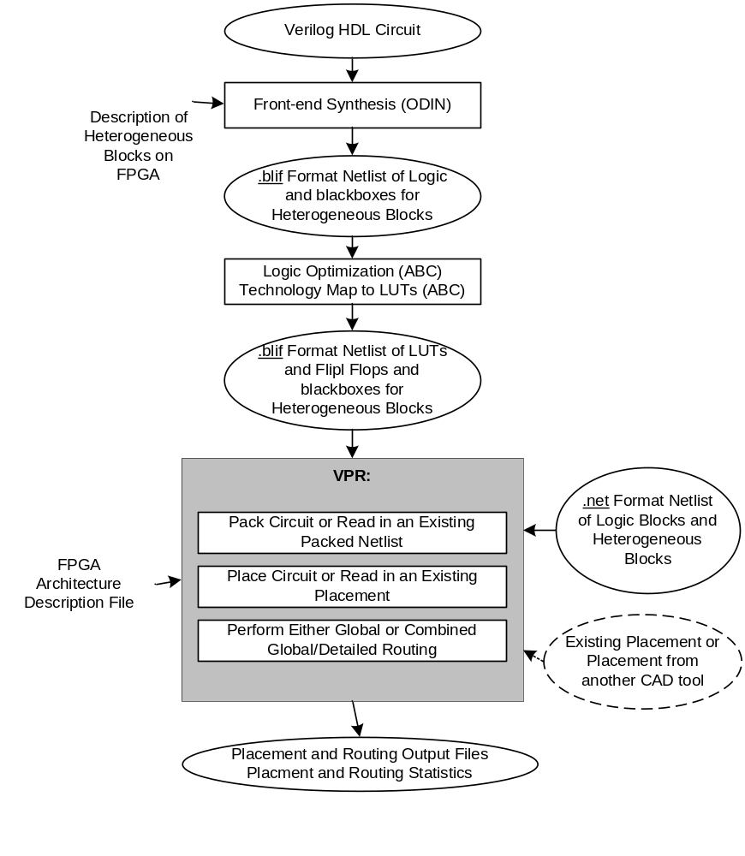
Figure 1

Operation of VPR
This section outlines VPR’s packing, placement and routing command-line options. We also describe how to use VPR graphics. The next section describes the format of each of the four VPR specific files.

Command-Line Options

VPR has a lot of options. The options most people will be interested in are -fast, -route_chan_width, and -nodisp. In general for the other options the defaults are fine, and only people looking at how different CAD algorithms perform will try many of them. To understand what the more esoteric placer and router options actually do, buy [3] or download [7, 8, 9, 10] from the author’s web page (http://www.eecg.toronto.edu/~vaughn).
In the following text, values in angle brackets, e.g. <int>, should be replaced by the appropriate filename or number. Values in curly braces separated by vertical bars, e.g. {on | off}, indicate all the permissible choices for an option.

Filename Options
VPR by default appends .blif, .net, .place, and .route to the circuit name provided by the user, and looks for an SDC file in the working directory with the same name as the circuit. Use the options below to override this default naming behaviour.
-blif_file <string>
Path to technology mapped user circuit in blif format
-net_file <string>
Path to packed user circuit in net format
-place_file <string>
Path to final placement file
-route_file <string>
Path to final routing file
-sdc_file <string>
Path to SDC timing constraints file
-outfile_prefix <string>
Prefix for output files

General Options
VPR runs all three stages of pack, place, and route if none of –pack, –place, or –route are specified.
-nodisp
Disables all graphics. Useful for scripting purposes or if you're not running X Windows.
Default: graphics is enabled (if VPR is compiled with graphics_enabled).
-auto <int>
Can be 0, 1, or 2. This sets how often you must click Proceed to continue execution after viewing the graphics. The higher the number, the more infrequently the program will pause.
Default: 1.
-pack
Run packing stage
Default: Off
-place
Run placement stage
Default: Off
-route
Run routing stage
Default: Off
-timing_analysis { on | off }
Turn VPR timing analysis off. If it is off, you don’t have to specify the various timing analysis parameters in the architecture file.
Default: on
-slack_definition { R | I | S | G | C | N }
The slack definition used in timing analysis. This option is for experimentation only; the default is fine for ordinary usage. See path_delay.c for details.
Default: R
-timing_analyze_only_with_net_delay <float> Deprecated
Perform timing analysis on netlist assuming all edges have the same specified delay
Default: off
-full_stats
Print out some extra statistics about the circuit and its routing useful for wireability analysis.
Default: off
-echo_file { on | off }
Generates echo files.
Default: off
-gen_postsynthesis_netlist { on | off }
Generates the Verilog and SDF files for the post-synthesized circuit. The Verilog file can be used to perform functional simulation and the SDF file enables timing simulation of the post-synthesized circuit.
The Verilog file contains instantiated modules of the primitives in the circuit. Currently VPR can generate Verilog files for circuits that only contain LUTs , Flip Flops , IOs , Multipliers , and BRAMs. The Verilog description of these primitives are in the primitives.v file. To simulate the post-synthesized circuit, one must include the generated Verilog file and also the primitives.v Verilog file, in the simulation directory.
If one wants to generate the post-synthesized Verilog file of a circuit that contains a primitive other than those mentioned above, he/she should contact the VTR team to have the source code updated. Furthermore to perform simulation on that circuit the Verilog description of that new primitive must be appended to the primitives.v file as a separate module.
Default: off

Packer Options
AAPack is the packing tool built into VPR. AAPack takes as input a technology-mapped blif netlist consisting of LUTs, flip-flops, memories, mulitpliers, etc and outputs a .net formatted netlist composed of more complex logic blocks. The logic blocks available on the FPGA are specified through the FPGA architecture file. For people not working on CAD, you can probably leave all the options to their default values.

-connection_driven_clustering {on | off}
Controls whether or not AAPack prioritizes the absorption of nets with fewer connections into a complex logic block over nets with more connections.
Default: on
-allow_unrelated_clustering {on | off}
Controls whether or not primitives with no attraction to the current cluster can be packed into it.
Default: on.
-alpha_clustering <float>
A parameter that weights the optimization of timing vs area. A value of 0 focuses solely on area, a value of 1 focuses entirely on timing.
Default: 0.75
-beta_clustering <float>
A tradeoff parameter that controls the optimization of smaller net absorption vs. the optimization of signal sharing. A value of 0 focuses solely on signal sharing, while a value of 1 focuses solely on absorbing smaller nets into a cluster. This option is meaningful only when connection_driven_clustering is on.
Default: 0.9.
-timing_driven_clustering {on|off}
Controls whether or not to do timing driven clustering
Default: on
---cluster_seed_type {timing | max_inputs}
Controls how the packer chooses the first primitive to place in a new cluster. Timing means that the unclustered primitive with the most timing-critical connection is used as the seed, while max_inputs means the unclustered primitive that has the most connected inputs is used as the seed.
Default: timing if timing_driven_clustering is on; max_inputs otherwise.

Placer Options
The placement engine in VPR places logic blocks using simulated annealing. By default, the automatic annealing schedule [3, 9] is used. This schedule gathers statistics as the placement progresses, and uses them to determine how to update the temperature, when to exit, etc. This schedule is generally superior to any user-specified schedule. If any of init_t, exit_t or alpha_t is specified, the user schedule, with a fixed initial temperature, final temperature and temperature update factor is used.
Note: The non-linear congestion option for placement has been deprecated.

-seed <int>
Sets the initial random seed used by the placer.
Default: 1.
-enable_timing_computations {on | off}
Controls whether or not the placement algorithm prints estimates of the circuit speed of the placement it generates. This setting affects statistics output only, not optimization behaviour.
Default: on if timing-driven placement is specified, off otherwise.
-block_dist <int> Deprecated
Specifies that the placement algorithm should print out an estimate of the circuit critical path, assuming that each inter-block connection is between blocks a (horizontal) distance of block_dist logic blocks apart. This setting affects statistics output only, not optimization behaviour.
Default: 1. (Currently the code that prints out this lower bound is #ifdef ’ed out in place.c -- define PRINT_LOWER_BOUND in place.c to reactivate it.)
-inner_num <float>
The number of moves attempted at each temperature is inner_num * num_blocks^(4/3) in the circuit. The number of blocks in a circuit is the number of pads plus the number of clbs. Changing inner_num is the best way to change the speed/quality tradeoff of the placer, as it leaves the highly-efficient automatic annealing schedule on and simply changes the number of moves per temperature.
Note: Specifying -inner_num 1 will speed up the placer by a factor of 10 while typically reducing placement quality only by 10% or less (depends on the architecture). Hence users more concerned with CPU time than quality may find this a more appropriate value of inner_num.
Default: 10.
-init_t <float>
The starting temperature of the anneal for the manual annealing schedule.
Default: 100.
-exit_t <float>
The (manual) anneal will terminate when the temperature drops below the exit temperature.
Default: 0.01.
-alpha_t <float>
The temperature is updated by multiplying the old temperature by alpha_t when the manual annealing schedule is enabled.
Default: 0.8.
-fix_pins {random | <file.pads>}
Do not allow the placer to move the I/O locations about during the anneal. Instead, lock each I/O pad to some location at the start of the anneal.
If -fix_pins random is specified, each I/O block is locked to a random pad location to model the effect of poor board-level I/O constraints. If any word other than random is specified after -fix_pins, that string is taken to be the name of a file listing the desired location of each I/O block in the netlist (i.e. -fix_pins <file.pads>).
This pad location file is in the same format as a normal placement file, but only specifies the locations of I/O pads, rather than the locations of all blocks.
Default: off (i.e. placer chooses pad locations).
-place_algorithm {bounding_box | net_timing_driven | path_timing_driven}
Controls the algorithm used by the placer.
Bounding_box focuses purely on minimizing the bounding box wirelength of the circuit.
Path_timing_driven focuses on minimizing both wirelength and the critical path delay.
Net_timing_driven is similar to path_timing_driven, but assumes that all nets have the same delay when estimating the critical path during placement, rather than using the current placement to obtain delay estimates.
Default: path_timing_driven.
-place_chan_width <int>
Tells VPR how many tracks a channel of relative width 1 is expected to need to complete routing of this circuit. VPR will then place the circuit only once, and repeatedly try routing the circuit as usual.
Default: 100

Placement Options Valid Only With Timing-Driven Placement
The options listed here are only valid when the placement engine is in timing-driven mode (timing-driven placement is used by default).

-timing_tradeoff <float>
Controls the trade-off between bounding box minimization and delay minimization in the placer. A value of 0 makes the placer focus completely on bounding box (wirelength) minimization, while a value of 1 makes the placer focus completely on timing optimization.
Default: 0.5.
-recompute_crit_iter <int>
Controls how many temperature updates occur before the placer performs a timing analysis to update its estimate of the criticality of each connection.
Default: 1.
-inner_loop_recompute_divider <int>
Controls how many times the placer performs a timing analysis to update its criticality estimates while at a single temperature.
Default: 0.
-td_place_exp_first <float>
Controls how critical a connection is considered as a function of its slack, at the start of the anneal. If this value is 0, all connections are considered equally critical. If this value is large, connections with small slacks are considered much more critical than connections with small slacks. As the anneal progresses, the exponent used in the criticality computation gradually changes from its starting value of td_place_exp_first to its final value of td_place_exp_last.
Default: 1.
-td_place_exp_last <float>
Controls how critical a connection is considered as a function of its slack, at the end of the anneal. See discussion for -td_place_exp_first, above.
Default: 8.

Router Options

-max_router_iterations <int>
The number of iterations of a Pathfinder-based router that will be executed before a circuit is declared unrouteable (if it hasn’t routed successfully yet) at a given channel width.
Default: 50.
Speed-quality trade-off: reduce this number to speed up the router, at the cost of some increase in final track count. This is most effective if -initial_pres_fac is simultaneously increased.
-initial_pres_fac <float>
Sets the starting value of the present overuse penalty factor.
Default: 0.5.
Speed-quality trade-off: increase this number to speed up the router, at the cost of some increase in final track count. Values of 1000 or so are perfectly reasonable.
-first_iter_pres_fac <float>
Similar to -initial_pres_fac. This sets the present overuse penalty factor for the very first routing iteration. -initial_pres_fac sets it for the second iteration.
Default: 0.5.
-pres_fac_mult <float>
Sets the growth factor by which the present overuse penalty factor is multiplied after each router iteration.
Default: 1.3.
-acc_fac <float>
Specifies the accumulated overuse factor (historical congestion cost factor).
Default: 1.
-bb_factor <int>
Sets the distance (in channels) outside of the bounding box of its pins a route can go. Larger numbers slow the router somewhat, but allow for a more exhaustive search of possible routes.
Default: 3.
-base_cost_type {demand_only | delay_normalized | intrinsic_delay}
Sets the basic cost of using a routing node (resource). Demand_only sets the basic cost of a node according to how much demand is expected for that type of node. Delay_normalized is similar, but normalizes all these basic costs to be of the same magnitude as the typical delay through a routing resource. Intrinsic_delay sets the basic cost of a node to its intrinsic delay. Default: delay_normalized for the timing-driven router and demand_only for the breadth-first router.
Note: intrinsic_delay is not supported this release and may give unusual results
-bend_cost <float>
The cost of a bend. Larger numbers will lead to routes with fewer bends, at the cost of some increase in track count. If only global routing is being performed, routes with fewer bends will be easier for a detailed router to subsequently route onto a segmented routing architecture.
Default: 1 if global routing is being performed, 0 if combined global/detailed routing is being performed.
-route_type {global | detailed}
Specifies whether global routing or combined global and detailed routing should be performed.
Default: detailed (i.e. combined global and detailed routing).
-route_chan_width <int>
Tells VPR to route the circuit with a certain channel width. No binary search on channel capacity will be performed to find the minimum number of tracks required for routing -- VPR simply reports whether or not the circuit will route at this channel width.
-router_algorithm {breadth_first | timing_driven | directed_search}
Selects which router algorithm to use. The breadth-first router focuses solely on routing a design successfully, while the timing-driven router focuses both on achieving a successful route and achieving good circuit speed. The breadth-first router is capable of routing a design using slightly fewer tracks than the timing-driving router (typically 5% if the timing- driven router uses its default parameters; this can be reduced to about 2% if the router parameters are set so the timing-driven router pays more attention to routability and less to area). The designs produced by the timing-driven router are much faster, however, (2x - 10x) and it uses less CPU time to route. The directed_search router is routability-driven and uses an A* heuristic to improve runtime over breadth_first.
Default: timing_driven.

Timing-Driven Router Options
-astar_fac <float>
Sets how aggressive the directed search used by the timing-driven router is. Values between 1 and 2 are reasonable, with higher values trading some quality for reduced CPU time.
Default: 1.2.
-max_criticality <float>
Sets the maximum fraction of routing cost that can come from delay (vs. coming from routability) for any net. A value of 0 means no attention is paid to delay; a value of 1 means nets on the critical path pay no attention to congestion.
Default: 0.99.
-criticality_exp <float>
Controls the delay - routability tradeoff for nets as a function of their slack. If this value is 0, all nets are treated the same, regardless of their slack. If it is very large, only nets on the critical path will be routed with attention paid to delay. Other values produce more moderate tradeoffs.
Default: 1.
-routing_failure_predictor {safe | aggressive | off}
Controls the aggressiveness of the router in predicting that a routing will not be successful, and giving up early. Using this option can significantly reduce the runtime of a binary search for the minimum channel width. Safe only declares failure when it is extremely unlikely a routing will succeed, given the amount of congestion existing in the design. Aggressive can further reduce the CPU time for a binary search for the minimum channel width but can increase the minimum channel width by giving up on some routings that would succeed. Off turns off this feature, which can be useful if you suspect the predictor is declaring routing failure too much on your architecture.
Default: safe.

Power Estimation Options
The following options are used to enable power estimation in VPR. More information about power estimation can be found in the manual ‘Power Estimation for VTR’, which is located at <vtr_installation>/doc/power/power_manual.pdf.

--power
Enable power estimation
--tech_properties <file>
XML File containing properties of the CMOS technology (transistor capacitances, leakage currents, etc). These can be found at <vtr_installation>/vtr_flow/tech/, or can be created for a user-provided SPICE technology (instructions provided in the power manual).
--activity_file <file>
File containing signal activites for all of the nets in the circuit. The file must be in the format:
<net name1> <signal probability> <transition density>
<net name2> <signal probability> <transition density>
…

Instructions on generating this file are provided in the power manual.

Graphics

The graphics included in VPR are very easy to use. First, compile VPR with the flag ENABLE_GRAPHICS in the Makefile set to true (the default). (If running VPR on Microsoft Visual Studio, set WIN32 as a preprocessor definition in VPR Properties.) A window will pop up when you run VPR. Click any mouse button on the arrow keys to pan the view, or click on the Zoom-In, Zoom-Out and Zoom-Fit keys to zoom the view. Alternatively, click and drag the mouse wheel to pan the view, or scroll the mouse wheel to zoom in and out. Click on the Window button, then on the diagonally opposite corners of a box, to zoom in on a particular area. Selecting PostScript creates a PostScript file (in pic1.ps, pic2.ps, etc.) of the image on screen. Proceed tells VPR to continue with the next step in placing and routing the circuit, while Exit aborts the program. The menu buttons will be greyed out to show they are not selectable when VPR is working, rather than interactively displaying graphics.
The Toggle Nets button toggles the nets in the circuit visible/invisible. When a placement is being displayed, routing information is not yet known so nets are simply drawn as a “star;” that is, a straight line is drawn from the net source to each of its sinks. Click on any clb in the display, and it will be highlighted in green, while its fanin and fanout are highlighted in blue and red, respectively. Once a circuit has been routed the true path of each net will be shown. Again, you can click on Toggle Nets to make net routings visible or invisible. If the nets routing are shown, click on a clb or pad to highlight its fanins and fanouts, or click on a pin or channel wire to highlight a whole net in magenta. Multiple nets can be highlighted by pressing ctrl + mouse click.
When a routing is on-screen, clicking on Toggle RR will switch between various views of the routing resources available in the FPGA. Wiring segments are drawn in black, input pins are drawn in sky blue, and output pins are drawn in pink. Direct connections between output and input pins are shown in medium purple. Connections from wiring segments to input pins are shown in sky blue, connections from output pins to wiring segments are shown in pink, and connections between wiring segments are shown in green. The points at which wiring segments connect to clb pins (connection box switches) are marked with an “X”. Switch box connections will have buffers (triangles) or pass transistors (circles) drawn on top of them, depending on the type of switch each connection uses. Clicking on a clb or pad will overlay the routing of all nets connected to that block on top of the drawing of the FPGA routing resources, and will label each of the pins on that block with its pin number. Clicking on a routing resource will highlight it in magenta, and its fanouts will be highlighted in red and fanins in blue. Multiple routing resources can be highlighted by pressing ctrl + mouse click. The routing resource view can be very useful in ensuring that you have correctly described your FPGA in the architecture description file -- if you see switches where they shouldn’t be or pins on the wrong side of a clb, your architecture description needs to be revised.
When a routing is shown on-screen, clicking on the Congestion button will show any overused routing resources (wires or pins) in red, if any overused resources exist. Clicking on the same button the second time will show overused routing resources in red and all other used routing resources in blue. Finally, when a routing is on screen you can click on the Crit. Path button to see each of the nets on the critical path in turn. The current net on the critical path is highlighted in cyan; its source block is shown in yellow and the critical sink is shown in green.

File Formats
The architecture description file and packing description file follow standard XML while the placement and routing files still use an older custom format. In the placement and routing file formats, a sharp (#) character anywhere in a line indicates that the rest of the line is a comment, while a backslash (\) at the end of a line (and not in a comment) means that this line is continued on the line below.

FPGA Architecture File (.xml) Format
The architecture file is specified in xml format. It is composed of a hierarchy of start and end tags with optional attributes and content inside each tag giving additional information. As a convention, curly brackets {…} represents an option with each option separated by |. For example, a={1 | 2 | open} means field “a” can take a value of 1, 2, or open.
The first tag in all architecture files is the <architecture> tag. This tag contains all other tags in the architecture file. The architecture tag contains seven other tags. They are <models>, <layout>, <device>, <switchlist>, <segmentlist>, <directlist> and < complexblocklist>.

Description of Recognized Blif Models
The <models> tag contains <model name=”string”> tags. Each <model> tag describes the .subckt model_name blif instances that are accepted by the FPGA architecture. The name of the model must match the corresponding name of the blif model. Standard blif structures (.names, .latch, .input, .output) are accepted by VPR by default so these models should not be described in the <models> tag.
Each model tag must contain 2 tags: <input_ports> and <output_ports>. Each of these contains <port> tags explained below.
<port name=”string” is_clock=”0|1”/>
This tag defines the port for a model.
Name: Specifies the name of the port
is_clock (optional): Specifies whether a port is a clock (1) or not (0). The is_clock attribute applies only to input ports. (Default: 0)

Description of Global FPGA Information

<layout {auto=”float” | width=”int” height=”int”}/>
This tag specifies the size and shape of the FPGA in grid units. The keyword auto indicates that the size should be chosen to be the minimal dimensions that fits the given circuit. The size is determined from the number of grid tiles used by the circuit as well as the number of IO pins that it uses. The aspect ratio of the FPGA is given after the auto keyword and is the ratio width/height.
Alternately, the size can be explicitly given as the size in the x direction (width) followed by the size in the y direction (height).
<device>content</device>
Content inside this tag specifies device information. It contains the tags <sizing>, <timing>, <area>, <chan_width_distr>, and <switch_block>.
<switchlist>content</switchlist>
Content inside this tag contains a group of <switch> tags that specify the types of switches and their properties.
<segmentlist>content</segmentlist>
Content inside this tag contains a group of <segment> tags that specify the types of wire segments and their properties.
<complexblocklist>content</complexblocklist>
Content inside this tag contains a group of <pb_type> tags that specify the types of functional blocks and their properties.

Description of Device Information in the FPGA
The tags within the device tag are described in the following table.

<sizing R_minW_nmos="float" R_minW_pmos="float" ipin_mux_trans_size="int"/>
Specifies parameters used by the area model built into VPR
R_minW_nmos: The resistance of minimum-width nmos transistor. This data is used only by the area model built into VPR.
R_minW_pmos: The resistance of minimum-width pmos transistor. This data is used only by the area model built into VPR.
ipin_mux_trans_size: This specifies the size of each transistor in the ipin muxes. Given in minimum transistor units. The mux is implemented as a two-level mux.).
<timing C_ipin_cblock="float" T_ipin_cblock="float"/>
Attributes specify timing information general to the device. Must be specified for timing analysis, optional otherwise.
C_ipin_cblock: Input capacitance of the buffer isolating a routing track from the connection boxes (multiplexers) that select the signal to be connected to a logic block input pin. One of these buffers is inserted in the FPGA for each track at each location at which it connects to a connection box. For example, a routing segment that spans three logic blocks, and connects to logic blocks at two of these three possible locations would have two isolation buffers attached to it. If a routing track connects to the logic blocks both above and below it at some point, only one isolation buffer is inserted at that point. If your connection from routing track to connection block does not include a buffer, set this parameter to the capacitive loading a track would see at each point where it connects to a logic block or blocks.
T_ipin_cblock:
Delay to go from a routing track, through the isolation buffer (if your architecture contains these) and a connection block (typically a multiplexer) to a logic block input pin.
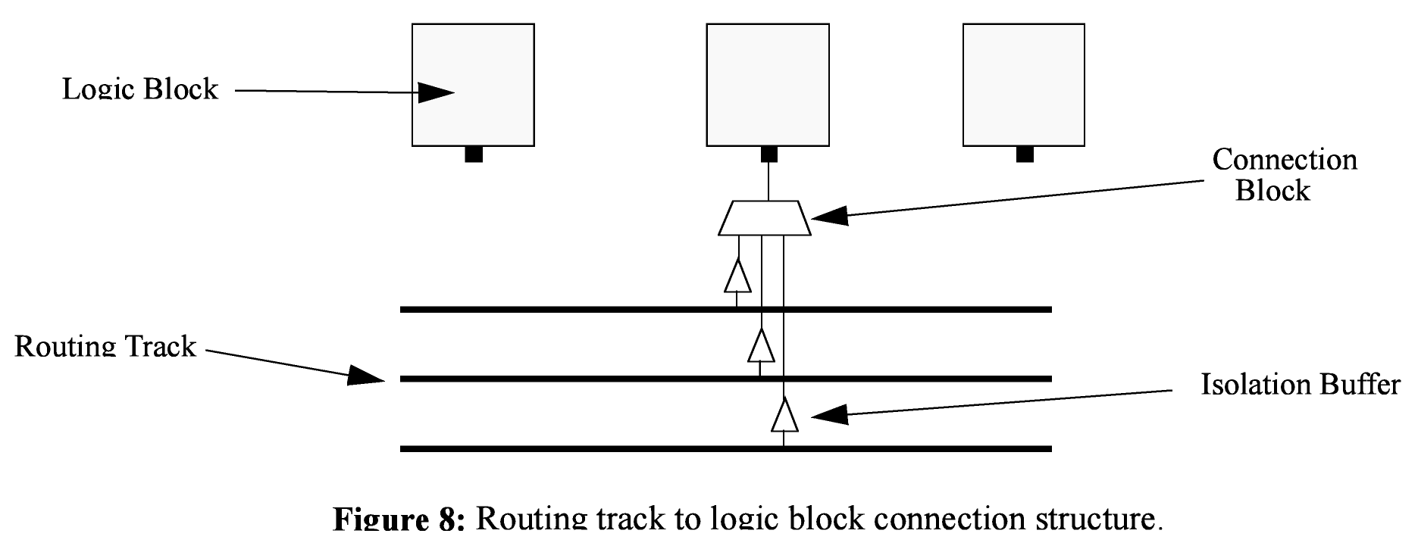
<area grid_logic_tile_area="float"/>
Used for an area estimate of the amount of area taken by all the functional blocks. This specifies the area of a 1x1 tile excluding routing.
<switch_block type="{wilton|subset|universal}" fs="int"/>
When using bidirectional segments, all the switch blocks [12] have Fs = 3. That is, whenever horizontal and vertical channels intersect, each wire segment can connect to three other wire segments. The exact topology of which wire segment connects to which can be one of three choices. The subset switch box is the planar or domain-based switch box used in the Xilinx 4000 FPGAs -- a wire segment in track 0 can only connect to other wire segments in track 0 and so on. The wilton switch box is described in [13], while the universal switch box is described in [14]. To see the topology of a switch box, simply hit the “Toggle RR” button when a completed routing is on screen in VPR. In general the wilton switch box is the best of these three topologies and leads to the most routable FPGAs.
When using unidirectional segments, one can specify an F_{s} that is any multiple of 3. We use a modified wilton switch block pattern regardless of the specified switch_block_type. For all segments that start/end at that switch block, we follow the wilton switch block pattern. For segments that pass through the switch block that can also turn there, we cannot use the wilton pattern because a undirectional segment cannot be driven at an intermediate point, so we assign connections to starting segments following a round robin scheme (to balance mux size). Note: The round robin scheme is not tileable.
<chan_width_distr>content</chan_width_distr>
Content inside this tag is only used when VPR is in global routing mode. The contents of this tag are described in the next table.

If global routing is to be performed, channels in different directions and in different parts of the FPGA can be set to different relative widths. This is specified in the content within the <chan_width_distr> tag. If detailed routing is to be performed, however, all the channels in the FPGA must have the same width.

<io width= “float”/>
Width of the channels between the pads and core relative to the widest core channel.
<x distr=”{gaussian|uniform|pulse|delta}” peak=”float” width=” float” xpeak=” float” dc=” float”/>
Warning: Shaped channels for global routing is rarely used so it is unknown if this feature still works.
The italicized quantities are needed only for pulse, gaussian, and delta (which doesn’t need width). Most values are from 0 to 1. Sets the distribution of tracks for the x-directed channels -- the channels that run horizontally.
If uniform is specified, you simply specify one argument, peak. This value (by convention between 0 and 1) sets the width of the x-directed core channels relative to the y-directed channels and the channels between the pads and core. Figure should make the specification of uniform (dashed line) and pulse (solid line) channel widths more clear. The gaussian keyword takes the same four parameters as the pulse keyword, and they are all interpreted in exactly the same manner except that in the gaussian case width is the standard deviation of the function.
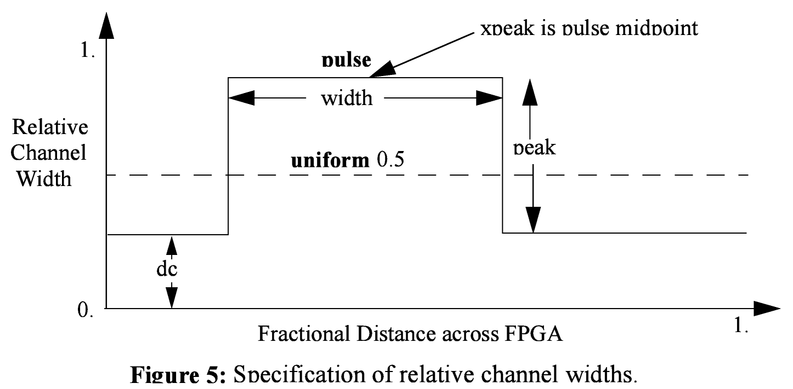
The delta function is used to specify a channel width distribution in which all the channels have the same width except one. The syntax is chan_width_x delta peak xpeak dc. Peak is the extra width of the single wide channel. Xpeak is between 0 and 1 and specifies the location within the FPGA of the extra-wide channel -- it is the fractional distance across the FPGA at which this extra-wide channel lies. Finally, dc specifies the width of all the other channels. For example, the statement chan_width_x delta 3 0.5 1 specifies that the horizontal channel in the middle of the FPGA is four times as wide as the other channels.
Examples:
<x distr=”uniform” peak=”1”/>
<x distr=”gaussian” width=”0.5” peak=”0.8” xpeak=”0.6” dc=”0.2”/>
<y distr=”{gaussian|uniform|pulse|delta}” peak=” float” width=” float” xpeak=” float” dc=” float”/>
Sets the distribution of tracks for the y-directed channels.

Description of Complex Logic Blocks
For step-by-step walkthrough examples on how to build a complex block using this language, please refer to http://www.eecg.utoronto.ca/vpr/arch_language.html.
The content within the <complexblocklist> tag describes the complex logic blocks found within the FPGA. Each type of complex logic block is specified by a <pb_type name=”string” height=”int”> tag within the <complexblocklist> tag. The name attribute is the name for the complex block. The height attribute specifies how many grid tiles the block takes up.
The internals of a complex block is described using a hierarchy of <pb_type> tags. The top-level <pb_type> tag specifies the complex block. Children <pb_type> tags are either clusters (which contain other <pb_type> tags) or primitives (leaves that do not contain other <pb_type> tags). Clusters can contain other clusters and primitives so there is no restriction on the hierarchy that can be specified using this language. All children <pb_type> tags contain the attribute num_pb=”int” which describes the number of instances of that particular type of cluster or leaf block in that section of the hierarchy. All children <pb_type> tags must have a name =”string” attribute where the name must be unique with respect to any parent, sibling, or child <pb_type> tag. Leaf <pb_type> tags may optionally have a blif_model=”string” attribute. This attribute describes the type of block in the blif file that this particular leaf can implement. For example, a leaf that implements a LUT should have blif_model=”.names”. Similarly, a leaf that implements “.subckt user_block_A” should have attribute blif_model=”.subckt user_block_A”. The input, output, and/or clock, ports for these leaves must match the ports specified in the <models> section of the architecture file. There is a special attribute for leaf nodes called class that will be described in more detail later.
The following tags are common to all <pb_type> tags.
<input name=”string” num_pins=”int” equivalent=”true|false” is_non_clock_global=”{true|false}”/>
Describes an input port. Multple input ports are described using multiple <input> tags.
name: Name of the input port.
num_pins: Number of pins that this input port has
equivalent (applies only to top-level pb_type):
Describes if the pins of the port are logically equivalent. Input logical equivalence means that the pin order can be swapped without changing functionality. For example, an AND gate has logically equivalent inputs because you can swap the order of the inputs and it’s still correct; an adder, on the otherhand, is not logically equivalent because if you swap the MSB with the LSB, the results are completely wrong.
is_non_clock_global (applies only to top-level pb_type):
Describes if this input pin is a global signal that is not a clock. Very useful for signals such as FPGA-wide asychronous resets. These signals have their own dedicated routing channels and so should not use the general interconnect fabric on the FPGA.
<output name=”string” num_pins=”int” equivalent=”{true|false}”/>
Describes an output port. Multple output ports are described using multiple <output> tags.
name: Name of the output port.
num_pins: Number of pins that this output port has
equivalent (applies only to top-level pb_type):
Describes if the pins of the port are logically equivalent. (See above case on inputs),
<clock name=”string” num_pins=”int” equivalent=”{true|false}”/>
Describes a clock port. Multple clock ports are described using multiple <clock> tags.
(See above case on inputs/outputs).
<mode name=”string”>
Specifies a mode of operation for the <pb_type>. Each child mode tag denotes a different mode of operation for that <pb_type>. A mode tag contains <pb_type> tags and <interconnect> tags. If a <pb_type> has only one mode of operation, then this mode tag can be omitted. More on interconnect later.
name: Name for this mode. Must be unique compared to other modes.

The following tags are unique to the top level <pb_type> of a complex logic block. They describe how this complex block interface with the extra block world.

<fc default_in_type="{frac|abs}" default_in_val="{int|float}" default_out_type="{frac|abs}" default_out_val="{int|float}">
Content:
Sets the number of tracks to which each logic block pin connects in each channel bordering the pin. The Fc [12] value used is always the minimum of the specified Fc and the channel width, W.
default_in_type: Indicates whether the default Fc in value should be interpreted as the number (abs) or fraction (frac) of tracks from which each input pin connects.
default_in_val: # of tracs each input pin connects (abs), or fraction of tracks in a channel from which each input pin connects (frac).
default_out_type: Indicates whether the default Fc in value should be interpreted as the number (abs) or fraction (frac) of tracks to which each output pin connects.
default_out_val: # of tracs each output pin connects (abs), or fraction of tracks in a channel to which each output pin connects (frac).

Special case:
If you have complex block pins that do not connect to general interconnect (eg. carry chains), you would use this tag, within the <fc> tag, to specify them:
<pin name="<string>" fc_type="frac" fc_val="0"/>
Where the attribute “name” is the name of the pin. Note: fc_val must be 0. Other values are not yet supported.
<pinlocations pattern=”{spread|custom}”>
Describes the locations where the input, output, and clock pins are distributed in a complex logic block.
The pattern “spread” denotes that the pins are to be spread evenly on all sides of the complex block.
The pattern “custom” allows the architect to specify specifically where the pins are to be placed using <loc> tags. A <loc> tag is defined as:
<loc side="{left|right|bottom|top}" offset=”int”>name_of_complex_logic_block.port_name[int:int] … </loc>
Where … represents repeat as needed (Do not put … in the architecture file). The side attribute specifies which of the four directions the pins in the contents are located on and offset attribute specifies the grid distance from the bottom grid tile that the pin is specified for. Pins on the bottom grid tile have an offset value of 0 (offset defaults to 0 if not specified). The offset value must be less than the height of the functional block. Pin groupings are specified by the complex block name, the port those pins belong to, and the range of pins being referenced. A functional block may not contain pins inside of itself (ie. All pins must be on the periphery of the block).

Physical equivalence for a pin is specified by listing a pin more than once for different locations. For example, a LUT whose output can exit from the top and bottom of a block will have its output pin specified twice: once for the top and once for the bottom.

<gridlocations>
Specifies the columns on the FPGA that will consist of this complex logic block. The columns are specified by a group of <loc> tags and there are three ways to use this tag:
<loc type="col" start="<int>" repeat="<int>" priority="<int>"/>
This specifies an absolute column assignment. The first column to contain this complex logic block is specified in start. Every column that satisfies x = start_x + k*repeat, where k is any integer, will be composed of this complex logic block.

<loc type="rel" pos="0.5" priority="<int>"/>
This specifies a single column to be composed of this complex logic block where the column is specified as a fraction of the width.

<loc type="fill" priority="1"/>
This is a special specification such that all unspecified columns get assigned this complex logic block.

For all three <loc> tags, the priority attribute is used to resolve collisions when two different functional block is supposed to use the same column. The larger integer specified for priority gets the location.

<power method=”string”>
This is used to indicate the method of power estimation used for the given pb_type. The complete list of options, their descriptions, and required sub-fields are indicated in the power manual (<vtr_installation>/doc/power/power_manual.pdf).

As stated earlier, the mode tag contains <pb_type> tags and a <interconnect> tag. The following describes the tags that are accepted in the <interconnect> tag.

<complete name=”string” input=”string” output=”string”/>
Describes a fully connected crossbar. Any pin in the inputs can connect to any pin at the output.
name: Identifier for the interconnect.
input: Pins that are inputs to this interconnect
output: Pins that are outputs of this interconnect.

Example:

<direct name=”string” input=”string” output=”string”/>
Describes a 1-to-1 mapping between input pins and output pins.
name: Identifier for the interconnect.
input: Pins that are inputs to this interconnect
output: Pins that are outputs of this interconnect.

Example:
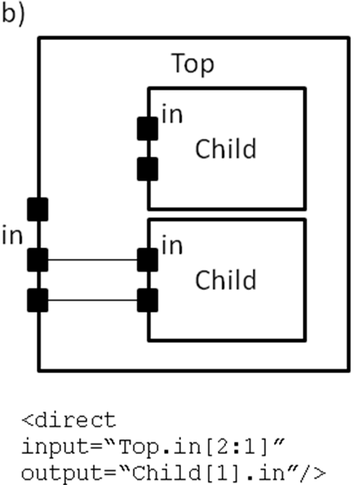
<mux name=”string” input=”string” output=”string”/>
Describes a bus-based multiplexer. Note: Buses are not yet supported so all muxes must use one bit wide data only!
name: Identifier for the interconnect.
input: Pins that are inputs to this interconnect. Different data lines are separated by a space.
output: Pins that are outputs of this interconnect.

Example:
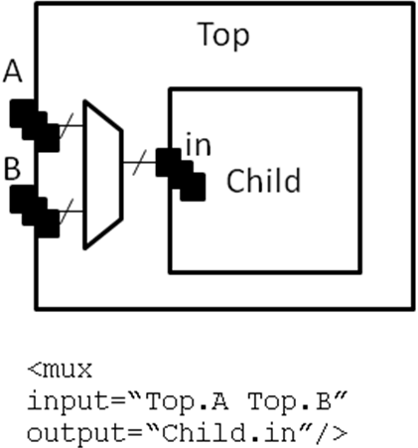

A <complete>, <direct>, or <mux> tag may take an additional, optional, tag called <pack_pattern> that is used to describe molecules. A pack pattern is a power user feature directing that the CAD tool should group certain netlist atoms (eg. LUTs, FFs, carry chains) together during the CAD flow. This allows the architect to help the CAD tool recognize structures that have limited flexibility so that netlist atoms that fit those structures be kept together as though they are one unit. This tag impacts the CAD tool only, there is no architectural impact from defining molecules.
<pack_pattern name=”string” in_port=”string” out_port=”string”/>
This is a power user option. This tag gives a hint to the CAD tool that certain architectural structures should stay together during packing. The tag labels interconnect edges with a pack pattern name. All primitives connected by the same pack pattern name becomes a single pack pattern. Any group of atoms in the user netlist that matches a pack pattern are grouped together by VPR to form a molecule. Molecules are kept together as one unit in VPR. This is useful because it allows the architect to help the CAD tool assign atoms to complex logic blocks that have interconnect with very limited flexibility. Examples of architectural structures where pack patterns are appropriate include: optionally registered inputs/outputs, carry chains, multiply-add blocks, etc.

There is a priority order when VPR groups molecules. Pack patterns with more primitives take priority over pack patterns with less primitives. In the event that the number of primitives is the same, the pack pattern with less inputs takes priority over pack patterns with more inputs.
name: The name of the pattern.
in_port: The input pins of the edges for this pattern.
out_port: Which output pins of the edges for this pattern.

For example, consider a classic basic logic element (BLE) that consists of a LUT with an optionally registered flip-flop. If a LUT is followed by a flip-flop in the netlist, the architect would want the flip-flop to be packed with the LUT in the same BLE in VPR. To give VPR a hint that these blocks should be connected together, the architect would label the interconnect connecting the LUT and flip-flop pair as a pack_pattern. Sample code below:

<pack_pattern name="ble" in_port="lut.out" out_port="ff.D"/>

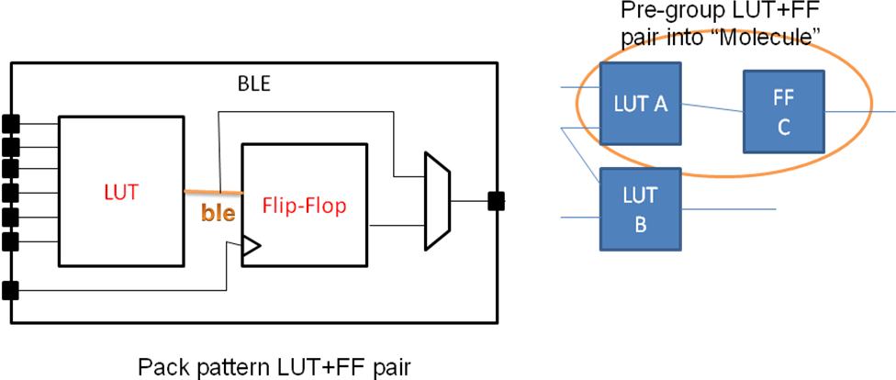

*Special Case: To specify carry chains, we use a special case of a pack pattern. If a pack pattern has exactly one connection to a logic block input pin and exactly one connection to a logic block output pin, then that pack pattern takes on special properties. The prepacker will assume that this pack pattern represents a structure that spans multiple logic blocks using the logic block input/output pins as connection points. For example, lets assume that a logic block has two, 1-bit adders with a carry chain that links adjacent logic blocks. The architect would specify those two adders as a pack pattern with links to the logic block cin and cout pins. Lets assume the netlist has a group of 1-bit adder atoms chained together to form a 5-bit adder. VPR will now break that 5-bit adder into 3 molecules: two 2-bit adders and one 1-bit adder connected in order by a the carry links.

Using these structures, we believe that one can describe any digital complex logic block. However, we believe that certain kinds of logic structuers are common enough in FPGAs that special shortcuts should be available to make their specification easier. These logic structures are: flip-flops, LUTs, and memories. These structures are described using a “class=string” attribute in the <pb_type> primitive. The classes we offer are:
Lut
Describes a K-input lookup table. The unique characteristic of a lookup table is that all inputs to the lookup table are logically equivalent. When this class is used, the input port must have a port_class=”lut_in” attribute and the output port must have a port_class=”lut_out” attribute
flipflop
Describes a flipflop.
Input port must have a port_class=”D” attribute added.
Output port must have a port_class=”Q” attribute added.
Clock port must have a port_class=”clock” attribute added.

Memory
Describes a memory. Memories are unique in that a single memory physical primitive can hold multiple, smaller, logical memories as long as: 1) The address, clock, and control inputs are identical and 2) There exists sufficient physical data pins to satisfy the netlist memories when the different netlist memories are merged together into one physical memory.
For single ported memories, there should be:
An input port with port_class=”address” attribute
An input port with port_class=”data_in” attribute
An input port with port_class=”write_en” attribute
An output port with port_class=”data_out” attribute
A clock port with port_class=”clock” attribute

For dual ported memories, there should be:
An input port with port_class=”address1” attribute
An input port with port_class=”data_in1” attribute
An input port with port_class=”write_en1” attribute
An input port with port_class=”address2” attribute
An input port with port_class=”data_in2” attribute
An input port with port_class=”write_en2” attribute
An output port with port_class=”data_out1” attribute
An output port with port_class=”data_out2” attribute
A clock port with port_class=”clock” attribute

Timing is specified through tags contained in pb_type, complete, direct, or mux tags as follows:
<delay_constant max=”float” in_port=”string” out_port=”string”/>
Delay equal to the value specified in max from in_port to out_port.
<delay_matrix type=”max” in_port=”string” out_port=”string”> matrix </delay>
Describe a timing matrix for all edges going from in_port to out_port. Number of rows of matrix should equal the number of inputs, number of columns should equal the number of outputs. For example a 4 input pin 3 output pin timing matrix would look like:
1.2e-10 1.4e-10 3.2e-10
4.6e-10 1.9e-10 2.2e-10
4.5e-10 6.7e-10 3.5e-10
7.1e-10 2.9e-10 8.7e-10

<T_setup value=”float” port=”string” clock=”string”/>
Specify setup time (value) for pins of port. The clock attribute describes which clock this setup time is with respect to.
Note: Applies to sequential pb_type only
<T_clock_to_Q max=”float” port=”string” clock=”string”/>
Specify the clock-to-Q delay of output port of sequential pb_type. Delay is specified by the max attribute, pins by the port attribute, and the clock this refers to by the clock attribute.

Description of the Wire Segments

The content within the <segmentlist> tag consists of a group of <segment> tags. The <segment> tag and its contents are described in the table below.

<segment length=”int” type=”{bidir|unidir}” freq=”float” Rmetal=”float” Cmetal=”float”>content</segment>
Describes the properties of a segment

length: Either the number of logic blocks spanned by each segment, or the keyword longline. Longline means segments of this type span the entire FPGA array.
freq: The supply of routing tracks composed of this type of segment. VPR automatically determines the percentage of tracks for each segment type by taking the frequency for the type specified and dividing with the sum of all frequencies. It is recommended that the sum of all segment frequencies be in the range 1 to 100.
Rmetal: Resistance per unit length (in terms of logic blocks) of this wiring track, in Ohms. For example, a segment of length 5 with Rmetal = 10 Ohms / logic block would have an end-to-end resistance of 50 Ohms.
Cmetal: Capacitance per unit length (in terms of logic blocks) of this wiring track, in Farads. For example, a segment of length 5 with Cmetal = 2e-14 F / logic block would have a total metal capacitance of 10e-13F.
directionality: This is either unidirectional or bidirectional and indicates whether a segment has multiple drive points (bidirectional), or a single driver at one end of the wire segment (unidirectional). All segments must have the same directionality value. See [15] for a description of unidirectional single-driver wire segments.

Content contains the switch names and the depopulation pattern as described below.
<sb type=”pattern”>int list</sb>
This tag describes the switch block depopulation (as illustrated in the figure below) for this particular wire segment. For example, the firsth length 6 wire in the figure below has an sb pattern of “1 0 1 0 1 0 1”. The second wire has a pattern of “0 1 0 1 0 1 0”. A “1” indicates the existance of a switch block and a “0” indicates that there is no switch box at that point. Note that there a 7 entries in the integer list for a length 6 wire. For a length L wire there must be L+1 entries seperated by spaces.
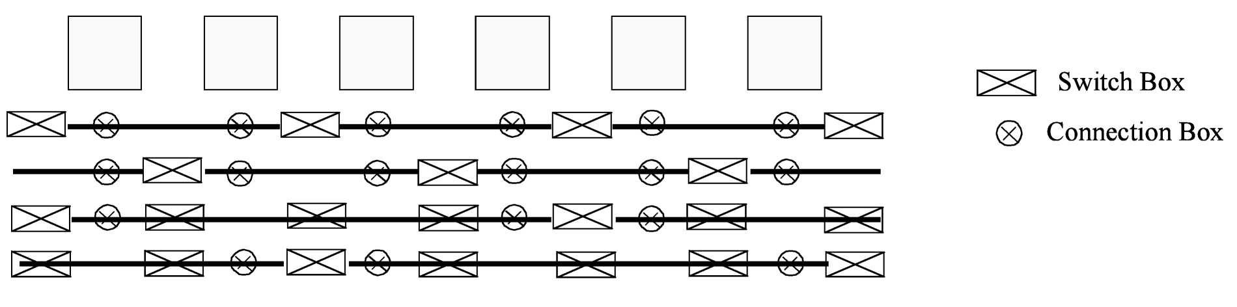
<cb type=”pattern”>int list</cb>
This tag describes the connection block depopulation (as illustrated by the circles in the figure above) for this particular wire segment. For example, the firsth length 6 wire in the figure below has an sb pattern of “1 1 1 1 1 1”. The third wire has a pattern of “1 0 0 1 1 0”. A “1” indicates the existance of a connection block and a “0” indicates that there is no connection box at that point. Note that there a 6 entries in the integer list for a length 6 wire. For a length L wire there must be L entries seperated by spaces.
<mux name=”string”/>
Option for UNIDIRECTIONAL only. Tag must be included and the name must be the same as the name you give in <switch type=”mux” name=”…
<wire_switch name=”string”/>
Option for BIDIRECTIONAL only. Tag must be included and the name must be the same as the name you give in <switch type=”buffer” name=”… for the switch which represents the wire switch in your architecture.

name: The index of the switch type used by other wiring segments to drive this type of segment. That is, switches going to this segment from other pieces of wiring will use this type of switch.
<opin_switch name=”string”/>
Option for BIDIRECTIONAL only. Tag must be included and the name” must be the same as the name you give in <switch type=”buffer” name=”… for the switch which represents the output pin switch in your architecture.

name: The index of the switch type used by clb and pad output pins to drive this type of segment.
NOTE: In unidirectional segment mode, there is only a single buffer on the segment. Its type is specified by assigning the same switch index to both wire_switch and opin_switch. VPR will error out if these two are not the same.
NOTE: The switch used in unidirectional segment mode must be buffered.

Description of the Switch list
The content within the <switchlist> tag consists of a group of <switch> tags. The <switch> tag and its contents are described in the table below.

<switch type=”{buffered|mux}” name=”unique name” R=”float” Cin=” float” Cout=” float” Tdel=” float” buf_size=”float” mux_trans_size=”float”/>
Describes a type of switch. This statement defines what a certain type of switch is -- segment statements refer to a switch types by their number (the number right after the switch keyword). The various values are:
name: is a unique alphanumeric string which needs to match the segment definition (see above)
buffered: if this switch is a tri-state buffer
mux: if this is a multiplexer
R: resistance of the switch.
Cin: Input capacitance of the switch.
Cout: Output capacitance of the switch.
Tdel: Intrinsic delay through the switch. If this switch was driven by a zero resistance source, and drove a zero capacitance load, its delay would be Tdel + R * Cout. The ‘switch’ includes both the mux and buffer when in unidirectional mode.
buf_size: [Only for unidirectional and optional] May only be used in unidirectional mode. This is an optional parameter that specifies area of the buffer in minimum-width transistor area units. If not given, this value will be determined automatically from R values. This allows you to use timing models without R’s and C’s and still be able to measure area.
mux_trans_size: [Only for unidirectional and optional] This parameter must be used if and only if unidirectional segments are used since bidirectional mode switches don’t have muxes. The value controls the size of each transistor in the mux, measured in minimum width transistors. The mux is a two-level mux.

Description of the Direct List
The content within the <directlist> tag consists of a group of <direct> tags. The <direct> tag and its contents are described in the table below.
<direct name=”string” from_pin=”string” to_pin=”string” x_offset=”int” y_offset=”int” z_offset=”int” switch_name=”string”/>
Describes a dedicated connection between two complex block pins that skips general interconnect. This is useful for describing structures such as carry chains as well as adjacent neighbour connections. The various values are:
name: is a unique alphanumeric string to name the connection.
from_pin: pin of complex block that drives the connection.
to_pin: pin of complex block that receives the connection.
x_offset: The x location of the receiving CLB relative to the driving CLB.
y_offset: The y location of the receiving CLB relative to the driving CLB.
z_offset: The z location of the receiving CLB relative to the driving CLB.
switch_name: [Optional, defaults to delay-less switch if not specified] The name of the <switch> from <switchlist> to be used for this direct connection.

For example, if one were to specify a carry chain where the cout of each CLB drives the cin of the CLB immediately below it, using the delay-less switch one would enter the following:
<direct name="adder_carry" from_pin="clb.cout" to_pin="clb.cin" x_offset="0" y_offset="-1" z_offset="0"/>

An Example Architecture Specification
The listing below is for an FPGA with I/O pads, soft logic blocks (called CLB), configurable memory hard logic blocks, and fracturable multipliers.

<!-- VPR Architecture Specification File -->
<!--
Quick XML Primer:
-> Data is hierarchical and composed of tags (similar to HTML)
-> All tags must be of the form <foo>content</foo> OR <foo /> with the
latter form indicating no content. Don't forget the slash at the end.
-> Inside a start tag you may specify attributes in the form key="value".
Refer to manual for the valid attributes for each element.
-> Comments may be included anywhere in the document except inside a tag
where it's attribute list is defined.
-> Comments may contain any characters except two dashes.
-->

<!--
Architecture based off Stratix IV
Use closest ifar architecture: K06 N10 45nm fc 0.15 area-delay optimized, scale to 40 nm using linear scaling
n10k06l04.fc15.area1delay1.cmos45nm.bptm.cmos45nm.xml
- because documentation sparser for soft logic (delays not in QUIP), harder to track down, not worth our time considering the level of accuracy is approximate
- delays multiplied by 40/45 to normalize for process difference between stratix 4 and 45 nm technology (called full scaling)

Use delay numbers off Altera device handbook:

http://www.altera.com/literature/hb/stratix-iv/stx4_5v1.pdf
http://www.altera.com/literature/hb/stratix-iv/stx4_siv51004.pdf
http://www.altera.com/literature/hb/stratix-iv/stx4_siv51003.pdf
multipliers at 600 MHz, no detail on 9x9 vs 36x36
- datasheets unclear
- claims 4 18x18 independant multipliers, following test indicates that this is not the case:
created 4 18x18 mulitpliers, logiclocked them to a single DSP block, compile
result - 2 18x18 multipliers got packed together, the other 2 got ejected out of the logiclock region without error
conclusion - just take the 600 MHz as is, and Quartus II logiclock hasn't fixed the bug that I've seen it do to registers when I worked at Altera (ie. eject without warning)
-->

<architecture>

<!-- ODIN II specific config -->
<models>
<model name="multiply">
<input_ports>
<port name="a"/>
<port name="b"/>
</input_ports>
<output_ports>
<port name="out"/>
</output_ports>
</model>

<model name="single_port_ram">
<input_ports>
<port name="we"/> <!-- control -->
<port name="addr"/> <!-- address lines -->
<port name="data"/> <!-- data lines can be broken down into smaller bit widths minimum size 1 -->
<port name="clk" is_clock="1"/> <!-- memories are often clocked -->
</input_ports>
<output_ports>
<port name="out"/> <!-- output can be broken down into smaller bit widths minimum size 1 -->
</output_ports>
</model>

<model name="dual_port_ram">
<input_ports>
<port name="we1"/> <!-- write enable -->
<port name="we2"/> <!-- write enable -->
<port name="addr1"/> <!-- address lines -->
<port name="addr2"/> <!-- address lines -->
<port name="data1"/> <!-- data lines can be broken down into smaller bit widths minimum size 1 -->
<port name="data2"/> <!-- data lines can be broken down into smaller bit widths minimum size 1 -->
<port name="clk" is_clock="1"/> <!-- memories are often clocked -->
</input_ports>
<output_ports>
<port name="out1"/> <!-- output can be broken down into smaller bit widths minimum size 1 -->
<port name="out2"/> <!-- output can be broken down into smaller bit widths minimum size 1 -->
</output_ports>
</model>

</models>
<!-- ODIN II specific config ends -->

<!-- Physical descriptions begin (area optimized for N8-K6-L4 -->
<layout auto="1.0"/>

<device>
<sizing R_minW_nmos="6065.520020" R_minW_pmos="18138.500000" ipin_mux_trans_size="1.222260"/>
<timing C_ipin_cblock="0.000000e+00" T_ipin_cblock="7.247000e-11"/>
<area grid_logic_tile_area="14813.392"/> <!--area is for soft logic only-->
<chan_width_distr>
<io width="1.000000"/>
<x distr="uniform" peak="1.000000"/>
<y distr="uniform" peak="1.000000"/>
</chan_width_distr>
<switch_block type="wilton" fs="3"/>
</device>
<switchlist>
<switch type="mux" name="0" R="0.000000" Cin="0.000000e+00" Cout="0.000000e+00" Tdel="6.837e-11" mux_trans_size="2.630740" buf_size="27.645901"/>
</switchlist>
<segmentlist>
<segment freq="1.000000" length="4" type="unidir" Rmetal="0.000000" Cmetal="0.000000e+00">
<mux name="0"/>
<sb type="pattern">1 1 1 1 1</sb>
<cb type="pattern">1 1 1 1</cb>
</segment>
</segmentlist>

<complexblocklist>
<!-- Capacity is a unique property of I/Os, it is the maximum number of I/Os that can be placed at the same (X,Y) location on the FPGA -->
<pb_type name="io" capacity="8">
<input name="outpad" num_pins="1"/>
<output name="inpad" num_pins="1"/>
<clock name="clock" num_pins="1"/>

<!-- IOs can operate as either inputs or outputs -->
<mode name="inpad">
<pb_type name="inpad" blif_model=".input" num_pb="1">
<output name="inpad" num_pins="1"/>
</pb_type>
<interconnect>
<direct name="inpad" input="inpad.inpad" output="io.inpad">
<delay_constant max="4.243e-11" in_port="inpad.inpad" out_port="io.inpad"/>
</direct>
</interconnect>

</mode>
<mode name="outpad">
<pb_type name="outpad" blif_model=".output" num_pb="1">
<input name="outpad" num_pins="1"/>
</pb_type>
<interconnect>
<direct name="outpad" input="io.outpad" output="outpad.outpad">
<delay_constant max="1.394e-11" in_port="io.outpad" out_port="outpad.outpad"/>
</direct>
</interconnect>
</mode>

<fc default_in_type="frac" default_in_val="0.15" default_out_type="frac" default_out_val="0.10"/>

<!-- IOs go on the periphery of the FPGA, for consistency,
make it physically equivalent on all sides so that only one definition of I/Os is needed.
If I do not make a physically equivalent definition, then I need to define 4 different I/Os, one for each side of the FPGA
-->
<pinlocations pattern="custom">
<loc side="left">io.outpad io.inpad io.clock</loc>
<loc side="top">io.outpad io.inpad io.clock</loc>
<loc side="right">io.outpad io.inpad io.clock</loc>
<loc side="bottom">io.outpad io.inpad io.clock</loc>
</pinlocations>

<gridlocations>
<loc type="perimeter" priority="10"/>
</gridlocations>

</pb_type>

<pb_type name="clb">
<input name="I" num_pins="33" equivalent="true"/>
<output name="O" num_pins="10" equivalent="true"/>
<clock name="clk" num_pins="1"/>

<!-- Describe basic logic element -->
<pb_type name="ble" num_pb="10">
<input name="in" num_pins="6"/>
<output name="out" num_pins="1"/>
<clock name="clk" num_pins="1"/>
<pb_type name="soft_logic" num_pb="1">
<input name="in" num_pins="6"/>
<output name="out" num_pins="1"/>
<mode name="n1_lut6">
<pb_type name="lut6" blif_model=".names" num_pb="1" class="lut">
<input name="in" num_pins="6" port_class="lut_in"/>
<output name="out" num_pins="1" port_class="lut_out"/>

<!-- LUT timing using delay matrix -->
<delay_matrix type="max" in_port="lut6.in" out_port="lut6.out">
2.690e-10
2.690e-10
2.690e-10
2.690e-10
2.690e-10
2.690e-10
</delay_matrix>
</pb_type>
<interconnect>
<direct name="direct1" input="soft_logic.in[5:0]" output="lut6[0:0].in[5:0]"/>
<direct name="direct2" input="lut6[0:0].out" output="soft_logic.out[0:0]"/>
</interconnect>
</mode>
</pb_type>
<pb_type name="ff" blif_model=".latch" num_pb="1" class="flipflop">
<input name="D" num_pins="1" port_class="D"/>
<output name="Q" num_pins="1" port_class="Q"/>
<clock name="clk" num_pins="1" port_class="clock"/>
<T_setup value="2.448e-10" port="ff.D" clock="clk"/>
<T_clock_to_Q max="7.732e-11" port="ff.Q" clock="clk"/>
</pb_type>
<interconnect>
<!-- Two ff, make ff available to only corresponding luts -->
<direct name="direct1" input="ble.in" output="soft_logic.in"/>
<direct name="direct2" input="soft_logic.out" output="ff.D"/>
<direct name="direct4" input="ble.clk" output="ff.clk"/>
<mux name="mux1" input="ff.Q soft_logic.out" output="ble.out"/>
</interconnect>
</pb_type>
<interconnect>
<complete name="crossbar" input="clb.I ble[9:0].out" output="ble[9:0].in">
<delay_constant max="8.044000e-11" in_port="clb.I" out_port="ble[9:0].in" />
<delay_constant max="7.354000e-11" in_port="ble[9:0].out" out_port="ble[9:0].in" />
</complete>
<complete name="clks" input="clb.clk" output="ble[9:0].clk">
</complete>
<direct name="clbouts" input="ble[9:0].out" output="clb.O">
</direct>
</interconnect>

<fc default_in_type="frac" default_in_val="0.15" default_out_type="frac" default_out_val="0.10"/>

<pinlocations pattern="spread"/>
<gridlocations>
<loc type="fill" priority="1"/>
</gridlocations>
</pb_type>

<!-- This is the 36*36 uniform mult -->
<pb_type name="mult_36" height="4">
<input name="a" num_pins="36"/>
<input name="b" num_pins="36"/>
<output name="out" num_pins="72"/>

<mode name="two_divisible_mult_18x18">
<pb_type name="divisible_mult_18x18" num_pb="2">
<input name="a" num_pins="18"/>
<input name="b" num_pins="18"/>
<output name="out" num_pins="36"/>

<mode name="two_mult_9x9">
<pb_type name="mult_9x9_slice" num_pb="2">
<input name="A_cfg" num_pins="9"/>
<input name="B_cfg" num_pins="9"/>
<output name="OUT_cfg" num_pins="18"/>

<pb_type name="mult_9x9" blif_model=".subckt multiply" num_pb="1">
<input name="a" num_pins="9"/>
<input name="b" num_pins="9"/>
<output name="out" num_pins="18"/>
<delay_constant max="1.667e-9" in_port="mult_9x9.a" out_port="mult_9x9.out"/>
<delay_constant max="1.667e-9" in_port="mult_9x9.b" out_port="mult_9x9.out"/>
</pb_type>

<interconnect>
<direct name="a2a" input="mult_9x9_slice.A_cfg" output="mult_9x9.a">
</direct>
<direct name="b2b" input="mult_9x9_slice.B_cfg" output="mult_9x9.b">
</direct>
<direct name="out2out" input="mult_9x9.out" output="mult_9x9_slice.OUT_cfg">
</direct>
</interconnect>
</pb_type>
<interconnect>
<direct name="a2a" input="divisible_mult_18x18.a" output="mult_9x9_slice[1:0].A_cfg">
</direct>
<direct name="b2b" input="divisible_mult_18x18.b" output="mult_9x9_slice[1:0].B_cfg">
</direct>
<direct name="out2out" input="mult_9x9_slice[1:0].OUT_cfg" output="divisible_mult_18x18.out">
</direct>
</interconnect>
</mode>

<mode name="mult_18x18">
<pb_type name="mult_18x18_slice" num_pb="1">
<input name="A_cfg" num_pins="18"/>
<input name="B_cfg" num_pins="18"/>
<output name="OUT_cfg" num_pins="36"/>

<pb_type name="mult_18x18" blif_model=".subckt multiply" num_pb="1" >
<input name="a" num_pins="18"/>
<input name="b" num_pins="18"/>
<output name="out" num_pins="36"/>
<delay_constant max="1.667e-9" in_port="mult_18x18.a" out_port="mult_18x18.out"/>
<delay_constant max="1.667e-9" in_port="mult_18x18.b" out_port="mult_18x18.out"/>
</pb_type>

<interconnect>
<direct name="a2a" input="mult_18x18_slice.A_cfg" output="mult_18x18.a">
</direct>
<direct name="b2b" input="mult_18x18_slice.B_cfg" output="mult_18x18.b">
</direct>
<direct name="out2out" input="mult_18x18.out" output="mult_18x18_slice.OUT_cfg">
</direct>
</interconnect>
</pb_type>
<interconnect>
<direct name="a2a" input="divisible_mult_18x18.a" output="mult_18x18_slice.A_cfg">
</direct>
<direct name="b2b" input="divisible_mult_18x18.b" output="mult_18x18_slice.B_cfg">
</direct>
<direct name="out2out" input="mult_18x18_slice.OUT_cfg" output="divisible_mult_18x18.out">
</direct>
</interconnect>
</mode>
</pb_type>
<interconnect>
<direct name="a2a" input="mult_36.a" output="divisible_mult_18x18[1:0].a">
</direct>
<direct name="b2b" input="mult_36.b" output="divisible_mult_18x18[1:0].b">
</direct>
<direct name="out2out" input="divisible_mult_18x18[1:0].out" output="mult_36.out">
</direct>
</interconnect>
</mode>

<mode name="mult_36x36">
<pb_type name="mult_36x36_slice" num_pb="1">
<input name="A_cfg" num_pins="36"/>
<input name="B_cfg" num_pins="36"/>
<output name="OUT_cfg" num_pins="72"/>

<pb_type name="mult_36x36" blif_model=".subckt multiply" num_pb="1">
<input name="a" num_pins="36"/>
<input name="b" num_pins="36"/>
<output name="out" num_pins="72"/>
<delay_constant max="1.667e-9" in_port="mult_36x36.a" out_port="mult_36x36.out"/>
<delay_constant max="1.667e-9" in_port="mult_36x36.b" out_port="mult_36x36.out"/>
</pb_type>

<interconnect>
<direct name="a2a" input="mult_36x36_slice.A_cfg" output="mult_36x36.a">
</direct>
<direct name="b2b" input="mult_36x36_slice.B_cfg" output="mult_36x36.b">
</direct>
<direct name="out2out" input="mult_36x36.out" output="mult_36x36_slice.OUT_cfg">
</direct>
</interconnect>
</pb_type>
<interconnect>
<direct name="a2a" input="mult_36.a" output="mult_36x36_slice.A_cfg">
</direct>
<direct name="b2b" input="mult_36.b" output="mult_36x36_slice.B_cfg">
</direct>
<direct name="out2out" input="mult_36x36_slice.OUT_cfg" output="mult_36.out">
</direct>
</interconnect>
</mode>

<fc_in type="frac">0.15</fc_in>
<fc_out type="frac">0.10</fc_out>
<pinlocations pattern="spread"/>

<gridlocations>
<loc type="col" start="4" repeat="8" priority="2"/>
</gridlocations>
</pb_type>

<!-- Memory based off Stratix IV 144K memory. Setup time set to match flip-flop setup time at 45 nm. Clock to q based off 144K max MHz -->
<pb_type name="memory" height="6">
<input name="addr1" num_pins="17"/>
<input name="addr2" num_pins="17"/>
<input name="data" num_pins="72"/>
<input name="we1" num_pins="1"/>
<input name="we2" num_pins="1"/>
<output name="out" num_pins="72"/>
<clock name="clk" num_pins="1"/>

<mode name="mem_2048x72_sp">
<pb_type name="mem_2048x72_sp" blif_model=".subckt single_port_ram" class="memory" num_pb="1">
<input name="addr" num_pins="11" port_class="address"/>
<input name="data" num_pins="72" port_class="data_in"/>
<input name="we" num_pins="1" port_class="write_en"/>
<output name="out" num_pins="72" port_class="data_out"/>
<clock name="clk" num_pins="1" port_class="clock"/>
<T_setup value="2.448e-10" port="mem_2048x72_sp.addr" clock="clk"/>
<T_setup value="2.448e-10" port="mem_2048x72_sp.data" clock="clk"/>
<T_setup value="2.448e-10" port="mem_2048x72_sp.we" clock="clk"/>
<T_clock_to_Q max="1.852e-9" port="mem_2048x72_sp.out" clock="clk"/>
</pb_type>
<interconnect>
<direct name="address1" input="memory.addr1[10:0]" output="mem_2048x72_sp.addr">
</direct>
<direct name="data1" input="memory.data[71:0]" output="mem_2048x72_sp.data">
</direct>
<direct name="writeen1" input="memory.we1" output="mem_2048x72_sp.we">
</direct>
<direct name="dataout1" input="mem_2048x72_sp.out" output="memory.out[71:0]">
</direct>
<direct name="clk" input="memory.clk" output="mem_2048x72_sp.clk">
</direct>
</interconnect>
</mode>
<mode name="mem_4096x36_dp">
<pb_type name="mem_4096x36_dp" blif_model=".subckt dual_port_ram" class="memory" num_pb="1">
<input name="addr1" num_pins="12" port_class="address1"/>
<input name="addr2" num_pins="12" port_class="address2"/>
<input name="data1" num_pins="36" port_class="data_in1"/>
<input name="data2" num_pins="36" port_class="data_in2"/>
<input name="we1" num_pins="1" port_class="write_en1"/>
<input name="we2" num_pins="1" port_class="write_en2"/>
<output name="out1" num_pins="36" port_class="data_out1"/>
<output name="out2" num_pins="36" port_class="data_out2"/>
<clock name="clk" num_pins="1" port_class="clock"/>
<T_setup value="2.448e-10" port="mem_4096x36_dp.addr1" clock="clk"/>
<T_setup value="2.448e-10" port="mem_4096x36_dp.data1" clock="clk"/>
<T_setup value="2.448e-10" port="mem_4096x36_dp.we1" clock="clk"/>
<T_setup value="2.448e-10" port="mem_4096x36_dp.addr2" clock="clk"/>
<T_setup value="2.448e-10" port="mem_4096x36_dp.data2" clock="clk"/>
<T_setup value="2.448e-10" port="mem_4096x36_dp.we2" clock="clk"/>
<T_clock_to_Q max="1.852e-9" port="mem_4096x36_dp.out1" clock="clk"/>
<T_clock_to_Q max="1.852e-9" port="mem_4096x36_dp.out2" clock="clk"/>
</pb_type>
<interconnect>
<direct name="address1" input="memory.addr1[11:0]" output="mem_4096x36_dp.addr1">
</direct>
<direct name="address2" input="memory.addr2[11:0]" output="mem_4096x36_dp.addr2">
</direct>
<direct name="data1" input="memory.data[35:0]" output="mem_4096x36_dp.data1">
</direct>
<direct name="data2" input="memory.data[71:36]" output="mem_4096x36_dp.data2">
</direct>
<direct name="writeen1" input="memory.we1" output="mem_4096x36_dp.we1">
</direct>
<direct name="writeen2" input="memory.we2" output="mem_4096x36_dp.we2">
</direct>
<direct name="dataout1" input="mem_4096x36_dp.out1" output="memory.out[35:0]">
</direct>
<direct name="dataout2" input="mem_4096x36_dp.out2" output="memory.out[71:36]">
</direct>
<direct name="clk" input="memory.clk" output="mem_4096x36_dp.clk">
</direct>
</interconnect>
</mode>

<mode name="mem_4096x36_sp">
<pb_type name="mem_4096x36_sp" blif_model=".subckt single_port_ram" class="memory" num_pb="1">
<input name="addr" num_pins="12" port_class="address"/>
<input name="data" num_pins="36" port_class="data_in"/>
<input name="we" num_pins="1" port_class="write_en"/>
<output name="out" num_pins="36" port_class="data_out"/>
<clock name="clk" num_pins="1" port_class="clock"/>
<T_setup value="2.448e-10" port="mem_4096x36_sp.addr" clock="clk"/>
<T_setup value="2.448e-10" port="mem_4096x36_sp.data" clock="clk"/>
<T_setup value="2.448e-10" port="mem_4096x36_sp.we" clock="clk"/>
<T_clock_to_Q max="1.852e-9" port="mem_4096x36_sp.out" clock="clk"/>
</pb_type>
<interconnect>
<direct name="address1" input="memory.addr1[11:0]" output="mem_4096x36_sp.addr">
</direct>
<direct name="data1" input="memory.data[35:0]" output="mem_4096x36_sp.data">
</direct>
<direct name="writeen1" input="memory.we1" output="mem_4096x36_sp.we">
</direct>
<direct name="dataout1" input="mem_4096x36_sp.out" output="memory.out[35:0]">
</direct>
<direct name="clk" input="memory.clk" output="mem_4096x36_sp.clk">
</direct>
</interconnect>
</mode>
<mode name="mem_9182x18_dp">
<pb_type name="mem_9182x18_dp" blif_model=".subckt dual_port_ram" class="memory" num_pb="1">
<input name="addr1" num_pins="13" port_class="address1"/>
<input name="addr2" num_pins="13" port_class="address2"/>
<input name="data1" num_pins="18" port_class="data_in1"/>
<input name="data2" num_pins="18" port_class="data_in2"/>
<input name="we1" num_pins="1" port_class="write_en1"/>
<input name="we2" num_pins="1" port_class="write_en2"/>
<output name="out1" num_pins="18" port_class="data_out1"/>
<output name="out2" num_pins="18" port_class="data_out2"/>
<clock name="clk" num_pins="1" port_class="clock"/>
<T_setup value="2.448e-10" port="mem_9182x18_dp.addr1" clock="clk"/>
<T_setup value="2.448e-10" port="mem_9182x18_dp.data1" clock="clk"/>
<T_setup value="2.448e-10" port="mem_9182x18_dp.we1" clock="clk"/>
<T_setup value="2.448e-10" port="mem_9182x18_dp.addr2" clock="clk"/>
<T_setup value="2.448e-10" port="mem_9182x18_dp.data2" clock="clk"/>
<T_setup value="2.448e-10" port="mem_9182x18_dp.we2" clock="clk"/>
<T_clock_to_Q max="1.852e-9" port="mem_9182x18_dp.out1" clock="clk"/>
<T_clock_to_Q max="1.852e-9" port="mem_9182x18_dp.out2" clock="clk"/>
</pb_type>
<interconnect>
<direct name="address1" input="memory.addr1[12:0]" output="mem_9182x18_dp.addr1">
</direct>
<direct name="address2" input="memory.addr2[12:0]" output="mem_9182x18_dp.addr2">
</direct>
<direct name="data1" input="memory.data[17:0]" output="mem_9182x18_dp.data1">
</direct>
<direct name="data2" input="memory.data[35:18]" output="mem_9182x18_dp.data2">
</direct>
<direct name="writeen1" input="memory.we1" output="mem_9182x18_dp.we1">
</direct>
<direct name="writeen2" input="memory.we2" output="mem_9182x18_dp.we2">
</direct>
<direct name="dataout1" input="mem_9182x18_dp.out1" output="memory.out[17:0]">
</direct>
<direct name="dataout2" input="mem_9182x18_dp.out2" output="memory.out[35:18]">
</direct>
<direct name="clk" input="memory.clk" output="mem_9182x18_dp.clk">
</direct>
</interconnect>
</mode>

<mode name="mem_9182x18_sp">
<pb_type name="mem_9182x18_sp" blif_model=".subckt single_port_ram" class="memory" num_pb="1">
<input name="addr" num_pins="13" port_class="address"/>
<input name="data" num_pins="18" port_class="data_in"/>
<input name="we" num_pins="1" port_class="write_en"/>
<output name="out" num_pins="18" port_class="data_out"/>
<clock name="clk" num_pins="1" port_class="clock"/>
<T_setup value="2.448e-10" port="mem_9182x18_sp.addr" clock="clk"/>
<T_setup value="2.448e-10" port="mem_9182x18_sp.data" clock="clk"/>
<T_setup value="2.448e-10" port="mem_9182x18_sp.we" clock="clk"/>
<T_clock_to_Q max="1.852e-9" port="mem_9182x18_sp.out" clock="clk"/>
</pb_type>
<interconnect>
<direct name="address1" input="memory.addr1[12:0]" output="mem_9182x18_sp.addr">
</direct>
<direct name="data1" input="memory.data[17:0]" output="mem_9182x18_sp.data">
</direct>
<direct name="writeen1" input="memory.we1" output="mem_9182x18_sp.we">
</direct>
<direct name="dataout1" input="mem_9182x18_sp.out" output="memory.out[17:0]">
</direct>
<direct name="clk" input="memory.clk" output="mem_9182x18_sp.clk">
</direct>
</interconnect>
</mode>
<mode name="mem_18194x9_dp">
<pb_type name="mem_18194x9_dp" blif_model=".subckt dual_port_ram" class="memory" num_pb="1">
<input name="addr1" num_pins="14" port_class="address1"/>
<input name="addr2" num_pins="14" port_class="address2"/>
<input name="data1" num_pins="9" port_class="data_in1"/>
<input name="data2" num_pins="9" port_class="data_in2"/>
<input name="we1" num_pins="1" port_class="write_en1"/>
<input name="we2" num_pins="1" port_class="write_en2"/>
<output name="out1" num_pins="9" port_class="data_out1"/>
<output name="out2" num_pins="9" port_class="data_out2"/>
<clock name="clk" num_pins="1" port_class="clock"/>
<T_setup value="2.448e-10" port="mem_18194x9_dp.addr1" clock="clk"/>
<T_setup value="2.448e-10" port="mem_18194x9_dp.data1" clock="clk"/>
<T_setup value="2.448e-10" port="mem_18194x9_dp.we1" clock="clk"/>
<T_setup value="2.448e-10" port="mem_18194x9_dp.addr2" clock="clk"/>
<T_setup value="2.448e-10" port="mem_18194x9_dp.data2" clock="clk"/>
<T_setup value="2.448e-10" port="mem_18194x9_dp.we2" clock="clk"/>
<T_clock_to_Q max="1.852e-9" port="mem_18194x9_dp.out1" clock="clk"/>
<T_clock_to_Q max="1.852e-9" port="mem_18194x9_dp.out2" clock="clk"/>
</pb_type>
<interconnect>
<direct name="address1" input="memory.addr1[13:0]" output="mem_18194x9_dp.addr1">
</direct>
<direct name="address2" input="memory.addr2[13:0]" output="mem_18194x9_dp.addr2">
</direct>
<direct name="data1" input="memory.data[8:0]" output="mem_18194x9_dp.data1">
</direct>
<direct name="data2" input="memory.data[17:9]" output="mem_18194x9_dp.data2">
</direct>
<direct name="writeen1" input="memory.we1" output="mem_18194x9_dp.we1">
</direct>
<direct name="writeen2" input="memory.we2" output="mem_18194x9_dp.we2">
</direct>
<direct name="dataout1" input="mem_18194x9_dp.out1" output="memory.out[8:0]">
</direct>
<direct name="dataout2" input="mem_18194x9_dp.out2" output="memory.out[17:9]">
</direct>
<direct name="clk" input="memory.clk" output="mem_18194x9_dp.clk">
</direct>
</interconnect>
</mode>

<mode name="mem_18194x9_sp">
<pb_type name="mem_18194x9_sp" blif_model=".subckt single_port_ram" class="memory" num_pb="1">
<input name="addr" num_pins="14" port_class="address"/>
<input name="data" num_pins="9" port_class="data_in"/>
<input name="we" num_pins="1" port_class="write_en"/>
<output name="out" num_pins="9" port_class="data_out"/>
<clock name="clk" num_pins="1" port_class="clock"/>
<T_setup value="2.448e-10" port="mem_18194x9_sp.addr" clock="clk"/>
<T_setup value="2.448e-10" port="mem_18194x9_sp.data" clock="clk"/>
<T_setup value="2.448e-10" port="mem_18194x9_sp.we" clock="clk"/>
<T_clock_to_Q max="1.852e-9" port="mem_18194x9_sp.out" clock="clk"/>
</pb_type>
<interconnect>
<direct name="address1" input="memory.addr1[13:0]" output="mem_18194x9_sp.addr">
</direct>
<direct name="data1" input="memory.data[8:0]" output="mem_18194x9_sp.data">
</direct>
<direct name="writeen1" input="memory.we1" output="mem_18194x9_sp.we">
</direct>
<direct name="dataout1" input="mem_18194x9_sp.out" output="memory.out[8:0]">
</direct>
<direct name="clk" input="memory.clk" output="mem_18194x9_sp.clk">
</direct>
</interconnect>
</mode>

<fc default_in_type="frac" default_in_val="0.15" default_out_type="frac" default_out_val="0.10"/>
<pinlocations pattern="spread"/>
<gridlocations>
<loc type="col" start="2" repeat="8" priority="2"/>
</gridlocations>
</pb_type>

</complexblocklist>
</architecture>

Notice that for the CLB, all the inputs are of the same class, indicating they are all logically equivalent, and all the outputs are of the same class, indicating they are also logically equivalent. This is usually true for cluster-based logic blocks, as the local routing within the block usually provides full (or near full) connectivity. However, for other logic blocks, the inputs and all the outputs are not logically equivalent. For example, consider the memory block. Swapping inputs going into the data input port changes the logic of the block because the data output order no longer matches the data input.

Circuit Netlist (.net) File Format
The circuit .net file is an xml file that describes a post-packed user circuit. It represents the user netlist in terms of the complex logic blocks of the target architecture. This file is generated from the packing stage and used as input to the placement stage in VPR.

The .net file is constructed hierarchically using block tags. The top level block tag contains the I/Os and complex logic blocks used in the user circuit. Each child block tag of this top level tag represents a single complex logic block inside the FPGA. The block tags within a complex logic block tag describes, hierarchically, the clusters/modes/primitives used internally within that logic block.

A block tag has the following attributes:
Name
A name to identify this component of the FPGA. This name can be completely arbitrary except in two situations. First, if this is a primitive (leaf) block that implements an atom in the input technology-mapped netlist (eg. LUT, FF, memory slice, etc), then the name of this block must match exactly with the name of the atom in that netlist so that one can later identify that mapping. Second, if this block is not used, then it should be named with the keyword open. In all other situations, the name is arbitrary.
Instance
The phyiscal block in the FPGA architecture that the current block represents. Should be of format: architecture_instance_name[instance #]. For example, the 5th index BLE in a CLB should have instance=”ble[5]”
Mode
What mode this block is set to

A block connects to other blocks via pins which are organized based on a hierarchy. All block tags contains the children tags: inputs, outputs, clocks. Each of these tags in turn contain port tags. Each port tag has an attribute name that matches with the name of a corresponding port in the FPGA architecture. Within each port tag is a list of named connections where the first name corresponds to pin 0, the next to pin 1, and so forth. The names of these connections use the following format:

- Unused pins are identified with the keyword open.
- The name of an input pin to a complex logic block is the same as the name of the net using that pin.
- The name of an output pin of a primitve (leaf block) is the same as the name of the net using that pin.
- The names of all other pins are specified by describing their immediate drivers. This format is [name_of_immediate_driver_block].[port_name][pin#]->interconnect_name.

The following is an example of what a .net file would look like. In this example, the circuit has 3 inputs (pa, pb, pc) and 4 outputs (out:pd, out:pe, out:pf, out:pg). The io pad is set to inpad mode and is driven by the inpad:

<block name="b1.net" instance="FPGA_packed_netlist[0]">
<inputs>
pa pb pc
</inputs>

<outputs>
out:pd out:pe out:pf out:pg
</outputs>

<clocks>

</clocks>

<block name="pa" instance="io[0]" mode="inpad">
<inputs>
<port name="outpad">open </port>
</inputs>
<outputs>
<port name="inpad">inpad[0].inpad[0]->inpad </port>
</outputs>
<clocks>
<port name="clock">open </port>
</clocks>
<block name="pa" instance="inpad[0]">
<inputs>
</inputs>
<outputs>
<port name="inpad">pa </port>
</outputs>
<clocks>
</clocks>
</block>
</block>
…

Placement File Format:
The first line of the placement file lists the netlist (.net) and architecture (.arch) files used to create this placement. This information is used to ensure you are warned if you accidentally route this placement with a different architecture or netlist file later. The second line of the file gives the size of the logic block array used by this placement.
All the following lines have the format:
block_name x y subblock_number
The block name is the name of this block, as given in the input .net formatted netlist. X and y are the row and column in which the block is placed, respectively. The subblock number is meaningful only for I/O pads. Since we can have more than one pad in a row or column when io_rat is set to be greater than 1 in the architecture file, the subblock number specifies which of the several possible pad locations in row x and column y contains this pad. Note that the first pads occupied at some (x, y) location are always those with the lowest subblock numbers -- i.e. if only one pad at (x, y) is used, the subblock number of the I/O placed there will be zero. For clbs, the subblock number is always zero.
The placement files output by VPR also include (as a comment) a fifth field: the block number. This is the internal index used by VPR to identify a block -- it may be useful to know this index if you are modifying VPR and trying to debug something.
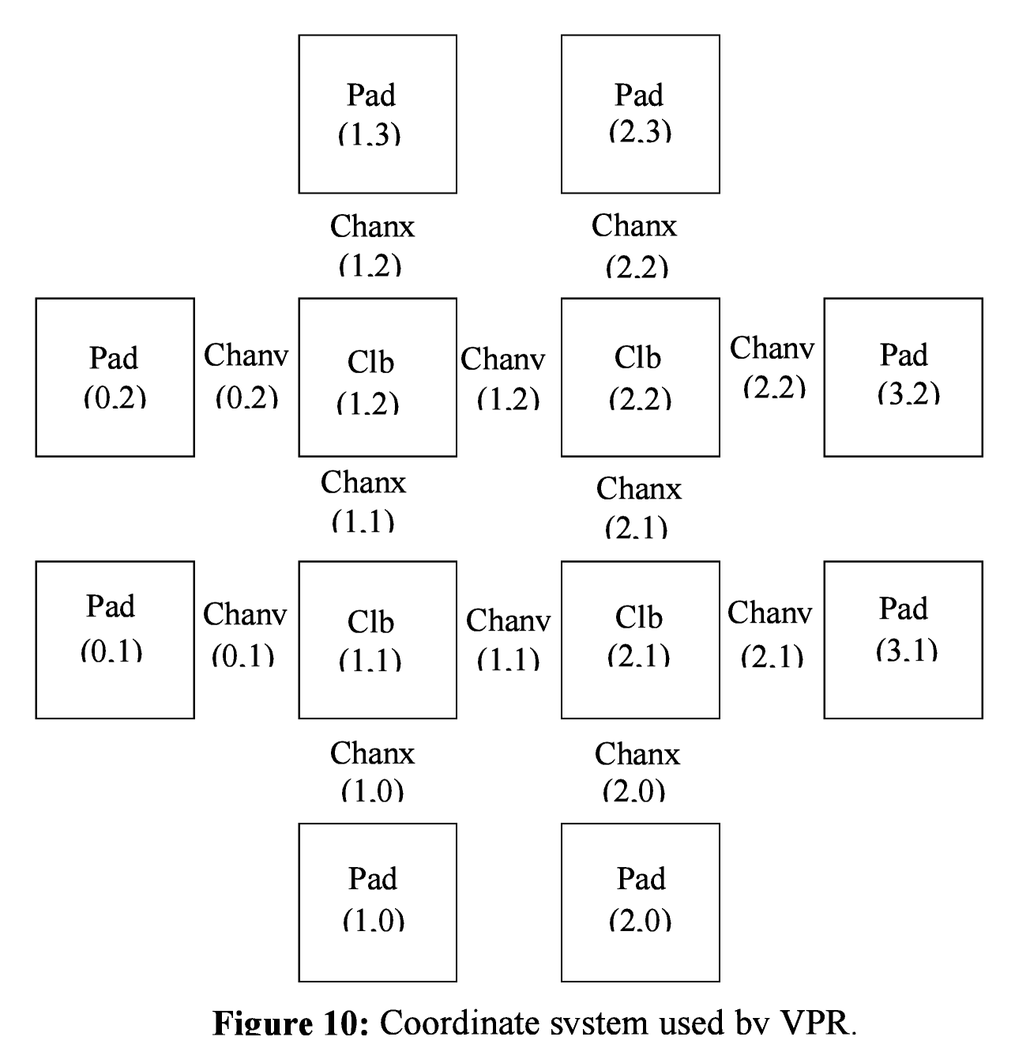
Figure shows the coordinate system used by VPR via a small 2 x 2 clb FPGA. The number of clbs in the x and y directions are denoted by nx and ny, respectively. Clbs all go in the area with x between 1 and nx and y between 1 and ny, inclusive. All pads either have x equal to 0 or nx + 1 or y equal to 0 or ny + 1.
An example placement file is given below.
Netlist file: xor5.net Architecture file: sample.arch
Array size: 2 x 2 logic blocks

#block name x y subblk block number
#---------- -- -- ------ ------------
a 0 1 0 #0 -- NB: block number is a comment.
b 1 0 0 #1
c 0 2 1 #2
d 1 3 0 #3
e 1 3 1 #4
out:xor5 0 2 0 #5
xor5 1 2 0 #6
[1] 1 1 0 #7
The blocks in a placement file can be listed in any order.

Routing File Format
The first line of the routing file gives the array size, nx x ny. The remainder of the routing file lists the global or the detailed routing for each net, one by one. Each routing begins with the word net, followed by the net index used internally by VPR to identify the net and, in brackets, the name of the net given in the netlist file. The following lines define the routing of the net. Each begins with a keyword that identifies a type of routing segment. The possible keywords are SOURCE (the source of a certain output pin class), SINK (the sink of a certain input pin class), OPIN (output pin), IPIN (input pin), CHANX (horizontal channel), and CHANY (vertical channel). Each routing begins on a SOURCE and ends on a SINK. In brackets after the keyword is the (x, y) location of this routing resource. Finally, the pad number (if the SOURCE, SINK, IPIN or OPIN was on an I/O pad), pin number (if the IPIN or OPIN was on a clb), class number (if the SOURCE or SINK was on a clb) or track number (for CHANX or CHANY) is listed -- whichever one is appropriate. The meaning of these numbers should be fairly obvious in each case. If we are attaching to a pad, the pad number given for a resource is the subblock number defining to which pad at location (x, y) we are attached. See Figure for a diagram of the coordinate system used by VPR. In a horizontal channel (CHANX) track 0 is the bottommost track, while in a vertical channel (CHANY) track 0 is the leftmost track. Note that if only global routing was performed the track number for each of the CHANX and CHANY resources listed in the routing will be 0, as global routing does not assign tracks to the various nets.
For an N-pin net, we need N-1 distinct wiring “paths” to connect all the pins. The first wiring path will always go from a SOURCE to a SINK. The routing segment listed immediately after the SINK is the part of the existing routing to which the new path attaches. It is important to realize that the first pin after a SINK is the connection into the already specified routing tree; when computing routing statistics be sure that you do not count the same segment several times by ignoring this fact. An example routing for one net is listed below.
Net 5 (xor5)

SOURCE (1,2) Class: 1 # Source for pins of class 1.
OPIN (1,2) Pin: 4
CHANX (1,1) Track: 1
CHANX (2,1) Track: 1
IPIN (2,2) Pin: 0
SINK (2,2) Class: 0 # Sink for pins of class 0 on a clb.
CHANX (1,1) Track: 1 # Note: Connection to existing routing!
CHANY (1,2) Track: 1
CHANX (2,2) Track: 1
CHANX (1,2) Track: 1
IPIN (1,3) Pad: 1
SINK (1,3) Pad: 1 # This sink is an output pad at (1,3), subblock 1.
Nets which are specified to be global in the netlist file (generally clocks) are not routed. Instead, a list of the blocks (name and internal index) which this net must connect is printed out. The location of each block and the class of the pin to which the net must connect at each block is also printed. For clbs, the class is simply whatever class was specified for that pin in the architecture input file. For pads the pinclass is always -1; since pads do not have logically-equivalent pins, pin classes are not needed. An example listing for a global net is given below.
Net 146 (pclk): global net connecting:
Block pclk (#146) at (1, 0), pinclass -1.
Block pksi_17_ (#431) at (3, 26), pinclass 2.
Block pksi_185_ (#432) at (5, 48), pinclass 2.
Block n_n2879 (#433) at (49, 23), pinclass 2.

SDC File Format
Synopsys Design Constraints (SDC) is the industry-standard format for specifying timing constraints. The following subset of SDC syntax is supported by VPR (italicized portions are optional):

create_clock -period <float> -waveform {rising_edge falling_edge} <netlist clock list or regexes>
create_clock -period <float> -waveform {rising_edge falling_edge} -name <virtual clock name>
Assigns a desired period (in nanoseconds) and offset to one or more clocks in the netlist (if the –name token is omitted) or to a single virtual clock (used to constrain input and outputs to a clock external to the design). Netlist clocks can be referred to using regular expressions, while the virtual clock name is taken as-is. Omitting the waveform creates a clock with a rising edge at 0 and a falling edge at the half period, and is equivalent to using -waveform {0 <period/2>}. Non-50% duty cycles are supported but behave no differently than 50% duty cycles, since falling edges are not used in analysis. If a virtual clock is assigned using a create_clock command, it must be referenced elsewhere in a set_input_delay or set_output_delay constraint. If a netlist clock is not specified with a create_clock command, paths to and from that clock domain will not be analysed.
set_clock_groups -exclusive -group {<clock list or regexes>} -group {<clock list or regexes>}
-group {<clock list or regexes>} ...
Tells the timing analyser to not analyse paths between the specified groups of clock domains, in either direction. May be used with netlist or virtual clocks in any combination. A set_clock_groups constraint is equivalent to a set_false_path constraint (see below) between each clock in one group and each clock in another. For example, the following sets of commands are equivalent:
set_clock_groups -exclusive -group {clk} -group {clk2 clk3}
and
set_false_path -from [get_clocks{clk}] -to [get_clocks{clk2 clk3}]
set_false_path -from [get_clocks{clk2 clk3}] -to [get_clocks{clk}]
set_false_path -from [get_clocks <clock list or regexes>] -to [get_clocks <clock list or regexes>]
Cut paths unidirectionally from each clock after -from to each clock after –to. Otherwise equivalent to set_clock_groups. Note that false paths are supported between entire clock domains, but not between individual registers.
set_max_delay <delay> -from [get_clocks <clock list or regexes>] -to [get_clocks <clock list or regexes>]
Overrides the default timing constraint calculated using the information from create_clock with a user-specified delay. Be aware that this may produce unexpected results.
set_multicycle_path -setup -from [get_clocks <clock list or regexes>] -to [get_clocks <clock list or regexes>] <num_multicycles>
Creates a multicycle at the clock domain level: adds (num_multicycles - 1) times the period of the destination clock to the default setup time constraint. Note that multicycles are supported between entire clock domains, but not between individual registers.
set_input_delay -clock <virtual or netlist clock> -max <max_delay> [get_ports {<I/O list or regexes>}]
set_output_delay -clock <virtual or netlist clock> -max <max_delay> [get_ports {<I/O list or regexes>}]
Use set_input_delay if you want timing paths from input I/Os analyzed, and set_output_delay if you want timing paths to output I/Os analyzed. If these commands are not specified in your SDC, paths from and to I/Os will not be timing analyzed.
These commands constrain each I/O pad specified after get_ports to be timing-equivalent to a register clocked on the clock specified after -clock. This can be either a clock signal in your design or a virtual clock that does not exist in the design but which is used only to specify the timing of I/Os. The command also adds the delay max_delay through each pad, thereby tightening the setup time constraint along paths travelling through the I/O pad; this additional delay can be used to model board level delays. For single-clock circuits, -clock can be wildcarded using * to refer to the single netlist clock, although this is not supported in standard SDC. This allows a single SDC command to constrain I/Os in all single-clock circuits.
Regular expressions may be used to refer to I/Os with this command.
# (comment), \ (line continued) and * (wildcard)
# starts a comment – everything remaining on this line will be ignored. \ at the end of a line indicates that a command wraps to the next line. * is used in a get_clocks command or at the end of create_clock to match all netlist clocks, and partial wildcarding (e.g. clk* to match clk and clk2) is also supported. As mentioned above, * can be used in set_input_delay and set_output delay to refer to the netlist clock for single-clock circuits only, although this is not supported in standard SDC.

Regular expressions may be used to refer to one or more netlist (but not virtual) clocks in all commands except set_input_delay and set_output_delay. Regular expressions may be used to refer to I/Os in set_input_delay and set_output_delay.

By default, VPR looks for a file named circuitname.sdc in the parent directory, where circuitname is the specified circuit name. An alternate SDC file name can be specified using the --sdc_file command-line option. If VPR is invoked from run_vtr_task.pl, it looks for a file named circuitname.sdc in the directory /vtr_flow/sdc. An alternate directory can be specified in an individual task’s /config/config.txt file, using “sdc_dir=path/to/folder/inside/vtr_flow” (e.g. “sdc_dir = sdc” will mimic default behaviour).

Default behaviour and sample SDC files
In this section, examples for multiple clocks assume the circuit has two clocks called clk and clk2.

If an SDC file named circuitname.sdc is not found, VPR uses the following defaults:

Combinational circuits
Constrains all I/Os on a virtual clock virtual_io_clock, and optimizes this clock to run as fast as possible.
Equivalent SDC file:
create_clock -period 0 -name virtual_io_clock
set_input_delay -clock virtual_io_clock -max 0 [get_ports{*}]
set_output_delay -clock virtual_io_clock -max 0 [get_ports{*}]

Single-clock circuits
Constrains all I/Os on the netlist clock, and optimizes this clock to run as fast as possible.
Equivalent SDC file:
create_clock -period 0 *
set_input_delay -clock * -max 0 [get_ports{*}]
set_output_delay -clock * -max 0 [get_ports{*}]

Multi-clock circuits
Constrains all I/Os a virtual clock virtual_io_clock. Does not analyse paths between netlist clock domains, but analyses all paths from I/Os to any netlist domain. Optimizes all clocks, including I/O clocks, to run as fast as possible.
Equivalent SDC file:
create_clock -period 0 *
create_clock -period 0 -name virtual_io_clock
set_clock_groups -exclusive -group {clk} -group {clk2}
set_input_delay -clock virtual_io_clock -max 0 [get_ports{*}]
set_output_delay -clock virtual_io_clock -max 0 [get_ports{*}]

Here are sample SDC files for common non-default use cases:

A. Cut I/Os and analyse only register-to-register paths, including paths between clock domains; optimize to run as fast as possible.
create_clock -period 0 *

B. Same as A, but with paths between clock domains cut. Separate target frequencies are specified.
create_clock -period 2 clk
create_clock -period 3 clk2
set_clock_groups -exclusive -group {clk} -group {clk2}

C. Same as B, but with paths to and from I/Os now analyzed. (Same as the multi-clock default, but with custom period constraints.)
create_clock -period 2 clk
create_clock -period 3 clk2
create_clock -period 3.5 -name virtual_io_clock
set_clock_groups -exclusive -group {clk} -group {clk2}
set_input_delay -clock virtual_io_clock -max 0 [get_ports{*}]
set_output_delay -clock virtual_io_clock -max 0 [get_ports{*}]

D. Changing the phase between clocks, and accounting for delay through I/Os with set_input/output delay constraints.
create_clock -period 3 -waveform {1.25 2.75} clk # rising edge at 1.25, falling at 2.75
create_clock -period 2 clk2
create_clock -period 2.5 -name virtual_io_clock
set_input_delay -clock virtual_io_clock -max 1 [get_ports{*}]
set_output_delay -clock virtual_io_clock -max 0.5 [get_ports{*}]

E. Sample using all supported SDC commands. Inputs and outputs are constrained on separate virtual clocks.
create_clock -period 3 -waveform {1.25 2.75} clk
create_clock -period 2 clk2
create_clock -period 1 -name input_clk
create_clock -period 0 -name output_clk
set_clock_groups -exclusive -group input_clk -group clk2
set_false_path -from [get_clocks{clk}] -to [get_clocks{output_clk}]
set_max_delay 17 -from [get_clocks{input_clk}] -to [get_clocks{output_clk}]
set_multicycle_path -setup -from [get_clocks{clk}] -to [get_clocks{clk2}] 3
set_input_delay -clock input_clk -max 0.5 [get_ports{in1 in2 in3}]
set_output_delay -clock output_clk -max 1 [get_ports{out*}]

Debugging Aids
To access detailed echo files from VPR’s operation, use the command-line option -echo_file on.
After parsing the netlist and architecture files, VPR dumps out an image of its internal data structures into net.echo and arch.echo. These files can be examined to be sure that VPR is parsing the input files as you expect. The critical_path.echo file lists details about the critical path of a circuit, and is very useful for determining why your circuit is so fast or so slow.
If the preprocessor flag DEBUG is defined in vpr_types.h, some additional sanity checks are performed during a run. I normally leave DEBUG on all the time, as it only slows execution by 1 to 2%. The major sanity checks are always enabled, regardless of the state of DEBUG. Finally, if VERBOSE is set in vpr_types.h, a great deal of intermediate data will be printed to the screen as VPR runs. If you set verbose, you may want to redirect screen output to a file.
The initial and final placement costs provide useful numbers for regression testing the netlist parsers and the placer, respectively. I generate and print out a routing serial number to allow easy regression testing of the router.
Finally, if you need to route an FPGA whose routing architecture cannot be described in VPR’s architecture description file, don’t despair! The router, graphics, sanity checker, and statistics routines all work only with a graph that defines all the available routing resources in the FPGA and the permissible connections between them. If you change the routines that build this graph (in rr_graph*.c) so that they create a graph describing your FPGA, you should be able to route your FPGA. If you want to read a text file describing the entire routing resource graph, call the dump_rr_graph subroutine.

VPR Contributors
Professors:

Jason Anderson, Vaughn Betz, Jonathan Rose

Graduate Students:

Jason Luu, Jeffrey Goeders, Ian Kuon, Alexander Marquardt, Andy Ye, Wei Mark Fang, Tim Liu

Summer Students:

Opal Densmore, Ted Campbell, Cong Wang, Peter Milankov, Scott Whitty, Michael Wainberg,
Suya Liu, Miad Nasr, Nooruddin Ahmed, Thien Yu

Companies:

Altera Corporation, Texas Instruments

References
[1] J. Pistorius, M. Hutton, A. Mishchenko, and R. Brayton. "Benchmarking method and designs targeting logic synthesis for FPGAs", Proc. IWLS '07, pp. 230-237.
[2] S. Cho, S. Chatterjee, A. Mishchenko, and R. Brayton, "Efficient FPGA mapping using priority cuts". (Poster.) Proc. FPGA '07.
[3] V. Betz, J. Rose and A. Marquardt, Architecture and CAD for Deep-Submicron FPGAs, Kluwer Academic Publishers, 1999.
[4] V. Betz, “Architecture and CAD for the Speed and Area Optimization of FPGAs,” Ph.D. Dissertation, University of Toronto, 1998.
[5] V. Betz and J. Rose, “Cluster-Based Logic Blocks for FPGAs: Area-Efficiency vs. Input Sharing and Size,” CICC, 1997, pp. 551 - 554.
[6] A. Marquardt, V. Betz and J. Rose, “Using Cluster-Based Logic Blocks and Timing-Driven Packing to Improve FPGA Speed and Density,” ACM/SIGDA Int. Symp. on FPGAs, 1999, pp. 37 - 46.
[7] V. Betz and J. Rose, “Directional Bias and Non-Uniformity in FPGA Global Routing Architectures,” ICCAD, 1996, pp. 652 - 659.
[8] V. Betz and J. Rose, “On Biased and Non-Uniform Global Routing Architectures and CAD Tools for FPGAs,” CSRI Technical Report #358, Department of Electrical and Computer Engineering, University of Toronto, 1996. (Available for download from http://www.eecg.toronto.edu/~vaughn/ papers/techrep.ps.Z).
[9] V. Betz and J. Rose, “VPR: A New Packing, Placement and Routing Tool for FPGA Research,” Seventh International Workshop on Field-Programmable Logic and Applications, 1997, pp. 213 - 222.
[10] A. Marquardt, V. Betz and J. Rose, “Timing-Driven Placement for FPGAs,” ACM/SIGDA Int. Symp. on FPGAs, 2000, pp. 203 - 213.
[11] V. Betz and J. Rose, “Automatic Generation of FPGA Routing Architectures from High-Level Descriptions,” ACM/SIGDA Int. Symp. on FPGAs, 2000, pp. 175 - 184.
[12] S. Brown, R. Francis, J. Rose, and Z. Vranesic, Field-Programmable Gate Arrays, Kluwer Academic Publishers, 1992.
[13] S. Wilton, “Architectures and Algorithms for Field-Programmable Gate Arrays with Embedded Memories,” Ph.D. Dissertation, University of Toronto, 1997. (Available for download from http://www.ece.ubc.ca/~stevew/publications.html).
[14] Y. W. Chang, D. F. Wong, and C. K. Wong, “Universal Switch Modules for FPGA Design,” ACM Trans. on Design Automation of Electronic Systems, Jan. 1996, pp. 80 - 101.
[15] G. Lemieux, E. Lee, M. Tom, and A. Yu, “Direction and Single-Driver Wires in FPGA Interconnect,” International Conference on Field-Programmable Technology, 2004, pp. 41-48
[16] P. Jamieson, K. Kent, F. Gharibian, and L. Shannon. Odin II-An Open-Source Verilog HDL Synthesis Tool for CAD Research. In IEEE Annual Int’l Symp. on Field-Programmable Custom Computing Machines, pages 149–156. IEEE, 2010.

