Applicant details:
Applicant Name :
Applicant Type : Startup/MSME or Large (Provide certificate if Startup or MSME registered)
Applicant Address:
GST Number:
Invoice Address:

Inventor details:
Name | Nationality | Address

INVENTION DISCLOSURE FORM

This form is provided to help you organize your thoughts about the invention. Please explain the invention, ideally in such a way as to be entirely clear to one who is not familiar with it.
A patent may be granted in respect of an invention that, broadly, fulfils two criteria. First, that it is new; second, that it constitutes an ‘inventive step’ over previous technology. The Patent Office would examine whether the invention adds a new technical aspect over existing technology, and the added aspect was a non-obvious addition over existing technology. Objectively, the patent office examines whether the invention solves a technical problem of existing technology.
Your answers to the questions below should allow us to begin drafting a patent specification for the invention. Please answer all parts as fully as you can.
IDENTIFICATION OF INVENTOR(S): Who was involved in devising the invention? Was there any collaboration with other people or another company?
Identify the key inventor to whom questions can be directed. For each inventor, provide the following:
A. (Key) Full legal name
Residence Address
Citizenship
Work Phone Number
Work email
B. Full legal name
Residence Address
Citizenship
Work Phone Number
Work email
C. Full legal name
Residence Address
Citizenship
Work Phone Number
Work email

Title | What do you call the invention?
Optimisation of test sequences using clock-level commonality scoring and engineer-approved reduction of test setup
Short name used in this form: Test Sequence Optimiser.

Background Information | Is there any deadline for filing the patent application?  - In the event that a product incorporating the invention is to be launched shortly or any other disclosure of the invention is planned, please indicate this.  - It is important that you do not disclose any details of the invention to anyone else, as prior publication may invalidate a patent application. If it becomes necessary to do so, please contact us before any such disclosure is made.  - Also disclose if any patent/paper related to the invention has been filed prior to this patent application
Deadline for filing
No fixed external deadline is known to us at the time of writing. [Applicant to confirm.]
Planned launch or disclosure
The software was developed as an internal engineering tool. Please note the following so the attorney can judge the impact:
• The source code has been in a public GitHub repository (naik1805/stil-setup-analyzer) since 24 September 2026.
• A working demo of the tool runs on a public web address (stil-setup-analyzer.onrender.com).
We would like advice on whether these should be taken private now, and whether they affect novelty.
Earlier patents or papers
No patent application and no paper on this invention has been filed or published by us before this form.

State of the Art | Describe the most similar, already known, solutions (prior art) you are aware of.  - What do you consider to be the closest item of prior art? This may have a similar function or may be missing an important function which is provided by the invention.  - Is there anything else known today which has a similar function? If not, how was the problem being solved till date, if at all?  - Have you seen anything like the invention, perhaps in related areas of application, or with slightly different features?  - Please provide references to any research articles including articles, brochures, textbooks you may have.  - Please share any inspirations or ideas, available online, forming a basis or methodology for this invention.
How the problem is handled today
Every pattern file produced for a chip starts with a test setup. The tester resets the chip, resets the JTAG TAP, loads an instruction, shifts the SIB bits that open the path to one DFT partition (island) and shifts a long TDR word that configures it. Only then do the real test vectors start. ATPG tools write this setup again into every file, so the stuck-at, scan-shift and memory BIST files of the same island each carry their own copy. In practice engineers either leave the setup alone or read it by hand in a text editor.
Known solutions we are aware of
• ATPG and DFT tools (for example Siemens Tessent, Synopsys TestMAX, Cadence Modus). They generate the setup procedure and can retarget IJTAG commands. When pattern sets are generated together in one run, a common setup can be used. They do not take already generated files, measure how much of the setup is really the same across them, or suggest which clocks can be removed.
• ATE pattern conversion tools from tester vendors (Advantest, Teradyne). They pack repeated vectors into repeat or loop instructions to save vector memory. The number of tester clocks spent stays the same, so test time does not go down.
• Generic text compare tools (diff, WinMerge, Beyond Compare). They compare lines of text. A Loop 5 line and five separate lines look different even though the tester does the same thing, and a 1400-bit TDR line is shown as one changed line with no idea which bits differ.
• Research on IJTAG network design and access time. This work reduces access time by changing how SIBs and TDRs are placed in the chip during design. It needs a design change and does not help with pattern files that already exist for a fixed chip.
• Test time reduction in general: scan compression, test scheduling and multi-site testing. These work on the test payload or on how many chips are tested at once, not on the setup sequence.
Closest prior art
The closest is the shared-setup option inside ATPG tools together with plain file compare. Neither gives a clock-accurate commonality score across finished files, neither separates safe clocks from protocol-critical clocks, and neither keeps an engineer approval step before a clock is removed.
Ideas and references that formed the basis
• Public JTAG, IJTAG and STIL standards for the meaning of TAP states, SIB, TDR and pattern blocks.
• Learning to Defer: D. Madras, T. Pitassi, R. Zemel, "Predict Responsibly: Improving Fairness and Accuracy by Learning to Defer", NeurIPS 2018; H. Mozannar, D. Sontag, "Consistent Estimators for Learning to Defer to an Expert", ICML 2020.
• Gradient boosting: J. H. Friedman, "Greedy Function Approximation: A Gradient Boosting Machine", Annals of Statistics, 2001.
[Inventor to add any internal documents, tool manuals or articles used.]

Brief Description of  Invention | Please describe briefly what you consider to be the invention. Include:  - State the technical problem to be solved and how the invention solves it.  - How the invention is better than the prior art literature (mentioned above).  - Be careful to describe what, specifically, makes the invention different from state of the art.  - What advantage(s) does the invention provide, compared to known devices or methods? Please mention the technical advantages. Do not use any business use cases and monetary advantages.  - Avoid general statements that your invention is "better." Please tell us why it is better, or what makes it better.
Technical problem
Pattern files for the same chip repeat a long test setup. In our test kit it is 1600 tester clocks per file. Part of it is protocol-critical (instruction, SIB and TDR bits that pick and configure the island). Part of it does no work: a reset level held one clock longer than needed, a second TAP reset after TRST has already reset the TAP, and idle clocks after the data has already been latched. Today there is no reliable way to (a) measure exactly how much of the setup is the same across files, at the level the tester actually runs, and (b) remove the wasted clocks without the risk of breaking the protocol-critical ones.
How the invention solves it
• It cuts the setup region out of each file, unrolls every loop into real tester clocks and records the pin values of every clock.
• It compares the files clock by clock. A clock is common only if every file has identical pin values at that clock. This gives a genuine commonality score for the whole set, for each protocol step and for each single clock.
• It marks every clock Keep or Redundant with DFT rules. IR, SIB, TDR, the first reset, the TRST release and the TAP exits are always Keep.
• A Learning-to-Defer model trained on the engineer's own decisions recommends a cut only when it is confident, keeps when it is confident, and hands the clock to the engineer otherwise.
• Nothing is removed until the engineer clicks Reject. The tool then writes a new pattern file in which only those clocks are missing; the test payload is copied unchanged.
What makes it different from the prior art
• Comparison is done on unrolled tester clocks, not on text lines, headers or step names. Two files that do the same thing on the tester score the same even if one uses loops.
• The score is given at three levels together (file set, step, clock), so the exact clocks that differ are pointed out. In our five-island example only 8 of 1600 clocks differ, and the tool names them.
• Commonality and safety are combined: a clock that is common to all test types of an island and is also redundant by rule is a safe candidate to remove once for all of them, while protocol-critical clocks can never be suggested for removal however common they are.
• The model has a third answer, "defer", so an uncertain clock is never decided by the machine.
Technical advantages
• Shorter test sequence: in the example, 97 of 1600 setup clocks are removed (1503 remain), a 6.1% shorter setup per file, with the same chip state at the start of the payload.
• Shared setup: files of different test types for one island are shown to be 100% identical in setup, so the setup can be run once instead of once per test type.
• Correct island selection is preserved because SIB, TDR and IR clocks are protected by rule and every cut is approved by a person.
• Readable result for long sequences: 1600 clocks are shown as about a dozen steps with clock ranges and scores, and only the differing clocks are listed in detail with each file's pin values side by side.
• Output pattern files keep a valid structure (pattern header, burst, exec and payload intact), so they load on the tester like the original.
• The model improves with every review, so recommendations match the engineer's practice over time.

Inventive Step | Where does the ‘cleverness’ of the invention lie?  Did you come across any technical difficulties when devising the invention? If so, how were these difficulties overcome? Please list the technical challenges you met while inventing the product or process.  What is the contribution of the invention in the technology domain?  Is there any visible output which can showcase improvements over the existing solutions?
Where the cleverness lies
The key idea is to treat the test setup as a sequence of tester clocks with pin values, not as text, and to use that one representation for two jobs at once: measuring commonality across files and deciding what can be removed safely. On top of that, the decision to remove is split between fixed protocol rules (what must never be touched), a learned model (what is probably waste) and the engineer (final say). None of the three alone is enough: rules alone miss cases, a model alone may cut a critical bit, and a person alone cannot read thousands of clocks.
Technical difficulties and how we overcame them
• Loops make files look different when they are not. Solved by unrolling every loop into tester clocks before comparing.
• Finding where setup ends. Stuck-at, scan-shift and MBIST files start their payload differently. We detect the payload start for each test type and also stop at the first numbered pattern, so the payload never enters the comparison.
• Corrupting the file when writing it back. An early version searched for the waveform statement and matched a copy inside the macro definitions, which damaged the pattern header. We now anchor on the pattern block itself and rewrite only the setup region, and we check that the structure is intact.
• Misleading similarity scores. Comparing step names said 100% for files that select different islands. Moving to pin-level comparison per clock fixed this; the five islands now correctly show 99.5% with the SIB and TDR differences named.
• Too much data to show. A 1400-bit TDR and 1600 rows made the screen unusable. We group clocks into steps with ranges, summarise long bit strings and show per-clock scores only on demand.
• Safety of machine suggestions. We added rule-level protection and the defer action so the model can never cause a critical clock to be removed.
• Few labels at the start. The model is first trained from the rule labels and then the engineer's real decisions override them.
• Hardware differences. The comparison and model use the GPU (CUDA) when present and fall back to the CPU, giving the same result on a laptop or a server without a GPU.
Contribution to the technology domain
It gives test engineers a measurable, clock-accurate way to see how much of a test sequence is shared, and a safe, reviewable way to shorten it, working on the final pattern files without any change to the chip design or the ATPG flow.
Visible output showing the improvement
• Commonality score card: 100% (1600/1600) for one island's three test types; 99.5% (1592/1600) for five islands, with the 8 differing clocks listed (SIB #44 to #48, TDR #1501 to #1503).
• Optimized pattern file: setup reduced from 1600 to 1503 tester clocks, payload unchanged.
• HTML report and dashboard screens showing step scores, per-clock scores and Keep/Reject decisions. [Screenshots to be attached.]

Benefits | What benefit, or advantage might this invention give in the overall product? What competitor companies might be interested?  What use do you envisage the invention being put to other than the current implementation? Other areas of implementation of the invention apart from the current implementation.  What do you see as the market for the invention?
Benefit in the overall product
Shorter test setup means less tester time per chip on every test insertion, for the life of the product. Sharing one verified setup across test types of an island removes repeated bring-up. Engineers spend less time reading setup code and the risk of a wrong manual edit goes away.
Companies that may be interested
• EDA companies that make ATPG and DFT tools (Siemens EDA, Synopsys, Cadence).
• ATE makers (Advantest, Teradyne) and their pattern conversion software.
• Semiconductor companies with large test programs, and outsourced test houses (OSATs).
Other uses
• Comparing pattern sets between two releases of the same chip to see exactly which setup clocks changed.
• Checking that files meant for the same island really share a setup before merging them under one shared setup.
• Other repeated initialisation sequences: boot and power-up sequences, SPI or I2C configuration sequences, burn-in and system-level test start-up.
• Any test format, not only STIL, once the vectors are expanded to tester clocks.
Market
Every company that tests digital chips with scan and IJTAG on ATE. The value grows with the number of DFT partitions, the number of test types per partition and the production volume.

Detailed Description of Proposed Embodiments | Please describe one or more ways of implementing the invention here in detail.  - In addition to describing all the functionalities, describe how they interact with each other.  - What does each functionality contribute to the invention? For each part, indicate if the part (or its form or interconnection) is essential to the invention.  - If you use any unusual terms, or ordinary terms in an unusual way, please explain them.  - If you have any additional materials describing the invention (e.g. an internal report or technical specification), please attach them to this form.  - Please include as much detail as possible including drawings, figures, flowcharts, snapshots etc.  - It helps to have drawings to illustrate the proposed embodiments of invention. Please attach drawings to this form. Do they need additional explanation? If so, please provide here  - Every description must contain an example as to how the problem is being solved. Merely explaining the steps shall not be considered sufficient disclosure
Overview
The preferred implementation is a Python program with a browser dashboard. It runs on a laptop or as a web service. Figure 1 shows the flow.
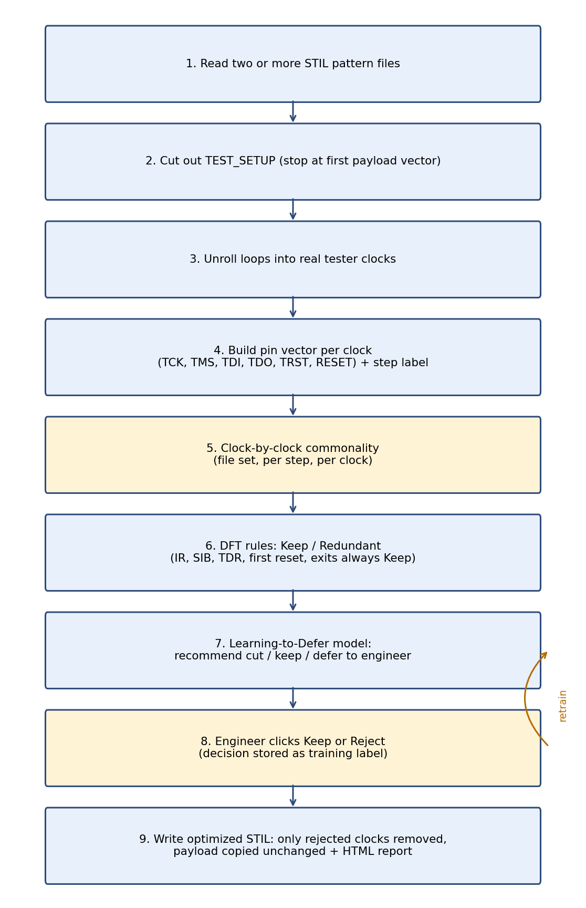
Figure 1. Flow of the Test Sequence Optimiser.
Functional blocks, how they interact, and whether they are essential
• Setup extractor (essential). Finds the pattern block, takes everything up to the first payload vector and passes it on. Without it, payload vectors would distort the scores.
• Clock expander (essential). Unrolls loops and macro calls so each entry equals one tester clock, and keeps the step label (reset, IR, SIB, TDR, exit, PLL) from the file annotations or from the TAP state.
• Pin-vector matrix (essential). One row per clock with TCK, TMS, TDI, TDO, TRST and RESET values, one matrix per file. All later blocks read this matrix.
• Commonality engine (essential). For clock i, it compares row i of every file. Headline score = clocks identical in all files / clocks compared. Clock score = files agreeing with the most common value / number of files. Step score = identical clocks in the step / clocks in the step. Island score uses the same rule within files that select the same partition. Runs on GPU if available.
• Rule classifier (essential). Marks each clock Keep or Redundant and gives a reason. Redundant only when: pins identical to the previous clock with no new TAP state, a second 5-clock TMS=1 reset after TRST, or idle after Update-DR. IR, SIB, TDR, first reset assert, TRST release and exits are protected.
• Learning-to-Defer model (preferred, not strictly essential). A gradient boosting classifier (80 trees, depth 3) uses 13 features per clock: duplicate of previous, TAP already reset, reset already released, TCK low, TMS high, is SIB, is TDR, is IR, is exit, is TAP-reset clock, is reset assert, loop repeat, rule says cut. It outputs the probability that the engineer would accept a cut. Above 0.65 it recommends a cut, below 0.35 it keeps, in between it defers to the engineer. Protected clocks are always Keep. The tool still works with rules only, but the model reduces how many clocks the engineer must look at over time.
• Review store (essential for the approval step). Saves each Keep/Reject with the clock features. Used as training labels and as the list of approved cuts.
• Rewriter (essential). Rebuilds the setup without the rejected clocks, keeps the header, burst, exec and payload exactly as they were, and writes one optimized file per input file.
• Dashboard and report (preferred). Shows the score card, a table per step with step score and expandable per-clock scores, the list of differing clocks with each file's pin values, and Keep/Reject buttons. Exports an HTML report and a zip of optimized files.
Terms used in an unusual way
• Tester clock: one clock cycle on the tester. A Loop 5 line counts as five tester clocks.
• Island: a DFT partition of the chip that is selected through SIBs and tested on its own.
• Genuine commonality: clocks with identical pin values in every selected file, divided by clocks compared. Not based on file names, headers or step names.
• Defer: the model's third answer, meaning "let the engineer decide".
Worked example (how the problem is solved)
Input: 15 pattern files we generated for five islands (dft_part_0 to dft_part_4); for each island a stuck-at file with 1000 patterns, a scan-shift file and an MBIST file. Each setup is 1600 tester clocks at a 20 ns period: 10 reset/TAP clocks, 32 Shift-IR, 2 Exit-IR, 64 SIB, 1400 TDR, 2 Exit-DR and a 90-clock PLL tail. This is a demonstration kit, not production data.
Case A, one island, three test types: the engine finds all 1600 clocks identical, score 100%. The setup can be shared, so for back-to-back tests the tester runs it once instead of three times.
Case B, stuck-at files of five islands: 1592 of 1600 clocks identical, score 99.5%. The SIB step scores 92.2% (clocks #44 to #48 at 80%, four of five files agree) and the TDR step 99.8% (clock #1501 at 80%, #1502 and #1503 at 60%). All other steps score 100%. These are exactly the bits that select and configure each island, which is expected and confirms the score is genuine. Figure 2 shows the step scores.
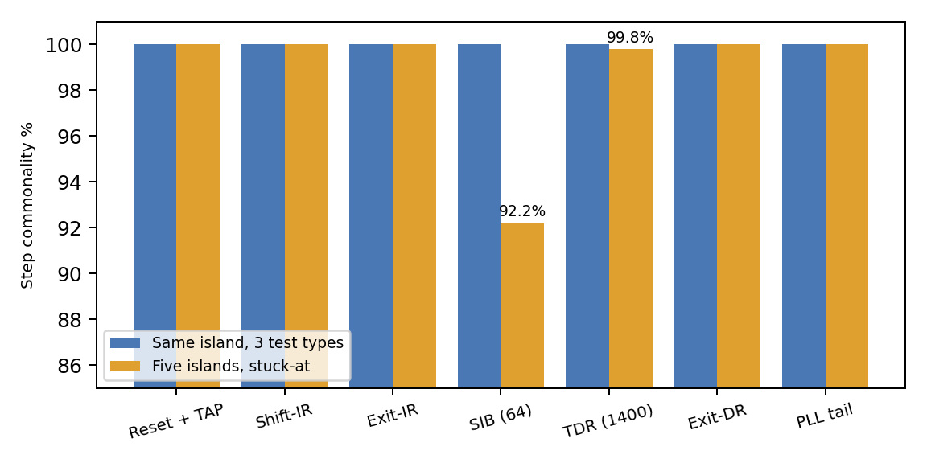
Figure 2. Step commonality for Case A and Case B.
Optimisation: the rule classifier and model mark 97 clocks Redundant: 1 duplicate reset hold, 5 clocks of a second TAP reset, 1 extra idle after reset release and 90 idle clocks after the IJTAG data was latched (in the demo kit these carry no PLL lock-wait requirement). The remaining 1503 are Keep. The engineer reviews the four groups and clicks Reject. The rewriter outputs new stuck-at, scan-shift and MBIST files with 1503 setup clocks each; the payload is byte-for-byte the same. If the shared setup of Case A is also used, the setup for one island's three tests drops from 4800 to 1503 clocks.
[Attach dashboard screenshots: score card, step table, differing clocks, Optimize screen.]

Alternate solutions | Please describe any alternative ways in which the invention could be achieved here.  - How else could you have accomplished the same end?  - Do not limit to exactly the preferred version of the invention  - Are there less desirable, but still useful, ways of making the invention work?  - Can the invention be used for anything other than its preferred use?
• Align clocks by protocol step (or by sequence alignment such as edit distance) instead of by position, so setups that are shifted by a few clocks can still be compared.
• Compare hashes of each step first and look at single clocks only where the hashes differ, for very long setups.
• Use a different model: random forest, logistic regression or a small neural network, or no model at all (rules plus engineer review only). Less adaptive, but still useful.
• Run as a command-line step inside the test-program build flow instead of a dashboard, with approved cuts read from a file.
• Build the same logic into an ATPG tool so it writes one shared, cleaned setup directly.
• Work on other vector formats (WGL, tester-native formats) after converting them to tester clocks.
• Apply to other repeated sequences: chip boot, SPI or I2C register configuration, burn-in and system-level test start-up.
• Use only the commonality part as a checking tool, for example to compare two releases of a pattern set.

Limitations | Please list any possible limitations of the invention that you are aware of  - Are there any situations in which the invention is not applicable?  - Under what circumstances might the invention not work?
• Clocks are compared by position. If one file has an extra clock early on, later clocks shift and the score drops even though the steps are the same.
• The rules cover the waste we have seen (duplicate holds, second TAP reset, extra idle). Other kinds of waste need new rules.
• Step labels come from annotations or from the TAP state. Files without either are harder to group.
• It does not shorten the test payload itself, only the setup.
• Setups that read TDO and branch on the result, or that depend on timing such as PLL lock wait, must not be shortened without checking the chip specification.
• Sharing one setup across test types is only possible if the tester runs them back to back without a power cycle or reset in between.
• The figures in this form come from a demonstration kit. Savings on a real chip must be measured on that chip, and every optimized file must be checked on the tester or in simulation before production use.

