Table of Contents
1 Introduction 4
1.1 Purpose 4
1.2 Scope 4
1.3 Definitions And Abbreviations 4
1.3.1 Resource: 4
1.3.2 Tag/ Tagging: 4
1.3.3 Parent Resource: 4
1.3.4 MyCourse: 5
1.4 References 5
1.5 Product Overview 5
2 Overall Description 5
2.1 Product perspective 5
2.2 Product functions 5
2.2.1.1 Add Resource 5
2.2.1.2 Remove Resource 5
2.2.1.3 Edit Resource 6
2.2.1.4 Edit Resource Permissions 6
2.2.1.5 Resource Search 6
2.2.1.6 Add Tag 6
2.2.1.7 Add Tag to a Resource 6
2.2.1.8 Branching an Existing Resource 6
2.3 User characteristics 6
2.3.1 User Classes 6
2.3.1.1 Resource Owner 7
2.3.1.2 Tutor 7
2.3.1.3 Generic Moodle user/Student 7
2.4 Constraints 7
2.5 Assumptions and dependencies 7
2.5.1 Dependencies 7
2.5.1.1 PHP 5.2.1 7
2.5.1.2 Moodle 1.8.8 8
3 Specific Requirements 8
3.1 External Interface Requirements 8
3.1.1 User Interfaces 8
3.1.1.1 Web Interface 8
3.1.2 Hardware Interfaces 8
3.1.3 Software Interfaces 8
3.1.4 Communications Protocols 9
3.2 Functional Requirements 9
3.3 Performance Requirements 9
3.4 Design constraints 9
3.4.1 Standards compliance 9
3.4.2 Hardware Limitations 9
3.5 Software system attributes 10
4 Additional Material 10
4.1 Domain Model 10
4.2 System Permissions Table 10

Introduction

Purpose
To provide a centralised point for tutors to store references to course related material. These references can then shared amongst the faculty and students.

Scope
The systems primarily role is to maintain a record of Resources, that are represented by URLs. Excluding the meta-data contained within the system about each resource, each resource is not the responsibility of the system. As a result this system provides no functionality to modify the actual resource.

Definitions And Abbreviations

Resource:
An object that contains a reference to a URL .

Tag/ Tagging:
A form of Categorisation. A keyword or word used to describe a resource.

Parent Resource:
The original resource from which another resource was derived.

MyCourse:
The customised implementation of Moodle running within Southampton Solent University

References
Moodle. 2009. Development – Coding Style. [Online] Available at: http://docs.moodle.org/en/Development:Coding_style [Accessed: May 8th, 2009].
Moodle. 2009. Development – Resource Types [Online] Available at: http://docs.moodle.org/en/Development:Resource_types [Accessed: May 8th, 2009].

Product Overview
The second section of this specification will provided a more detailed overview of the final products functions.

Overall Description

Product perspective
The final software will be written entirely in PHP, and act as a plug-in conforming to Moodles resource type plug-in interface.

Product functions

Add Resource
A Tutor can create a new resource.

Remove Resource
The Owner of a resource, can remove it.

Edit Resource
The Owner of a resource, and tutors who have been granted the permission by the resource owner can edit the metadata for a resource.

Edit Resource Permissions
The Owner of a resource can give other tutors permission to edit a resource

Resource Search
All users can search the system to find a resource

Add Tag
Add a keyword to the system

Add Tag to a Resource
Associate a Resource with a keyword.

Branching an Existing Resource
If a tutor wishes to modify a Resource within the system. A Tutor can branch an existing resource. This creates a new resource, which maintains it's relationship to it's parent

User characteristics

User Classes
There are two Major User classes within the application domain, and third, generic class that encompasses all users outside of the two primary classes

Resource Owner
This is the creator of the resource. Each resource can have a single owner. Only this user has the authority to delete

Tutor
A user who has the ability to modify a unit on mycourse

Generic Moodle user/Student
The majority of the users will have read only access to the resources.
All users will be a member of the Mycourse VLE
Users with mutable access are all tutors

Constraints
The system will be written in PHP on order to enable it to integrate with the pre existing moodle system.
Data created using the plug-in will be stored in the database of moodles chooses, using moodles built-in ORM.

Assumptions and dependencies

Dependencies

PHP 5.2.1
The customers current Moodle Install is running on a PHP 5.2.1 server.

Moodle 1.8.8
The customers current Moodle Install is version 1.8.8.

Specific Requirements

External Interface Requirements

User Interfaces

Web Interface
This is the primary interface that a user will use to interact with the system and the data stored within it.

Hardware Interfaces
There are no predefined requirements for hardware interfaces. The system will accept any device that emulates a keyboard and mouse.

Software Interfaces
The final software will be constructed in the PHP programming language, and will utilise PHP API's up to and including PHP 5.2.1, as defined in section 2.4.1.1.
The software will conform to Moodles Resource Type Plug-in specifications. This requires it to be a subclass of the resource_base class.

Communications Protocols
N/a

Functional Requirements
In accordance with the systems domain model, each object will be able to perform basic CRUD methods. These basic functions will be then be extended to facilitate additional functionality.

Performance Requirements
These have not be assessed yet. However the customer has not placed any specific performance on the system.

Design constraints

Standards compliance
The development team will follow the Moodle Coding Guidelines as defined in section 1.4

Hardware Limitations
There are no specific minimum system requirements. As a result the minimal system requirements are based on the current PHP install, and it's accompanying Moodle install.

Software system attributes

Additional Material

Domain Model
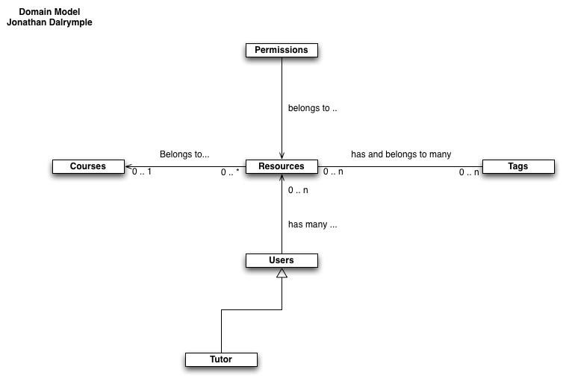

System Permissions Table

