**Chhattisgarhi To Hindi Voice Translation on Android**

Project report for the fulfilment of

**Vth Semester Minor Project to**

**Dr Ankit Chaudhary**

**in**

**Computer Science and Engineering**

**IIIT NR**

By,

**Ananya Verma (16100011)**

**Budati Rashi (16100020)**

**Grandhe Tejendher Venkata Akhilesh (16100029)**



**Dr. Shyama Prasad Mukherjee**

**International Institute of Information Technology, Naya Raipur**

**CERTIFICATE**

This is to certify that the project titled “Chhattisgarhi to Hindi Voice Translation on Android” by “Ananya Verma, Budati Rashi and Grandhe Akhilesh” has been carried out under my/our supervision and that this work has not been submitted elsewhere for a degree.

(Signature of Guide)

**Dr. Ankit Chaudhary**

**Assistant Professor**

**Department of Computer Science and Engineering**

**Dr. SPM IIIT-NR**

**December, 2018**

**Declaration**

I declare that this written submission represents my ideas in my own words and where others' ideas or words have been included, I have adequately cited and referenced the original sources. I also declare that I have adhered to all principles of academic honesty and integrity and have not misrepresented or fabricated or falsified any idea/data/fact/source in my submission. I understand that any violation of the above will be cause for disciplinary action by the Institute and can also evoke penal action from the sources which have thus not been properly cited or from whom proper permission has not been taken when needed.

(Signature of Author)

**_________________**

**Ananya Verma, Budati Rashi, Akhilesh Grandhe**

**(Roll Numbers – 16100011, 16100020, 16100029)**

**Date: 9/12/18**

**PLAGARISM REPORT**

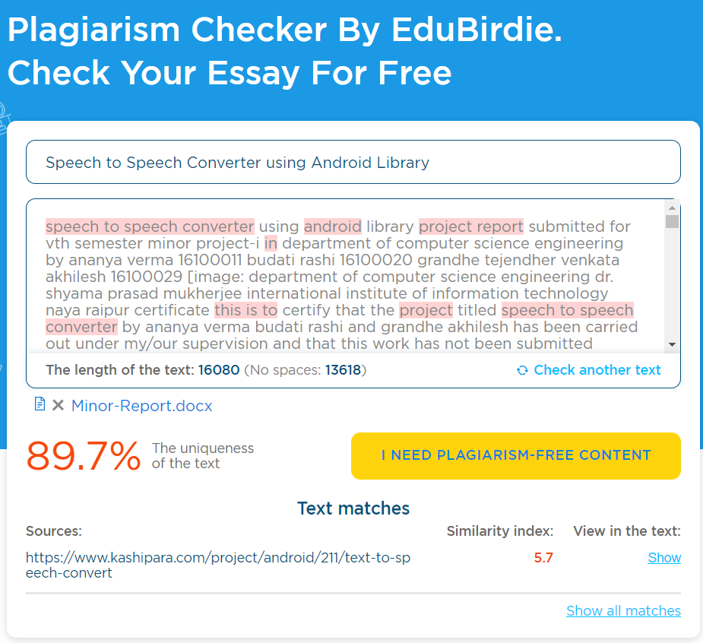

**Approval Sheet**

This project report entitled “SPEECH TO SPEECH CONVERTER” by “Ananya Verma, Budati Rashi and Grandhe Akhilesh” is approved for Vth Semester I Project.

(Signature of Examiner - I)

________________________

Dr. Anurag Singh

(Signature of Examiner - II)

________________________

Dr. Santosh Kumar

(Signature of Chair)

________________________

Dr. Ankit Chaudhary

Date: 9/12/18 Place: IIITNR

**ABSTRACT**

For past several decades, designers have processed speech for a wide variety of applications ranging from mobile communication to automatic reading machines. A smart speech to text/speech converter application is proposed in this paper. The system acquires a Chhattisgarhi speech at the run time through a microphone and processes the sampled speech to recognize the uttered translated text in Hindi which then converted into the corresponding Hindi speech.

This android application is developed by using Android Studio, Android Library and Google Speech API. Our system converts speech to text/speech. It can supplement other larger systems, giving users a different choice for data entry. A speech to text/speech system can also improve the system accessibility by providing data entry options for blind, deaf or physically challenged people.

With the advancement in the mobile technology, opens the window for mobile application development. A simple Chhattisgarhi Speech to Hindi speech converter is implemented as instance to use the basic working processes of Android application components. The developed application can convert Chhattisgarhi speech to corresponding Hindi text and Hindi speech. A CSV file is maintained in order to map the Chhattisgarhi words with Hindi words. We have also developed a python based project for the Chhattisgarhi sentence to Hindi sentence conversion.

Keywords- CSV, Android system, Application framework, NLP, Chhattisgarhi Language, Devnagri Script, voice translation;

**ACKNOWLEDGEMENT**

We have taken efforts in this project. However, it would not have been possible without the kind support and help of many individuals and organizations. We would like to extend our sincere thanks to all of them.

We are highly indebted to Dr. Ankit Chaudhary, Assistant Professor, CSE Department, for their guidance and constant supervision as well as for providing necessary information regarding the project & also for his support in completing the project.

We would like to express our gratitude towards member of IIITNR for their kind co-operation and encouragement which help us in completion of this project.

Our thanks and appreciations also go to our colleagues in developing the project and people who have willingly helped us out with their abilities.

**Table of Contents**

**Title Page No.**

**ABSTRACT…………………………………………………………. 5**

**ACKNOWLEDGEMENT………………………………………….. 6**

**TABLE OF CONTENTS………………………………………....... 7**

**LIST OF TABLES………………………………………………….. 8**

**LIST OF FIGURES……………………………………………….... 8**

**CHAPTER 1 INTRODUCTION…………………………………... 9**

**CHAPTER 2 LITERATURE REVIEW…………………………... 10**

**CHAPTER 3 PROPOSED SOLUTION…………………………… 12**

**CHAPTER 4 RESULTS……………………………………………. 15**

**CHAPTER 5 CONCLUSIONS…………………………………….. 17**

**REFERENCES……………………………………………………… 18**

**List of All Tables**

|  |  |  |
| --- | --- | --- |
| **Table No.** | **Table Title** | **Page Number** |
| 1 | Output Result | 16 |

**List of All Figures**

|  |  |  |
| --- | --- | --- |
| **Figure No.** | **Figure Title** | **Page Number** |
| 1. | Android Architecture | 13 |
| 2. | Sequence Diagram | 14 |
| 3. | Display of Android Application | 15 |
| 4. | CSV File | 15 |
| 5.1 | Output of the word तोर | 16 |
| 5.2 | Output of the word मोर | 16 |

1. **INTRODUCTION**

We are living in a world with technological things around us especially smartphones. The smartphones have become one of the important things in a person’s life. Smartphones have made the life of an individual easy and fast.

**Scenario –** When a Chhattisgarh Official visits a local Chhattisgarhi village, it’s quite very difficult for the officer to communicate with the villagers in order to get their problems and needs as neither the villagers don’t know Hindi nor the officer knows the local language this acts as barrier for medium of communication.

Therefore, a device needs to be formulated for proper communication at official level for better communication.

There are many tools formulated for language conversion using Machine Learning. Google Speech Translator sets a benchmark for all the speech to text/speech translators.

Since technology has reached its tremendous margins. Mobile phones become a common tool for every citizen of India, belonging from rural to urban parts of the country. It’s easier to propose a solution for mobile platform so that it can be accessible at all the levels.

Android is a software environment for mobile devices that includes an operating system, middleware and key application. The Android System Architecture is divided into 5 layers. The application layer of Android OS is visible to end user, and consists of user applications. The application layer includes basic applications which come with the operating system. The next layer represents the libraries, written in the C and C++ programming languages, and OS accesses them via framework.

CSV is a simple file format used to store tabular data, such as a spreadsheet or database. Files in the CSV format can be imported to and exported from programs that store data in tables, such as Microsoft Excel or OpenOffice Calc. CSV stands for "comma-separated values”

1. **LITERATURE REVIEW**
2. **Speech to Text Conversion using Android Platform** – B. Raghavendhar Reddy, E. Mahender

The application allows user to record and convert spoken messages into SMS text messages. Uses technique – hidden Markov models (HMM).

**Limitations:** The above paper uses the English speech and converts it into text for sending SMS purpose. The language is limited to English. The conversion is speech to text only. No translation is performed in the application.

1. **Android based Speech Recognition** – SonaliThite, Archana Gore, Sagar Yelmar, Yogesh Lonkar

It uses GPS(Global Positioning System), LBS (Location Based System), Speech Recognition Software: XVoice, ISIP, Ears to convert English speech to text/speech.

**Limitations:** The above uses the English speech only and converts it into text/speech. No translation is performed in the application.

1. **Android Based Smart Speech Recognition Application to perform Various tasks** – Lakshya Agrawal, Mayank Khaushik

Voice commands as input, Speech to text conversion using Google API Comparison with the dataset to select the appropriate command Machine Learning module – provides multiple functionalities. The first and foremost is the automatic execution of very frequent commands given by the users with user’s permission. Another functionality is to count the steps taken by the user within a specific period of time using Activity Recognition.

**Limitations:** This application takes commands as speech in input and converts it into text only. No language translation is performed. Specific to English language only.

1. **Google Speech API:** In the Google API, it employs a quantized LSTM (Long Short-Term Memory) acoustic model trained with connectionist temporal classification (CTC) to directly predict phoneme targets, and further reduce in its memory footprint using a SVD based compression scheme. It can process real-time streaming or pre-recorded data audio by using Google’s machine learning technology.

1. **Speechalator: two-way speech-to-speech translation on a consumer PDA**  - Alex Waibel, Ahmed Badran , Alan W Black, Robert Frederking , Donna Gates , Alon Lavie , Lori Levin , Kevin Lenz, Laura Mayfield Tomokiyo, Jurgen Reichert, Tanja Schultz, Dorcas Wallace , Monika Woszczyna

The paper describes a working two-way speech-to-speech translation system that can translate from English to Arabic and Arabic to English in the domain of medical interviews. The general architecture and frameworks within which developed each of the components: HMM-based recognition, interlingua translation (both rule and statistically based), and unit selection.

**Limitations**: The accuracy was around 80% and the language translation was restricted to few words.

1. **Continuous Hindi Speech Recognition Using Kaldi ASR based on Deep Neural Network**: Prashant Upadhyay, Sanjeev Kumar Mittal, Omar Farooq, Yash Vardhan Varshney and Musiur Raza Abidi

Context-Dependent Deep-Neural-network HMMs (CD-DNN-HMM) for large vocabulary Hindi speech using Kaldi automatic speech recognition toolkit. Experiments on AMUAV database demonstrate that CD-DNN-HMMs outperform the conventional CD-GMM-HMMs model and provide the improvement in word error rate of 3.1% over conventional triphone model.

**3. PROPOSED SOLUTION**

Now a days everyone has a smart phone with him or her. This led us motivated towards developing a model which everyone can use with ease. Therefore, we planned to develop a Speech to Speech converter using Android Library. There are some terms which a person should know before diving into the idea of our model.

**Android:**

Patterned after the Linux kernel, the Android also was released as open source code. Development for the Android may be done through Windows, Linux or Mac. Although primarily written in Java, there is no Java Development Machine (JDM) in the platform.

Instead of allowing Java programs to run through the JDM, Google developed Dalvik, a virtual machine specifically for the Android. Dalvik runs recompiled Java code and reads it as Dalvik bytecode and was designed to optimize battery power and maintain functionality in an environment with limited memory and CPU power, such as that of mobile phones, netbooks and tablet PCs.

One of the Android’s selling points is an ability to break down application boundaries. Another advantage is that it is easily developed, not to mention its speed of app development. A large community of developers continuously devises and designs apps that enhance the capability of devices. These apps are then made available worldwide through Google’s Android Market, or other third-party sites.

**Android Library:**

An Android library is structurally the same as an Android app module. It can include everything needed to build an app, including source code, resource files, and an Android manifest. However, instead of compiling into an APK that runs on a device, an Android library compiles into an Android Archive (AAR) file that you can use as a dependency for an Android app module. Unlike JAR files, AAR files can contain Android resources and a manifest file, which allows you to bundle in shared resources like layouts and drawable in addition to Java classes and methods.

A library module is useful in the following situations:

* When you're building multiple apps that use some of the same components, such as activities, services, or UI layouts.
* When you're building an app that exists in multiple APK variations, such as a free and paid version and you need the same core components in both.

**Android Architecture:**

Android is architected in the form of a software stack comprising applications, an operating system, run-time environment, middleware, services and libraries. This architecture can, perhaps, best be represented visually as outlined in Figure 1. Each layer of the stack, and the corresponding elements within each layer, are tightly integrated and carefully tuned to provide the optimal application development and execution environment for mobile devices.

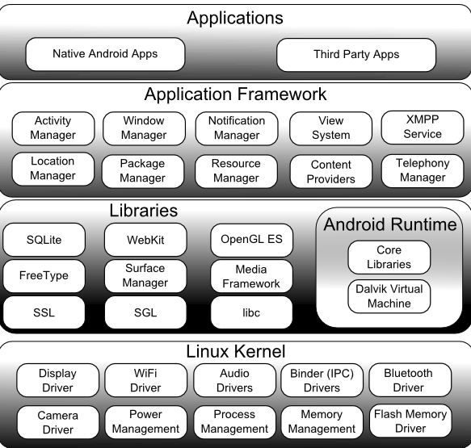

Figure 1 **Android Architecture**

**OUR METHODOLOGY:** Our model has several inbuilt functions like Extra Language Model, Recognizer Intent etc. The first step is to convert Chhattisgarhi speech to Hindi Text. We then converted our model to dynamic model. Later we included the voice output feature in our model. On recognizing the word spoken by the user the corresponding Hindi word is printed as the output and along with that there is also a voice output of the same word.

We used the recognizer intent to recognize the voice input. The extra language model has various languages inbuilt in it. Since we have Hindi as our required output language, we set the language as the same. For the voice output we used Text to Speech library and set the language as Hindi. We have chosen CSV file to store the words and the words are read from the same. This is one of the best features of our model because the developer need not change the entire code to add new words. However if a new feature is to be added then we need to change the code accordingly.

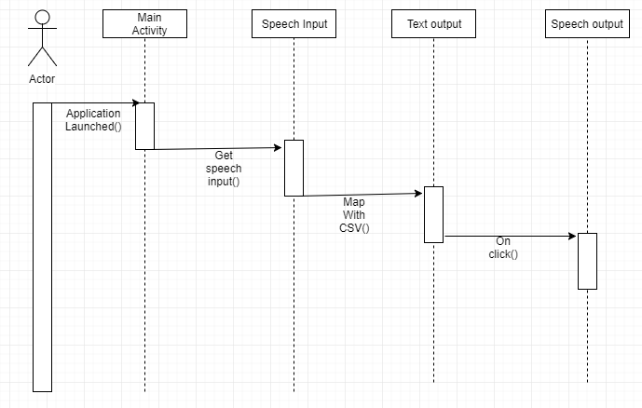

Figure 2 **Sequence diagram for speech Application**

**4. RESULTS**

We successfully built a android application which converts Chhattisgarhi speech to Hindi text and correspondingly gives the voice output (Figure 3).

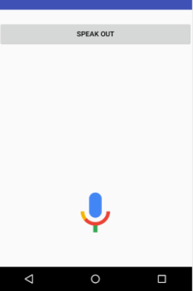

Figure 3 **Display of Android Application**

We stored the words in a CSV file (Figure 4). We mapped the corresponding Chhattisgarhi words to Hindi words.

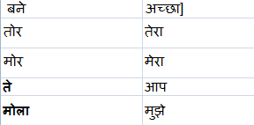

Figure 4 **CSV File**

The app prints the corresponding Hindi text when the user speaks the Chhattisgarhi word by hitting the " mic " icon (Figure 5.1 and Figure 5.2)

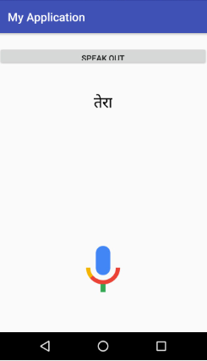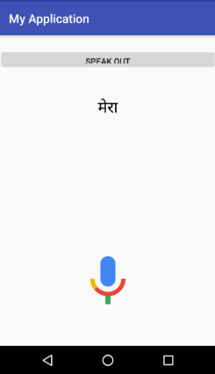

Figure 5.1 **(O/p of word तोर)** Figure 5.2 **(O/p of word मोर)**

The above figures are the text output of the words तोर and मोर respectively.

|  |  |  |
| --- | --- | --- |
| Pronounced Words | Output | Pass/Fail |
| तोर | तेरा | pass |
| मोर | मेरा | pass |

Table 1 **Output Result**

The above table represents the pass/fail status of few Chhattisgarhi speech converted to Hindi text

**5. CONCLUSION**

Our model has 85% accuracy. We can add more words according to the requirement and add many features as well. Our model is portable. The user can install in his or her mobile for their use. This way the problem of language barrier has been rectified to appreciable extent. However there are some prerequisites. The user’s smartphone should have Google speech services embedded in it. Our model recognises one word at a time. We will later try to develop a model which can detect the sentences. This way the user can communicate with ease.

**REFERENCES**

1. Lakshya Aggarwal, Mayank Kaushik, “Android Based Smart Speech Recognition Application to Perform Various Tasks”, International Journal on Recent and Innovation Trends in Computing and Communication, 10-Jun-2016
2. Sonali Thite, Archana Gore, Sagar Yelmar, Yogesh Lonkar, “Android Based Speech Recognition”, International Journal of Advanced Research in Computer Networking,Wireless and Mobile Communications Volume: 2 Issue: 1 09-Apr-2015,ISSN_NO: 2320-7248.
3. B. Raghavendhar Reddy, E. Mahender, “Speech to Text Conversion using Android Platform”, International Journal of Engineering Research and Applications (IJERA) ISSN: 2248-9622 Vol. 3, Issue 1, January -February 2013, pp.253-258
4. John Horton, “*Android Programming for Beginners”.*

1. Ed Burnette, “*Hello, Android: Introducing Google’s Mobile Development Platform Book”,* 4th Edition.
2. <https://www.androidhive.info/2014/07/android-speech-to-text-tutorial/>
3. <https://www.firstpost.com/tech/news-analysis/android-users-can-now-type-in-hindi-courtesy-the-google-hindi-input-app-3620901.html>
4. <https://stackoverflow.com/questions/43055661/reading-csv-file-in-android-app>
5. <https://www.tutorialspoint.com/android/android_text_to_speech.htm>
6. <https://www.androidauthority.com/how-to-add-words-to-android-dictionary-31136/>
7. https://mobile.developer.com/ws/android/programming/exploring-the-android-speech-api-for-voice-recognition.html