Hi I am interested in a quote for the Zahroof Straight flow valve and also have some additional questions.

We have 2 6 throw Dresser Rand BDC compressors that compress a hydrogen/methane mixture gas on 4 throws at 2 different stages and the final 2 throws compress methane waste gas in a single process stage. We have a total of 88 valves round pancake poppet style valves in 3 sets

|  |  |  |
| --- | --- | --- |
| Feed gas 1st stage | 13.0” diameter | Qty: 32 |
| Feed gas 2nd stage | 8.0” diameter | Qty: 24 |
| Waste gas | 13.0” diameter | Qty: 32 |

The Process summary is below

|  |  |  |  |  |  |  |  |
| --- | --- | --- | --- | --- | --- | --- | --- |
| Service | | Methane (Waste Gas)  (32 valves) | | 1st Stage Hydrogen/Methane (32 valve) | | 2nd Stage Hydrogen/Methane (24 valves) | |
| Cylinder number | | 033 | 034 | 012 | 013 | 023 | 024 |
| Suction Pressure | [psi abs] | 22.98 | 22.98 | 89.05 | 89.05 | 221.67 | 221.67 |
|  | [psig] | 8.28 | 8.28 | 74.35 | 74.35 | 206.97 | 206.97 |
|  | [kpag] | 57.09 | 57.09 | 512.64 | 512.64 | 1427.01 | 1427.01 |
| Suction Temperature | [˚F] | 95.00 | 95.00 | 106.00 | 106.00 | 120.20 | 120.20 |
|  | [˚C] | 35.00 | 35.00 | 41.11 | 41.11 | 49.00 | 49.00 |
| Discharge Pressure | [psi abs] | 65.63 | 65.63 | 240.80 | 240.80 | 518.49 | 518.49 |
|  | [psig] | 50.93 | 50.93 | 226.10 | 226.10 | 503.79 | 503.79 |
|  | [kpag] | 351.17 | 351.17 | 1558.91 | 1558.91 | 3473.48 | 3473.48 |
| Discharge Temperature | [˚F] | 248.00 | 248.00 | 279.00 | 279.00 | 268.00 | 268.00 |
|  | [˚C] | 120.00 | 120.00 | 137.22 | 137.22 | 131.11 | 131.11 |
| Actual Capacity | [cu.ft/min] | 10705 | Total for Both Cylinders | 9064 | Total for Both Cylinders | 3740 | Total for Both Cylinders |

The above information is for use developing a quote if Zahroof valves are a viable option then a more formal process overview will be provided.

Questions:

1. How is the cracking pressure of the Straight flow valves regulated?
2. Is there a way to size the valves for our current flow requirements with perforations in the top and bottom plates already installed for a future rate increase? I was wondering if there is also a solid module that can simply be removed in the event of a rate increase. Currently our plant is fine running at the current rates but there is talk in the next 4-5 years of increasing the flow requirements.

Thanks,

***Kyle Soehn, E.I.T.***

**HOG Reliability Engineer**

**NOVA Chemicals Ltd.**

Email: [Kyle.Soehn@novachem.com](mailto:Kyle.Soehn@novachem.com)

Phone: (403) 314-8492

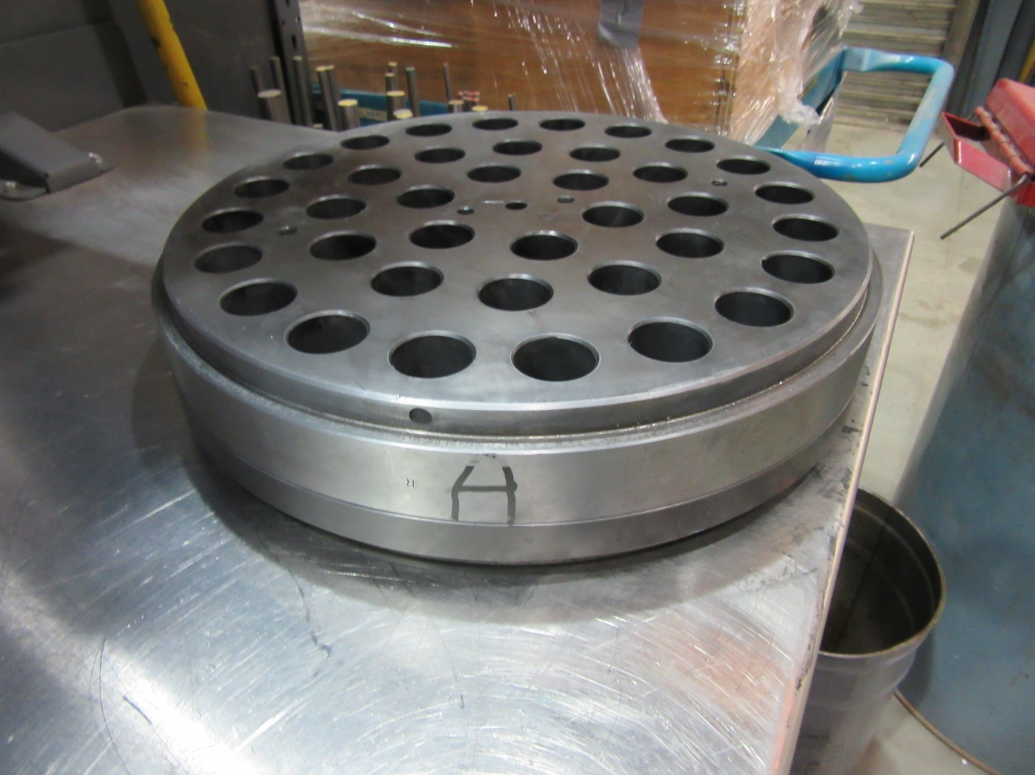

Current Valve shape for out waste gas suction and discharge valves