# Introduction

The objective of this report is to provide an analysis on the car insurance brokerage services. We are using a random sample of 400 customers which is being used for the analysis. This report is being investigated considering specific presumptions that are useful to draw out the important choices which are introduced underneath. It analyzes the customers who are benefited from using a broker and looks at the average savings of the customers. It highlights the difference in the savings for the negotiations done by customers without consulting their brokers. The report also underlines the difference in the savings based on the different brokers and compares their performance among each other. It compares the difference in the rural and urban area for the customers who are not satisfied with the brokers and looks at the average savings for the same. This report highlights the different evaluation methods used to compute the savings. This empowers you to bring the shrewd arrangements that could affect the future business arrangements.

I have completed the analysis for the random sample of 400 customers who obtained the services of car insurance brokers. As requested, please find the analysis below:

1. To estimate the proportion of customers who are worse off using the broker.

Customer who are worse off using the broker (having savings less than 0) are 18% of the entire population. With 95% confidence, we can say that the true proportion of all the customers who are worse off using the broker is between 14.24% and 21.76% of the entire customers. *[Appendix A.1]*

1. To estimate the average savings for all customers with luxury or sports cars.
   * Customers with luxury or sports cars are 27.75% of the entire population. The average savings of the 111 customers (that is 62 with luxury cars and 49 with sports cars) is 589.51 dollars. The lowest and highest saving for the customers are 108 dollars and 1956 dollars respectively. We can see that 25% of the customers have savings between 108-342.5 dollars and 25% of the customers have savings more than 716 dollars. *[Appendix A.2]*

* + The saving difference between the lowest and the highest is 1848 dollars. Moreover, there is a 359.39 average spread away from the average savings. The data provided indicates that there is quite a bit of variation in the average savings of the customers with luxury or sports cars. There were few customers who had average savings bit odd when compared with the rest and can be considered as an unusual case. *[Appendix A.2]*

Based on the above findings, we can say that with 95% confidence that the true average savings for all the customers who have either a luxury or sports cars is between 521.91 and 657.12 dollars. *[Appendix A.2]*

1. Evidence to suggest that the average savings on car insurance premiums have decreased from the figure claimed earlier by IBA.
   * The average savings of the 400 customers is 229.64 dollars. The lowest savings for the customers is in negative that is 87 dollars and the highest savings 1956 dollars. We can see that 25% of the customers have savings between (-)87 dollars and (+)12 dollars and 25% of the customers have savings more than 357 dollars. *[Appendix A.3]*

* + The saving difference between the lowest and the highest is 2043 dollars. Moreover, there is a 320.56 average spread away from the average savings. The data provided indicates that there is quite a bit of variation in the average savings of the customers. There were few customers who

had average savings bit odd when compared with the rest and can be considered as an unusual case. *[Appendix A.3]*

At 5 percent significance level, there is sufficient evidence to conclude that average savings for all the customers have reduced on the car insurance premiums and the claim made by Insurance Brokers Association (IBA) saying that their members saved minimum of 260 dollars on the insurance premiums is false. *[Appendix A.3]*

1. To test if the proportion of customers who attempted to negotiate a better deal with their insurance company before contacting a broker is far less than 20%.
   * Only 60 out of 400 customers approached their insurance company before contacting a broker, which is only 15% of the entire population or the sample data provided. *[Appendix A.4]*

At 5 percent level of significance there is sufficient evidence to conclude that true proportion of all the customers who attempted to negotiate a better deal before contacting their broker is far less than 20%. *[Appendix A.4]*

1. To conclude if broker iChoose ($262.44), on average, is able to save more on car insurance premiums than broker uChoose ($230.84).
   * The average savings by the iChoose and uChoose broker on car insurance premium are 262.44 dollars and 230.84 dollars. The lowest savings for the customers is in negative that is 78 dollars and the highest savings 1956 dollars. We can see that 25% of the iChoose customers have savings between (-)78 dollars and 0 dollars whereas for uChoose it is between (-)69 dollars and 24 dollars. 25% of the iChoose customers have savings more than 412.5 dollars and uChoose customers have more than 388.75 dollars. The saving difference between the lowest and the highest for iChoose broker is 2034 dollars and for uChoose is 1645 dollars. *[Appendix A.5]*

* + Moreover, there is a 356.76 and 311.16 average spread away from the average savings for iChoose and uChoose respectively. The data provided indicates that there is quite a bit of variation in the average savings of the customers by iChoose and uChoose broker. There were few customers who had average savings bit odd when compared with the rest and can be considered as an unusual case for both the iChoose and the uChoose broker. *[Appendix A.5]*

At 5 percent significance level, there is not enough evidence to conclude that the true average savings of all the customers of the iChoose broker is more than the true average savings of all the customers of the uChoose broker on car insurance premium. *[Appendix A.5]*

1. To check If the difference would hold across all customers for urban and rural area.
   * Proportion of customers who feel dissatisfied and very dissatisfied for the urban are 11.15% and 8.20% among the urban customers. Whereas, proportion of customers who feel dissatisfied and very dissatisfied for the rural are 24.21% and 10.53% among the rural customers. *[Appendix A.6]*

* + But when we look at the proportion of customers in the urban and rural who feel dissatisfied (i.e.

both ‘very dissatisfied’ and ‘dissatisfied’) are 19.34% and 34.74% among their respective area of customers. *[Appendix A.6]*

At 5 percent significance level, there is not enough evidence to conclude that the proportion of all urban customers who are dissatisfied (i.e. both ‘very dissatisfied’ and ‘dissatisfied’) hold the same difference across all the rural customers who are dissatisfied (i.e. both ‘very dissatisfied’ and ‘dissatisfied’). *[Appendix A.6]*

7a. To find if average savings on car insurance premiums for urban customers are different to rural customers.

* + The average savings for the urban and rural customers are 240.96 dollars and 193.32 dollars respectively. The lowest savings for the urban customers is in negative that is 78 dollars and the highest savings 1956 dollars whereas for the rural customers is in negative that is 87 dollars and the highest savings 1273 dollars. We can see that 25% of the urban customers have savings between (-)78 dollars and 10 dollars whereas for rural customers it is between (-)87 dollars and 17 dollars. 25% of the urban customers have savings more than 363 dollars and rural customers have more than 311.5 dollars. The saving difference between the lowest and the highest for urban is 2034 dollars and for rural is 1360 dollars. *[Appendix A.7.a]*

* + Moreover, there is a 333.03 and 275.20 average spread away from the average savings for urban and rural customers respectively. The data provided indicates that there is quite a bit of variation in the average savings for the urban and rural customers. There were few customers who had average savings bit odd when compared with the rest and can be considered as an unusual case for both urban and rural. *[Appendix A.7.a]*

At 5 percent significance level, there is not enough evidence to conclude that the true average savings for all the urban customers on car insurance premiums is different than that of all the rural customers average savings. *[Appendix A.7.a]*

At 95% confidence, the difference is inconclusive as the confidence interval contains both negative and positive values. We are unable to say whether one average saving is different to another. *[Appendix A.7.a]*

7b. To find if on average, customers with ‘Agreed Value’ policy saved more on their car insurance premiums than the customers with ‘Market Value’ policy.

* + The average savings for the customer with ‘Agreed Value’ and ‘Market Value’ policy are 360.63 dollars and 213.45 dollars. The lowest savings for the ‘Agreed Value’ customers is in negative that is 76 dollars and the highest savings 1651 dollars whereas for the ‘Market Value’ customers is in negative that is 87 dollars and the highest savings 1956 dollars. We can see that 25% of the ‘Agreed Value’ customers have savings between (-)76 dollars and 69.25 dollars and “Market Value’ customers have between (-)87 dollars and 0 dollars. 25% of the ‘Agreed Value’ customers have savings more than 494.75 dollars and “Market Value’ customers have more than 342.25 dollars. The saving difference between the lowest and the highest for ‘Agreed Value’ and ‘Market Value’ are 1727 and 2043 dollars respectively. *[Appendix A.7.b]*

* + Moreover, there is a 418.59 and 303.12 average spread away from the average savings for ‘Agreed Value’ and ‘Market Value’ customers. The data provided indicates that there is quite a bit of variation in the average savings for the customers with ‘Agreed Value’ and ‘Market Value’ policy. There were few customers who had average savings bit odd when compared with the rest and can be considered as an unusual case for the both. *[Appendix A.7.b]*

At 5 percent significance level, there is sufficient evidence to conclude that the true average savings for all the customers with ‘Agreed Value’ policy is more than that of all the customers average savings with ‘Market Value’ policy. *[Appendix A.7.b]*

With 95% confidence, we can say that the difference of average savings for the customers with ‘Agreed Value’ policy is more than the average savings for the customers with ‘Market Value’ policy and is between 47.40 to 246.97 dollars. *[Appendix A.7.b]*

7c. To check if the proportion of female customers with a Diamond level no claim bonus rating (NCBR) is less than male customers with a Diamond level no claim bonus rating (NCBR).

* + Based on the data provided, female customers having Diamond level no claims bonus ratings

(NCBR) are 64.07%, compared to the 79.83% of the males. *[Appendix A.7.c]*

At 5 percent, significance level, there is sufficient evidence to conclude that the proportion of all the female customers with a Diamond level no claim bonus ratings (NCBR) is less than that of all the male customers with the Diamond level no claim bonus ratings (NCBR). *[Appendix A.7.c]*

With 95% confidence, we can say that the difference of the proportion of female customers with Diamond level no claims bonus rating (NCBR) is less than that of the male customers with Diamond level no claims bonus ratings (NCBR) and is between -24.55% to -6.96%. *[Appendix A.7.c]*

8. Evaluating the business research approach adopted for this study.

Data used for sample has been obtained from the Insurance Broker Association (IBA) and consists of 400 customers sample who used the services provided by the car insurance brokers. The data has been collected using different collection processes. From the data, we can infer that data is both qualitative and quantitative.

Based on the type of data and the outcome of the result (if the statement is to be studied or to be proven), we have chosen our analysis methods. These methods have been used to provide some meaningful insights regarding the customers savings on car premiums based on the different parameters and how savings differs for the customers on the brokers or the policies. When we need to estimate we have used 95% confidence interval level to find the lower and the upper interval, whereas If a theory/claim must be tested, we have tested it with the 5 percent significance level.

# Conclusion

Following conclusions can be made based on the key findings of the analysis:

* More than 75% of the customers were benefited when using the brokers.
* Average savings of customers who had either luxury or sports cars lies between 521.91 to 657.12 dollars.
* Average customer savings on car insurance premium has reduced and is less than 260 dollars.
* Customer who attempted to negotiate a deal on their own are less than 20%.
* On an average, iChoose broker is not able to save more money for the customers than the uChoose broker.
* There is no difference in the dissatisfaction level for the urban and the rural customers.
* Urban and rural customers have roughly the same average savings on car insurance premiums.
* Customer with Agreed value policy saved more than the customers with Market value policy.
* There are less females when compared to the males for the Diamond level no claims bonus rating (NCBR).

# Appendix

A.1 Proportion of customers who are worse off using brokers.

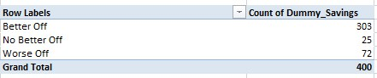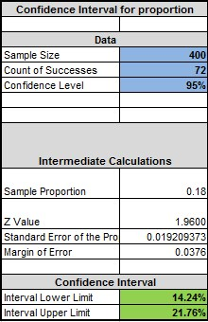

*Figure A.1 – Confidence Interval and Pivot Table for worse off customers* A.2 Average savings of customer with luxury or sports cars.

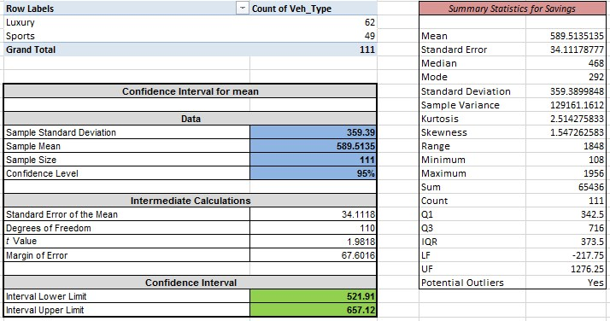

*Figure A.2 – Confidence Interval and Summary statistics for customers with luxury or sports cars*

A.3 Average savings on car insurance premiums.

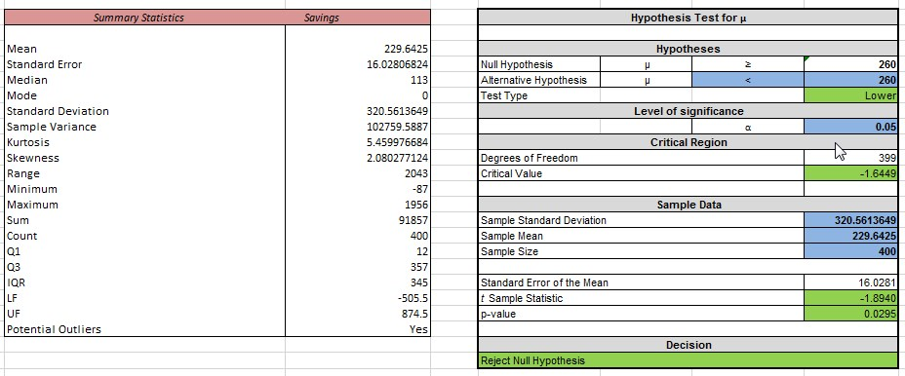

*Figure A.3 – Summary Statistics and Hypothesis testing for average savings* A.4 Customers who negotiated deals on their own are less than 20%.

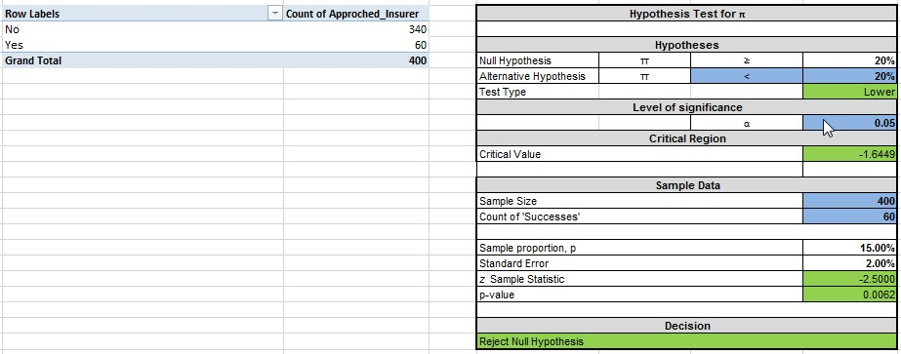

*Figure A.4 – Pivot table and Hypothesis testing for customers who negotiated deals on own* A.5 Average savings of iChoose compared to the uChoose broker.

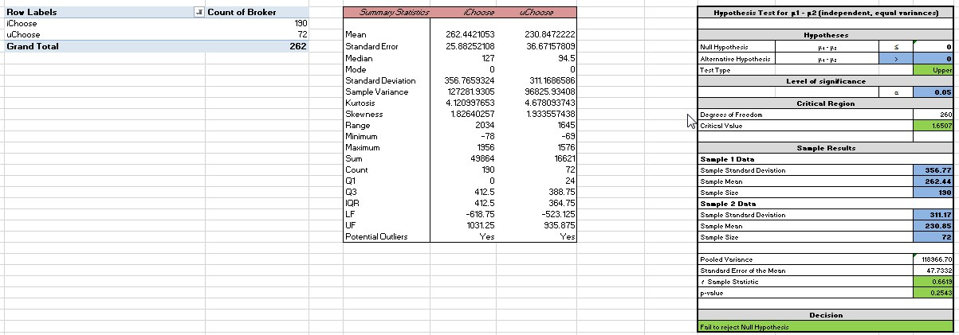

*Figure A.5 – Pivot Table, summary statisitics and hypothesis testing for iChoose and uChoose*

A.6 Dissatisfaction level among urban and rural customers.

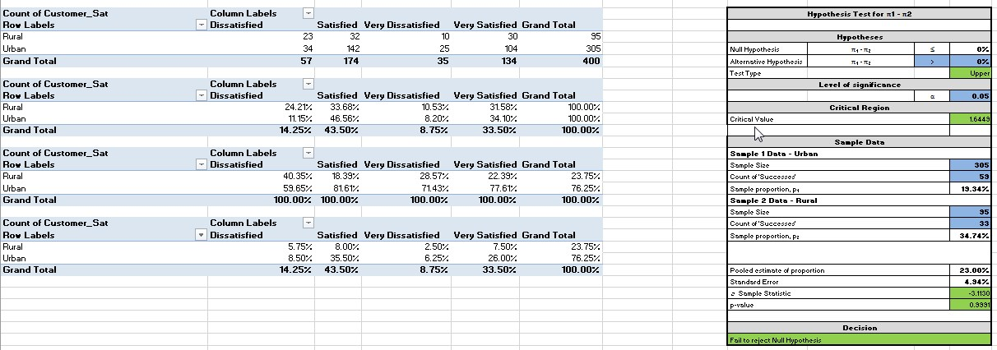

*Figure A.6 – Contingency table and hypothesis testing for dissatisfaction level in rural and urban* A.7.a Average savings for urban and rural customers.

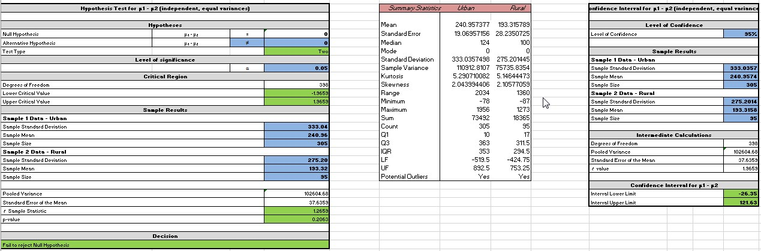

*Figure A.7.a – Hypothesis testing, summary statistics and confidence interval for average savings* A.7.b Average savings for Agree value and Market value policy.

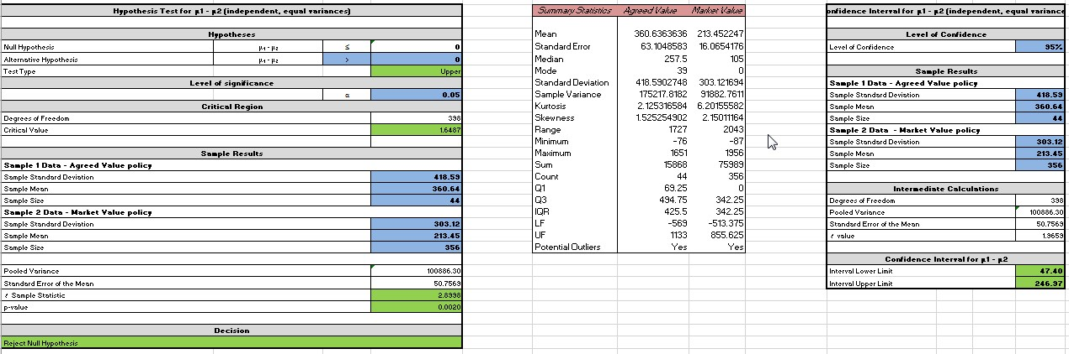

*Figure A.7.b – Hypothesis testing, summary statistics and confidence interval for average savings*

A.7.c Diamond level NCBR for female and male customers.

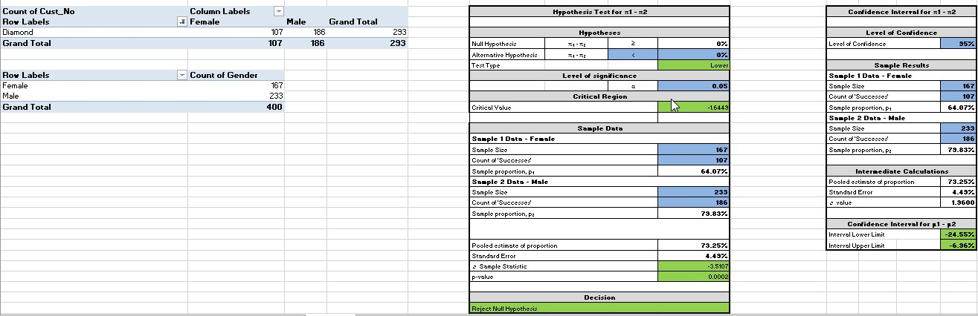

*Figure A.7.c – Pivot table, hypothesis testing and confidence interval for Diamond level NCBR*