1. First Create Databse name **shopbridge** and after that table under databse name **product_items** mentioned screenshot below: -

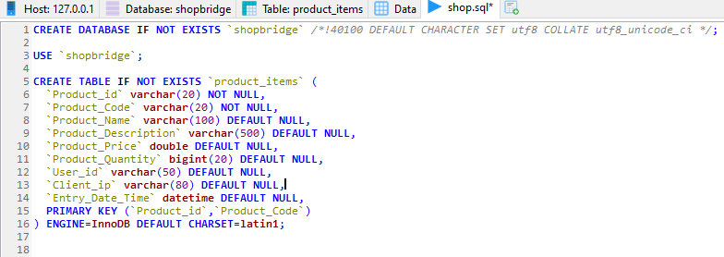

1. Second Create .Net Core API Project in Visual Studio name **shopbridge** under project ADD Controller Name **ProductAdminController** mentioned screenshot below**:-**

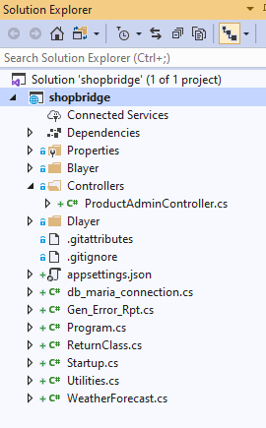

1. Third Create CRUD Operation in **ProductAdminController** with database Query and Validation typename:-
2. **Insert_Product**

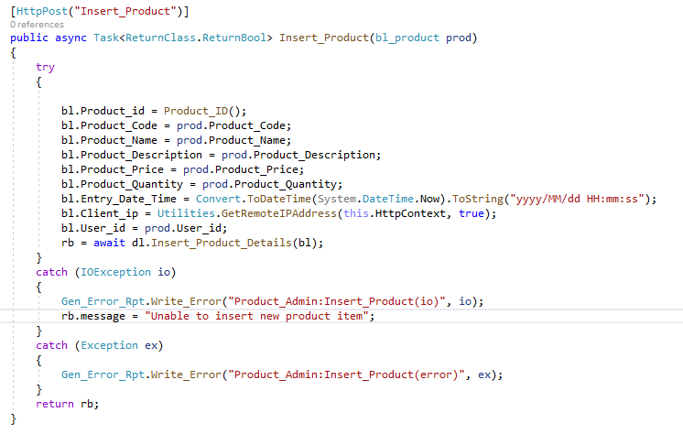

1. **Update_Product**

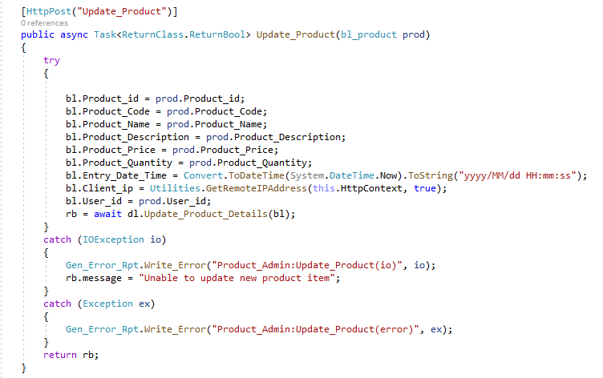

1. **Delete_Product**

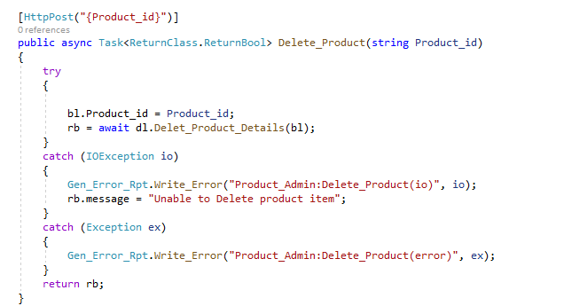

1. **Display_Product**

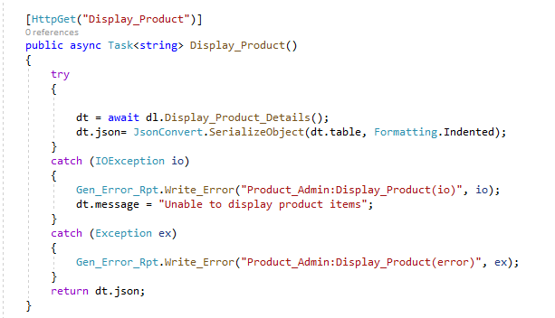

1. Create Folder name **blayer** and under that create class **bl_product.cs** for business Validation Summary Screenshot **:-**

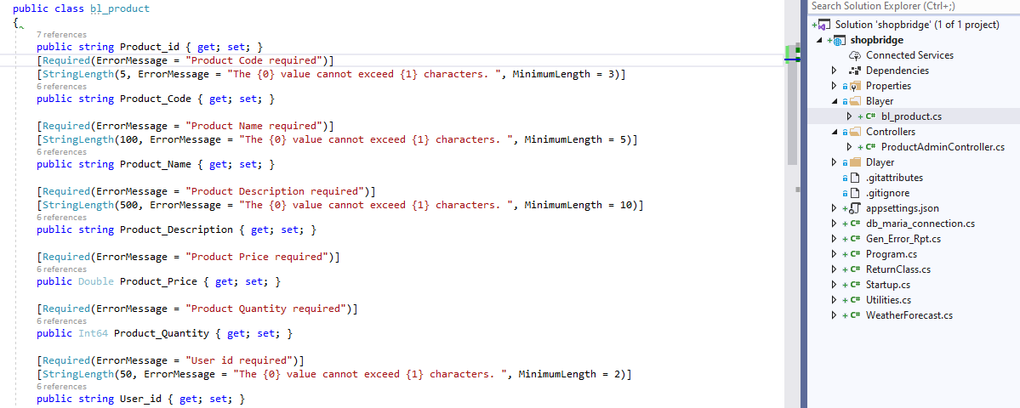

1. Create Folder name **dlayer** and under that create **dl_product.cs** for business logic query layer below screenshot:-

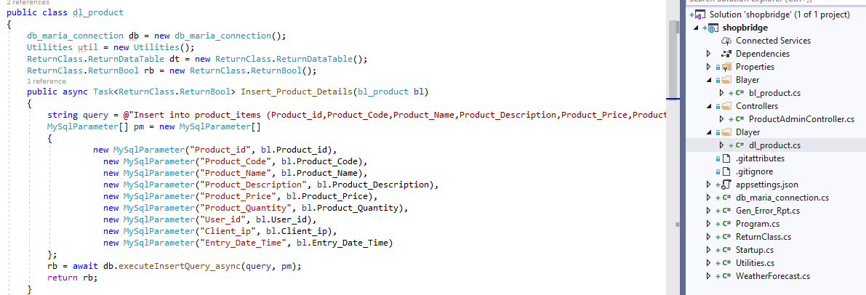

1. Than Test this CRUD API in **Postman** screenshot below:-
2. Insert Product

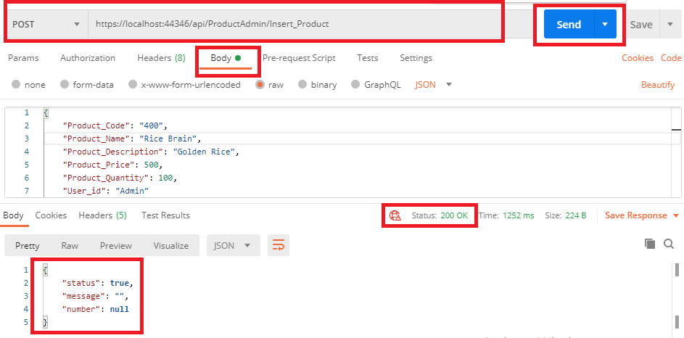

1. Update Product

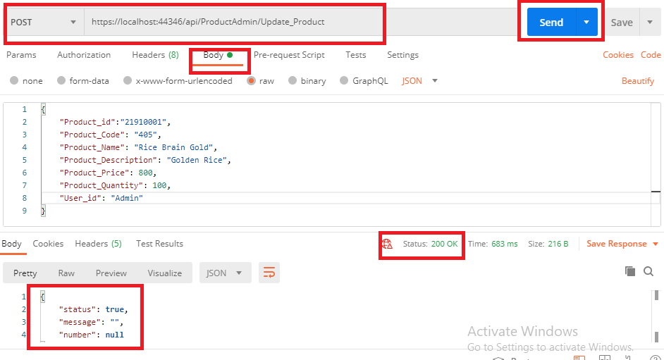

1. Delete Product

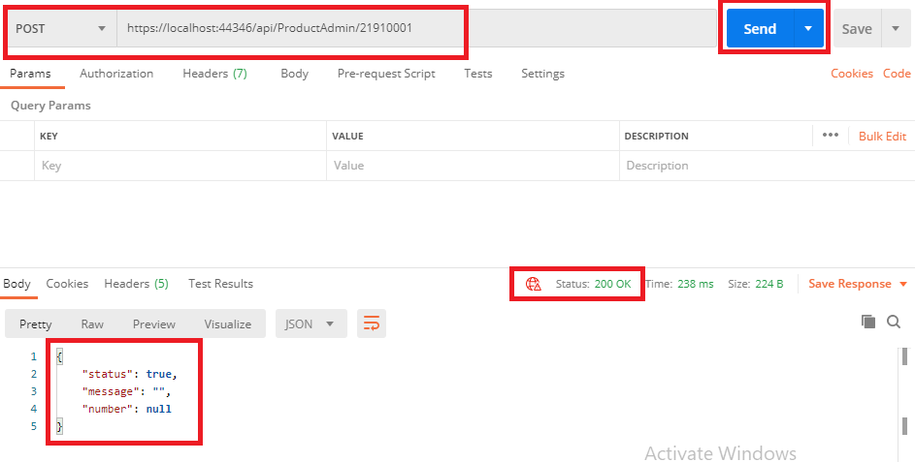

1. Display Product

