**ST LAB COMMANDS**

**1) AFL (American Fuzzy Lop)**

**STEP1 :- open AFL in terminal**

**TO get Executable file : afl-gcc -fno-stack-protector -z execstack $BENCHMARK.c -o $BENCHMARK**

**To Run file :- timeout 65 ./afl-fuzz -i ./testcase-Random/ -o ./results-afl-$BENCHMARK/ ./$BENCHMARK**

**Replace $BENCHMARK:- filename.c**

**sudo gedit /proc/sys/kernel/core_pattern**

**2)CBMC (bounded model checking)-> uses(checking exception, undefined behavior,user define exception)**

**Permission dena padegi**

**./cbmc examples/loop.c**

**3)CLANG AND INFER**

**TO run clangs**

**/home/issta21-322/TracerX/llvm/Release/bin/clang --analyze 01_w_Defects/bit_shift.c**

**/home/issta21-322/TracerX/llvm/Release/bin/clang --analyze 02_wo_Defects/bit_shift.c**

**infer :-**

**infer online Tool :-**

**https://codeboard.io/projects/11587?view=2.1-21.0-22.0**

**4)TracerX and Klee**

**./tx.sh trial1 1 (Klee)**

**./tx.sh trial1 2**

**5) Tcases :**

**export PATH=$PATH:/home/-----/bin**

**tcases -help**

**tcases filename**

**6) Jumble**

**1.Normal run**

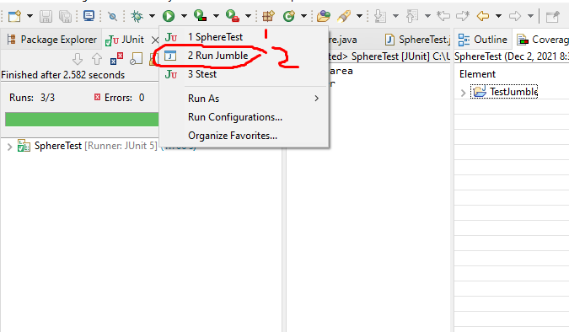

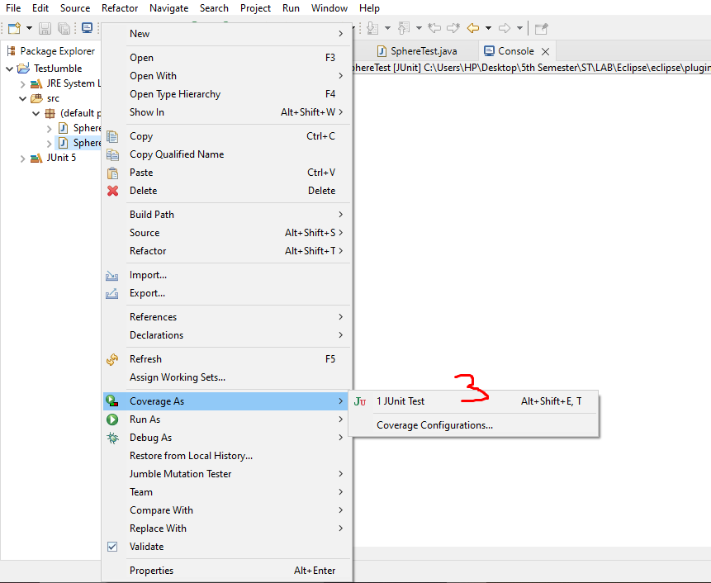

**7)Selinium WEB DRIVER**

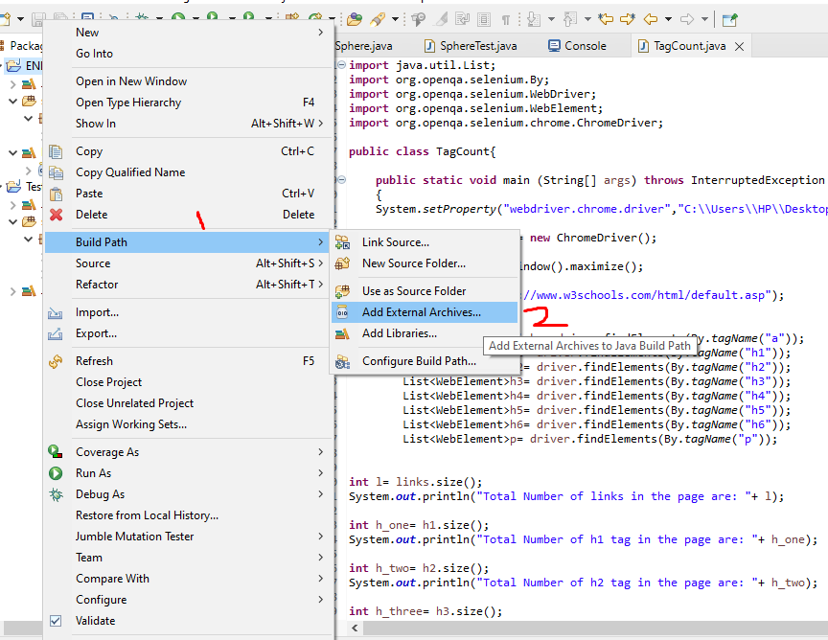

**8) JABUTI**

