**Phase 3 Results**

**Bush Model**

For Bush, I am using 3 layers for CNN2D and each is followed by a layer of Maxpooling2D, then one layer of flatten and dense layer having single output node having sigmoid activation

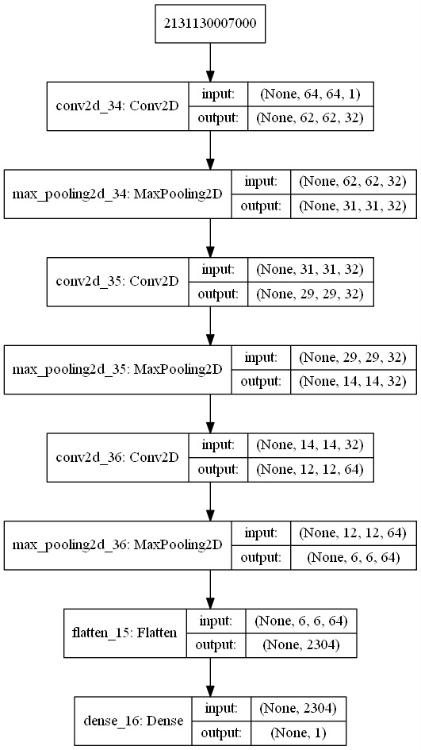

**Williams Model**

For Williams, I am using 3 layers for CNN2D and each is followed by a layer of Maxpooling2D, then one layer of dropout and the flatten and dense layer having single output node having sigmoid activation

