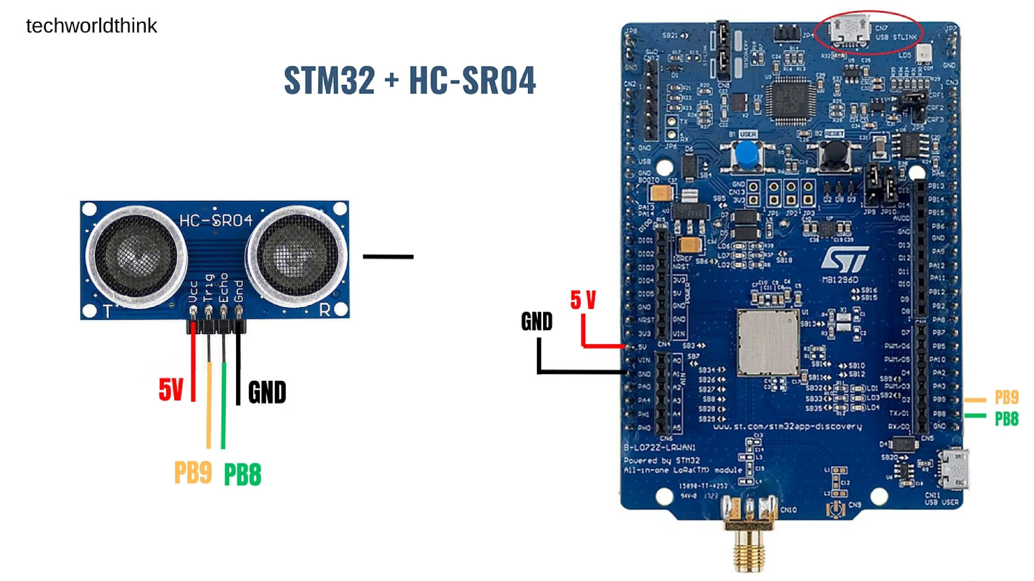
Experiment 9: Queue (Producer-Consumer)
A hands-on exploration of inter-task communication using FreeRTOS queues on STM32 microcontrollers. This
experiment demonstrates how tasks safely exchange data in a real-time embedded environment.
FREERTOS LAB
STM32
EMBEDDED SYSTEMS
Aim
This experiment is designed to build a solid understanding of how tasks communicate in a real-time operating system

environment. By the end of this lab, you will have practical experience with one of FreeRTOS's most important IPC

mechanisms.
Inter-Task Communication
Implement a reliable mechanism for two independent

FreeRTOS tasks to exchange data without direct

memory access or shared variable conflicts. The

producer task will generate sensor readings while the

consumer task processes them, both running

concurrently under the FreeRTOS scheduler.
FreeRTOS Queue Usage
Learn to create, initialise, and operate a FreeRTOS

queue as a thread-safe buffer for passing integer data

between a producer task and a consumer task. You

will configure queue depth, item size, and handle

blocking behaviour during send and receive

operations.
This experiment uses the CMSIS-RTOS2 API layer (
osMessageQueue
functions) which is portable across RTOS

implementations.
Apparatus
The following hardware and software components are required to complete this experiment. Ensure all connections are

verified before flashing the firmware to the board.
STM32 Board
STM32F4 or STM32F7 series

Nucleo/Discovery board running

FreeRTOS. The board provides

sufficient RAM and processing

capability to run multiple

concurrent tasks with a queue IPC

mechanism.
Ultrasonic Sensor
HC-SR04 module used by the

producer task to generate real-
time distance measurement data.

The sensor triggers a pulse and

measures echo return time to

calculate distance in centimetres.
STM32CubeIDE
Integrated development

environment for project

configuration, FreeRTOS

middleware setup, code writing,

and on-chip debugging. CubeMX

is used to configure the RTOS and

generate initialisation code.

Theory: FreeRTOS Queues
A
queue
in FreeRTOS is a
FIFO (First In, First Out)
data structure

that allows tasks and interrupt service routines to safely pass

messages. It is the primary inter-task communication (IPC)

mechanism provided by FreeRTOS.
Queues are
thread-safe
by design — the kernel handles all

synchronisation internally, eliminating race conditions when

multiple tasks access shared data. Each queue item is copied by

value, not by reference.
FIFO Order
Items are read in the same

order they were written.
Fixed Item Size
All items in a queue must

be the same data type and

size.
Blocking Support
Tasks can block while waiting to send or receive.
Queue Properties
Queue length (depth)
Item size in bytes
Blocking timeout (ticks)
Copy-by-value semantics
ISR-safe API variants

Concept: Producer-Consumer Model
The producer-consumer pattern is a classic concurrency design where one task generates data and another task

processes it. The queue acts as a
bounded buffer
between them, decoupling the two tasks in time and execution speed.
Consumer Task
FreeRTOS Queue
Producer Task
The diagram above illustrates the data flow: the producer pushes measurements into the queue, the queue holds them

in FIFO order, and the consumer retrieves and processes each value independently.
Producer Task
Reads the ultrasonic sensor at regular intervals and

pushes the distance value into the queue using
osMessageQueuePut()
. If the queue is full, the producer

can block or drop the sample based on the timeout

parameter.
Consumer Task
Waits on the queue using
osMessageQueueGet()
. When

data is available, it reads the value and processes it — for

example, printing to UART or triggering an alert if the

distance falls below a threshold.

Working Principle
The experiment operates as a continuous pipeline: sensor data flows from acquisition to processing through the queue.

Understanding the timing behaviour of each stage is key to tuning system performance.
01
Sensor Task Generates Data
The producer task triggers the HC-SR04 ultrasonic sensor,

measures the echo pulse width, and converts it to a

distance value in centimetres. This integer value is

prepared for queue insertion.
02
Queue Stores Values
The distance value is copied into the queue's internal

buffer. The queue maintains FIFO order and tracks the

count of available items. If the queue is full, the producer

blocks for the specified timeout.
03
Consumer Reads Values
The consumer task unblocks when data is available,

retrieves the oldest value from the queue, and processes it.

If the queue is empty, the consumer blocks until new data

arrives or the timeout expires.
04
Repeat Continuously
Both tasks run in an infinite loop under the FreeRTOS

scheduler, which switches between them based on priority

and blocking state, ensuring continuous data flow.
Implementation Details
Task Configuration
Producer Task:
Stack 128 words, Priority Low
Consumer Task:
Stack 128 words, Priority Low
Both tasks run in infinite
while(1)
loops
Scheduler starts after queue creation
Queue Configuration
Data Type:

uint32_t
(integer)
Queue Depth:
5 items (configurable)
Item Size:

sizeof(uint32_t)
Created before
osKernelStart()
Key Rule:
Always create the queue
b
e
f
o
r
e
starting the scheduler. The queue handle must be accessible to both

tasks — typically declared as a global or passed via task parameters.
In STM32CubeIDE, enable FreeRTOS middleware in the project settings, then use CubeMX to configure two tasks and a

queue object. The generated code provides handle variables that you will use in your application logic.

Code Logic
The CMSIS-RTOS2 API provides two core functions for queue operations. These functions handle all synchronisation

internally and support optional blocking timeouts.
osMessageQueuePut()
Sender (Producer)
osMessageQueuePut(

queueHandle,

&
data
,
// pointer to item

0
,
// priority

100

// timeout ticks
;
)
Returns
osOK
on success. Blocks if queue is full.
osMessageQueueGet()
Receiver (Consumer)
osMessageQueueGet(

queueHandle,

&data,
// pointer to buffer

NULL
,
// priority

100

// timeout ticks
)
;
Returns
osOK
on success. Blocks if queue is empty.
Delay Strategy
Both tasks use
osDelay(1000)
for a
1-
second interval

between operations. This creates a balanced producer-
consumer rate. Adjusting delays demonstrates queue

fill/empty behaviour.
Timeout Parameter
A timeout of
100
ticks means the task waits up to 100 ms

for the operation to complete. Use
osWaitForever
for

indefinite blocking.

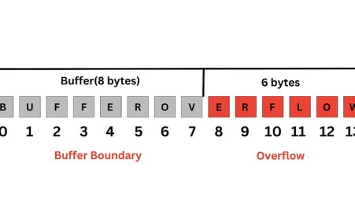
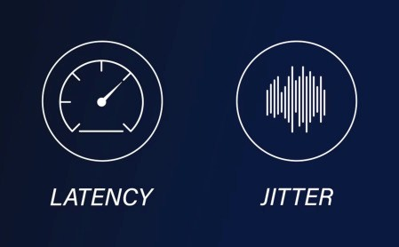
Observations
By varying task priorities and delay values, several important real-time system behaviours can be observed during this
experiment.
Producer Faster → Queue
Fills
When the producer delay is shorter
than the consumer delay, the queue
gradually fills. Once full,
osMessageQueuePut()
returns an error
or blocks, demonstrating back-
pressure.
Consumer Slower → Data
Delay
A slower consumer introduces latency
between data generation and
processing. Older readings may
become stale before they are
consumed — a critical consideration
in real-time systems.
Priority Affects Execution
Increasing the consumer's priority
ensures it runs before the producer
when both are ready, reducing queue
occupancy. Priority inversion
scenarios can also be explored.
1000
ms
Default Delay
Interval between each queue
operation in balanced mode.
5
Queue Depth
Maximum items buffered before
producer blocks.
2
Active Tasks
Producer and Consumer running
concurrently under scheduler.

Conclusion
This experiment successfully demonstrates the power and simplicity of FreeRTOS queues as a thread-safe inter-task

communication mechanism. The producer-consumer model implemented here is foundational to many real-world

embedded applications.
✅
Safe Communication
Queues eliminate race conditions

by handling all synchronisation

internally. Tasks never access

shared memory directly.
✅
Data Integrity
Copy-by-value semantics ensure

data is not corrupted by

concurrent access. Each item is

atomically transferred.
✅
Scalable Pattern
The producer-consumer model

scales to multiple producers,

multiple consumers, and can be

extended with multiple queues for

different data types.
FreeRTOS queues provide a robust, kernel-managed solution for inter-task data exchange — a fundamental building

block for any real-time embedded application.
EXPERIMENT COMPLETE
NEXT: SEMAPHORES & MUTEXES

