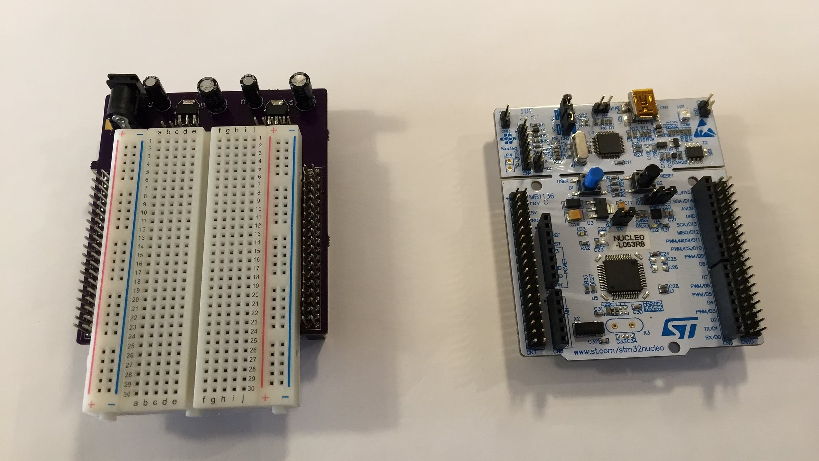
EMBEDDED SYSTEMS LAB
Experiment 7: FreeRTOS Task Priority
Explore how FreeRTOS schedules tasks on the STM32 platform using priority-based preemption. This experiment
demonstrates real-time task scheduling, LED control, and the impact of priority assignment on CPU execution.
STM32 + FREERTOS
TASK SCHEDULING
PRIORITY ANALYSIS
OBJECTIVE
Aim of the Experiment
This experiment is designed to give hands-on experience with FreeRTOS task management on the STM32

microcontroller. By the end, you will understand how the RTOS scheduler allocates CPU time based on task priorities

and observe the practical effects on hardware output.
1
Create Two FreeRTOS

Tasks
Define and register two

independent tasks within the

FreeRTOS kernel, each

responsible for controlling a

separate LED on the Nucleo

board.
2
Assign Different

Priorities
Configure each task with a

distinct priority level to observe

how the scheduler decides which

task gets CPU time when both are

ready to run.
3
Analyse LED Behaviour
Observe and record the blinking

patterns of both LEDs under equal

and unequal priority

configurations to validate

theoretical scheduling behaviour.
SETUP
Apparatus Required
Gather the following hardware and software components before beginning the experiment. Ensure all connections are

secure and the IDE is properly configured for your board.
STM32 Nucleo-F446RE
The main development board

featuring the ARM Cortex-M4F core.

This board supports FreeRTOS and

provides onboard debugging via ST-
LINK.
LEDs & Breadboard
Two LEDs with current-limiting

resistors (220
Ω
–330
Ω
connected to
)

GPIO pins for visual output. A

breadboard simplifies wiring and

testing.
STM32CubeIDE & CubeMX
ST's official IDE for project creation,

code generation, and debugging.

CubeMX handles peripheral and

FreeRTOS configuration through a

graphical interface.
THEORY
Priority-Based Scheduling in FreeRTOS
FreeRTOS implements a
preemptive, priority-based scheduler
. Each task is assigned a numeric priority — the higher

the value, the more urgently the scheduler treats that task. When a higher-priority task becomes ready to run, it

immediately preempts any lower-priority task currently executing.
High Priority Task
Executes first whenever it is in the Ready state.

Preempts lower-priority tasks without waiting for them

to yield or block.
Runs immediately on unblocking
Preempts lower-priority tasks
Gets CPU time preferentially
Low Priority Task
Executes only when no higher-priority task is ready. May

experience delayed execution or even starvation if a

high-priority task never blocks.
Runs when higher tasks are blocked
Delayed if high-priority task is ready
May starve under constant preemption

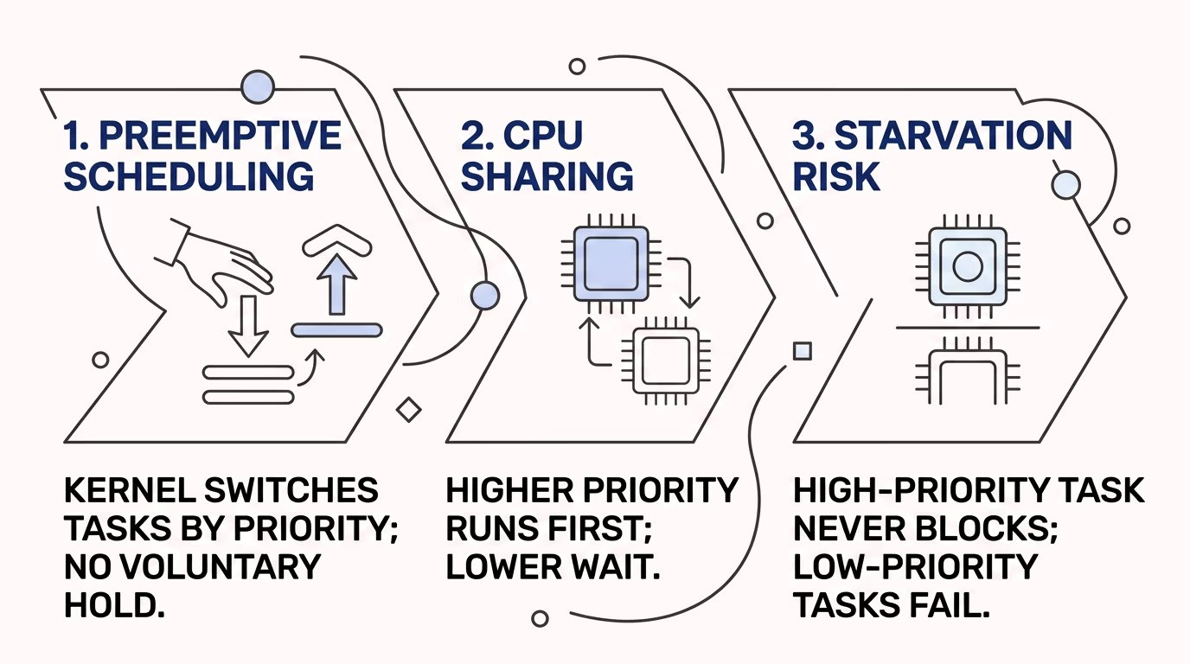
CORE CONCEPT
Preemptive Scheduling & CPU Sharing
In a preemptive RTOS, the kernel controls the CPU and decides at every moment which task should run. Priority is the
primary factor in this decision. Understanding this mechanism is essential for designing reliable real-time systems.
Key Insight:
A task only gives up the CPU when it
blocks
(e.g., via
osDelay()
)
,
yields
, or is
preempted
by a higher-
priority task becoming ready.

EXPERIMENT DESIGN
How the Experiment Works
Two FreeRTOS tasks are created —
LED_1
and
LED_2
— each toggling a separate LED with the same delay interval. The

scheduler determines which task runs based on their assigned priorities. By changing priority values, we observe

distinct behavioural patterns.
1
Task Creation
LED_1 and LED_2 tasks are defined

with separate function bodies and

registered with
osThreadNew()
.
2
Priority Assignment
Each task receives a priority value

(
e.g.,
osPriorityNormal
or
osPriorityHigh
)
during creation.
3
Scheduler Controls

Execution
FreeRTOS scheduler runs the

highest-priority ready task. Both

tasks call
osDelay(500)
to block and

yield CPU.
IMPLEMENTATION
Step-by-Step Implementation
Follow these steps in STM32CubeIDE to set up the experiment. CubeMX handles most of the configuration, letting you

focus on task logic.
01
Configure GPIO Pins
In CubeMX, set two GPIO pins (e.g., PA5 and PB10) as
GPIO_Output
for LED_1 and LED_2. Enable the

corresponding ports in the pinout view.
02
Enable FreeRTOS
Navigate to
Middleware
→
FreeRTOS
in CubeMX. Select

the CMSIS_V2 API, set heap size (e.g.,
configTOTAL_HEAP_SIZE
= 12KB), and enable the scheduler.
03
Create Two Tasks
In the FreeRTOS configuration, add two tasks:
LED_1_Task

and
LED_2_Task
. Assign stack sizes (e.g., 128 words) and

set initial priorities. Generate code.
04
Add LED Toggle Logic
In each task function, add
HAL_GPIO_TogglePin()
followed by

osDelay(500)
. Build and flash to the Nucleo board.

CODE LOGIC
Inside Each Task Function
Each task follows a simple infinite loop: toggle the LED, send a debug message via SWV, then delay for 500 ms. The delay

is critical — it blocks the task, allowing the scheduler to switch to the other task.
LED_1 Task
void
LED_1_Task
void *arg)
(
{

for (;;) {

HAL_GPIO_TogglePin
(

GPIOA, GPIO_PIN_5);

ITM_SendChar
(
'
1
');

osDelay
(
500
)
;

}
}
LED_2 Task
void
LED_2_Task
(
void *arg)
{

for (;;) {

HAL_GPIO_TogglePin
(

GPIOB, GPIO_PIN_10);

ITM_SendChar
(
'
2
');

osDelay
(
500
)
;

}
}
Both tasks use
osDelay(500)
to block for 500 ms, yielding

CPU time. The SWV output via
ITM_SendChar()
lets you

trace execution in the IDE's Live Watch.
Tip:
Use the
SWV Trace
feature in STM32CubeIDE to monitor task execution in real time without halting the

processor.

RESULTS
Observations Across Priority Configurations
Run the experiment with three different priority configurations and record the LED behaviour. The table below

summarises expected outcomes for each scenario.
Configuration
LED_1 Behaviour
LED_2 Behaviour
Equal Priority (Normal /

Normal)
Blinks regularly every 500 ms
Blinks regularly every 500 ms — both

share CPU equally
LED_1 Higher (High /

Normal)
Blinks on time, dominates CPU
Blinks slower or irregularly — gets CPU

only when LED_1 delays
LED_1 Much Higher (no

delay)
Continuous toggling, no blocking
Starved — LED_2 may never execute if

LED_1 never yields
ms
500
Delay Interval
Both tasks block for 500 ms per cycle,

allowing the scheduler to switch

context.
2
Tasks Created
LED_1 and LED_2 run concurrently

under FreeRTOS kernel management.
5
Priority Levels
FreeRTOS supports multiple priority

levels — osPriorityIdle to

osPriorityRealtime.

SUMMARY
Conclusion & Key Takeaways
This experiment demonstrates the fundamental behaviour of FreeRTOS priority-based scheduling on real hardware. The

LED observations directly reflect how the kernel allocates CPU time — a critical concept for any embedded real-time

system designer.
Priority Dictates

Execution
Higher-priority tasks always

execute before lower-priority

ones. This is deterministic and

predictable — a core RTOS

guarantee.
High Priority Dominates

CPU
A task that never blocks will starve

all lower-priority tasks. Always

ensure high-priority tasks yield or

block periodically.
RTOS Scheduling is

Visible
Physical LED output and SWV

trace make abstract scheduling

concepts tangible. Use both for

debugging and validation.
Understanding task priority and preemption is the foundation of reliable real-time embedded software. Always

design with scheduling behaviour in mind from the start.

