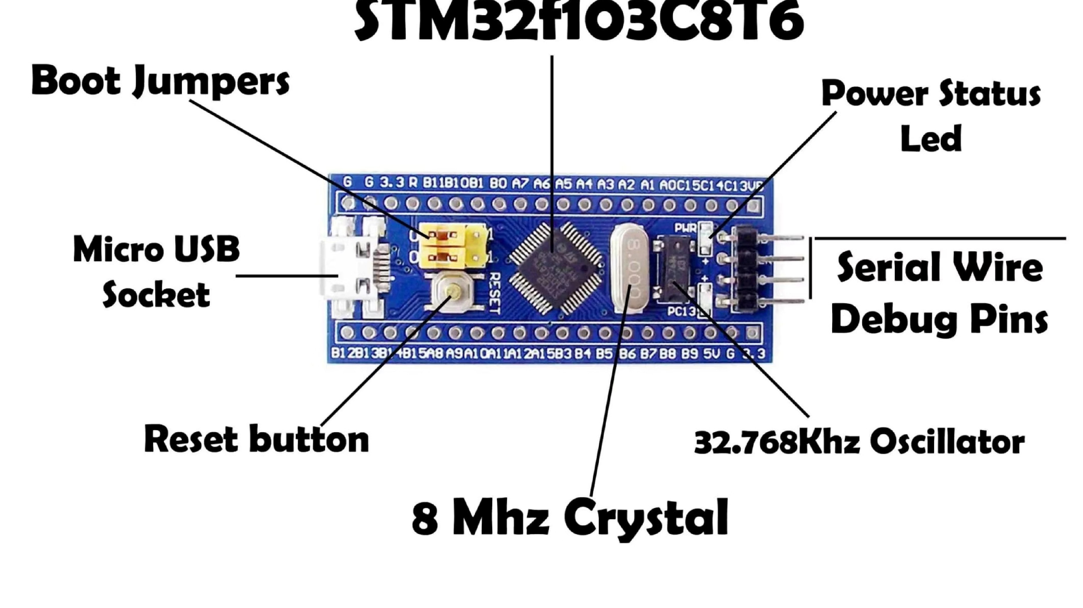
Experiment 8: EXTI + Binary Semaphore
This experiment demonstrates how to combine an External Interrupt (EXTI) with a FreeRTOS Binary Semaphore on an
STM32 microcontroller. The goal is to build an event-driven system where a hardware button press triggers an interrupt,
which in turn signals a FreeRTOS task to perform work — toggling an LED — without busy-waiting or polling.
EMBEDDED SYSTEMS LAB
STM32 + FREERTOS
Aim
This experiment has two core objectives that together illustrate a fundamental real-time embedded design pattern. By

the end, you should be able to integrate hardware interrupts with RTOS synchronization primitives in a clean, efficient

manner.
Interrupt + Semaphore Integration
Use an External Interrupt (EXTI) to trigger an ISR, and

have that ISR release a binary semaphore. A FreeRTOS

task then waits on that semaphore, demonstrating

proper ISR-to-task communication without shared

variables or polling loops.
LED Control via Button Press
Control an LED entirely through event-driven logic —

the LED toggles only when the user presses a physical

push button. The CPU remains idle (in low-power

mode, if configured) until the interrupt fires,

showcasing efficient resource usage.
Apparatus
The following hardware and software tools are required to complete this experiment. Each component plays a specific

role in the interrupt-driven, semaphore-synchronized workflow.
STM32 Board
An STM32F103 or STM32F407

development board (e.g., Blue Pill or

Nucleo). This serves as the target

MCU, providing GPIO pins for the

button input and LED output, as well

as the NVIC for interrupt handling and

the FreeRTOS port.
Push Button
A momentary tactile push button

connected to pin PC13 (typically the

onboard user button on many STM32

boards). It is configured to trigger a

falling-edge EXTI interrupt on press.
STM32CubeIDE
STMicroelectronics' official IDE based

on Eclipse. Used to configure the

MCU via STM32CubeMX, generate

initialization code, write application

logic, and flash the firmware onto the

board.
Theory
In real-time embedded systems, Interrupt Service Routines (ISRs) must execute as quickly as possible. A long-running

ISR blocks all other interrupts and can cause missed deadlines. The solution is
deferred processing
— the ISR does the

bare minimum, and a lower-priority task handles the heavy lifting.
Why ISRs Must Be Short
ISRs run with interrupts disabled or masked
Long ISRs increase interrupt latency for other

sources
Blocking calls (e.g., delays) are illegal inside ISRs
RTOS APIs that can block must NOT be called from

ISR context
Deferred Processing Pattern
The ISR signals a synchronization object (binary

semaphore). A dedicated FreeRTOS task waits on that

semaphore. When signaled, the task runs at normal

priority and performs the required work — safely using

any RTOS API.
This pattern cleanly separates
interrupt context

(
fast, minimal) from
task context
(full RTOS

capabilities).

Concept: ISR–Task Synchronization
The binary semaphore acts as a
one-bit signal
passed from the ISR to the task. It starts at count 0 (unsignaled). When

the button is pressed, the ISR increments it to 1. The waiting task unblocks immediately and consumes the semaphore,

returning the count to 0.
Task

Unblocks
Semaphore

=

1
ISR Signal
This mechanism guarantees that the task runs
e
x
a
c
t
l
y

o
n
c
e
per button press, with no missed events and no polling

overhead. The semaphore also provides inherent protection against race conditions between the ISR and the task.

Working
The end-to-end flow from a physical button press to an LED toggle involves both hardware and software layers working

in concert. Understanding each stage helps in debugging and extending the design.
1
Button Press
User presses the push button on PC13. The GPIO pin

transitions (falling edge), triggering the EXTI line.
2
Interrupt Fires
The NVIC routes the EXTI interrupt to the ISR

(
HAL_GPIO_EXTI_Callback()
)
. The ISR executes in interrupt

context.
3
Semaphore Released
Inside the ISR,
osSemaphoreRelease()
is called. The

binary semaphore count increments, unblocking the

waiting task.
4
LED Toggled
The task acquires the semaphore and toggles the LED

five times in a loop, then returns to the blocked state.

Implementation Details
Configuring the EXTI and FreeRTOS semaphore correctly in STM32CubeIDE is the foundation of this experiment. Pay

close attention to the NVIC settings and semaphore initial count.
EXTI Configuration (CubeMX)
Pin PC13 set to
GPIO_EXTI13
mode
Trigger edge:
Falling Edge
NVIC: EXTI15_10 interrupt
enabled
Preemption priority set appropriately for your

application
Semaphore Initialization
Type:
Binary Semaphore
Initial count:
0
(task starts blocked)
Max count:
1
Task Configuration
Stack size: minimum
128
words
Priority: above idle, below time-critical ISRs
Entry function: calls
osSemaphoreAcquire()
in a loop
On acquire: executes LED toggle loop (5 iterations)
The task is
initially blocked
— it consumes zero

CPU cycles until the first button press.

Code Logic
The core of this experiment lies in two FreeRTOS API calls:
osSemaphoreAcquire()
in the task and
osSemaphoreRelease()
in

the ISR. Here is how they map to the working behavior.
1
osSemaphoreAcquire() —

Wait
Called inside the task's main loop

with
osWaitForever
timeout. The

task blocks here indefinitely until

the semaphore is available. No

CPU is wasted while blocked.
2
osSemaphoreRelease() —

Trigger
Called inside
HAL_GPIO_EXTI_Callback()
(ISR

context). Uses the
FromISR
variant

if required by your FreeRTOS port.

Signals the waiting task

immediately.
3
LED Toggle Loop — 5

Times
After acquiring the semaphore,

the task toggles the LED five

times with a short delay between

each toggle, then loops back to
osSemaphoreAcquire()
and blocks

again.
// Inside Task function
for (;;) {

osSemaphoreAcquire
(
semHandle, osWaitForever);

// Semaphore acquired — button was pressed

for (int i =
0
; i <
5
; i++) {

HAL_GPIO_TogglePin
(
LED_GPIO, LED_PIN);

osDelay
(
100
)
;

}
}
// Inside ISR callback
void
HAL_GPIO_EXTI_Callback
(
uint16_t GPIO_Pin)
{

if (GPIO_Pin == GPIO_PIN_13) {

osSemaphoreRelease
(
semHandle);

}
}

Observations
When the firmware is running on the STM32 board, the following behaviors should be observed during testing and

debugging.
🔒
Task Initially Blocked
On startup, the LED remains OFF

and the task is in the
Blocked

state. A FreeRTOS-aware

debugger (or trace) will show the

task waiting on the semaphore

with zero CPU usage.
⚡
Runs Only on Button

Press
The task transitions to
Ready
→

Running
only when the button is

pressed. The LED toggles exactly

five times per press, then the task

returns to Blocked state

automatically.
📡
Event-Driven Behavior
No polling loop, no
HAL_Delay()

waiting for input. The system is

entirely
event-driven
— the CPU

can enter sleep mode between

events, maximizing power

efficiency.

Conclusion
This experiment successfully demonstrates a production-grade pattern used in real-time embedded systems:

combining hardware interrupts with RTOS synchronization to achieve efficient, responsive, and maintainable firmware.
0
CPU Waste
Task consumes zero CPU cycles while

waiting — no polling, no busy-wait

loops.
1
Signal Path
A single binary semaphore cleanly

bridges ISR context and task context.
5
LED Toggles
Each button press produces exactly 5

toggles — deterministic, repeatable

behavior.
Key Takeaways
ISR + Task separation
keeps interrupt latency low
Binary semaphore
is the correct primitive for one-
shot event signaling
Deferred processing
enables full RTOS API usage in

the task
Real-time responsiveness
is achieved without

sacrificing efficiency
Next Steps
Try using a
counting semaphore
for multiple rapid

presses
Add a
debounce delay
in the task to filter noise
Replace LED toggle with a
sensor read + UART

transmit
Experiment with
interrupt priorities
and preemption

effects

