

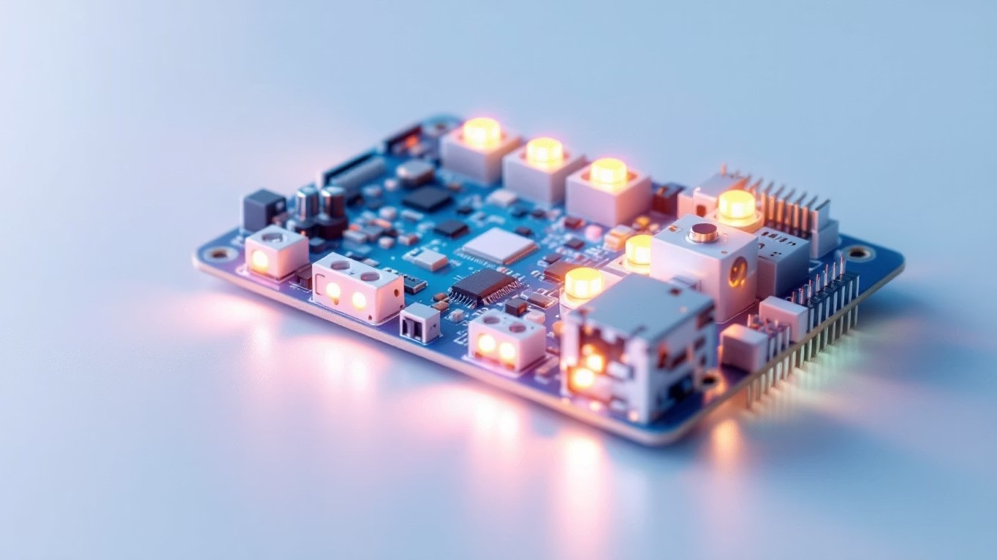
PWM Signal Generation using STM32F446RE
RTOS Lab Experiment 4



Introduction to PWM
Pulse Width Modulation (PWM) is a powerful technique used to control analog devices using digital signals. This
method allows microcontrollers to produce variable power levels without requiring complex analog circuitry, making it
ideal for embedded systems applications.
In PWM, a digital signal rapidly switches between HIGH and LOW states, effectively creating an analog-like output. The
technique is widely employed in embedded systems for controlling LED brightness, motor speed, servo positions, and
power delivery efficiently.
One of the key advantages of PWM over traditional analog control methods is its ability to reduce power loss
significantly. Since the switching device is either fully ON or fully OFF, minimal power is dissipated as heat during
operation, leading to improved efficiency and reduced component stress.


Experiment Objectives
Understand PWM Generation
Learn the fundamental concepts behind PWM signal
generation and its applications in embedded systems
Configure STM32 Timer
Set up timer peripherals in PWM mode for precise
signal generation
Control LED Brightness
Implement duty cycle variation to control LED
intensity
Observe Real-Time Output
Monitor and verify PWM output variations in real-
time


Components Used
This experiment requires the following hardware and software components:
STM32 Nucleo-F446RE
Development board featuring STM32F446RE
microcontroller with integrated debugging
USB Cable
Standard USB Type-A to Micro-B cable for power
and programming
STM32CubeIDE
Integrated development environment for writing,
building, and debugging code
STM32CubeMX
Graphical configuration tool for initializing
peripherals and generating initialization code




PWM Concept Explained
What is PWM?
PWM signal is a square wave that
alternates between HIGH and
LOW states at a fixed frequency.
The key parameter is the
duty
cycle
, which represents the
percentage of time the signal
remains in the HIGH state during
each period.
How Duty Cycle Works
The duty cycle directly controls
the average voltage delivered to
the load. By rapidly switching the
signal, the effective power can be
precisely controlled without
changing the supply voltage.
0
% Duty Cycle
LED remains completely OFF as the signal never goes HIGH
50
% Duty Cycle
LED shows medium brightness with equal ON and OFF periods
100
% Duty Cycle
LED reaches maximum brightness as the signal stays HIGH
continuously



Working Principle
The STM32 timer generates PWM signals using an internal counter that continuously increments and compares its
value with a predefined threshold.
Internal Counter
Timer counter increments
continuously at a configured
frequency
Comparison
Counter value is compared with
Capture Compare Register (CCR)
Output Generation
Output goes HIGH when counter <
CCR, LOW when counter
≥
CCR
By changing the CCR value, we can modify the duty cycle, which in turn changes the LED brightness. This comparison
happens continuously, creating a stable PWM signal.


Timer Configuration
PWM is generated using TIM2 timer peripheral on the STM32F446RE microcontroller. Proper configuration of timer
parameters is essential for stable output generation.
Prescaler (PSC)
Controls clock division by dividing
the timer clock frequency.
Determines how fast the counter
increments. Lower values
produce higher frequency PWM.
Auto Reload Register (ARR)
Defines the period of the PWM
signal by setting the maximum
counter value. Determines PWM
frequency along with prescaler.
Capture Compare Register
(
CCR
)
Controls duty cycle by setting the
comparison threshold. Changing
this value during runtime adjusts
LED brightness.
Configuration Tip:
The relationship between these parameters determines the PWM frequency and
resolution. For LED control, a frequency above 100 Hz is recommended to avoid visible flickering.



Step-by-Step Procedure
01
Open STM32CubeMX
Launch the graphical configuration tool
02
Select STM32F446RE
Choose the correct microcontroller from the device list
03
Configure PA5 as TIM2 Channel
Set pin PA5 as PWM output using TIM2 channel 1
04
Set PSC and ARR Values
Configure prescaler and auto-reload for desired frequency
05
Generate Code
Click "Generate Code" to create initialization files
06
Open in STM32CubeIDE
Import the generated project into the IDE
07
Write PWM Logic
Implement duty cycle variation in main loop
08
Build and Run
Compile code and flash to the board



Results and Observations
The LED brightness varies smoothly as the duty cycle changes, demonstrating successful PWM implementation. The
fade-in and fade-out effect is clearly visible when cycling through different duty cycle values.
Low Duty Cycle
LED appears dim or barely visible
as the signal spends most time in
OFF state. Average power
delivered is minimal.
Medium Duty Cycle
LED shows moderate brightness
with noticeable glow. Balanced
ON and OFF periods provide
intermediate intensity.
High Duty Cycle
LED reaches maximum
brightness approaching full
intensity. Signal remains HIGH
for most of the period.
Key Observation:
The transition between different brightness levels is smooth and continuous, confirming proper
PWM signal generation. This validates the relationship between duty cycle percentage and average output voltage.



Conclusion
PWM provides an efficient method for controlling analog output using digital systems. This experiment successfully
demonstrates the fundamental relationship between duty cycle and output intensity, forming a solid foundation for
advanced embedded applications.
The implementation on STM32F446RE showcases the practical application of timer peripherals for signal generation.
By understanding and mastering PWM techniques, engineers can develop sophisticated control systems for motor
speed regulation, LED lighting, power management, and automation applications.
Technical Achievement
Successful PWM signal
generation using STM32 timer
peripherals
Learning Foundation
Understanding core concepts
applicable to motor control and
automation
Practical Skills
Hands-on experience with
STM32CubeMX configuration and
real-time control
This experiment demonstrates a crucial embedded systems technique with wide-ranging applications in
modern electronics and industrial control systems.

