Java Memory Management AND Garbage collector : Stack, Heap (Young generation, Old generation), Non Heap (also called as Meta space), References (Strong, Weak, Soft), Eden & Survivor object, Heap Algos ( Mark and sweep or CMS), Version of GC’s (Serial, Parallel, CMS)
Exception Handling:
What is exception?
It's an event, that occurs during the execution Of the program.
- It will disrupt your program normal flow.
- It Creates the Exception Object, which contain information about the Error like
o Its Type of Exception and Message
o Stack trace etc.
- Runtime system use this Exception Object and find the class which can handle it
Diff between error and exception:
Errors are respected to JVM which we cant control them. like OutOfMemoryError (creating very huge array) or StackOverFlowError (infinite recursion).
Note: Errors belong to run-time.
Exception are respected to our code, we can control them.

There are 2 types of exception:
Checked Exception/Compile time exception : (Code wont get compile if we have checked exception)
Compiler verifies them during the compile time Of the code and if not handled properly, code compilation will fail.
Un-checked Exception/Run time exception : (Code with get compile, but if we run program, it will fail)
These are the exceptions which occurs during runtime and compiler not forcing us to handle them.

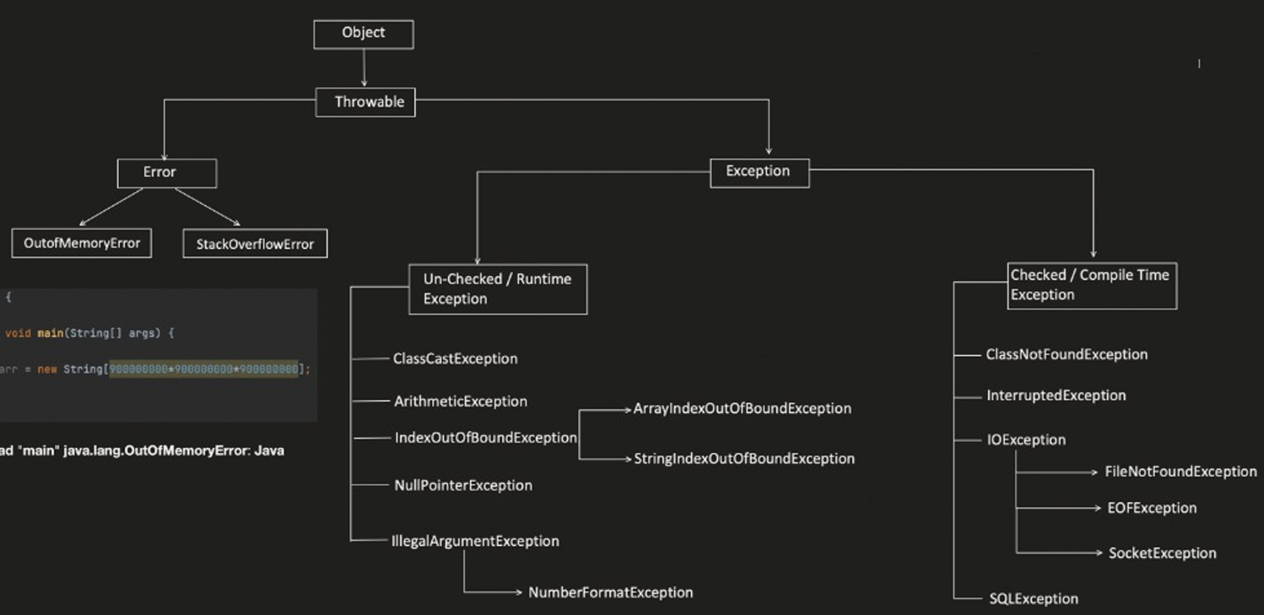

ClassCastException : when you try to cast an object to a class or interface that it does not actually fit or inherit from.
Object x = 0; // Integer object String s = (String) x; // Throws ClassCastException!
ArithmeticException: When we make some arithemetic mistake.
IndexOutOfBoundException: Happens for String or array if we try to get out of bound index value.
NullPointerException: happens when your code tries to use an object reference that is currently pointing to null (nothing).
String text = null;
int length = text.length(); // ❌ Throws NullPointerException!
IllegalArgumentException: happens when a method receives an argument that is inappropriate, invalid, or out of acceptable bounds.
Int val = Integer.parselnt( s: "abc");

Compile Time Exception handling using: try, catch, finally, throw, throws
Finally will always get executed excepts JVM related issues. Finally will be always atmost 1.

1. throws" tells hat, this method MIGHT throw this exception (or might not), so pls caller you handle it appropriately.
public static void main() throws ClassNOtFOundException{
method1();
}
public static void method1() throws ClassNotFoundException{
throw new ClassNOtFOundException();
}
2. try catch finally (normal node)
public static void main() {
try {
method1();
} catch (ClassNotFoundException expObj){
// 'handle it
}
}
public static void method1() throws ClassNOtFOundException {
throw new ClassNotFoundException();
}
OR
public static void main() {
method1();
}
public static void method1() throws ClassNOtFOundException {
try {
throw new ClassNotFoundException();
} catch (ClassNotFoundException expObj){
// 'handle it
}
}

We can write multiple catch separatly, also we can use pipe operator in catch(ClassNotFound | FileNotFound exp)
If we are using try without catch, then caller needs to handle the exception.
Custom or UserDefined Exception:
public class MyCustomException extends Exception {

MyCustomException(String message) {
super(message);
}
}

public class Main{

public static void main() {
method1();
}

public static void method1() throws MyCustomException {
try {
throw new MyCustomException ();
} catch (MyCustomException expObj){
// 'handle it
}
}
}

Generics = type-safe parameterization
Boxing = primitive → wrapper
Unboxing = wrapper → primitive
Generics : Generics allows us to write classes, interfaces, methods, and constructors to make code type-safe with a type parameter and reusable.
Generics methods, Generic class, Generic Collection,
Bounded Generics : Upper bound & Multi bound,
Wildcards : (Upper bound, lower bound, Unbound), TypeErasure.

Upper bound means class and its child can be accepted eg T extends Number, now T can have Integer, Float, Double, Bigint
Multi bound strictly follows generic types.
Wildcards :
Upper bound wildcard <? extends UpperboundClassName > i.e class name and below
lower bound wildcard <? Super LowerboundClassName > i.e class name and above
Unbound wildcard <?> i.e only you can read

Note : use normal generic for more restrictive parameter, wildcards are little flexible
TypeErasure : It will erase the generic types with real values or object during compilation

class Box<T> {
private T value;

public void set(T value) {
this.value = value;
}

public T get() {
return value;
}
}

List<String> names = new ArrayList<>(); // generic in list
public List<String> void Hello (List<String> list){} // generic in methods

Why do we need Generics?
1. Type safety, 2. No unnecessary casting 3. Reusable code

Singleton, Immutable Classes
Singleton :
The objective of this class is to create only single object.
For example :If we want to create a DBConnection, we want it to be singleton.

Different ways of creating Singleton Class:
- Eager Initialization : Create constructor in advance by making method as private and static. Static means it belong to this class only. Demerit construction creation eventhough we don’t need it.
- Lazy Initialization: Same as Eager, just a check on constructor is null. Problem 2 concurrent thread may think oh its null just create it, so 2 objects created .
- Synchronization Block : put synchronized in lazy Initialization, so solved concurrent problem. Issue here is synchronization makes it slow, like put lock and unlock, think if method is getting called from 1k places
- Double Check Lock :(there is a memory issue, resolved through Volatile instance variable) : same as Synchronization Block, but has double check for null.
Volatile Keyword means that the object will be created in memory instead of cache . So, if we've created any object using volatile, read/write operation happening to this, will always happens in memory
- Bill Pugh Solution: It uses Eager Initialization smartly. It will put construction creation inside nested method. (best)
- Enum Singleton: In Enum , all constructors are by-default private and only one object of enum is created per JVM. So by default enum are singleton (best)

Immutable Classes : An immutable class is a class whose object's state cannot be changed after the object is created.
Immutable means once an object is created, its state cannot be modified.
To make a class immutable:
- Make the class final → cannot be extended.
- Make fields private and final.
- Initialize fields through the constructor.
- Don't provide setters.
- Provide getters.
- For mutable objects, getters should return a copy rather than the original object.
Functional Interface and Lambda (or arrow) expression
Functional Interface: Any interface with only one abstract concrete method is called as functional interface. Also we can represent that interface with
@FunctionalInterface // optional if we have one method, now we cant add more than one method
public Interface Bird{
void canFly(); // public abstract automatically
void hello(); // X not allowed
}

public Interface Bird{
void canFly();
void hello(); // allowed
}

@FunctionalInterface // below method is correct as it has only one abstract method
public Interface Bird{
void canFly();
default void hello();
static void eat();
String toString(); // Object class method or already inherited to all classes
}

Lambda Expression (or arrow) : Represented by ()->
It is used to directly provide implementation for Functional interface class. Although we can implement with normal class or anonymous class. But Lambda expression reduce the complexity and boiler plate code for implantation class where Functional Interface has been called.

Types of Functional Interface : They are already inbuilt in Java
Consumer: represent function accepts 1 input parameter and produces no result. Interface Supplier <T> { void accept(T t);}
Supplier: represent function accepts no input parameter and produces a result. Interface Supplier <T> { T get();}
Function : represent function accepts only 1 argument and produces a result based on return type. Interface Function<T,R> { R appy(T);}
Predicate :represent function accepts only 1 argument and always returns Boolean. Interface Function<T> { boolean appy(T);}

Java Reflection
Reflection are used to examine the classes, methods, fields, interfaces, at run time. Also it can possibly change the behavior of class too.
JVM creates a class Class for every class, during runtime for each and every classes we have in our program.

How to do Reflection of Classes? 3 ways)
- Using forNameMethod(), 2. Using .class 3. Usign getClass() method.
Note : Reflection breaks singleton. To fix that in singleton use null condition to prevent it. Also reflection happens at run time so it makes program slow, so don’t use it until its not required.

Java Annotations
Annotations @ are Meta Data to our code. It can be applied at anywhere like classes, methods, interface, fields, parameters etc.
Types of Annotations: 1) Pre-defined 2) Custom/ User defined
Pre-defined annotation on java code:
@Depreciated: applied at method or class level,
@Override : applied on method level,
@FunctionalInterface : applied on interface,
@SupressWarning: applied on Field, Method, Parameter, Constructor, Local Variable, Type (Class or interface or enum),
@SafeVarargs: applied on method (final,static, private) or construction which has Variabe argument as parameter. (used to suppress heap pollution warning).

Annotations used over Another Annotations (META-ANNOTATIONS):
@ Target: - This meta-annotation Will restrict, where to use the annotation. Either at method or Constructor or fields etc..
@Target(ElementType.METHOD)
Public @interface Override {}

@Target(ElementType.CONSTRUCTOR, ElementType.METHOD)
Public @interface SafeVarargs {}

Element Type:
FIELD, METHOD, PARAMETER, CONSTRUCTOR, LOCAL_VARIABLE, ANNOTATION_TYPE, PACKAGE,
TYPE _ PARAMETER ( allow you to apply on generic types <T> ),
TYPE _ USE (Java 8 feature, allow you to use annotation at all places where Type you can declare (like List< @annotation String>

Streams :
A Stream in Java is a sequence of elements that allows us to process and transform data using a declarative pipeline of operations, such as filtering, mapping, sorting, and reducing.
Streams don't store data themselves; they process data from a source such as a List, Set, or array. They also don't modify the original collection unless we explicitly perform some side effect.
A Stream is not a collection. A collection stores data; a stream processes data.

Intermediate operations → build the pipeline
eg. filter(), map(), sorted(), distinct(), limit()
Terminal operations → actually produce the result
Eg. toList(), collect(), forEach(), count(), reduce(), findFirst()

Why use Streams?
They make collection processing more concise and declarative, especially when we need to combine multiple operations like filtering, transformation, sorting, and aggregation into a pipeline.

List<String> result = users.stream()
.filter(user -> user.getAge() > 18)
.map(User::getName)
.toList();

// user -> user.getName() is same as User::getName (method reference)

Method reference = directly pass an existing method.
Lambda = write additional logic/condition.

Different ways to create a stream:
1. From Collection
List<Integer> salaryList = Arrays.asList(3000, 4100, 9000, 1000, 3500);

Stream<Integer> streamFromIntegerList = salaryList.stream();

2. From Array
Integer[] salaryArray = {3000, 4100, 9000, 1000, 3500};

Stream<Integer> streamFromIntegerArray = Arrays.stream(salaryArray);

3. From Static Method
Stream<Integer> streamFromStaticMethod =
Stream.of(1000, 3500, 4000, 9000);

4. From Stream Builder
Stream.Builder<Integer> streamBuilder = Stream.builder();

streamBuilder.add(1000)
.add(9000)
.add(3500);

Stream<Integer> streamFromStreamBuilder = streamBuilder.build();

5. From Stream.iterate()
Stream<Integer> streamFromIterate =
Stream.iterate(1000, n -> n + 5000)
.limit(5);

Source | Method
Collection | collection.stream()
Array | Arrays.stream(array)
Direct values | Stream.of(...)
Builder | Stream.builder()
Generated sequence | Stream.iterate(...)

Multi threading and Concurrency :
Process : Process is an instance of program which is getting executed.
Compilation (iavac Test.java) : generates bytecode that can be executed by JVM.
Execution (java Test) : at this point, JVM starts the new Process, here Test is the class which has "public static void main(String args)” method.
Thread : Smallest sequence of instructions that are executed by CPU independently.

Multitasking is the execution of multiple independent tasks, typically managed by the operating system.
Multithreading is the execution of multiple threads within the same process, where threads share the process's resources.

Thread creation, thread lifecycle, inter thread communication
Thread can be created using extends Thread class or using implements Runnable interface.
thread lifecycle :
The official Java Thread.State has 6 states:
NEW -> RUNNABLE -> RUNNING* -> TERMINATED

And while runnable, it can temporarily enter:
WAITING, TIMED_WAITING, BLOCKED

┌── BLOCKED ───────┐
│ ↓
NEW → RUNNABLE ← WAITING │──> TERMINATED
↑ │
└ TIMED_WAITING ───┘

Thread communication:
Monitor Lock : A monitor lock is Java's built-in mechanism for ensuring that only one thread at a time can execute a synchronized section for a particular object.
A monitor lock belongs to an object, not to the synchronized keyword itself.

wait() releases the object's monitor lock and puts the current thread into the WAITING state until it is notified (notify()/notifyAll()) or interrupted.sleep() does not release lock.
sleep() pauses the current thread for a specified amount of time. It does NOT release any monitor lock the thread currently holds.
notify() wakes one thread that is waiting on the same object's monitor. The lock is NOT released immediately; the notifying thread must first leave the synchronized block/method, after which the awakened thread can compete to acquire the lock.

Thread A → owns lock → notify()
↓
Thread B is awakened
↓
Thread A still owns lock
↓
Thread A exits synchronized block
↓
Thread B can acquire lock

notifyAll() wakes all threads waiting on the same object's monitor. They don't immediately run; they must compete to reacquire the monitor after the current thread releases it.

Method | What happens to current thread | Releases monitor lock?
wait() | Waits until notified/interrupted | ✅ Yes
sleep() | Pauses for specified time | ❌ No
notify() | Wakes one waiting thread | ❌ Not immediately
notifyAll() | Wakes all waiting threads | ❌ Not immediately

Why stop, suspended and resume depreciated?
Since both stop and suspend can lead to issues like dead lock.
Stop : Terminates the thread abruptly. No lock release happen, No resource clean up happened. So may be other thread is waiting for cleanup or lock.
Suspend: Put the thread on hold(suspend) for temporary time. No lock is release too.
Resume: used to resume the suspended thread. Since suspend got depreciated, so it also got depreciated.

Thread Join : When a JOIN method [t1.join()] is invoked on a Thread object, current thread will be blocked and waits for specific thread to finish.
It is helpful when we want to coordinate between threads or to ensure we complete certain task before moving on.
public class Main {
public static void main(String args[]) {

SharedResource resource = new SharedResource();

System.out.println("Main thread started");

Thread th1 = new Thread(() -> {
System.out.println("Thread1 calling produce method");
resource.produce();
});
th1.start();

System.out.println("Main thread is finishing its work");
}}
Thread Priority : We can set custom priority on thread using setPriority( int priority ) method.
Priorities are ranging from 0 to 10. 0 mean low, 10 means high.
Note : Thread priority doesn’t guarantee to follow specific order. Its just a hint to thread schedular which to execute next
Demon Thread : Demon means something running behind the scene like async.
Demon will run till any one user thread is alive, its lifecycle get ended with main/user thread.
Common example for Demon thread are : GEC, Autosave while typing, Logging while code is running.
To create Demon thread use setDemon(true).
Thread t1 = new Thread(()-{});
T1.setDemon(true)

Locks and Concurrency in Thread
Locks do not depend on Objects (like synchronize blocks or method).
In below example 2 Locks are getting acquired by Objects. This can be prevented via using Locks

public class MonitorLock {
public synchronized void task(){
System.out.println("lock acquired by thread" + Thread.currentThread().getName());
try{ Thread.sleep(5000);}
catch (Exception e){};
System.out.println("lock release by thread" + Thread.currentThread().getName());
}
}

Usage :
MonitorLock monitorLock1 = new MonitorLock();
Thread t1 = new Thread(()->monitorLock1.task() );
MonitorLock monitorLock2 = new MonitorLock();
Thread t2 = new Thread(()->monitorLock2.task());
t1.start();
t2.start();

Output :
lock acquired by threadThread-0
lock acquired by threadThread-1
lock release by threadThread-0
lock release by threadThread-1

Locks make sure only one object will grab the lock no matter how many objects are trying to grab it. Eg Db Atomic update, pessimistic lock.
In locking we don’t depend on synchronize.
We have 4 types of custom locks : Reentrant Lock, Read-Write Lock, Semaphore Lock, Stamped Lock.
Tool | Main purpose
ReentrantLock | One thread at a time, with more control than synchronized
ReadWriteLock | Multiple readers (having Shared lock) OR one writer (having Exclusive lock)
Semaphore | Limit concurrent access to N threads
StampedLock | Read/write lock + optimistic reads

- ReentrantLock: Like synchronized, but with more control.
ReentrantLock lock = new ReentrantLock();

lock.lock();
try {
// critical section
} finally {
lock.unlock();
}

- ReadWriteLock: Many readers can read simultaneously, but writing requires exclusive access.
Reading :
ReadWriteLock lock = new ReentrantReadWriteLock();

lock.readLock().lock();
try {
// read
} finally {
lock.readLock().unlock();
}
Write :
lock.writeLock().lock();
try {
// modify
} finally {
lock.writeLock().unlock();
}
- Semaphore : Semaphore controls how many threads can access a resource at the same time.

Semaphore semaphore = new Semaphore(3); // up to 3 threads can acquire the permit simultaneously.
semaphore.acquire();

try {
// use limited resource
} finally {
semaphore.release();
}

- StampedLock: StampedLock provides read/write locking plus an optimistic read mechanism

StampedLock lock = new StampedLock();

long stamp = lock.tryOptimisticRead(); // doesn't immediately block writers like a normal read lock

int value = data;

if (!lock.validate(stamp)) { // checks whether a write happened while you were reading
stamp = lock.readLock();
try {
value = data;
} finally {
lock.unlockRead(stamp);
}
}

Concurrency can be achived by Lock based mechanism as discussed above. Other way is Lock free mechanism.
Lock free mechanism they are more faster only useful for some specific use-cases.
It can be achieved by using CAS operation (Compare and swap). Classes which use CAS are : AtomicInteger, AtomicBoolean, AtomicLong, AtomicRefrenece.
Use Lock free mechanism for READ, MODIFY, UPDATE.
CAS function has 3 parameters. CAS(Memory, Expected, New Value)

Atomiclnteger counter = new Atomiclnteger( initialValue: 0);
counter. incrementAndGet();

incrementAndGet internal working:
do{
expected : read value from memory via volatile
}
while (CAS(Memory, Expected, New Value))

Note : Atomic and volatile both are not same. Atomic is used for thread safety. Volatile has no relation with thread safety.
Volatile is used to read/write data from Memory RAM instead cache.

Thread Pool (ThreadPoolExecutor) in Javaq: (Concept is similar to Node Libuv)
Exexcutor (I), ExexcutorService(I), ThreadPoolExecutor ©, ForkJoinPool, ScheduledExecutorService(I), ScheduledThreadPoolExecutor ©

ThreadPoolExecutor poolExecutor = new ThreadPoolExecutor (
int corePoolSize,
int maximumPoolSize,
long keepAliveTime,
TimeUnit unit,
BlockingQueue<Runnable> workQueue,
ThreadFactory threadFactory,
ExecutionHandler defaultHandler )
poolExecutor.submit(()->{});

Life Cycle of ThreadPoolExecutor :
┌── Shut Down ─────┐
Running │──> TERMINATED
└───── Stop ───┘

Future, Callable & CompletableFuture :
Future : is a Interface which represent the result of async task. It allows us to check : computation is completed, get the result, take care of exception.

Future<?> future = poolExecutor.submit(()->{}); // ? wild card shows we don’t know what we are receiving from promise
Inside submit() we are calling runnable or runnable with some return type, although we can use Callable.
Callable : Callable represents a task which needs to get executed just like Runnable. The only difference is Callable has capacity to return a value where as
Runnable do not return anything.
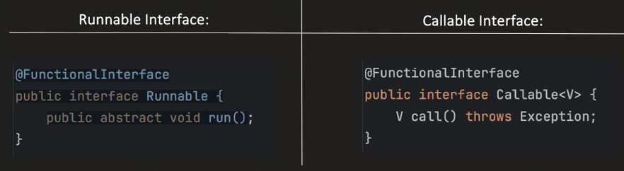

Callable example :

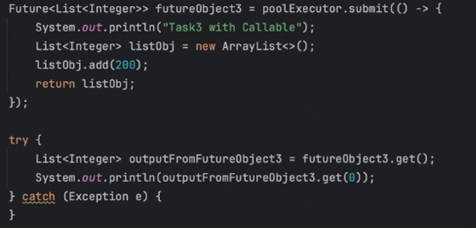

CompletableFuture: Advanced version of Future provides additional capability like chaining. It implements Future.

Future = represents a result that will be available later.
CompletableFuture = Future + asynchronous chaining/composition, similar to JavaScript Promises
Callable = a task that can return a value and throw checked exceptions.

Future<String> future = executor.submit(() -> fetchUser());
String user = future.get(); // get() blocks the current thread until the result is available.

CompletableFuture is where you get the powerful async composition:
future
.thenApply(...)
.thenCompose(...)
.thenAccept(...)
.exceptionally(...);

Executor Utility & Fork-Join Pool
Executor provides Factory methods which we can use to create ThreadPoolExecutor (instead of manual creation).
- Fixed ThreadPoolExecutor : newFixedThreadPool method will create a thread pool executor with a fixed number of threads.
Property | Fixed Thread Pool
Min & Max Pool | Same
Queue Size | Unbounded queue
Threads alive when idle | Yes
When to use | When you know approximately how many async tasks / concurrent threads are needed
Disadvantage | Not ideal for heavy workloads because concurrency is limited by the fixed number of threads

// Fixed thread pool executor
ExecutorService poolExecutor1 = Executors.newFixedThreadPool(5);

poolExecutor1.submit(() -> "this is the async task");

newFixedThreadPool(n) keeps a fixed number of worker threads, while additional tasks wait in an unbounded queue.
- Cached ThreadPoolExecutor : newCachedThreadPool method creates a thread pool that creates a new thread as Needed (dynamically).
Key point: If no idle thread is available, a cached thread pool can create a new thread instead of putting the task into a normal task queue.
Property | Cached Thread Pool
Min Pool | 0
Max Pool | Integer.MAX_VALUE
Queue Size | 0 — uses SynchronousQueue
Thread alive when idle | 60 seconds
When to use | Good for handling bursts of short-lived tasks
Disadvantage | If many long-running tasks are submitted rapidly, the pool can create a very large number of threads, increasing memory/resource usage
// Cached thread pool executor
ExecutorService poolExecutor = Executors.newCachedThreadPool();

poolExecutor.submit(() -> "this is the async task");
- Single Thread Executor: 'newSingleThreadExecutor' creates Executor with just single Worker thread.
Property | Single Thread Executor
Min Pool | 1
Max Pool | 1
Queue Size | Unbounded queue
Thread alive when idle | Yes
When to use | When tasks need to be processed sequentially
Disadvantage | No task-level concurrency because only one worker executes tasks at a time
// Single thread pool executor
ExecutorService poolExecutor = Executors.newSingleThreadExecutor();

poolExecutor.submit(() -> "Task 1");
poolExecutor.submit(() -> "Task 2");
poolExecutor.submit(() -> "Task 3");

// Execution is sequential: Task 1 → Task 2 → Task 3
Even if you submit many tasks, only one task executes at a time; the remaining tasks wait in the queue.
- WorkStealing Pool Executor:
ExecutorService pool = Executors.newWorkStealingPool(); // Using Executors
ForkJoinPool pool = ForkJoinPool.commonPool(); // directly

Don't think of Fork/Join as simply "a thread pool with two queues."
The important architecture is: One submission mechanism + one work-stealing deque per worker.

Fork/Join Pool Executor
- It creates a ForkJoinPool executor.
- The number of threads depends on the available processors, or we can specify the parallelism level explicitly.

Queues: There are two types of queues involved:
- Submission Queue — tasks submitted using submit().
- Work-Stealing Queue — each worker thread has its own deque.

How it works
- When we call submit(), the task goes into the submission queue.
- A worker thread picks up the task.
- If the task is split into subtasks using fork():
  - The worker can execute one subtask.
  - Other subtasks are placed into that worker's work-stealing deque.
- If another worker becomes free and has no work of its own, it can steal a task from another worker's deque.
Submission Queue
│
┌─────────┼─────────┐
↓ ↓ ↓
Thread A Thread B Thread C
│ │ │
Deque A Deque B Deque C
│
Subtask 1
Subtask 2

The important idea is work stealing:
An idle worker can take work from another busy worker instead of sitting idle.

When to use Fork/Join : It is particularly useful when a large computation can be recursively divided into smaller independent subtasks.
The task should extend/implement one of:
- RecursiveTask<V> — when you need to return a result
- RecursiveAction — when you don't need a return value

Shutdown:
• Initiates orderly shutdown of the ExecutorService.
• After calling 'Shutdown', Executor will not accept new task submission.
• Already Submitted tasks, will continue to execute.
AwaitTermination:
• Its an Optional functionality. Return true/false.
• It is used after calling 'Shutdown' method.
• Blocks calling thread for specific timeout period, and wait for ExecutorService shutdown.
• Return true, if ExecutorService gets shutdown withing specific timeout else false
shutdownNow:
• Best effort attempt to stop/interrupt the actively executing tasks
• Halt the processing of tasks which are waiting
• Return the list of tasks which are awaiting execution

ScheduledThreadPoolExecutor: Helps to schedule the tasks
1. schedule(Runnable command, long delay, TimeUnit unit)
Schedules a Runnable task after specific delay.
Only one time task runs.
2. schedule(Callable callable, long delay, TimeUnit unit)
Schedules a Callable task after specific delay.
Only one time task runs.
3. scheduleAtFixedRate(RunnabIe command, long initialDeIay, long period, TimeUnit unit)
Schedules a Runnable task for repeated execution with fixed rate.
We can use cancel method to stop this repeated task.
Also lets say, if threadl is taking too much time to complete the task and next task is ready to run, till previous task will not get completed, new task can not be start (it will wait in queue).
4. scheduleWithFixedDeIay(RunnabIe command, long initialDeIay, long delay, TimeUnit unit)
Schedules a Runnable task for repeated execution with a fixed delay (Means next task delay counter start only after previous one task completed)

ThreadLocal: ThreadLocal class provide access to Thread-Local variables.
• This 'Thread-Local' variable hold the value for particular thread.
• Means each Thread has its own copy of Thread-Local variable.
• We need only 1 object of ThreadLocal class and each thread can use it to set and get its own Thread-variable variable
Virtual Thread Vs Platform (normal) thread:
Virtual threads are primarily designed to increase throughput for applications with a large number of concurrent, mostly blocking tasks, rather than to reduce the execution latency of an individual task.
Virtual threads are managed by the JVM. When a virtual thread performs a blocking operation, the JVM can park/unmount the virtual thread, freeing the underlying carrier/platform thread to run another virtual thread.
Platform threads are backed by OS threads. The JVM manages the Java-level thread abstraction, but the actual execution is performed by the operating system's native threads.

Thread th1 = Thread.ofVirtual().start(RunnableTask);
Or ExecutorService exeObj = Executors.newVirtualThreadPerTaskExecutor();
exeObj.submit(RunnableTask)

Java new features:
Lombok :
Used to reduce boilerplate code.
Top 10 features:
1. val and var
val : marks local variable as final and we don’t have to define any explit type. Eg: val num = 20; num = 10 X not allowed;
var: Local variable non final. Eg: var num = 20; num = 10; allowed

2. @NonNull : generates a null check exception and throws NPE if value is null.
Can be used in method or Constructor parameter
void demo(@NotNull String name){}

3. Getter & Setter : Lombok will generate default getter and setter methods.
Can be used at class level. Field level.
We can use acees level to control getter and setter on field level Eg. AccessLevel.PRIVATE or AccessLevel.PROTECTED.
They are only applied for non-static and non-final fields only.
On class level if we have created @Getter @Setter. To control Setter at field level we can use @Setter(AccessLevel.NONE)

4. @ToString : used to generate toString() method on class level.
@ToString.Exclude used if we don’t want to include any field in our toString()
@ToString.Exclude
Boolean hello;

To skip field names from log we can use
@ToString(includeFieldName = false)
public class Hello{}

To explicitly include field names to log we can use
@ToString(onlyExplicitlyIncluded = true)
public class Hello{
@ToString.Include
boolean something;
}
5. @NoArgsConstructor, @RequiredArgsConstrutor, @AllArgsRequiresConstructor : used to generate toString() method on class level.
@NoArgsConstructor : generate no args constructor
@RequiredArgsConstrutor : generate constructor with all fields,
@AllArgsRequiresConstructor: generates constructor with only @NonNull and final fields.

6. @EqualAndHashCode:
7. @Data : Shortcut for all mentioned fields. @ToString, @EqualAndHashCode, @Getter, @Setter, @RequiredArgsConstrutor
It will create all the above mentioned functionality above

8. @Value : Its an immutable version of @Data
• All fields are made "private" and "final".
• Setters are not generated.
• Class itself made final.
• Like @Data, toString, Equal and HashCode method generated.
• @Getter on all fields
• @RequiredArgsConstructor (since all fields are final, constructor with
all fields will get generated, so its equivalent to @AllArgsConstructor)

9. @Builder : Create builder object. Same what we have learn in LLD
User object = User.builder().age(20).name(“xyz”).build(); // use case

10. @Cleanup : Any resource which we want to close after the current scope is finished use Cleanup

SequencedCollection, SequencedSet, SequencedMap :
These are new interfaces added in collection hirerachy.
What's the criteria of putting these interfaces at this specific place? Like I can see it left out Queue
and PriorityQueue, why? Why not include those also?

Any Collection which follows below conditions, can be termed as Sequenced

• Collection should follow Predictable Iteration :
Means elements are returned in consistent and well defined order every time we iterate over the collection.
So if a collection maintains elements in: Insertion order, or Sorted order (e.g., ascending or descending)
Then we can say, it follows Predictable iteration.
• Collection provide support for Access or Manipulate the First and Last element
• Collection supports Reversible View
Method supported : addFirst, addLast, removeFirst, removeLast, getFirst, getLast, array.reversed();

Sealed Classes and Sealed Interfaces: Extra control over inheritance by providing some keyword. I didn’t found anything useful as of now.
Switch Expressions:
1. commas separated case grouping
2. Fall through by default:
New form of Switch Label i.e. "case L -> " , tells that only the code to the right of the label need to be executed, if the label is matched. No need of add "break" for each case now.
Switch can be used as an statement or expression. Expression means getting something as a return value. int num = switch(par){ case Day -> 1}
Note : when we use Switch as an expression , compiler will force us to cover all the cases or throw exception

Pattern Matching for instanceof Operator:
Previous version :
Object obj = “hello world”

If( obj instanceof String){
String str = (String) obj; // manual type casting
Println(str)
}

New version :
Object obj = “hello world”

if( obj instanceof String str){// compiler take care of type casting
Println(str)
}

// works with && comarator as well, but wont work with OR oerator
Object obj = 6;

if( obj instanceof Integer i && i < 10 ){// compiler take care of type casting
Println(i)
}

// works with inheritance as well
Object obj = new TwoWheeler;

if( obj instanceof Vehicle vehicle ){// compiler take care of type casting
vehicle.drive();
}

pattern matching for switch using instanceof : Note it is very slow compare to traditional switch
Object obj = "hello world";

switch (obj) {
case String s:
System.out.println("String: " + s);
break;

case Integer i:
System.out.println("Integer: " + i);
break;

default:
System.out.println("Other type");
}

Record Class:
To write a basic immutable POJO class we have to write a lot of boilerplate code. That is fixed by Record class.
Note: Record keyword is equivalent to final class.
record internally extends java.lang.Record.class that is why record extend another class is not possible, but implementing interface is allowed
Access specifier rules are same for record class.
The parameter in record class are called as record components which are by-default private final.
Syntax: record RecordName(Type field, Type field, …..){}

record User(String name, int age){ // declare
String last; // X non-static not allowed, as record classes are known for Transparent data carrier
static String last; // static allowed,
}

User user = new User(“vikas”, 7); // invoke

Now will be thinking Lombok will be doing the same thing?
Lombok is a external library, where as record class is a feature of java. Other than that record class wont allow setter method.

Text Blocks: It is a solution for multiline string, example sql query or json data. Text blocks make multi line reading/ writing string simpler and easier.
It start with 3 double quotes. i.e “”” something “””
It is a sugarcoating over traditional multiliner string. .class will generate the same older version during compilation.
All the methods of string are applied on text blocks as well.
To preserve space use /s, to preserve continuation of line use /
String str = “””
This is multi line text.
Easy to read & write
“””

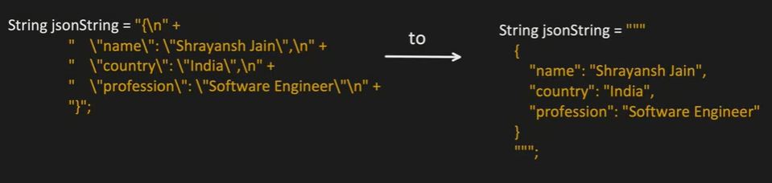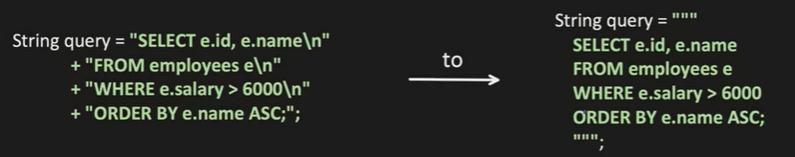

Optional in Java: Look to notes
"Java Optional is a container object introduced in Java 8 to explicitly represent the presence or absence of a value in a method's return type. Its primary goal is to provide a clear, compile-time contract to the client that a value might be missing, forcing them to handle that case explicitly instead of relying on runtime null checks”
- It's for Return Types Only: Explain that Optional should almost exclusively be used as a method return type. It should not be used for class fields (as it is not Serializable) or as method parameters (which complicates the calling code).
- Fluent API (Anti-if checks): Mention that it allows for a cleaner, functional programming style using methods like .map(), .filter(), and .orElse() instead of writing classic if-else blocks.
- Performance Consideration: Acknowledge that Optional is an object wrapper. Overusing it in high-throughput, low-latency loops can add unnecessary memory overhead.

File handling : Traditional and NIO
Traditional:
File file = new File(“./Sample.text) // this does not open, read or write the file
It just represent the file system path and provides helper methods to interact with that path via the OS.
Path helper : file.getName(); file.getAbsolutePath();
MetaData helper : file.exists(); file.lastModified(); file.isDirectory();
File Operation helper : file.createNewFile(); file.delete(); file.mkdir();

Input/Output Streams: It makes OS to call or do crud on file. Streams act as a bridge to OS to manage file. Read, Write are one directional flow.
InputStream are abstract class for reading files, OutputStream are abstract class for writing files.
At lowest level no matter we are reading or writing any file, image, txt, every things happens in byte only.

FileInputStream fis = new FileInputStream(“sample.txt) // to read file, it will make os call everytime
FileOutputStream fis = new FileOutputStream (“sample.txt) // to write file, it will make os call everytime

BufferedInputStream fis = new BufferedInputStream( new FileInputStream(“sample.txt)) // to read file, it will make os call based on buffer chunks default 8192 byte
BufferedOputStream fis = new BufferedOputStream ( new FileOutputStream (“sample.txt)) // to write file, it will make os call based on buffer chunks
When we are working with primitives data, we can use DataOutputStream / DataInputStream. They will be having encoding / decoding logic.
DataInputStream/ DataOutputStream:
DataOuputStream let us write the primitives field by field, but what if we want to write or read whole object which have 10 fileds? We have to write each field manullay and then read it back in same order. This problem is solves by serialization which is often known as DataInputStream/ DataOutputStream.

Interview questions:
1. Equals & hascode
equals() answers: "Are these two objects logically equal?"
hashCode() answers: "Which hash bucket should this object belong to?"

If a.equals(b) is true, then a.hashCode() MUST equal b.hashCode().
2.
HashMap → fast but unsafe
Hashtable → safe but coarse-grained locking
ConcurrentHashMap → safe + designed for high concurrency

