React Mini Project

Build an iPod using React.js. The following are the instructions:

- Build a menu of options like you see such as Settings, Games, Music etc
- On clicking of the centre button go inside the menu
- Clicking on the menu should hide the menu and open a screen of that particular option, like settings, games etc
- Click and hold on the circular menu and move the mouse in a circular fashion inside the menu boundary (white circle is the menu) to navigate in the iPod menu
- Clicking on “Menu” should take you back to the main menu
- (Optionally) can create sub menu inside menu like in Music option, it has sub menu with options “All songs”, “Artists” etc

Try to build it yourself first, if anyone is having any difficulty please view the hints document.
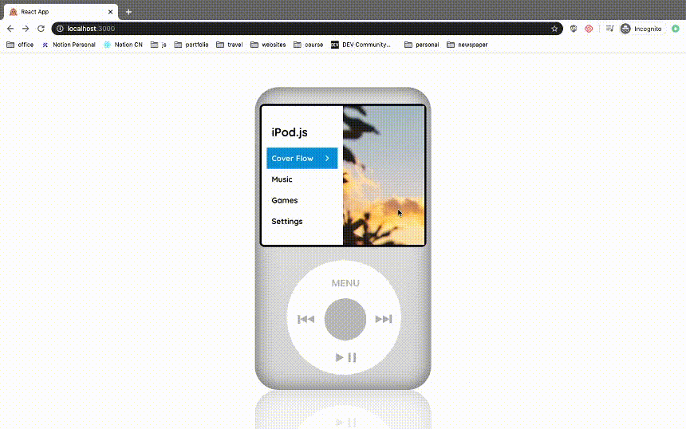

Final project video - Link
Hints link - Link
Your project will be evaluated on following parameters -
- Innovation (Max Score 10)
- Comments (Max Score 10)
- Basic Functionality (Max Score 20)
- Code Quality - Setting up proper directory structure and neat code (Max Score 10)

I have followed all the parameters as written in the project guideline (Innovation, Comments, Basic Functionality, Code Quality), and my project has been running well. Even then a fair evaluation has not been done by TA. The reason assigned, for which I have been evaluated improperly, has already been fulfilled by me in the project itself.If I would have not applied all four states (In each context.setState) then, of course, it would have not been functioning."INNOVATION " section has also been marked improperly.As I have been marked negatively for making a parent folder, so I would like to mention that whenever a zip file is created, the parent folder gets created on its own.I have also attached a GitHub link and video of my project
https://github.com/sbm04/ipod_js

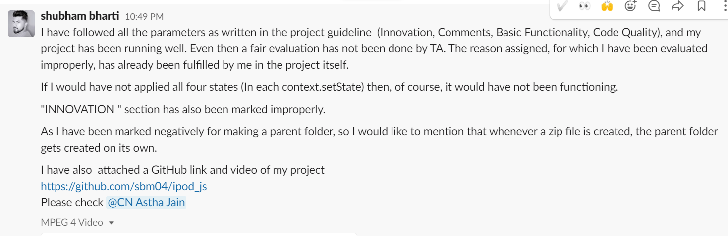

Try making a great UI, add some extra features, like theme, actual music
Make zingTouch movement smooth
If you follow this make it nicely, you can easily fetch at least 90% marks
Make a seperate folder for styles, components
Try putting your own innovation, think of this sample as a base.
You can also add the ping pong game you created in frontend course
This would really give a great impression.

