**NAME:**

Simran Jena

**REG NO:**

21

BEC

1215

**DATE:**

12/04/2024

**EXPERIMENT**

**-**

**10**

**PROGRAMS ON EXTERNAL INTERRUPT (HARDWARE)**

**AIM**

**:**

To execute the following

programs

on external

interrupt

by using 8051 tool

-

kit and

Keil software.

**TOOLS USED**

**:**

•

8051

tool

-

kit

•

Keil software

**TASK**

**-**

**1**

A switch is connected to pin P3.2. When the switch is pressed, the corresponding line

goes low Display 0A at port 0. Write a C program to blink alternate LEDS connected

to Port 1 Simultaneously.

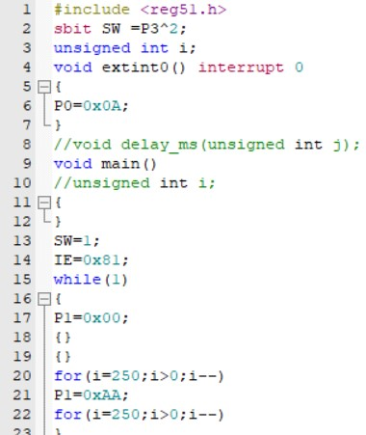

**TASK**

**-**

**2**

A switch is

connected to pin P3.3. When the switch is pressed, the corresponding line

goes low Display 0A at port 0. Write a C program to blink alternate LEDS connected

to Port 2 Simultaneously.

**RESULT**

**:**

The given programs on external interrupts have been executed

and the

outputs

have been verified

.

**OUTPUT VERIFICATION**

**:**

