**NAME:** Simran Jena **REG NO:** 21BEC1215

**DATE:** 12/04/2024

**EXPERIMENT-10**

**PROGRAMS ON LCD (HARDWARE)**

**AIM:** To execute the following programs on LCD by using 8051 tool-kit and Keil software.

**TOOLS USED:**

* 8051 tool-kit
* LCD display
* Keil software **TASK-1:**

Program to display "SENSE" in the first row of the LCD all characters at once (8BIT MODE).

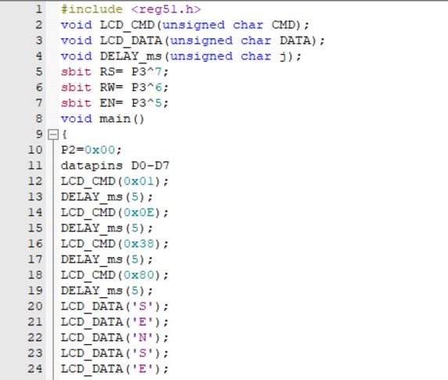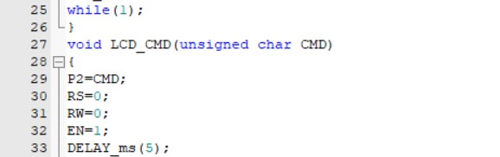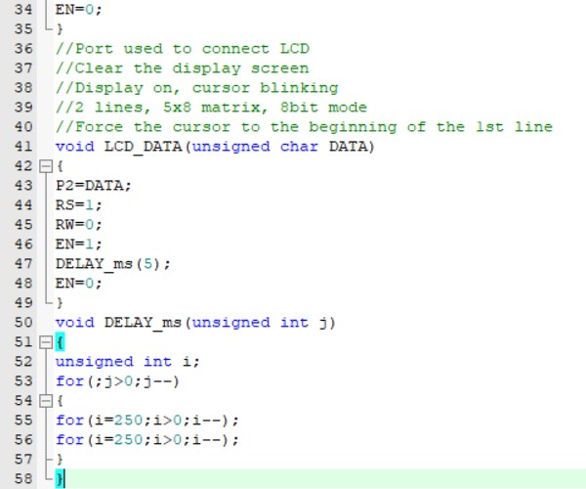

**TASK-2:**

Program to display "Welcome To VIT" in the first row and "SENSE" in 2nd row of the LCD, all characters at once (8-BIT MODE)

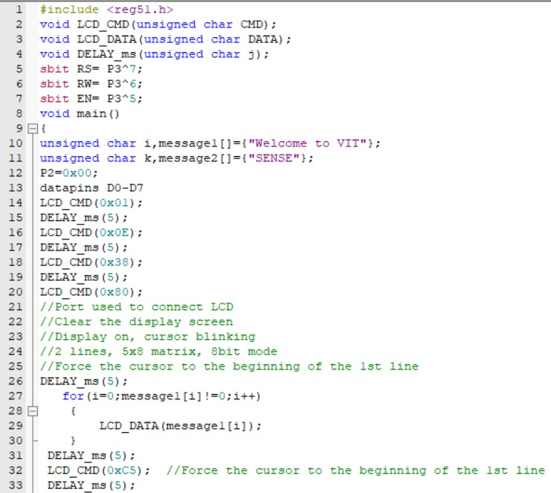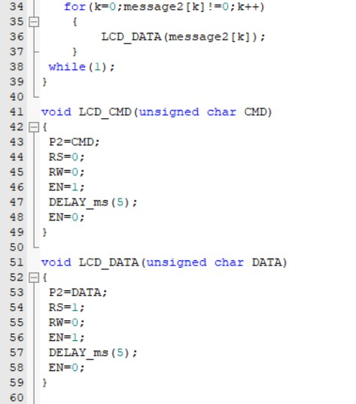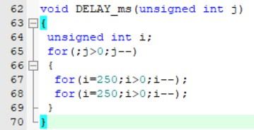

**RESULT:** The given programs on LCD have been executed using 8051 tool-kit and the outputs have been verified.

**OUTPUT VERIFICATION:**