**NAME : Simran Jena** **REG NO:** 21BEC1215

**EXPERIMENT-9**

**INTERRUPT**

**AIM:** To execute the given programs on interrupts (8051).

**SOFTWARE USED:** Keil uvision **TASK-1**:

Use 16-bit timer in mode 1:

Assume that XTAL = 11.0592 MHz, write a C program continuously gets a single bit of data from PI. 7 and sends it to P1.0, Simultaneously generate a square wave of 2 kHz frequency on pin P1.5. Crystal frequency is 11.0592MHz.

**Steps involved:**

1. T = 1 / f = 1 / 2 kHz = 500 us the period of square wave.
2. 1 / 2 of it for the high and low portion of the pulse is 250 us.
3. 250 us / 1.085 us = 230 and 65536 – 230 = 65306 which in hex FF1AH.
4. TL = 1A and TH = FF, all in hex.

**CODE:**

#include <reg51.h> sbit SW =P1^7; sbit IND =P1^0; sbit WAVE =P1^5; void timer0(void) interrupt 1

{

WAVE=~WAVE; //toggle pin

}

void main()

{

SW=1; //make switch input

TMOD=0x01;

TL0=0xFF;

TH0=0x1A; //for delay

IE=0x82; //enable interrupt for timer 0

TR0=1;

while (1)

{

IND=SW; //send switch to LED

}

}

**OUTPUT:**

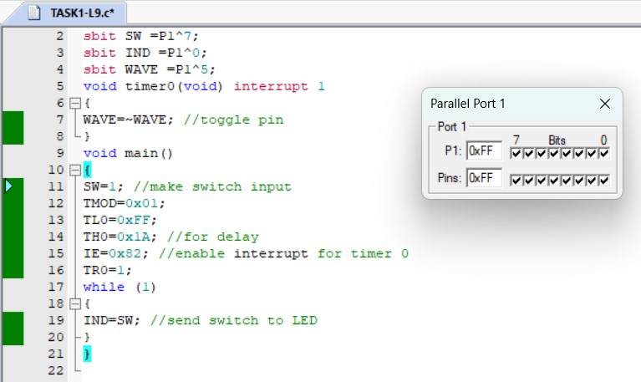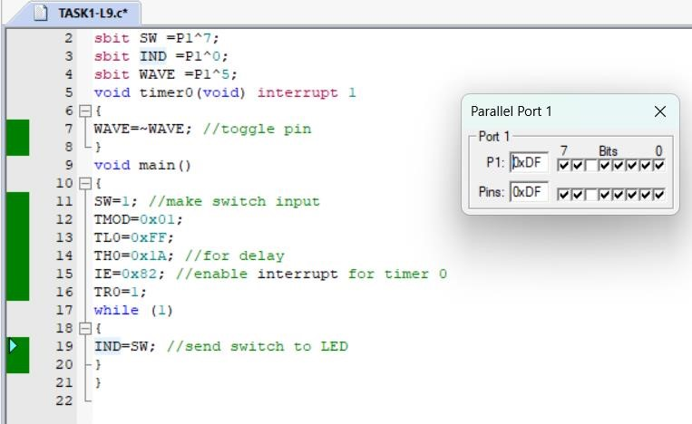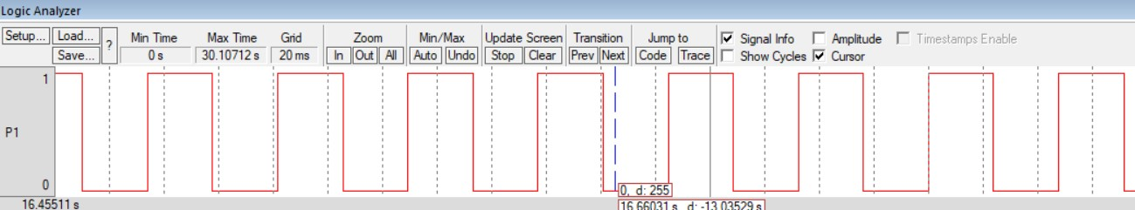

**TASK-2:**

(Use 8-bit auto-reload)

Write a C program that continuously gets a single bit of data from PI. 7 and sends it to P1.0, while simultaneously creating a square wave of 200us (as period) on pin

P1.5. Use timer 0 in mode 2 to create the square wave. Assume that XTAL = 11.0592 MHz.

**CODE:**

#include <reg51.h> sbit SW =P1^7; sbit IND =P1^0; sbit WAVE =P1^5; void timer0(void) interrupt 1

{

WAVE=~WAVE; //toggle pin

}

void main()

{

SW=1; //make switch input

TMOD=0x02;

TH0=0xA4; //TH0=-92

IE=0x82; //enable interrupt for timer 0

TR0=1; while (1)

{

IND=SW; //send switch to LED

}

}

OUTPUT:

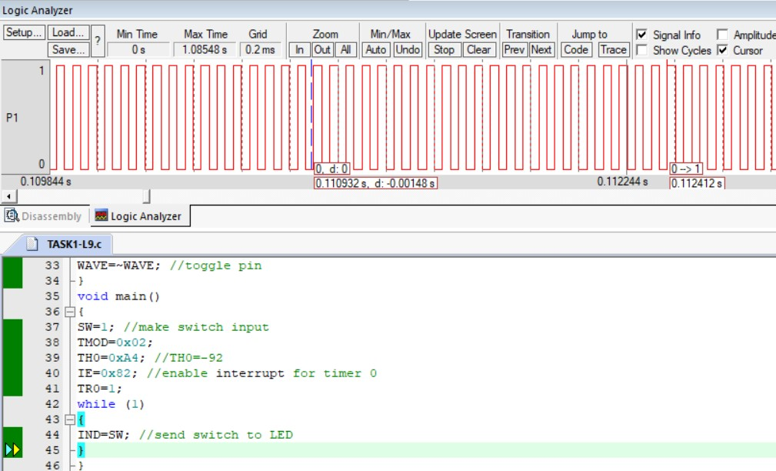

**TASK-3**

A switch is connected to pin P3.2. When switch is pressed the corresponding line goes low Display 0A at port0. Write a C program to blink alternate LEDS connected to Port 1 Simultaneously.

**CODE:**

#include <reg51.h> sbit SW =P3^2; unsigned int i;

void extint0() interrupt 0

{

P0=0x0A;

}

//void delay_ms(unsigned int j); void main()

//unsigned int i;

{

SW=1; IE=0x81;

while(1)

{

P1=0x00; for(i=250;i>0;i--) {}

{}

}

P1=0xAA;

for(i=250;i>0;i--)

}

OUTPUT:

**TASK-4**

(Use timer 0 interrupt and external interrupt1)

Write a C program using interrupts to do the following:

1. Generate a 10 KHz frequency on P2.1 using T0 8-bit auto-reload
2. Assume that the clock pulse is connected to external interrupt1 EX1. Count the pulses and display it on P0. Assume that XTAL = 11.0592 MHz. Set the baud rate at 9600.

**CODE:**

#include <reg51.h> sbit WAVE =P2^1; unsigned char cnt; void timer0() interrupt 1

{

WAVE=~WAVE; //toggle pin

}

//void timer1() interrupt 3

void extint1() interrupt 2

{

cnt++; //increment counter P0=cnt; //display value on pins

}

void main()

{

cnt=0; //set counter to 0

TMOD=0x02;

TH0=0x46; //10 KHz

IE=0x86; //enable interrupts TR0=1; //start timer 0

while (1); //wait until interrupted }

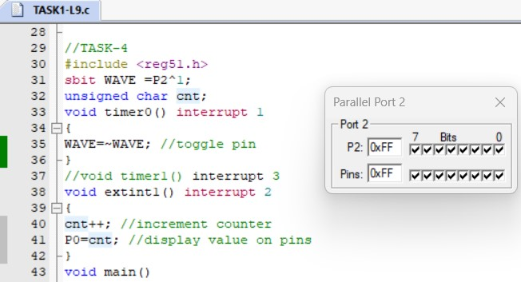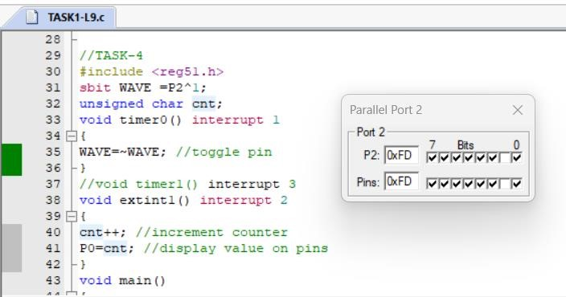

**RESULT:** Programs on interrupts (8051) have been executed.