Supplementary Figures S1-S7 (preview, not for submission)
Supplementary Figure S1. Discovery object provenance and AUcell-matched input overview. Sample composition of the GSE268807 astrocyte pilot object, QC/downsampling tracking, the final sample-by-group cell matrix, and construction of the AUCell-matched analysis object.
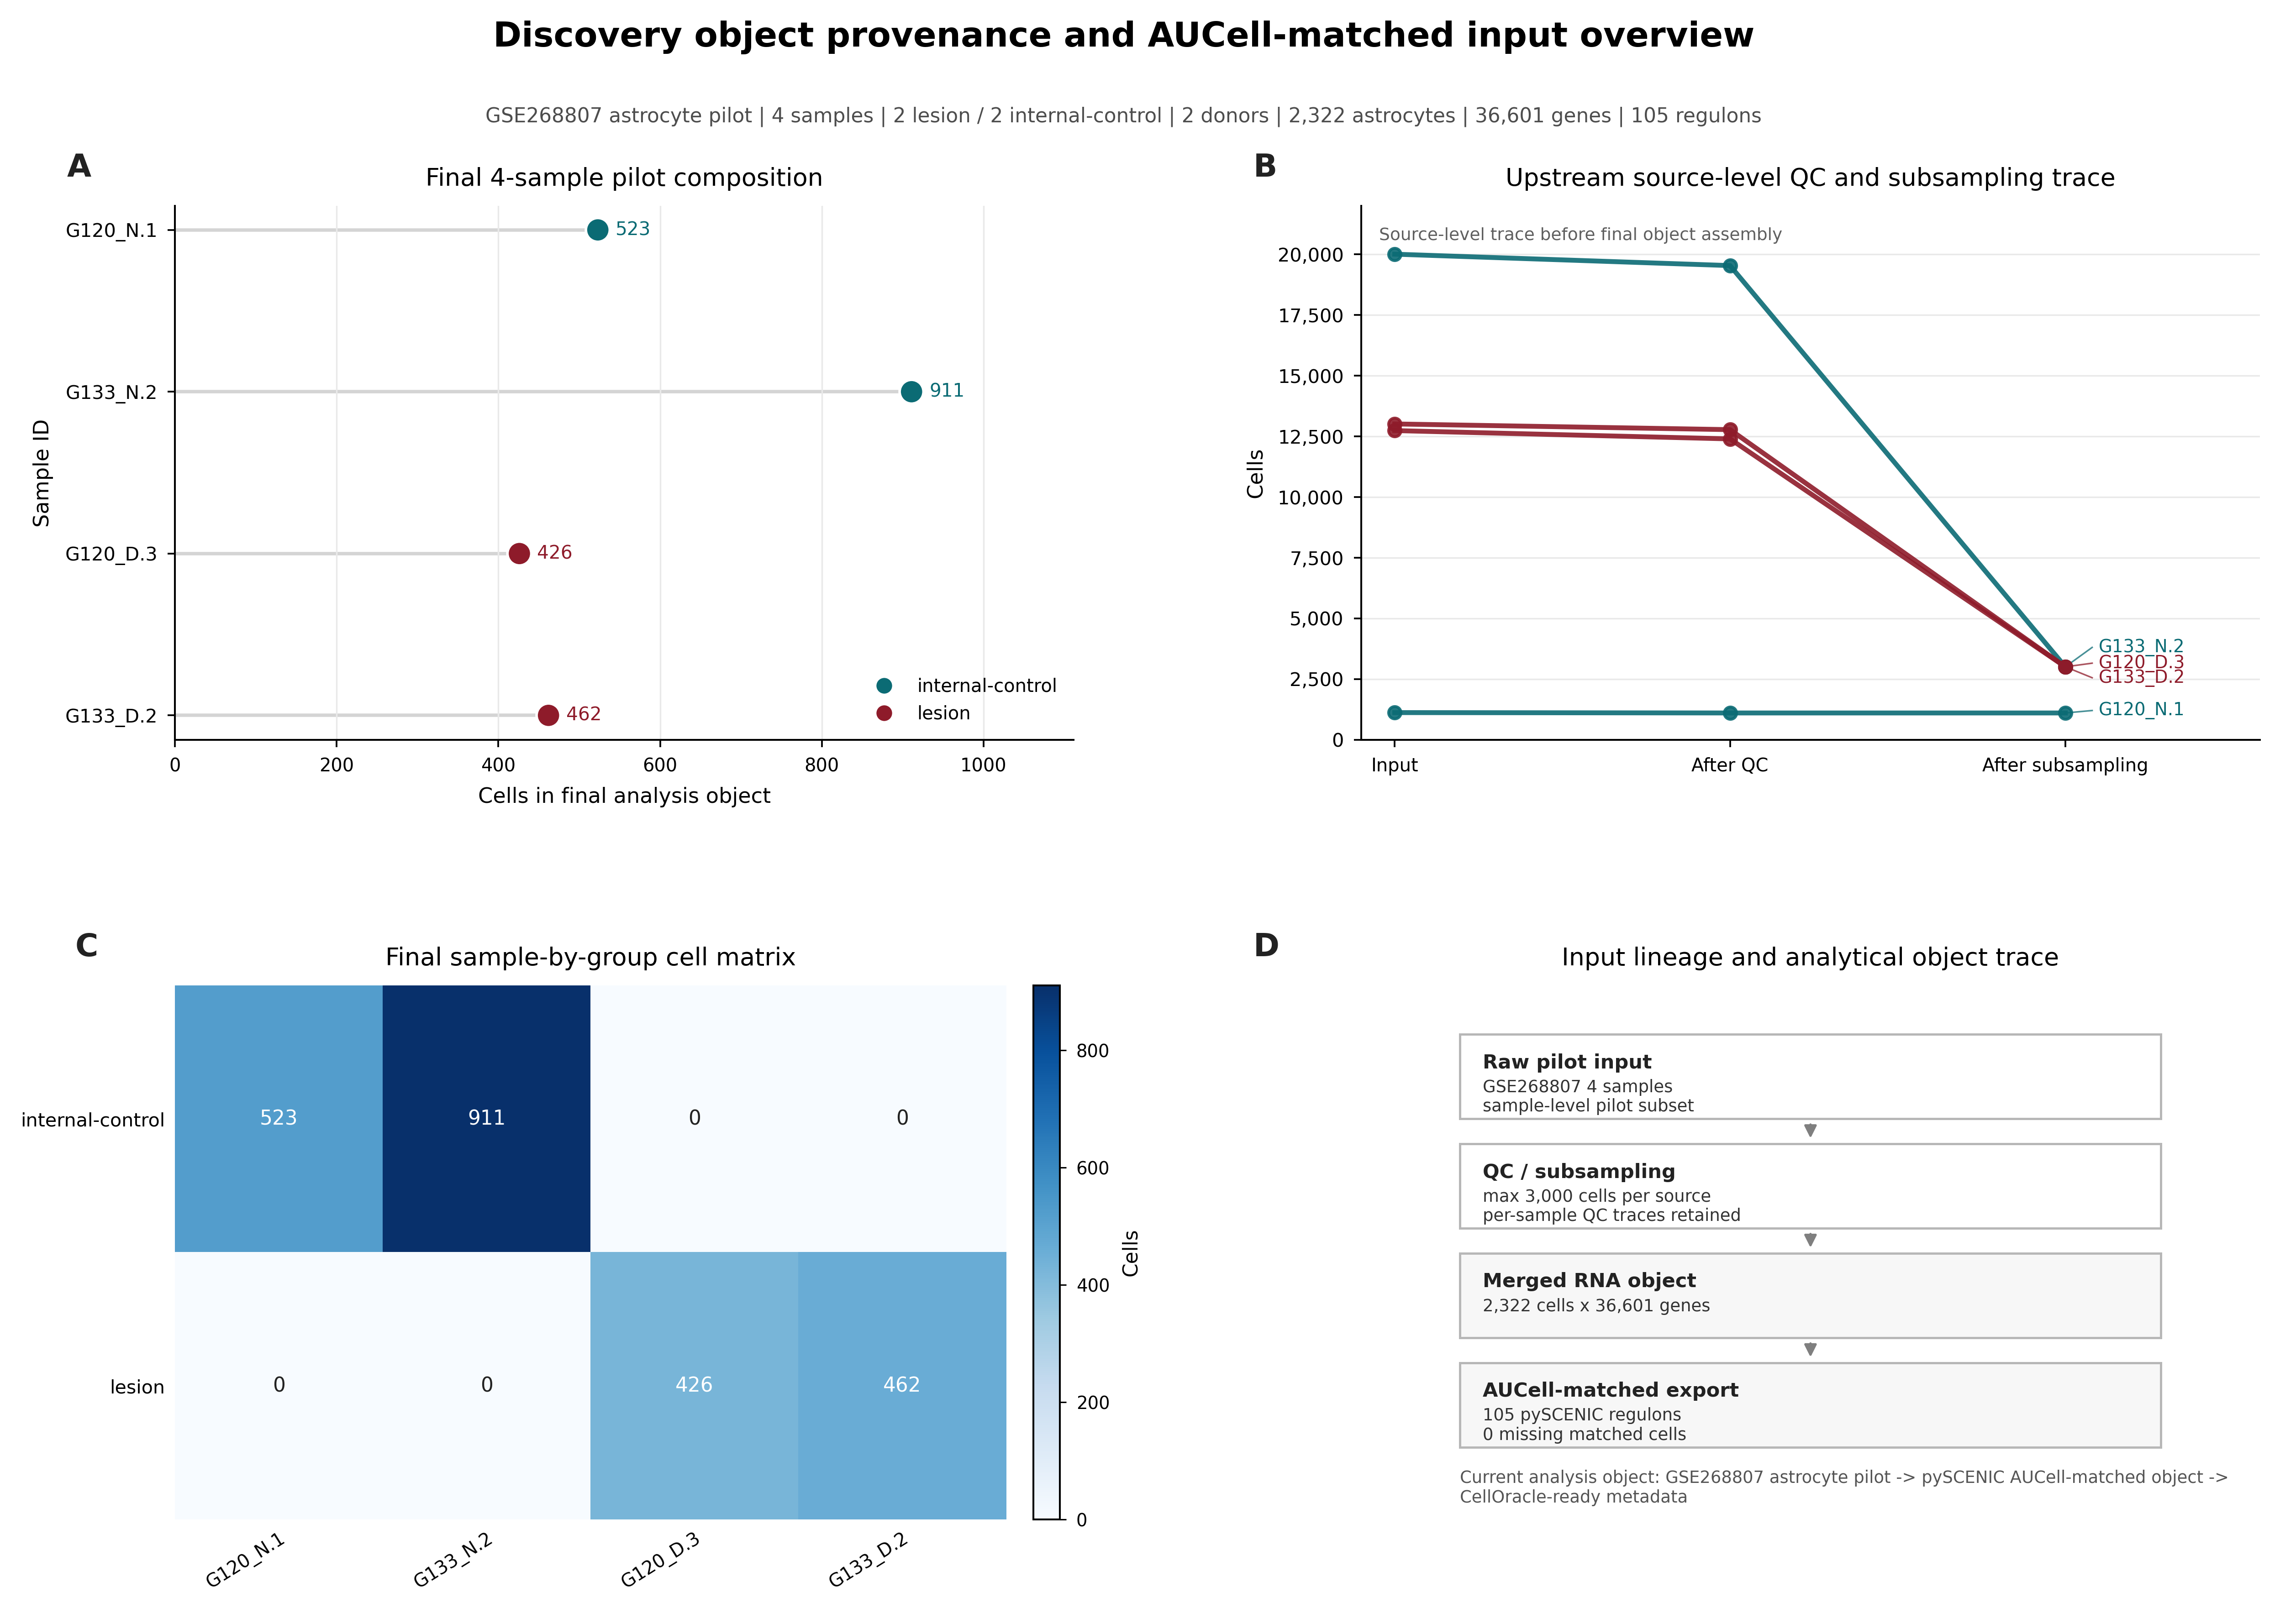

Supplementary Figure S2. Full differential regulon landscape in the GSE268807 astrocyte pilot. Complete differential regulon landscape, all-regulon differential summary, and ranked internal-control-associated and lesion-associated regulons, complementing main Figure 2.
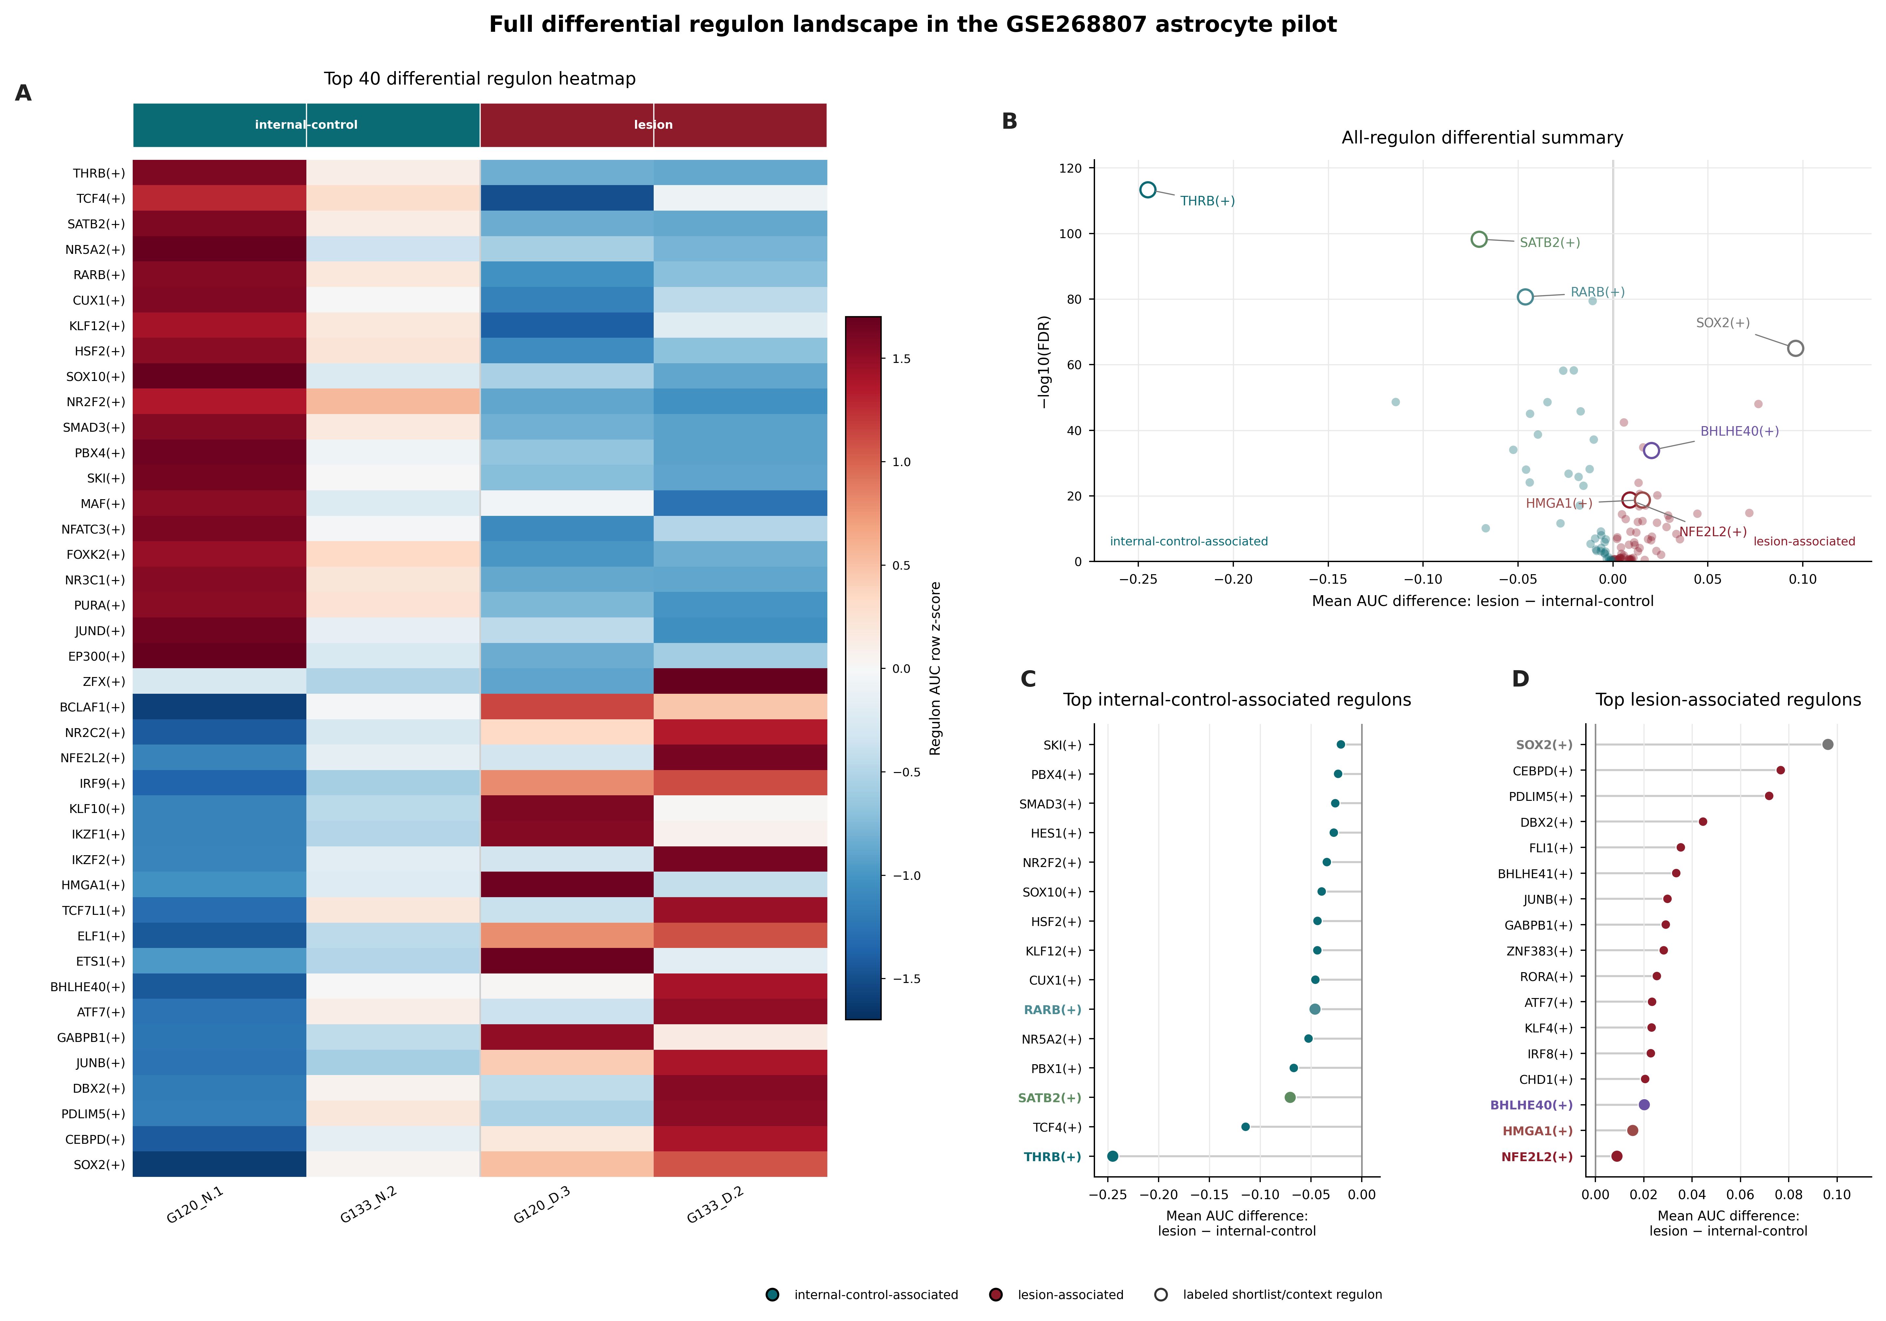

Supplementary Figure S3. Complete CellOracle in silico perturbation metrics and randomized-control assessment. Full CellOracle in silico perturbation metrics for candidate transcription factors, representative simulated perturbation fields, and randomized-control assessment. These results represent computational simulation only and do not constitute experimental knockout or disease-reversal evidence.
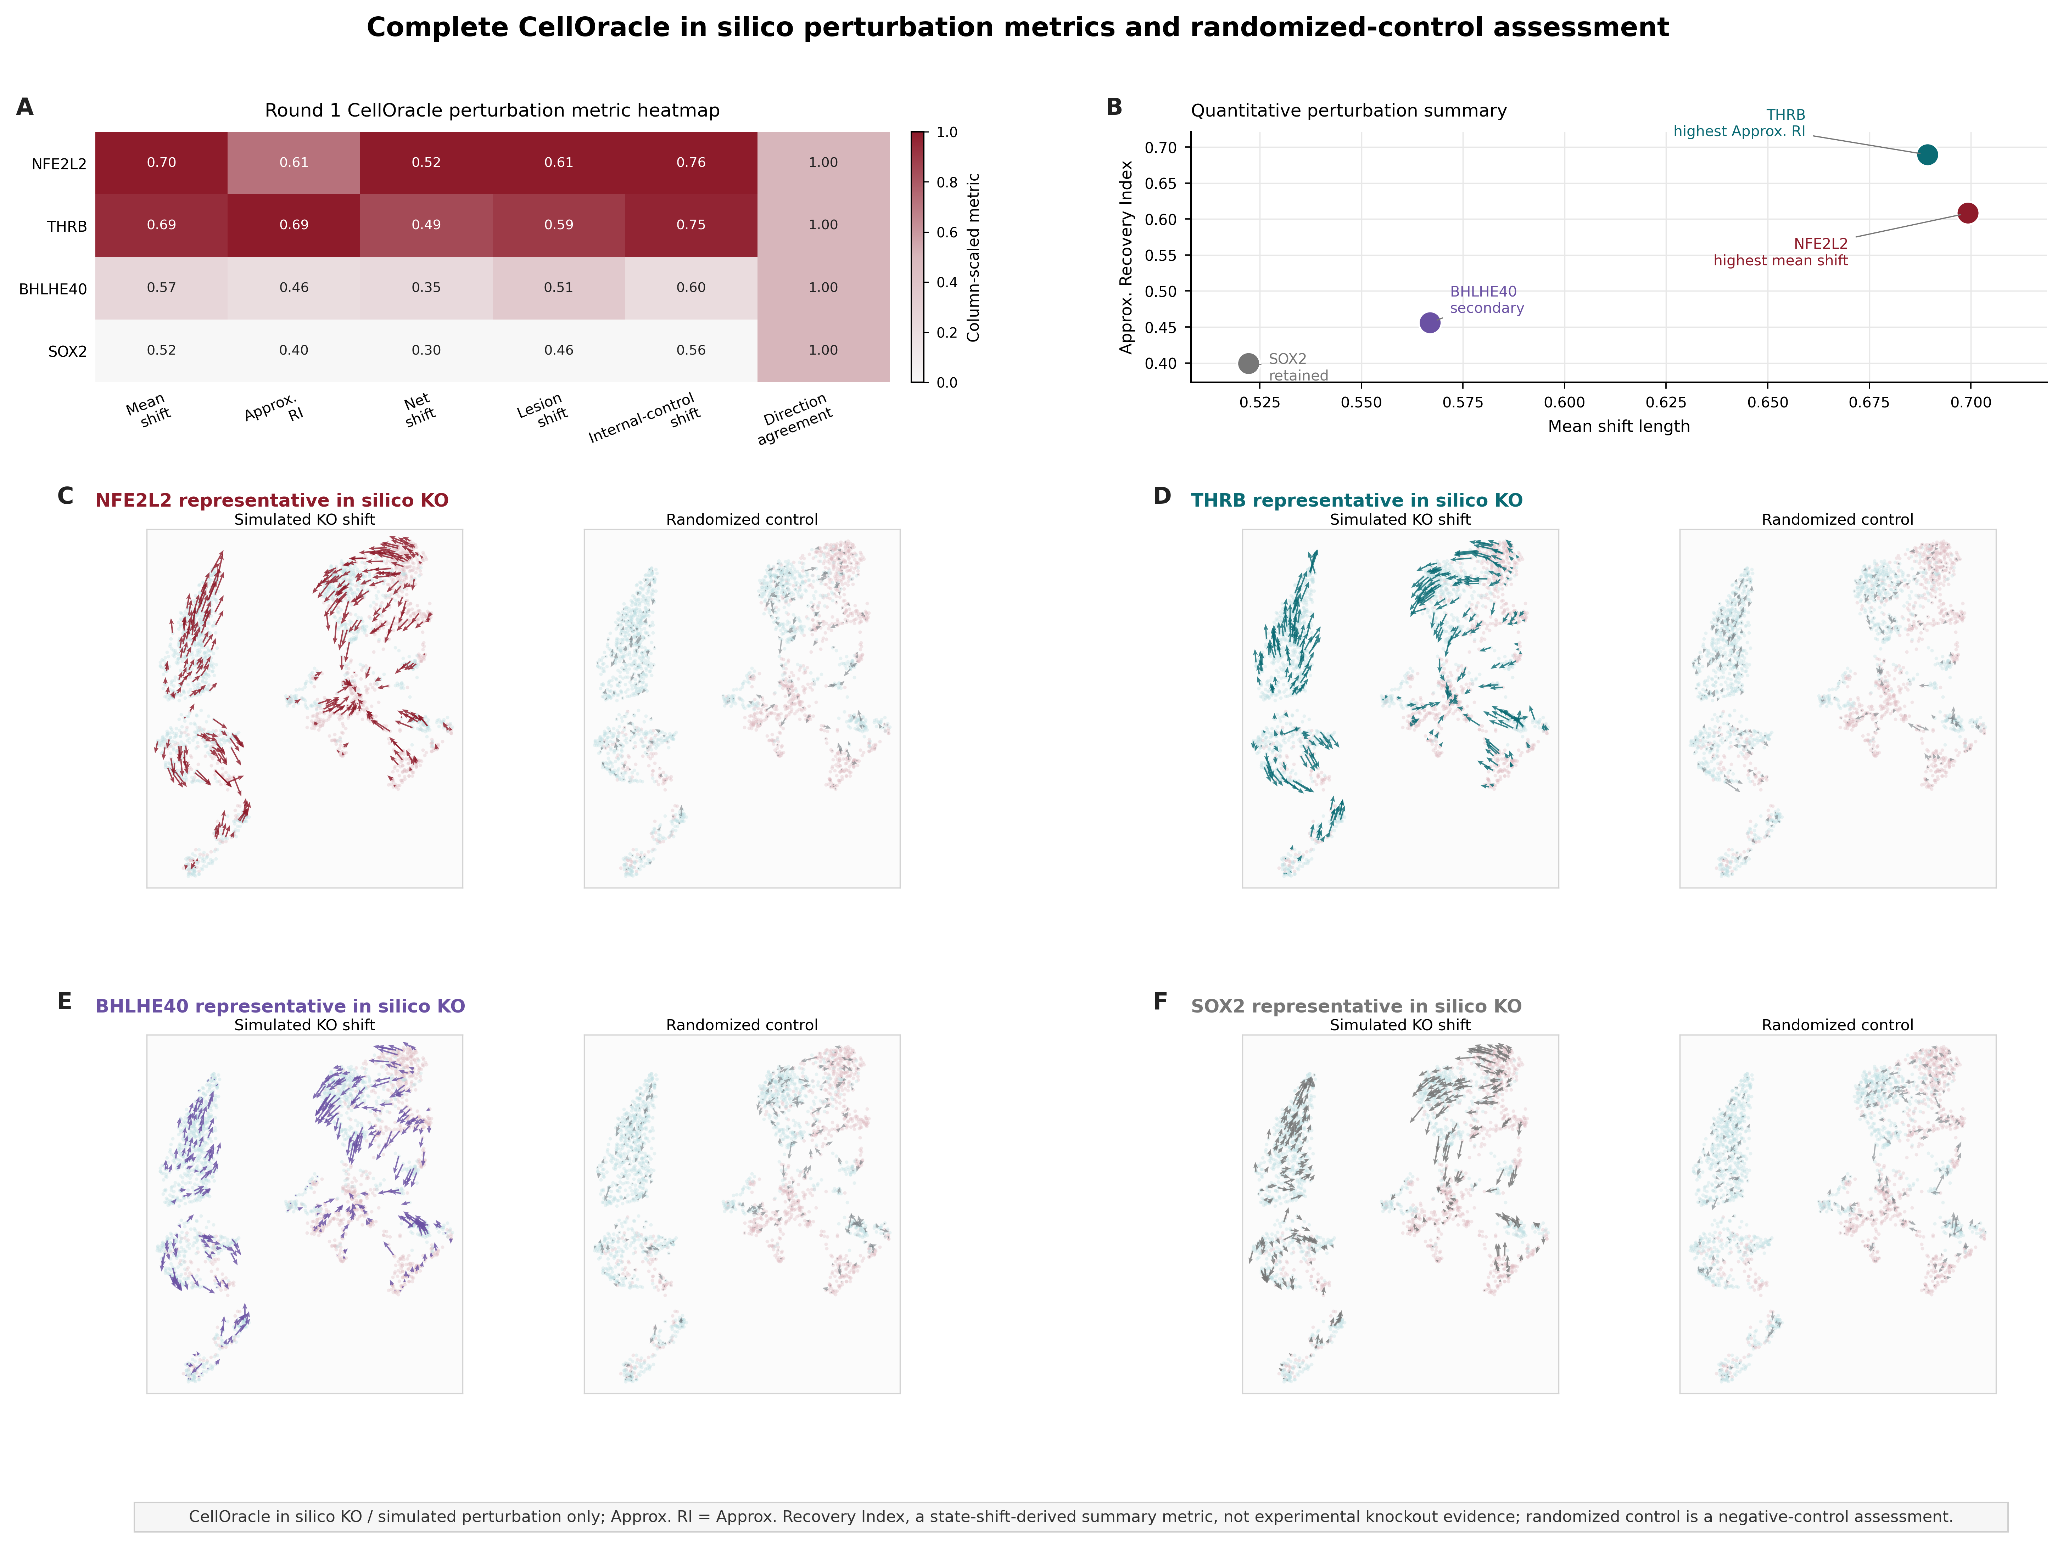

Supplementary Figure S4. Complete sample-level robustness and sensitivity analyses. Leave-one-sample-out expression effects, leave-one-sample-out regulon effects, pseudobulk support, and threshold sensitivity analyses evaluating sample-level robustness of the candidate transcription factor signals.
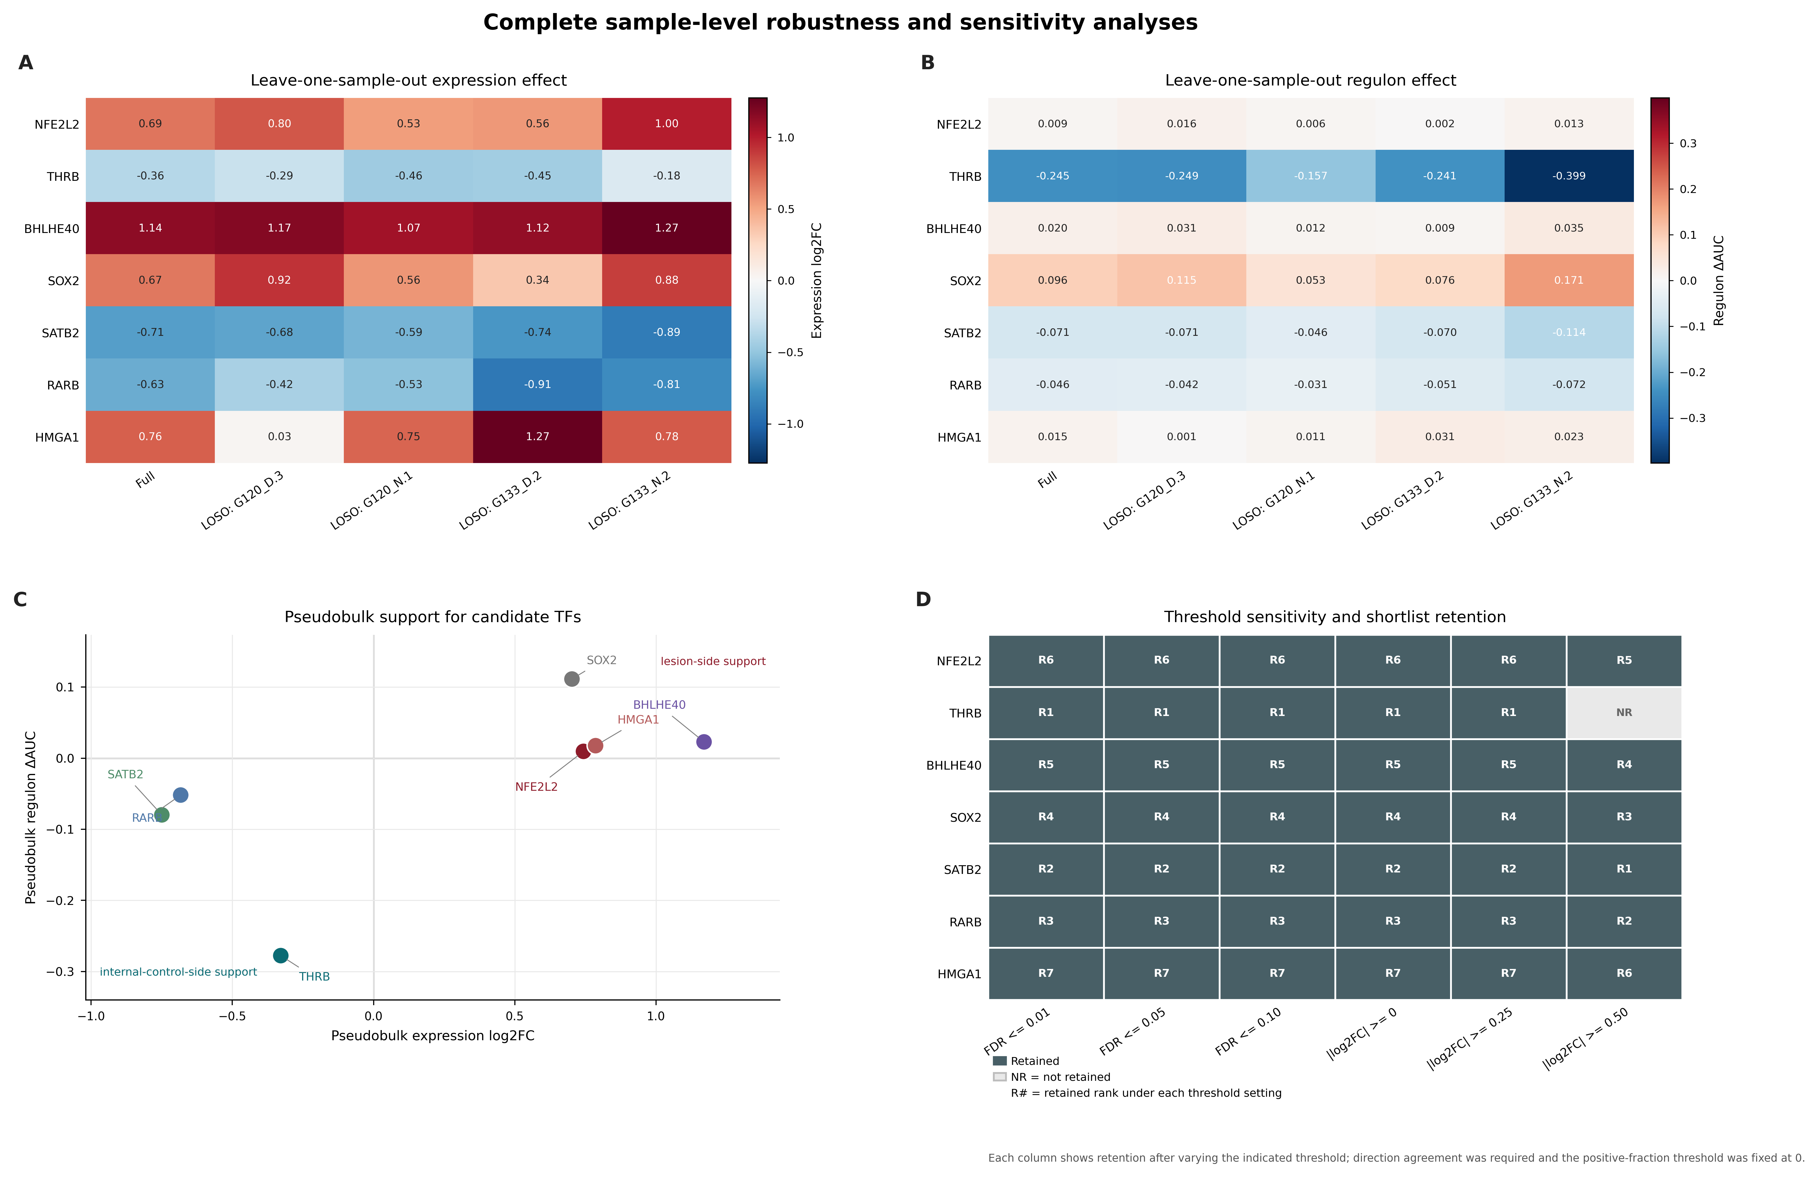

Supplementary Figure S5. Supportive/contextual evidence from GSE140393 and GSE190452. (A) GSE140393 single-group expression-support heatmap across 5 samples for the four candidate TFs; (B) ranked single-group support score (NFE2L2: disease-side; THRB: partial internal-control-like; SOX2: partial / retained; BHLHE40: attenuated); (C) GSE190452 cross-syndrome expression vs. target-set support scatter (THRB, BHLHE40, SOX2, NFE2L2); (D) GSE190452 cluster-level directionally-signed expression-support heatmap across 32 clusters. Conservative interpretation: NFE2L2 shows consistent disease-side support; THRB shows partial internal-control-like support; SOX2 and BHLHE40 show only partial / attenuated support. All findings are supportive/contextual and do not constitute independent regulon-level replication.
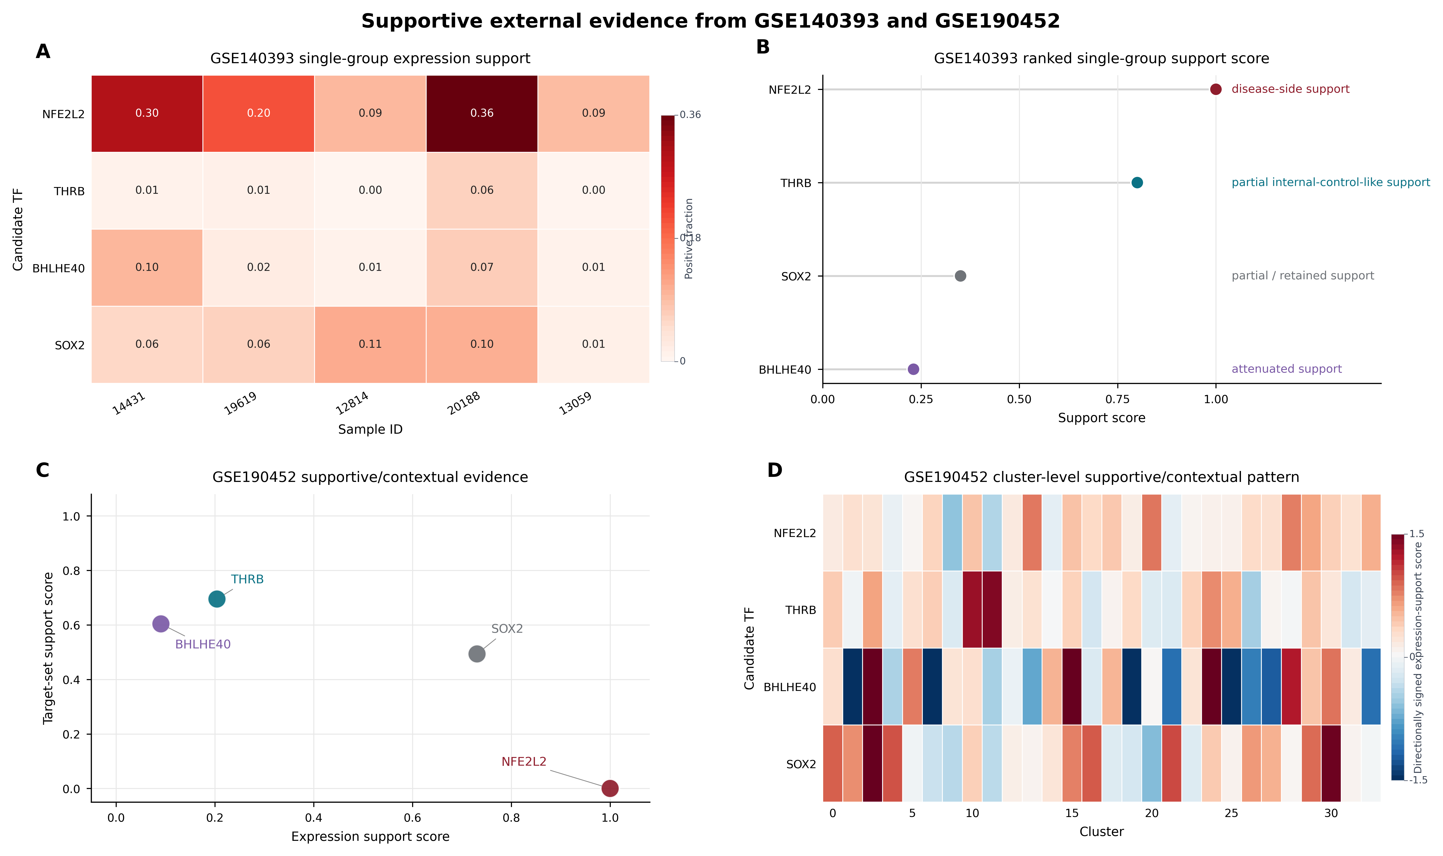

Supplementary Figure S6. Full functional enrichment landscape and program convergence. Complete GO/KEGG enrichment landscape for NFE2L2, THRB, BHLHE40, and SOX2, regulon-DEG program convergence, and significant functional term counts.
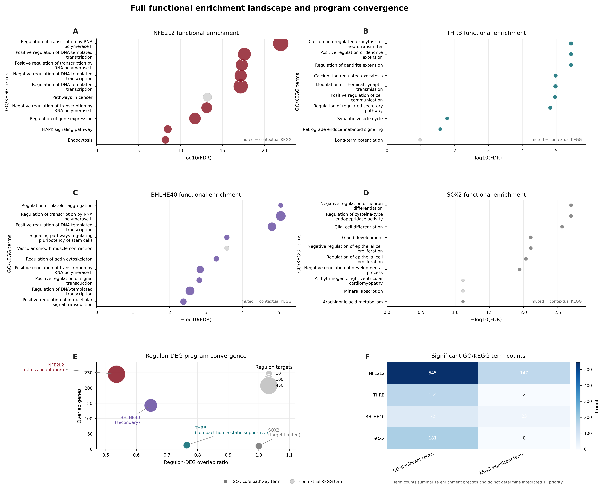

Supplementary Figure S7. Exploratory drug-signature enrichment and BBB-layered prioritization. (A) BBB-layered exploratory clue matrix for the four candidate TFs (mechanism-direction / supportive / peripheral-program-modulating); (B) ranked exploratory after-BBB drug-signature clues; (C) pre-BBB vs. after-BBB exploratory score shift; (D) mechanism-theme distribution across the three exploratory layers. Conservative interpretation: mechanism-direction clues are enrichment-derived, BBB-retained, and hypothesis-generating only; supportive clues are secondary signals requiring manual review; peripheral/program-modulating clues are program-linked but not prioritized for CNS-directed interpretation. No compound is interpreted as a validated therapy or treatment recommendation. BBB = blood-brain barrier.
