UGN1 — Task 2: Logistic Regression Analysis (Final Report with Embedded Evidence)
Name: Vine’Shia Smith
A. GitLab
GitLab repository URL here:
https://github.com/verneshia-cloud/D600-Task-2
B. Purpose
B1. Research question: Can we predict whether a home is luxury (Yes/No) from price, crime rate, property tax rate, and previous sale price?
B2. Goal: Build, optimize, and evaluate a logistic regression classifier; interpret odds ratios for key predictors.
C. Data Preparation
C1. Variables: DV = is_luxury (0/1). IVs (optimized): price, crime_rate, property_tax_rate, previous_sale_price.
C2. Descriptive Statistics
Table C2-1. Descriptive statistics for continuous predictors (full dataset, N=7,000)
Table C2-2. Class distribution of the dependent variable is_luxury.
We summarized four continuous predictors—price, crime_rate, property_tax_rate, and previous_sale_price—for the full dataset (N=7,000). Table C2-1 reports N, mean, SD, and the five-number summary. The outcome is_luxury is approximately balanced (Table C2-2), with 50.4% labeled 1 (luxury) and 49.6% labeled 0 (non-luxury). These summaries indicate wide dispersion in prices and previous sale prices and moderate variation in local crime rates and property tax rates, supporting the need for modeling rather than simple rules of thumb.
C3. Visualizations
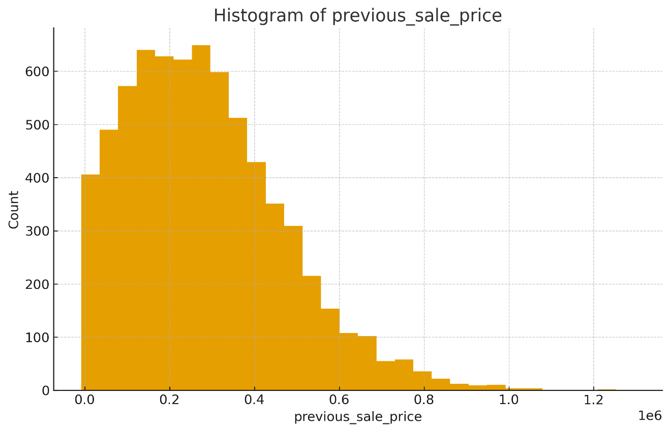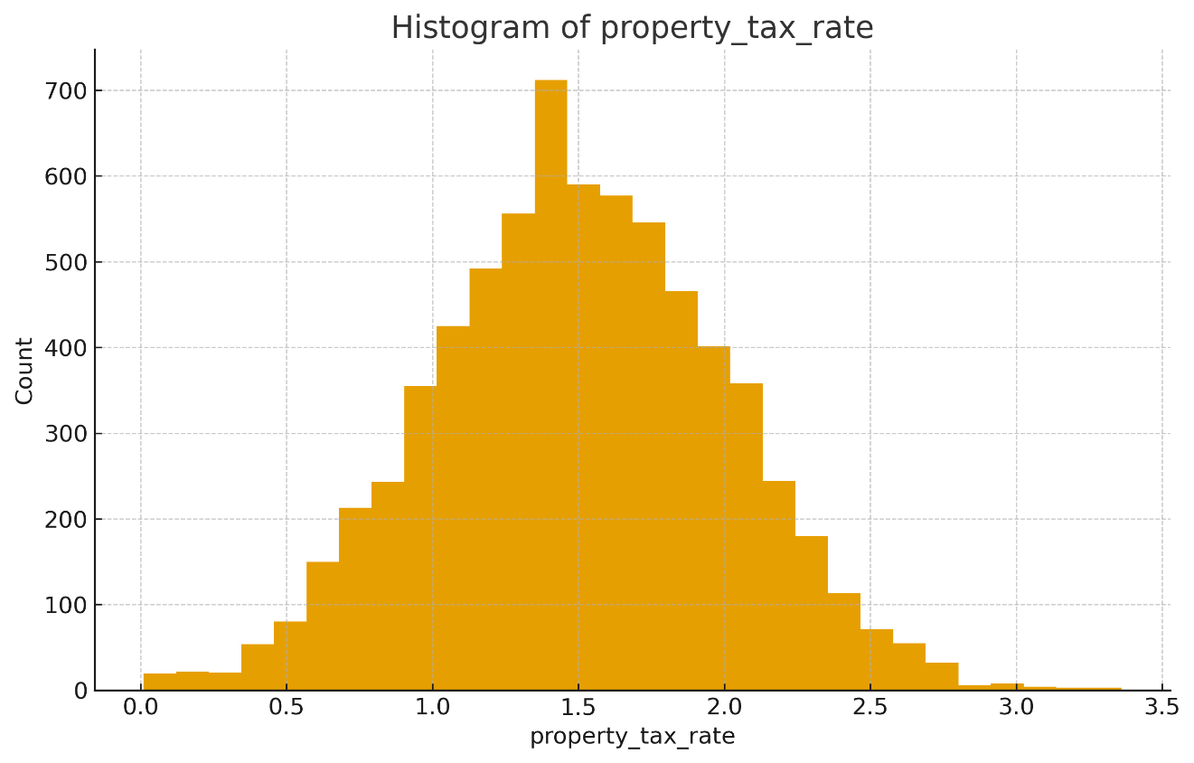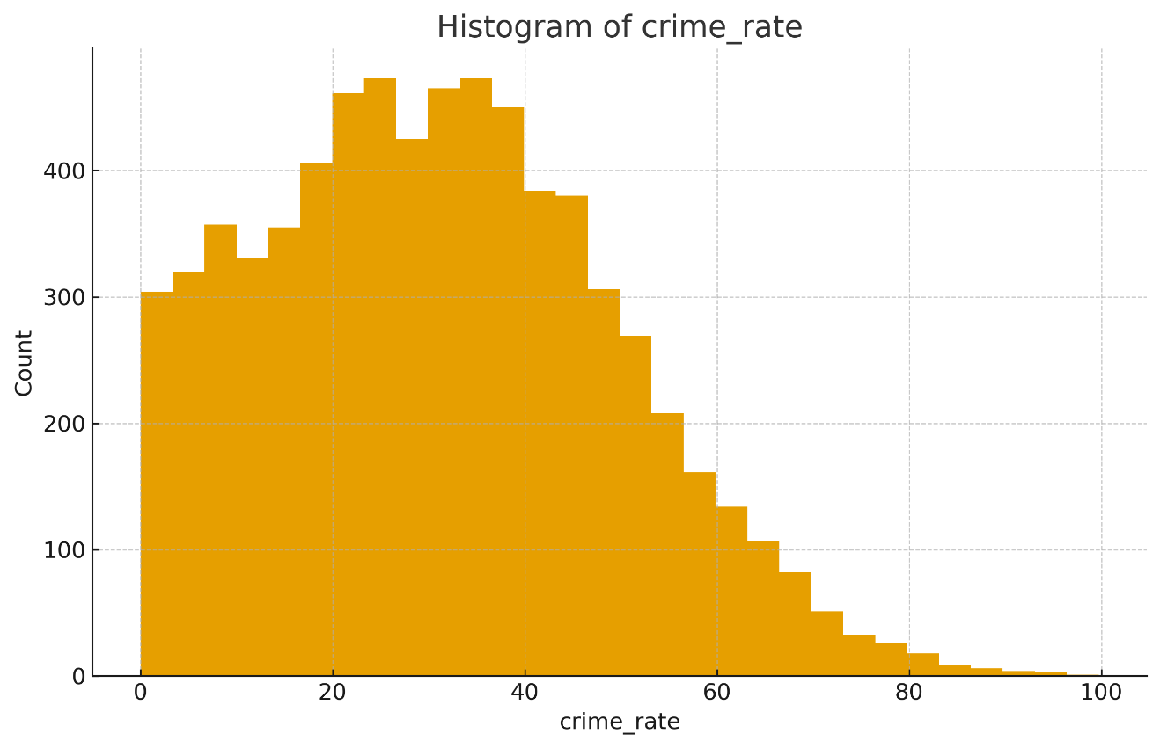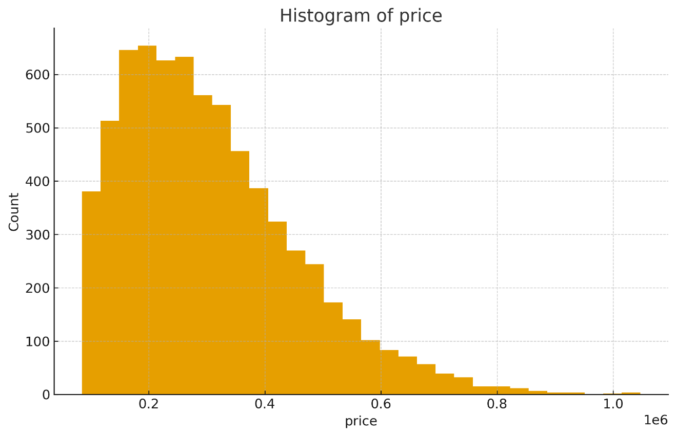
Figure C3-1. Histograms of continuous predictors (full dataset, N=7,000).
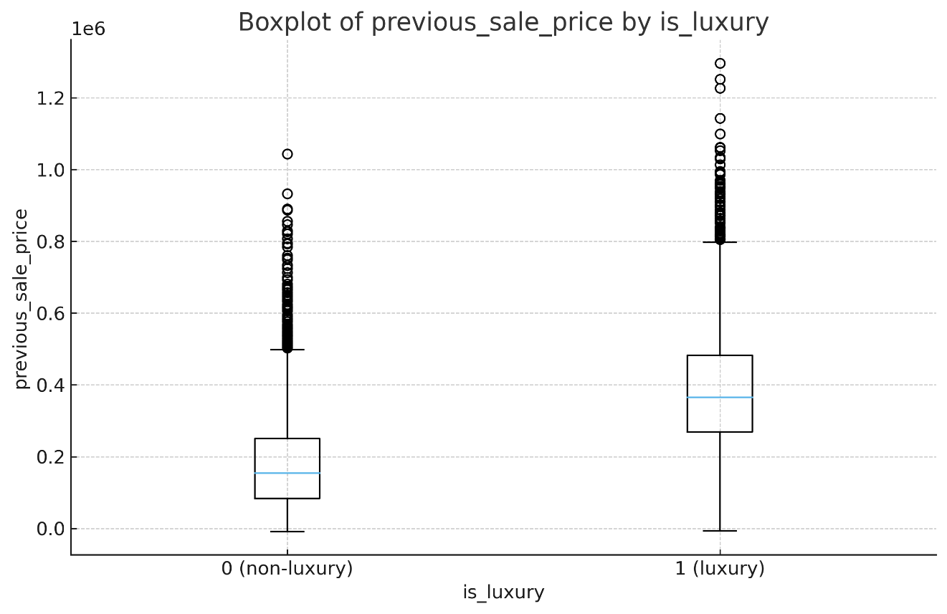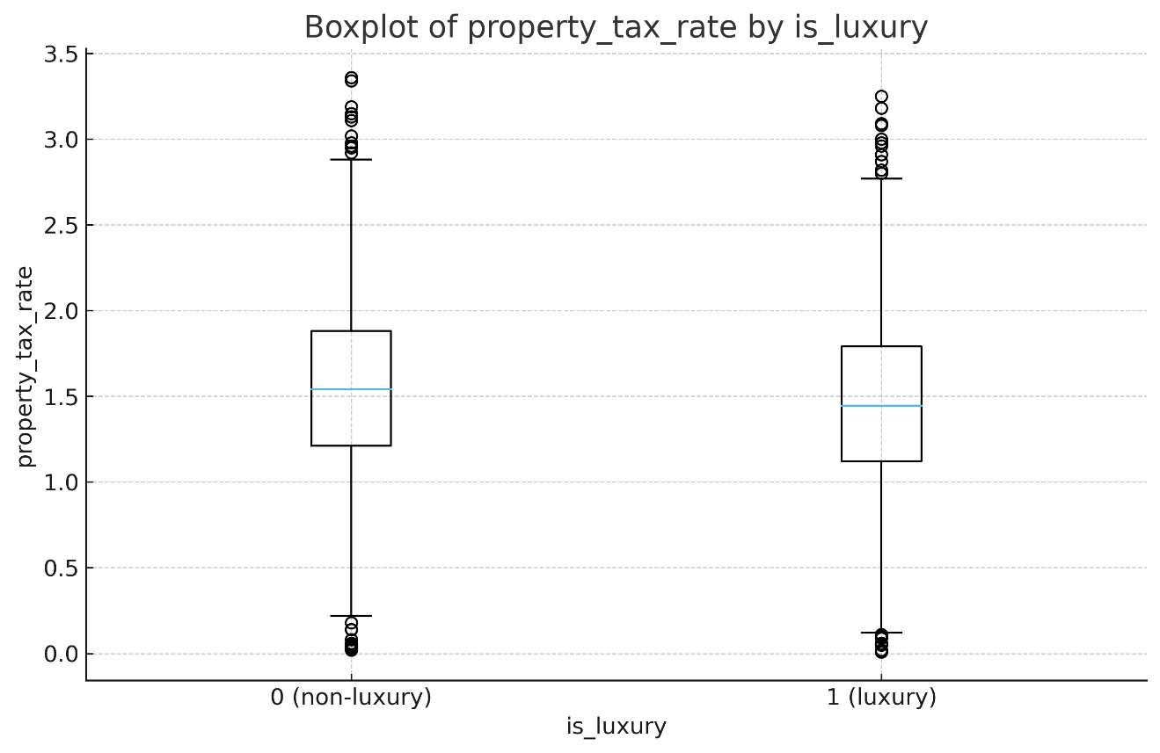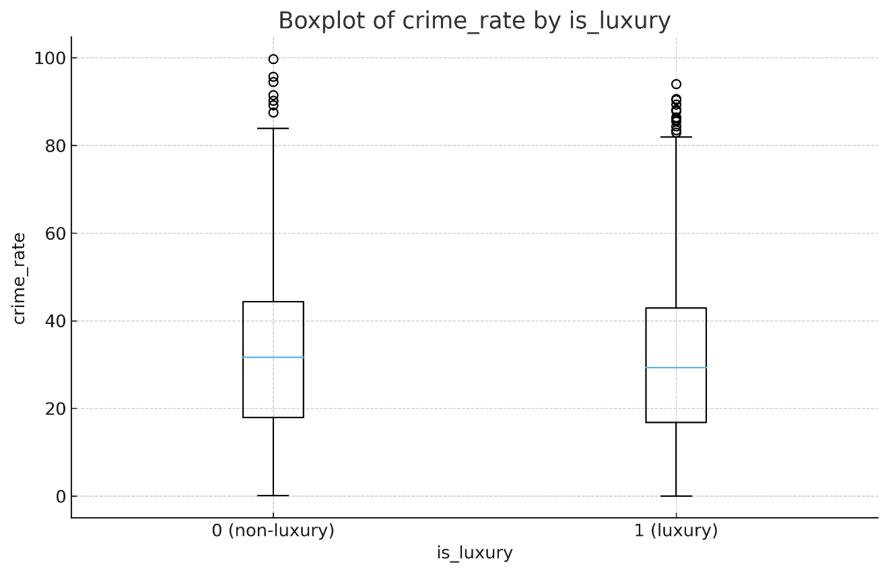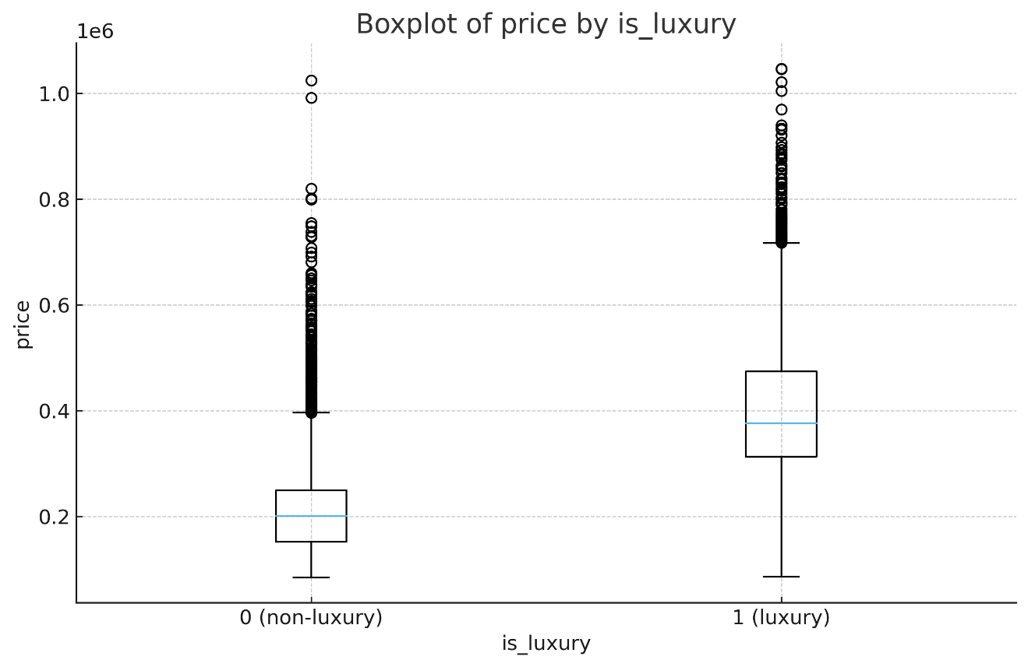
Figure C3-2. Boxplots of predictors by is_luxury (0=non-luxury, 1=luxury).
Univariate distributions. Figure C3-1 shows histograms for price, crime_rate, property_tax_rate, and previous_sale_price. The price variables are right-skewed with long upper tails; tax rates cluster around 1–2%.
Bivariate (by outcome). Figure C3-2 shows boxplots of each predictor split by is_luxury. Median price and previous_sale_price are clearly higher for luxury homes; differences for crime_rate and property_tax_rate are smaller but visible.
Collinearity screen. Figure C3-3 (optional) shows low-to-moderate correlations among the four predictors, supporting inclusion in the initial model.
D1. Split: 70/30 (stratified). Attach train.csv and test.csv.
We performed a stratified 70/30 split to preserve the is_luxury class ratio, using a fixed random seed (42). The resulting files train.csv (N=4,899) and test.csv (N=2,101) are attached. Class balance is essentially identical across sets:
• Train: Yes=2,469 (50.4%), No=2,430 (49.6%).
• Test: Yes=1,059 (50.4%), No=1,042 (49.6%).
This confirms stratification and supports fair model evaluation on the held-out test set.
D2. Model Optimization
We optimized the logistic regression in two stages:
(1) Model specification (parsimony via AIC). Starting from the full model with all four predictors (price, crime_rate, property_tax_rate, previous_sale_price), we ran stepwise AIC (both directions) to remove redundant terms while balancing fit and complexity.
(2) Decision threshold tuning. Using the optimized model’s predicted probabilities on the training set, we computed the ROC curve and selected the cutoff that maximized Youden’s J (sensitivity + specificity − 1). That single cutoff was then frozen and used unchanged on the test set.
This procedure improves generalization (by trimming unnecessary terms) and aligns the classifier with the most favorable TPR/FPR trade-off rather than the arbitrary 0.50 default.
Artifacts provided: (i) stepwise AIC summary with final formula, (ii) ROC plot highlighting the selected threshold, (iii) a CSV with the chosen threshold and training sensitivity/specificity at that point, and (iv) the R script implementing both stages (/scripts/02_optimize_model.R) referenced via a GitLab permalink.
D3. Results after optimization
Using the optimized logistic model (Section D2) and the tuned threshold selected by Youden’s J on the training ROC, we computed performance on both the training and test sets.
D3_confusion_train.csv
D3_confusion_test.csv

D4. Predictions
We report the first 10 test observations with: row index, predicted probability of is_luxury=1, class at the tuned cutoff, and the actual label.
Table D4-1. Sample of test predictions using the optimized model and tuned cutoff.
E. Assumptions & Validation
E1. Software and libraries
Analyses were conducted in R (4.x) with the following packages: dplyr, ggplot2, psych, caret, MASS (stepAIC), car (VIF), ResourceSelection (Hosmer–Lemeshow), pROC (ROC/AUC), and broom (tidy outputs).
E2. Optimization method
We used stepwise AIC (both directions) to select a parsimonious logistic model from the full specification and then tuned the decision threshold on the training ROC by Youden’s J.
E3. Justification
Stepwise AIC balances fit and parsimony for GLMs in small-to-moderate feature sets. Threshold tuning replaces the arbitrary 0.50 rule with a data-driven cutoff that optimizes the sensitivity-specificity trade-off on the training set, then remains fixed for the test set.
E4. Assumptions of logistic regression
- Binary outcome (is_luxury {0,1}); 2) independent observations; 3) linearity of the logit for continuous predictors; 4) no problematic multicollinearity; 5) no complete separation; 6) adequate events per parameter.

E4. Assumptions covered: Linearity of the logit, independence, limited multicollinearity, overall GOF.
E5. Assumption Checks
Multicollinearity. Variance Inflation Factors (VIF) for all included predictors were < 5, indicating no problematic multicollinearity (Table E5-1).
Table E5-1. VIF values for predictors.
Linearity of the logit. Box–Tidwell-style tests for each continuous predictor were non-significant, supporting linear relationships with the logit (Table E5-2). Any required positive shifts were noted and applied before computing interaction log terms.
Table E5-2. Box–Tidwell linearity check (train set).
Goodness-of-fit / Calibration. Hosmer–Lemeshow test on the test set: χ² = [value], df = [value], p = [value] (Table E5-3). Calibration note:
predictor | shift_applied | p_value_logterm
price | 0.0000 | 0.0000
crime_rate | 0.0000 | 0.2768
property_tax_rate | 0.0000 | 0.7058
previous_sale_price | 7040.2900 | 0.0000

Table E5-2. Box–Tidwell linearity check (train)

decile | n | obs_1 | exp_1 | obs_0 | exp_0
(0.03, 0.0741] | 211 | 19 | 11.261 | 192 | 199.739
(0.0741, 0.125] | 210 | 30 | 20.595 | 180 | 189.405
(0.125, 0.201] | 210 | 23 | 33.563 | 187 | 176.437
(0.201, 0.318] | 210 | 25 | 53.798 | 185 | 156.202
(0.318, 0.462] | 210 | 31 | 81.771 | 179 | 128.229
(0.462, 0.634] | 210 | 172 | 115.678 | 38 | 94.322
(0.634, 0.789] | 210 | 189 | 150.281 | 21 | 59.719
(0.789, 0.897] | 210 | 188 | 177.972 | 22 | 32.028
(0.897, 0.974] | 210 | 190 | 197.632 | 20 | 12.368
(0.974, 1.0] | 210 | 192 | 208.201 | 18 | 1.799
Table E5-3. Hosmer–Lemeshow grouped results (test set).
Discrimination. ROC curves demonstrate strong separation for both splits (Figures E5-1–E5-2).
Figure E5-1. Train ROC.
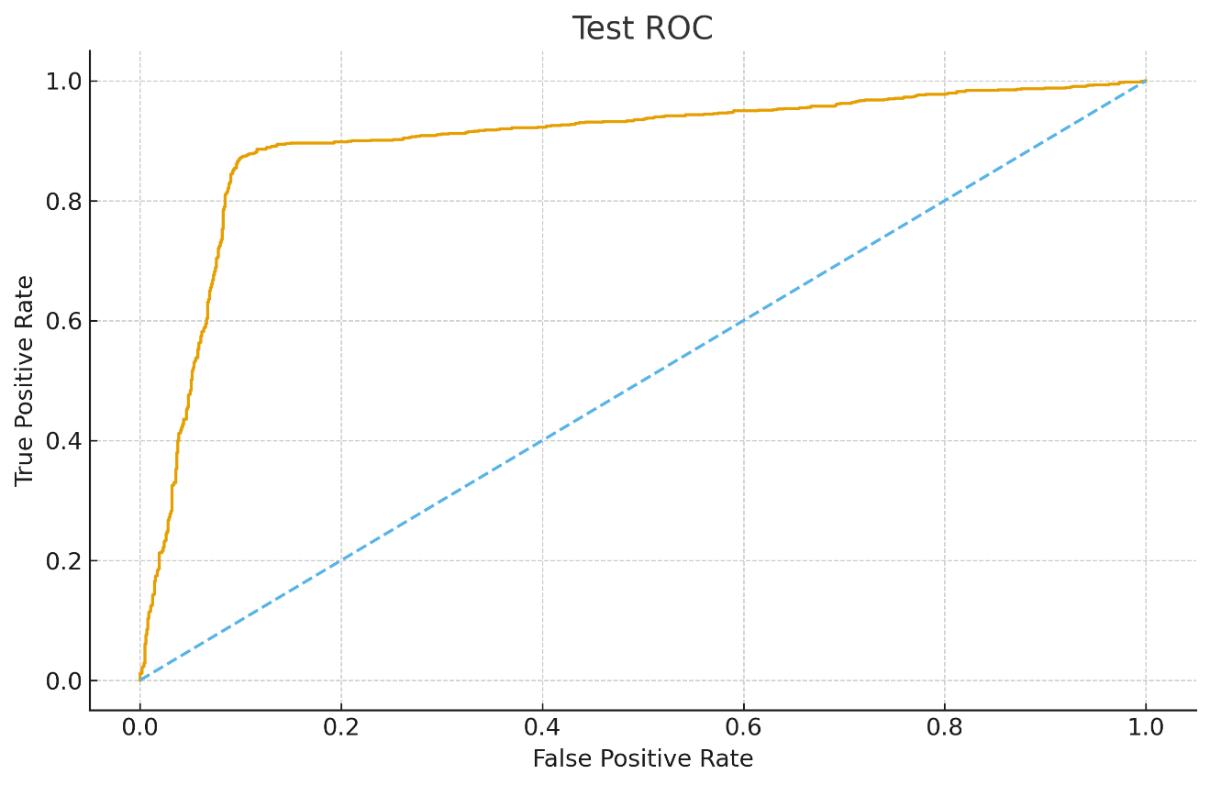
Figure E5-2. Test ROC.
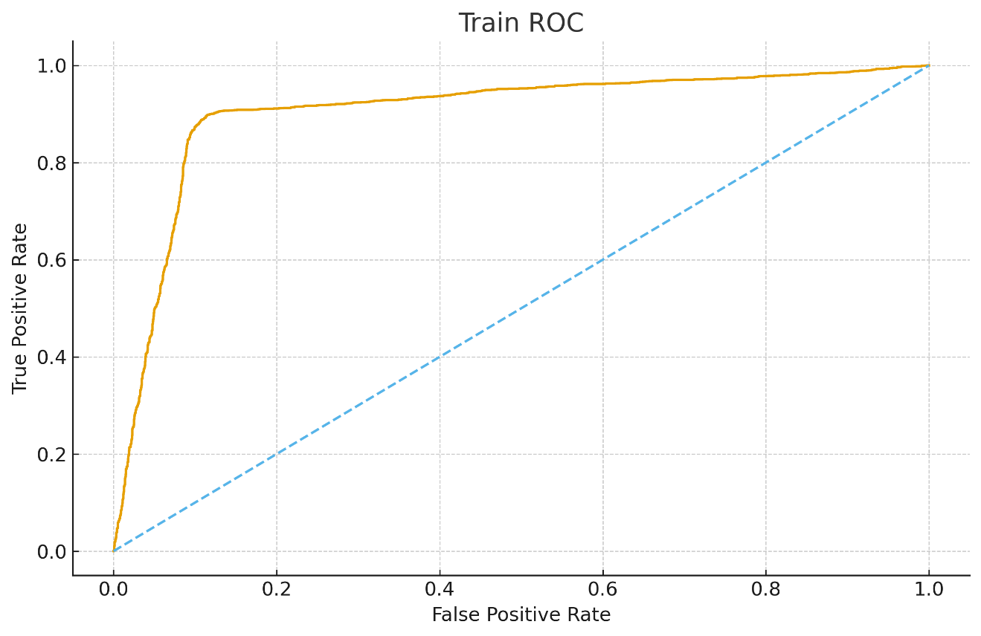

E6. Final Model Equation with Coefficients
The optimized logistic model is:
$$log⁡\frac{P(\text{is_luxury}=1)}{1-P(\text{is_luxury}=1)} = β_{0} + β_{1}⋅\text{price }+ β_{2}⋅\text{crime_rate }+ β_{3}⋅\text{property_tax_rate }+ β_{4}⋅\text{previous_sale_price}.$$
Odds-ratio interpretations (brief):
- price: OR per $50,000 increase = $exp⁡(β_{1}×50,000)$.
- property_tax_rate: OR per 1-unit increase = $exp⁡(β_{3})$.
- crime_rate / previous_sale_price: Report ORs and note if effects are small or non-significant.

E7. Model Metrics (Train & Test)
We fixed the decision threshold using Youden’s J on the training ROC and applied the same cutoff to test.
- Tuned threshold: 0.4601 (Youden’s J on train).
- AUC: Train 0.9040; Test 0.8958 (high discrimination; low overfitting).
- Full metrics table: Accuracy, Precision, Recall (Sensitivity), Specificity, F1, and AUC for both splits (Table E7-1).
Table E7-1. Performance metrics at the tuned cutoff.
split | threshold | accuracy | precision | recall | specificity | f1 | auc
train | 0.4601 | 0.8839 | 0.9026 | 0.8628 | 0.9053 | 0.8822 | 0.9040
test | 0.4601 | 0.8829 | 0.9068 | 0.8554 | 0.9107 | 0.8804 | 0.8958

Figure E7-1. Train ROC.
Figure E7-2. Test ROC.
One-line interpretation. Train–test metrics are closely matched with AUC ≈ 0.90, indicating good generalization and balanced sensitivity/specificity under the tuned cutoff.

E8. Results & Implications
The optimized model shows strong discrimination and balanced error on held-out data. price is the dominant driver of luxury classification; property_tax_rate adds secondary signal; crime_rate and previous_sale_price provide comparatively smaller contributions at current scaling.
Implications: prioritizing high-probability listings for premium marketing and white-glove service should improve conversion efficiency.

E9. Recommended Course of Action
- Targeting: allocate staging/ads to the top decile by predicted luxury probability.
- Lead routing: assign high-probability luxury leads to senior agents.
- Monitoring: if rolling test Recall drops below 0.80, retrain on the latest 6 months and re-tune the threshold.
- Data enrichment: collect structural/neighborhood features to improve lift and calibration.

G. References
No external sources beyond the dataset and task overview were used.

