C. Chan, Gutierrez, Macam, M. Tan
Class Diagram
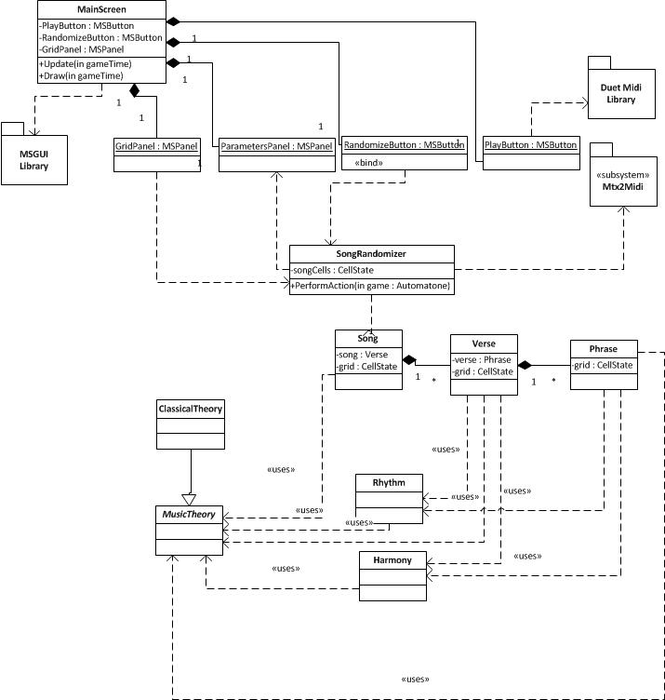
LoadContent
<<bind>>
Dictionary
NoteName
Dictionary
NoteName
GetRhythmCurve
List
PDL

MainScreen Class

void PlayPauseButtonChanged(object sender, EventArgs e)
{
if (playPauseButton is selected )
{
if (automatone_state equal to midiPlayer_State.STOPPED)
rewriteSong();

automatone_playMidi();
}
else
{
Automatone_pauseMidi();
}

}

void RandomizeButtonPressed(object sender, EventArgs e)
{
StopButtonChanged(sender, e);
SongGenerator.GenerateSong(automatone, new Random(), new ClassicalTheory(), out output);
automatone.SongCells = output;
automatone.Tempo = (ushort)(40 + (new Random()).NextDouble() * 120);
}

void StopButtonChanged(object sender, EventArgs e)
{
automatone.Sequencer.StopMidi();
automatone.GridScreen.Reset();
automatone.GridScreen.ScrollWithMidi = false;
playPauseButton.Selected = false;
stopButton.Selected = false;
}
Note Class

class Note{
NoteName noteName;
byte octave;
double remainingDuration;
int startMeasure;
double startBeat;

byte MidiNumber {
get {
return (byte)(noteName.ChromaticIndex + (octave + 1) * 12);
}
}

Note(NoteName note_name, byte octave, double duration, int start_measure, double start_beat){
this.noteName = note_name;
this.octave = octave;
this.remainingDuration = duration;
this.startMeasure = start_measure;
this.startBeat = start_beat;
}

String NoteName GetNoteName()
{
return noteName;
}

byte GetOctave()
{
return octave;
}

double GetRemainingDuration()
{
return remainingDuration;
}

int GetStartMeasure()
{
return startMeasure;
}

double GetStartBeat()
{
return startBeat;
}

double Update(double beat_resolution)
{
remainingDuration -= beat_resolution;
return remainingDuration;
}

int CompareTo(Note n)
{
return (int)Math.Round((startMeasure + startBeat) * 100 - (n.startMeasure + n.startBeat) * 100);
}

}
SongGenerator Class

class SongGenerator
{
byte START_OFFSET = 21;
void RewriteSong(Automatone automatone)
{
NoteThread thread = new NoteThread(Automatone.getBeatResolution(), automatone.SongCells);
automatone.Song = thread.ToString();
}

void GenerateSong(Automatone automatone, Random random, MusicTheory theory, out CellState[,] song)
{
Song s = new Song(theory, random);
NoteThread thread = new NoteThread(Automatone.getBeatResolution(), s.Notes);
CellState[,] grid = new CellState[theory.PIANO_SIZE,s.MeasureCount * Automatone.SUBBEATS_PER_MEASURE];
foreach (List<Note> nts in s.Notes)
{
foreach (Note n in nts)
{
grid[n.GetOctave() * 12 + n.GetNoteName().ChromaticIndex, Math.Min(n.GetStartMeasure() * Automatone.SUBBEATS_PER_MEASURE + (int)(n.GetStartBeat() * Automatone.SUBBEATS_PER_MEASURE), s.MeasureCount * Automatone.SUBBEATS_PER_MEASURE - 1)] = CellState.START;
for (int i = 1; i < n.GetRemainingDuration() * Automatone.SUBBEATS_PER_MEASURE; i++)
{
if (grid[n.GetOctave() * 12 + n.GetNoteName().ChromaticIndex, Math.Min(i + n.GetStartMeasure() * Automatone.SUBBEATS_PER_MEASURE + (int)(n.GetStartBeat() * Automatone.SUBBEATS_PER_MEASURE), s.MeasureCount * Automatone.SUBBEATS_PER_MEASURE - 1)] == CellState.SILENT)
{
grid[n.GetOctave() * 12 + n.GetNoteName().ChromaticIndex, Math.Min(i + n.GetStartMeasure() * Automatone.SUBBEATS_PER_MEASURE + (int)(n.GetStartBeat() * Automatone.SUBBEATS_PER_MEASURE), s.MeasureCount * Automatone.SUBBEATS_PER_MEASURE - 1)] = CellState.HOLD;
}
}
}
}
song = grid;
automatone.Song = thread.ToString();
}

int verseToThread(CellState[,] songCells, int globalStartMeasure)
{
int globalEndMeasure = globalStartMeasure;

return globalEndMeasure;
}

class NoteThread
{
const double EPSILON = 0.00001;

const string START_TRACK = "MTrk\n";
const string PREFIX_PORT = "0 Meta 0x21 00\n";
const string PREFIX_CHANNEL = "0 Meta 0x20 00\n";
const string META_END_TRACK = " Meta TrkEnd\n";
const string END_TRACK = "TrkEnd\n";

List<Note> notes;
double beatResolution;

NoteThread(double beat_resolution, CellState[,] notes)
{
this.notes = new List<Note>();
for (int i = 0; i < notes.GetLength(0); i++)
{
for (int j = 0; j < notes.GetLength(1); j++)
{
if (notes[i, j] equal to CellState.START)
{
double duration = Automatone.getBeatResolution();
int k = j + 1;
while (k < notes.GetLength(1) && notes[i, k] == CellState.HOLD)
{
duration += Automatone.getBeatResolution();
k++;
}
this.notes.Add(new Note(new NoteName((byte)(i % 12)), (byte)(i / 12), duration, (int)(j / Automatone.SUBBEATS_PER_MEASURE), (j % Automatone.SUBBEATS_PER_MEASURE) / (double)Automatone.SUBBEATS_PER_MEASURE));
}
}
}
beatResolution = beat_resolution;
}

NoteThread(double beat_resolution, List<List<Note>> notes)
{
this.notes = new List<Note>();
foreach (List<Note> nts in notes)
{
foreach (Note n in nts)
{
this.notes.Add(n);
}
}
beatResolution = beat_resolution;
}

string ProgramChange(ulong time, byte channel, byte programNumber)
{
return time + " PrCh ch=" + channel + " p=" + programNumber + "\n";
}

string SetVolume(ulong time, byte channel, byte volume)
{
return time + " Par ch=" + channel + " c=7 v=" + volume + "\n";
}

string SetPanning(ulong time, byte channel, byte pan)
{
return time + " Par ch=" + channel + " c=10 v=" + pan + "\n";
}

string SetReverb(ulong time, byte channel, byte reverb)
{
return time + " Par ch=" + channel + " c=91 v=" + reverb + "\n";
}

string TurnNoteOn(ulong time, byte channel, byte noteMidiNumber, byte velocity)
{
return time + " On ch=" + channel + " n=" + noteMidiNumber + " v=" + velocity + "\n";
}

string TurnNoteOff(ulong time, byte channel, byte noteMidiNumber, byte velocity)
{
return time + " Off ch=" + channel + " n=" + noteMidiNumber + " v=" + velocity + "\n";
}
}
}

