Symmetric Matrix – Complete Conceptual and Visual Guide

# 1. What is a Symmetric Matrix?

A symmetric matrix is a square matrix that is equal to its transpose. That is:  
A = Aᵗ  
This means that the element at row i and column j is equal to the element at row j and column i (Aᵢⱼ = Aⱼᵢ).  
  
Example:  
[ [1, 2, 3],  
 [2, 5, 6],  
 [3, 6, 9] ] is symmetric because it mirrors itself across the diagonal.

# 2. Why Do We Care About Symmetry?

Symmetry in matrices gives us beautiful mathematical properties:  
- Eigenvalues are guaranteed to be real.  
- Eigenvectors are guaranteed to be orthogonal.  
- Quadratic forms (like βᵗAβ) become easy to differentiate.  
- It simplifies optimization problems and ensures stable solutions.

# 3. What If the Matrix Is Not Symmetric?

- Eigenvalues might be complex (imaginary).  
- Eigenvectors may not be perpendicular.  
- Matrix may twist or rotate space.  
- Many simplifications (like ∇(βᵗAβ) = 2Aβ) no longer work.  
- Optimization landscapes become irregular.

# 4. What If the Matrix Is Symmetric?

- Matrix stretches space along its eigenvectors.  
- These eigenvectors are real and perpendicular (orthogonal).  
- Some vectors (eigenvectors) maintain direction and are only scaled.  
- Clean, predictable behavior without rotation.  
- Convex loss surfaces enable guaranteed minima in ML.

# 5. Use of Symmetric Matrices in Machine Learning

- Covariance matrices (used in PCA, statistics) are symmetric.  
- XᵗX in linear regression is always symmetric.  
- Hessians (second derivative matrices in optimization) are symmetric.  
- Symmetry ensures stability, uniqueness, and interpretability.

# 6. Visual: Symmetric Matrix Transformation

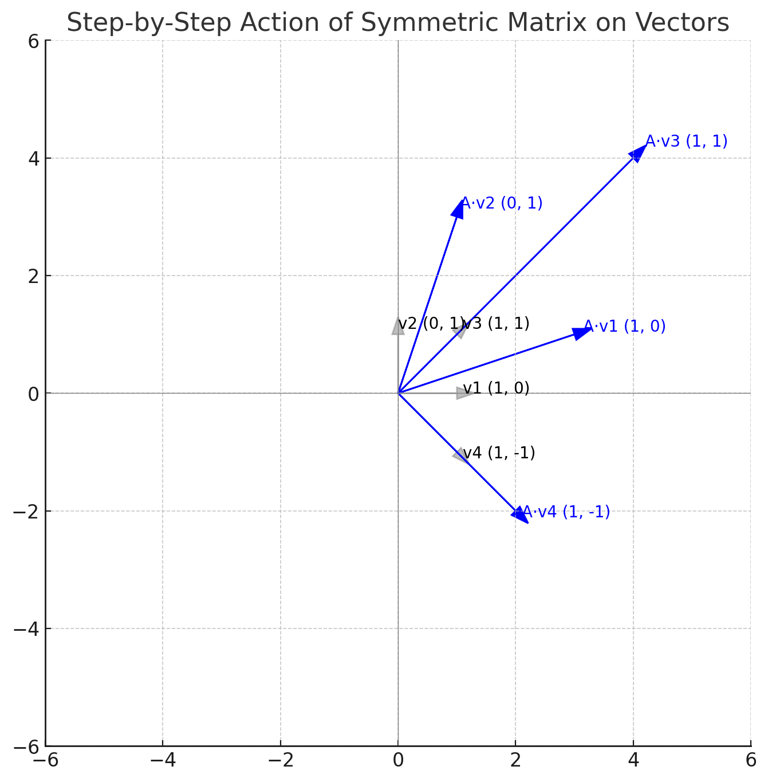

**What You See:**

* **Gray Arrows**: Original vectors (v1 to v4).
* **Blue Arrows**: Result after applying the symmetric matrix

**What’s Happening Here:**

**🔹 v3 (1, 1) and v4 (1, -1)**

* These are the **eigenvectors** of the matrix.
* Notice: they point in **exactly the same direction** before and after — just longer.
* That’s the core property of an eigenvector:

$$Av = \backslash lambda v$$

The direction is **preserved**, only **scaled**.

**7. Visual: Rotation Matrix Transformation**

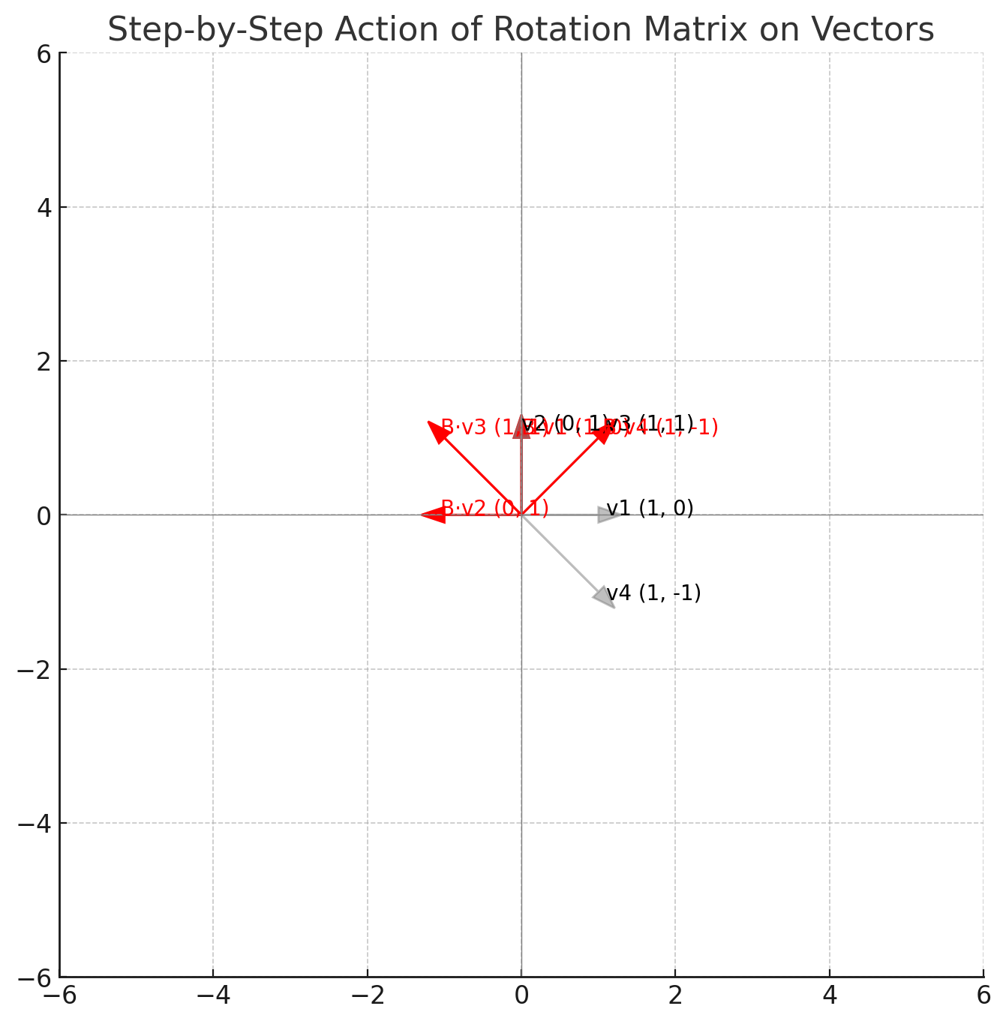

Here’s the **step-by-step transformation by a rotation matrix**

B=[0 , -1

1 0]

which performs a **90° counter-clockwise rotation**.

**🔴 What You See:**

* **Gray Arrows**: Original vectors (same as before).
* **Red Arrows**: Vectors after applying the rotation matrix.
* Labels show the original and rotated vector names.

# 8. Final Insight – Comparing Transformations

Symmetric Matrix:  
- Stretches space along eigenvectors.  
- Some vectors stay aligned, only scaled.  
- No spinning of the whole space.  
  
Rotation Matrix:  
- Rotates every vector by 90°.  
- Preserves length and angle.  
- Spins the entire space without distortion.