# Invitees / Participants:

Caneel, Glen J. (Leidos) <Glen.Caneel@va.gov>;

Ablaya, Reynold E <Reynold.Ablaya@va.gov>;

Bodnarchuk, Stephen (GovCIO) <Stephen.Bodnarchuk@va.gov>;

Snyder, Sarah (GovCIO) <Sarah.Snyder2@va.gov>;

Cordi, Michael (Halfaker & Associates) <Michael.Cordi@va.gov>;

Plastow, James S. <James.Plastow@va.gov>;

Rudik, Toby S. <toby.rudik@va.gov>;

Bennett, Dana (Leidos) ([dana.bennett@va.gov](mailto:dana.bennett@va.gov));

Bartlett, Robert (GovCIO) <Robert.Bartlett@va.gov>

# Meeting Goals:

* Discuss Current FSC ICD group work (including ICD Contents)
  + Grouping of Transactions by FHIR Resource
* Type of information this group needs to provide
* Overview of Current TAS Core Architecture
* Next Steps

# Discussion

* The MCCF EDI Transaction Application System (TAS) is the web application that is being developed where all current VistA reports, screens, and transactions will be ported. VistA will still be used to store the data.
  + Question – does TAS have the ability to store non-VistA data? Yes, that is in the design.
* The current ICD work is defining the new TAS to FSC interfaces that will replace the current VistA to FSC interfaces. Development will happen after the ICDs are finalized.
  + Some of the current VistA to FSC interfaces will need to be maintained as the new TAS to FSC interfaces are implemented.
* The product teams defined in the slide deck from the kick off meeting are working on the definition of the FHIR resources/bundles for the new TAS to FSC ICD for each transaction.
* There will be one common interface technical architecture/design that will be used by all transactions for the new TAS to FSC itnerfaces.
* This smaller group will develop the new TAS to FSC interface technical architecture/design.
* FSC and TASCore architects agreed on the following:
  + Data will be delivered by TAS for each transaction in FHIR resources/bundles.
  + Transformation/translation of the data for each transaction from FHIR to X12 will still occur on the FSC side.
  + The design work will need to focus on how the data is transferred from TAS to FSC, including:
    - How Much and How Often Transactions will be transmitted;
    - What type of transactions and how they will be Grouped;
      * Real Time
      * Batch
  + The current MCCF backlog is set up to port existing functionality then make updates. Steve stated that we should take opportunities to update current functionality and not be constrained by current state. Mike and Tony agreed.
  + We should consider standardizing on an event driven design for all transactions and potentially handle current batch processing that way.

Review Included:

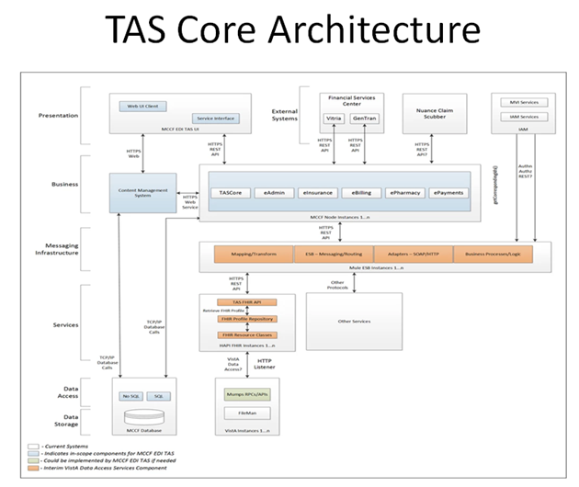

ICD Overview Information

* Interface Definition
  1. System Overview
     1. Overview Diagram
  2. Interface Overview
     1. Connectivity between the systems
  3. Operations
     1. Data Extraction
     2. Data Transformation
     3. Sending/Receiving
  4. Data Transfer
     1. Data is transferred between the FSC and the TAS Core Application Stack
  5. Transaction Types
     1. Defined for Each ICD
  6. Data Exchanges
     1. FHIR Based Resources
     2. JSON Format
     3. Bundle Definition
  7. Communication Methods
     1. HTTP(S)
     2. Ports and Protocols
     3. ESB Configuration(s)
     4. System Configuration
  8. Performance Requirements
  9. Security
     1. Is within the VA Firewall
  10. Testing Requirements
      1. Comparison of Data
      2. Completeness
  11. Policies and Constraints
      1. HIPAA Compliance

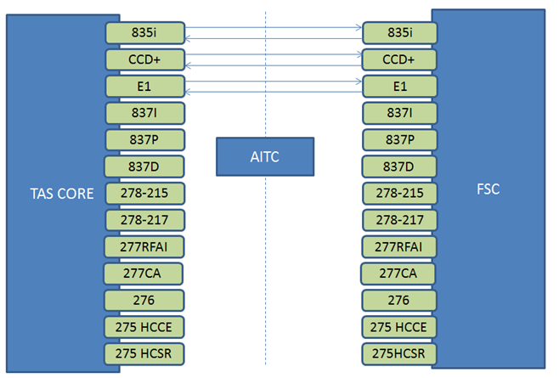

# Action Items

* Tony – Send out information regarding next meeting in a Week Same time
* Steve – Review meeting with others within FSC to start developing an overall architecture, confirm discussions internally, and identify resources – there are resource constraints currently in FSC