TA6255 Prototype ESB Service Management and Monitoring in Mule based on the design in US2855, US2992, and TA5815

# ESB Monitoring and Reporting

Mule Ecosystem

<https://docs.mulesoft.com/runtime-manager/alerts-on-runtime-manager>

<https://docs.mulesoft.com/runtime-manager/>

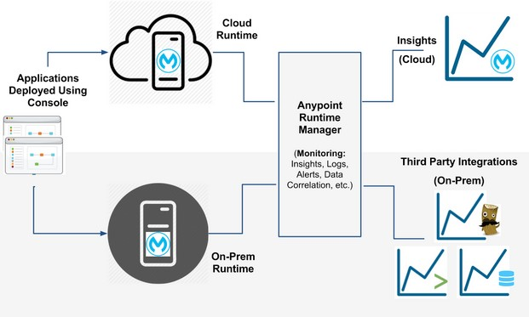

Requires Enterprise License

ELK, Splunk, Custom

<https://docs.mulesoft.com/anypoint-private-cloud/v/1.1.0/installing-anypoint-on-premises>

<https://docs.mulesoft.com/runtime-manager/flow-metrics>

<https://forums.mulesoft.com/questions/45782/how-can-i-calculate-http-response-time-for-every-h.html>

1. If you run Enterprise Edition you can use [business events](https://docs.mulesoft.com/mule-user-guide/v/3.8/business-events) and enable tracing on the HTTP request processor by setting the tracking:enable-default-events="true"attribute. You can then track the time it takes to execute this processor in MMC or Anypoint Runtime Manager.
2. You can place the HTTP request processor in it's own flow and add a [timer interceptor](https://docs.mulesoft.com/mule-user-guide/v/3.8/using-interceptors). This will log the time it takes to execute the flow in the log file. This works in Community Edition.
3. You can also write you custom interceptor and place that before the http requester processor. This also works in Community Edition.

https://docs.mulesoft.com/mule-user-guide/v/3.9/logging-in-mule

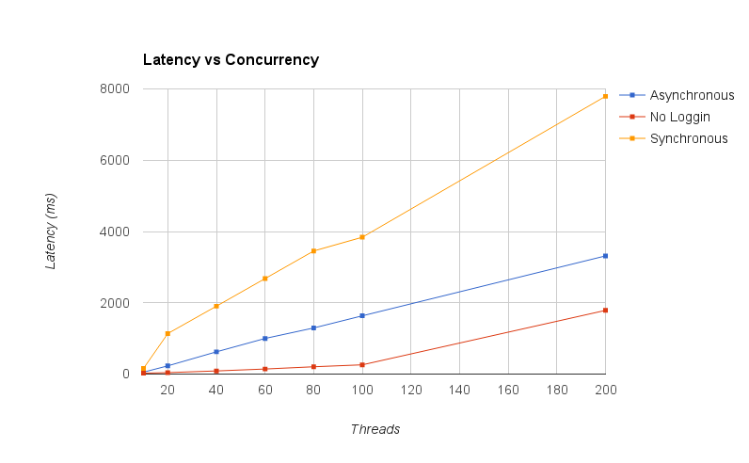

## Deploying

<https://docs.mulesoft.com/mule-user-guide/v/3.9/deploying-to-multiple-environments>

Simple deployment – Export to Anypoint zip file

[~~https://docs.mulesoft.com/runtime-manager/developing-applications-for-cloudhub#specifying-an-http-https-host~~](https://docs.mulesoft.com/runtime-manager/developing-applications-for-cloudhub#specifying-an-http-https-host)

~~Cloud hub – must have ${http.port} reserved~~

~~<http:listener-config name=~~*~~"HTTP_Listener_Configuration_http_port"~~*

~~host=~~*~~"0.0.0.0"~~* ~~port=~~*~~"${http.port}"~~* ~~doc:name=~~*~~"HTTP Listener Configuration"~~* ~~/>~~

## Dead ends

<!-- DJH 11/25/2017 -->

<AsyncLogger name=*"httpclient.wire"* level=*"DEBUG"*/> // doesn’t output anything

<AsyncLogger name=*"org.mule.module.http.internal.HttpMessageLogger"* level=*"DEBUG"* /> // Doesn’t output response time

<AsyncLogger name=*"com.ning.http"* level=*"DEBUG"* />

### Mule Management Console – MMC – requires Enterprise License –

<https://docs.mulesoft.com/mule-management-console/v/3.8/installing-the-production-version-of-mmc>

### Runtime Manager Console

Not applicable – requires enterprise runtime license

<https://docs.mulesoft.com/runtime-manager/flow-metrics>