# TA6495 Prototype authentication/authorization in HAPI FHIR based on IAM design

Methods in provider classes that want to access the header info (SAML token) need to provide a HttpServletRequest parameter.

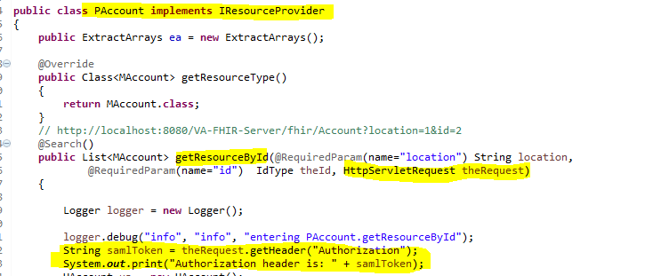

Call the service with Authorization header:

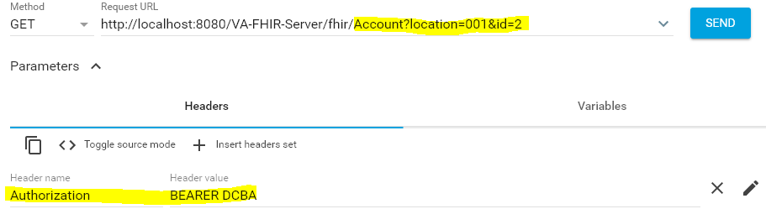

Authorization header gets logged:

