TAS Core Developer Tutorial



March 2018

Department of Veterans Affairs

Office of Information and Technology (OI&T)

### Revision History

| **Date** | **Revision** | **Description** | **Author** |
| --- | --- | --- | --- |
|  |  |  |  |
|  |  |  |  |

Table of Contents

– 1

Revision History 1

Get Git 2

Clone Repo 2

Editing Code 4

Install JavaScript Framework Tools 4

Refresh Code Base and Start Angular Server 4

# Get Git

Git Bash is the console and source control environment required for working with the TAS Core code base. Download Git Bash.

<https://git-scm.com/download/win>

# Clone Repo

Log into Bitbucket and make sure you have permissions to see the code repository.

<https://bitbucket.org/halfaker/mccf_tas_core>

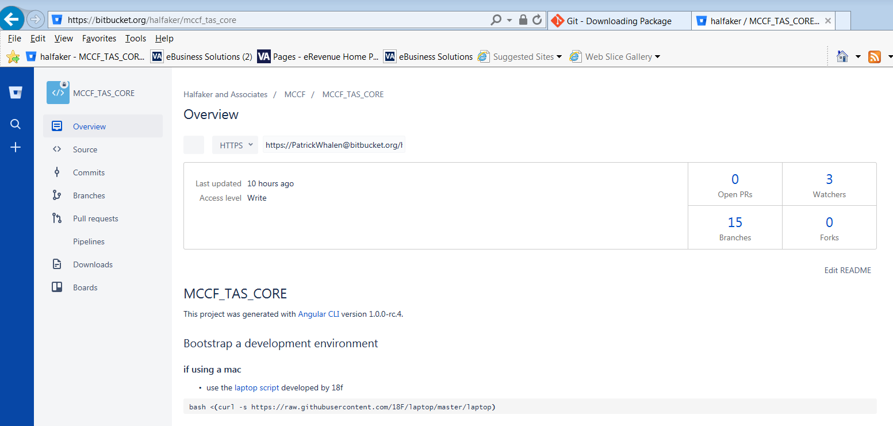

Clone the repo from Git Bash console with git clone and the repo URL. This URL can be found on the Overview page. Note: the account name will change.

**git clone https://PatrickWhalen@bitbucket.org/halfaker/mccf_tas_core.git**

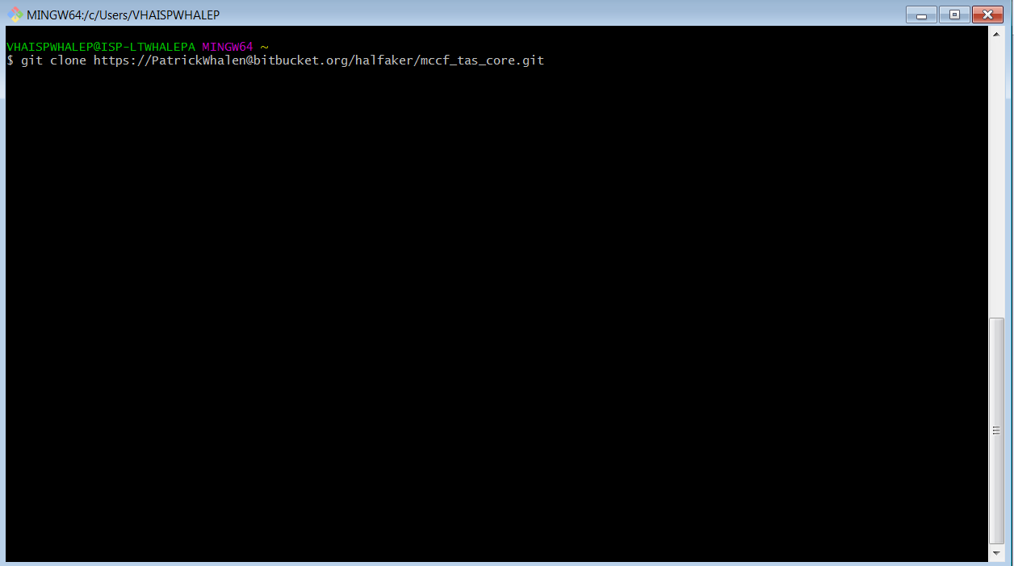

Change to the **mccf_tas_core** directory to see the source code.

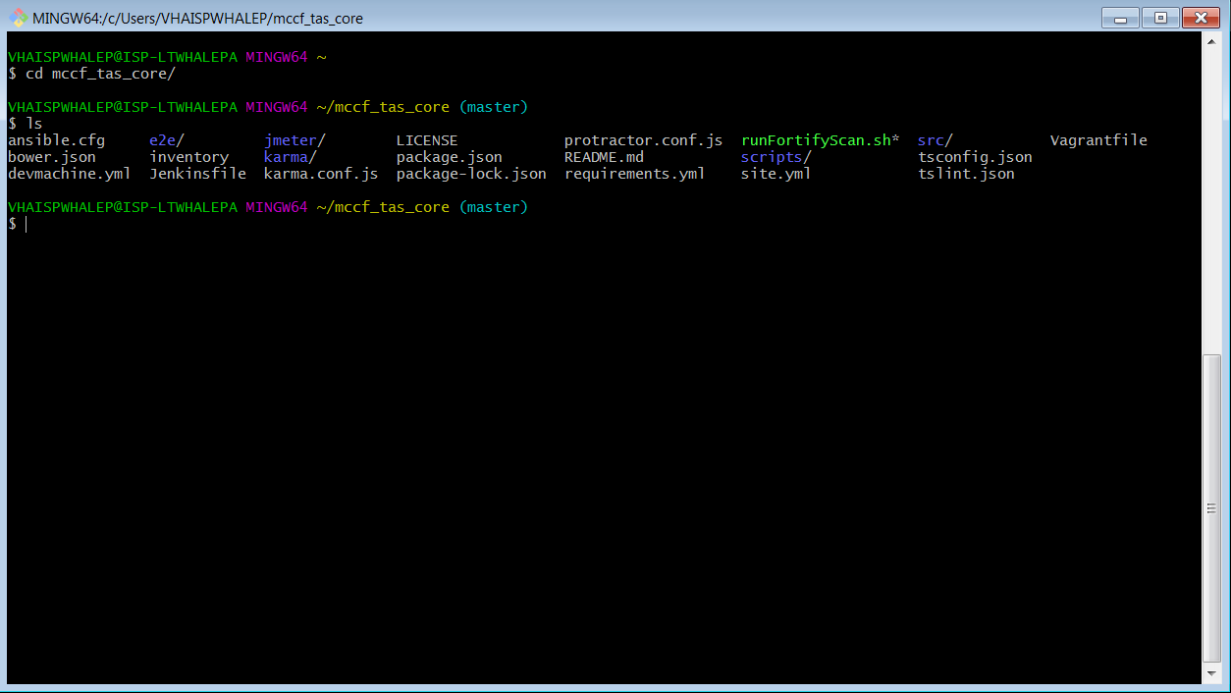

# Editing Code

Next we want to setup an integrated development environment (IDE). You can choose any IDE that supports Angular 2. MCCF team members use **Atom IDE (ide.atom.io)**.

**Atom IDE** requires packages to handle TypeScript code. After installing **Atom, click on “Help” -> “**Welcome Guide” -> “Install a package”. Type in the below package names and click “install”:

* atom-typescript
* busy-signal
* intentions
* linter
* linter-tslint
* linter-ui-default
* merge-conflicts

Finally, add the project folder. Click “File” -> “Add Project Folder”. Navigate to your **MCCF_TAS_CORE** project folder and add it. Now you can edit code inside **Atom IDE**.

# Install JavaScript Framework Tools

1. Go to [https://nodejs.org/en and install nodejs](https://nodejs.org/en%20and%20install%20nodejs)
2. From Git Bash console run: **$ npm install –g @angular/cli**

To verify Angular was installed type in console: **$ ng -v**

(if firewall gives “self signed certificate” error, try: **npm config set strict-ssl false**)

# Refresh Code Base and Start Angular Server

In the Git Bash console we need to get the latest code from the repository and start the development server. Type in the following commands.

Get latest code from repo  
**$ git pull origin master**

Install supporting NPM libraries. This download will take a few minutes.  
**$ npm install**

Start Angular development server  
**$ npm start**