# Content based routing flow

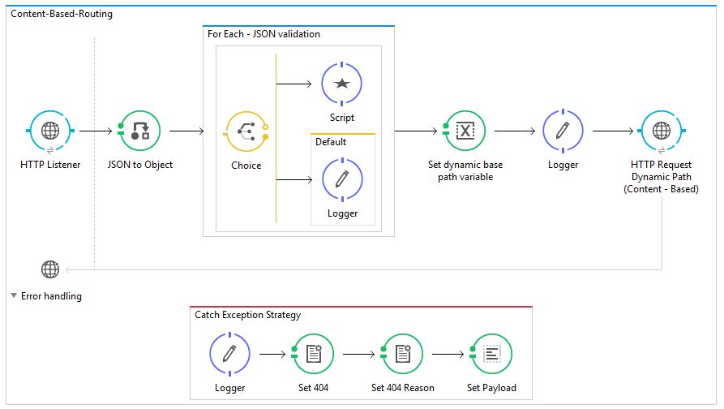

## Prototype

This flow demonstrates an ESB endpoint which accepts a json body, checks to see that it has routing fields, sets those fields as variables and then makes an HTTP request to the target case. The HTTP handles the response error conditions.

### Input JSON (for prototype)

To-Be – will be FHIR.json Bundle Resource

#!/bin/sh  
### leaving query.textSearch undefined  
curl -v -X POST -H "Content-Type: application/json" http://localhost:8081/ -d '[{  
 "type": "warning",  
 "level": "info",  
 "data": "this is an error message - DJH",  
 "dynamic_base_path" : "/api/v1/menus"  
}]  
'

## Config

mule-app.properties config

### inbound port; use this for cloudhub deployments as well

http.port:8081

### target REST API server port

dynamic.request.uri.host:localhost

### target REST API server port

dynamic.request.uri.port:8193

### target REST API http header settings

dynamic.request.x.key:12345

dynamic.request.x.userid:user01x

## Error handling

### Connection Refused

Connection refused is a TCP error condition (no http status) and occurs the target server is offline. ESB error handing has a significant limitation – it cannot trap the exact exception - java.net.ConnectException: Connection refused: no further information

Flow result:

http.status: 404

http.reason: org.mule.api.MessagingException: Error sending HTTP request

message body: Unknown error while attempting: http://localhost:8193/api/v1/menus Exception: org.mule.api.MessagingException: Error sending HTTP request.

### Invalid dynamic url from the json is not

Invalid dynamic url – specifically the url is not , for example /api/v1/menus1 instead of /api/v1/menus as below

Flow result:

http.status: 404

http.reason: ResponseValidatorException: Response code 404 mapped as failure.

message body: Unknown error while attempting: http://localhost:8193/api/v1/menus1 Exception: org.mule.module.http.internal.request.ResponseValidatorException: Response code 404 mapped as failure.

### Malformed json - POST json does not have the expected field

Malformed formed json – json does not have the expected *#[flowVars.dynamic_base_path]*

Flow result:

http.status: 404

http.reason: org.mule.api.MessagingException: null (java.lang.NullPointerException).

message body: Unknown error while attempting: http://localhost:8193null Exception: org.mule.api.MessagingException: null (java.lang.NullPointerException).

HTTP_Request_Configuration_Dynamic set to 5000 ms

## MuleUnit – munit tests

