Medical Care Collections Fund (MCCF) eBilling

Electronic Data Interchange (EDI)

Transactions Applications Suite (TAS)

Interface Control Document

ASC X12N/005010 276/277 Health Care Claim Status  
Request and Response

Logo for the Department of Veterans Affairs, Office of Information and Technology, Product Development, including the official seal of the Department of Veterans Affairs


Department of Veterans Affairs

March 2018

Version 2.0

Revision History

|  |  |  |  |
| --- | --- | --- | --- |
| Date | Version | Description | Author |
| 2/20/18 | 0.0.1 | Initial creation of document | Steffen Maerdian - Halfaker |
| 2/23/18 | 0.0.2 | Creation of the specific transaction document | Keith Oulson- Halfaker |
| 3/2/18 | 0.9 | Finalization of draft | Steffen Maerdian - Halfaker |
| 3/5/18 | 1 | Final review of draft | Keith Oulson - Halfaker |
| 3/19/18 | 1.1 | Incorporating review remarks from FSC and product tea | Steffen Maerdian - Halfaker |
| 3/22/18 | 1.2 | Finishing missing sections | Steffen Maerdian - Halfaker |
| 3/26/18 | 2.0 | Final Draft Review | Keith Oulson – Halfaker & Associates |
|  |  |  |  |
|  |  |  |  |
|  |  |  |  |
|  |  |  |  |
|  |  |  |  |
|  |  |  |  |
|  |  |  |  |
|  |  |  |  |
|  |  |  |  |
|  |  |  |  |
|  |  |  |  |
|  |  |  |  |
|  |  |  |  |

Table of Contents

1 Introduction 1

1.1 Purpose 1

1.2 Scope 1

1.3 System Identification 1

1.3.1 MCCF EDI TAS eBilling 1

1.3.2 FSC 2

1.4 Operational Agreement 2

2 Interface Definition 2

2.1 System Overview 2

2.1.1 Overview Diagram 3

2.2 Interface Overview 5

2.2.1 Connectivity between the systems 5

2.3 Operations 5

2.3.1 Data Extraction 5

2.3.2 Data Transformation 6

2.3.3 Sending/Receiving 6

2.4 Data Transfer 6

2.5 Transaction Types 6

2.6 Data Exchanges 6

2.6.1 FHIR Based Resources 6

2.6.2 JSON Format 7

2.6.3 Bundle Definition 7

2.7 Communications Methods 10

2.7.1 Ports and Protocols 10

2.7.2 ESB Configuration(s) 10

2.7.3 System Configuration 10

2.8 Performance Requirements 10

2.9 Security 10

2.10 Testing Requirements 10

2.10.1 Comparison of Data 10

2.10.2 Completeness 10

2.10.3 Load Testing 11

2.11 Policies and Constraints 11

2.11.1 HIPAA Compliance 11

3 Appendix A 12

3.1 Data Elements 12

3.2 Bundle 12

3.3 Resource Sections 13

3.3.1 276 Request FHIR Bundle Resources 13

3.3.2 277 Response FHIR Bundle Resources 14

3.3.3 Mapping Sheet 14

4 Appendix B - TASCore Mapping Rules 14

5 Appendix C – TASCore Default Values 14

6 Appendix D – FSC Mapping Rules 15

7 Appendix E – FSC Default Values 15

8 Appendix F - Glossary 15

9 Attachment A – Approval Signatures 16

9.1 Signature page continued 17

Table of Figures

Figure 1 - Interim Solution 3

Figure 2 - To Be Solution 4

Figure 3 - Connectivity 5

Figure 4 - FHIR Bundle 8

Figure 5 - FHIR Bundle JSON 9

# Introduction

This document describes the interface between a MCCF EDI TAS application and the VA Financial Services Center in Austin, TX (FSC).

## Purpose

The purpose of this Interface Control Document (ICD) is to define the message structure and protocols which govern the interchange of data between eBilling within MCCF EDI TAS and the VA Financial Services Center (FSC) related to the electronic processing of ASC X12N/005010 276/277 Health Care Claim Status Request (276) and Response (277) messages.

## Scope

This ICD specifies the interface between MCCF EDI TAS eBilling and FSC. This document provides details on the functional, performance, operational and design requirements for the interface. This document defines the layouts for the data that the FSC receives from MCCF EDI TAS eBilling (Request) and the layout for the data that MCCF EDI TAS eBilling receives from the FSC (Response). This document is intended for all parties requiring such information, including business stakeholders, end-users, software developers, system designers, testers and anyone else responsible for implementing this interface.

## System Identification

This ICD describes a generalized interface between the MCCF EDI TAS Platform and the system(s) at the FSC.

### MCCF EDI TAS eBilling

The MCCF EDI TAS Platform will modernize and automate the business processes used currently as part of the VA revenue cycle. This includes insurance verification, billing, and claims processing, payment, and remittance. These processes are tied to other processes that are out of scope, including documenting the care provided, coding treatment and encounters, and sending claims and receiving remittance to and from the clearinghouse.

MCCF EDI TAS eBilling is software designed to support the request and responses related health care claim status inquiries. This interface supports the electronic transmission of 276 Health Care Claim Status Requests and 277 Response between MCCF EDI TAS eBilling and FSC.

|  |  |
| --- | --- |
| System | Details |
| Title | tbd |
| Abbreviation | tbd |
| Version number | tbd |
| Release number | tbd |
| Point of Contact | tbd |
| Vendor [optional] | tbd |

### FSC

The system(s) at FSC, receive(s) the data from the MCCF EDI TAS Platform, translate(s) the data into a standard ASC X12N/005010 276 Health Care Claim Status Request message(s), validate(s) that the data complies with HIPAA standards, and then forward(s) the data to Health Care Clearing House (HCCH). The system(s) at FSC also receive(s) an ASC X12N/005010 277 Health Care Claim Status Response message(s) from the HCCH and forward(s) it/them to the MCCF EDI TAS Platform.

|  |  |
| --- | --- |
| System | Details |
| Title | tbd |
| Abbreviation | tbd |
| Version number | tbd |
| Point of Contact | tbd |
| Vendor [optional] | tbd |

## Operational Agreement

This ICD provides the specification for an interface between MCCF EDI TAS eBilling and FSC regarding Health Care Services Review data. The Chief Business Office (CBO) is responsible for notifying FSC personnel of any potential or planned changes to data feeds once these changes are known to minimize adverse impacts.

# Interface Definition

Health Care Services Review data is transmitted between MCCF EDI TAS eBilling and the FSC in FHIR bundles.

## System Overview

The MCCF EDI TAS eBilling is designed to facilitate transmission of health care claim status requests to the FSC and health care claim status responses from the FSC.

FSC is designed to receive FHIR data from MCCF EDI TAS and to translate that data into a 276 request message. It is also designed to receive a 277 response from the payer and translates it to FHIR data.

### Overview Diagram

Interim solution

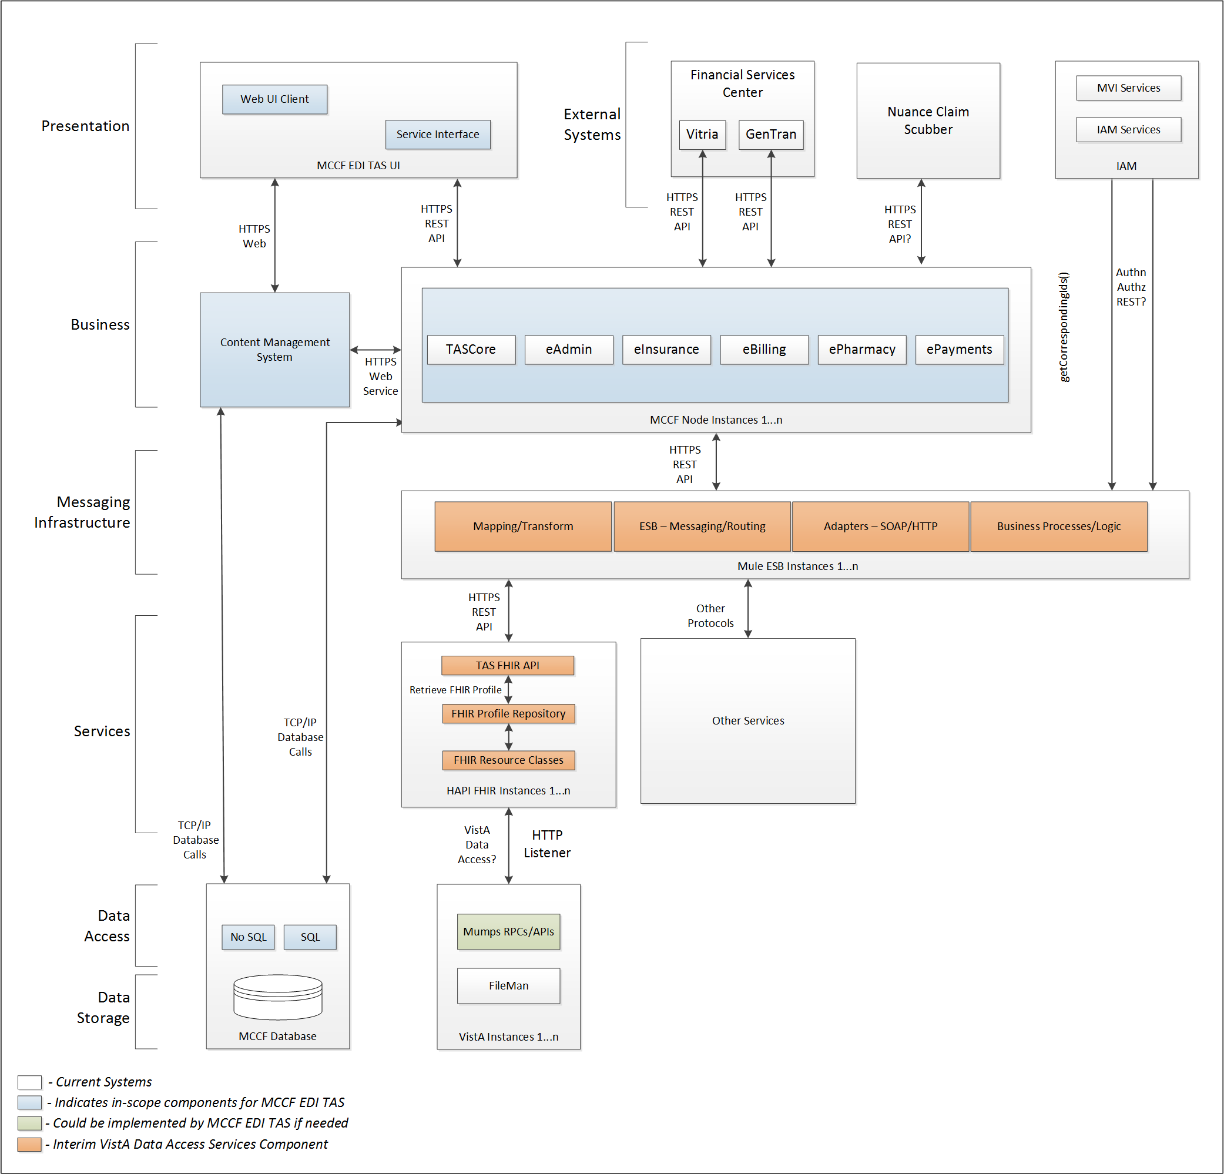

Figure - Interim Solution

To be solution

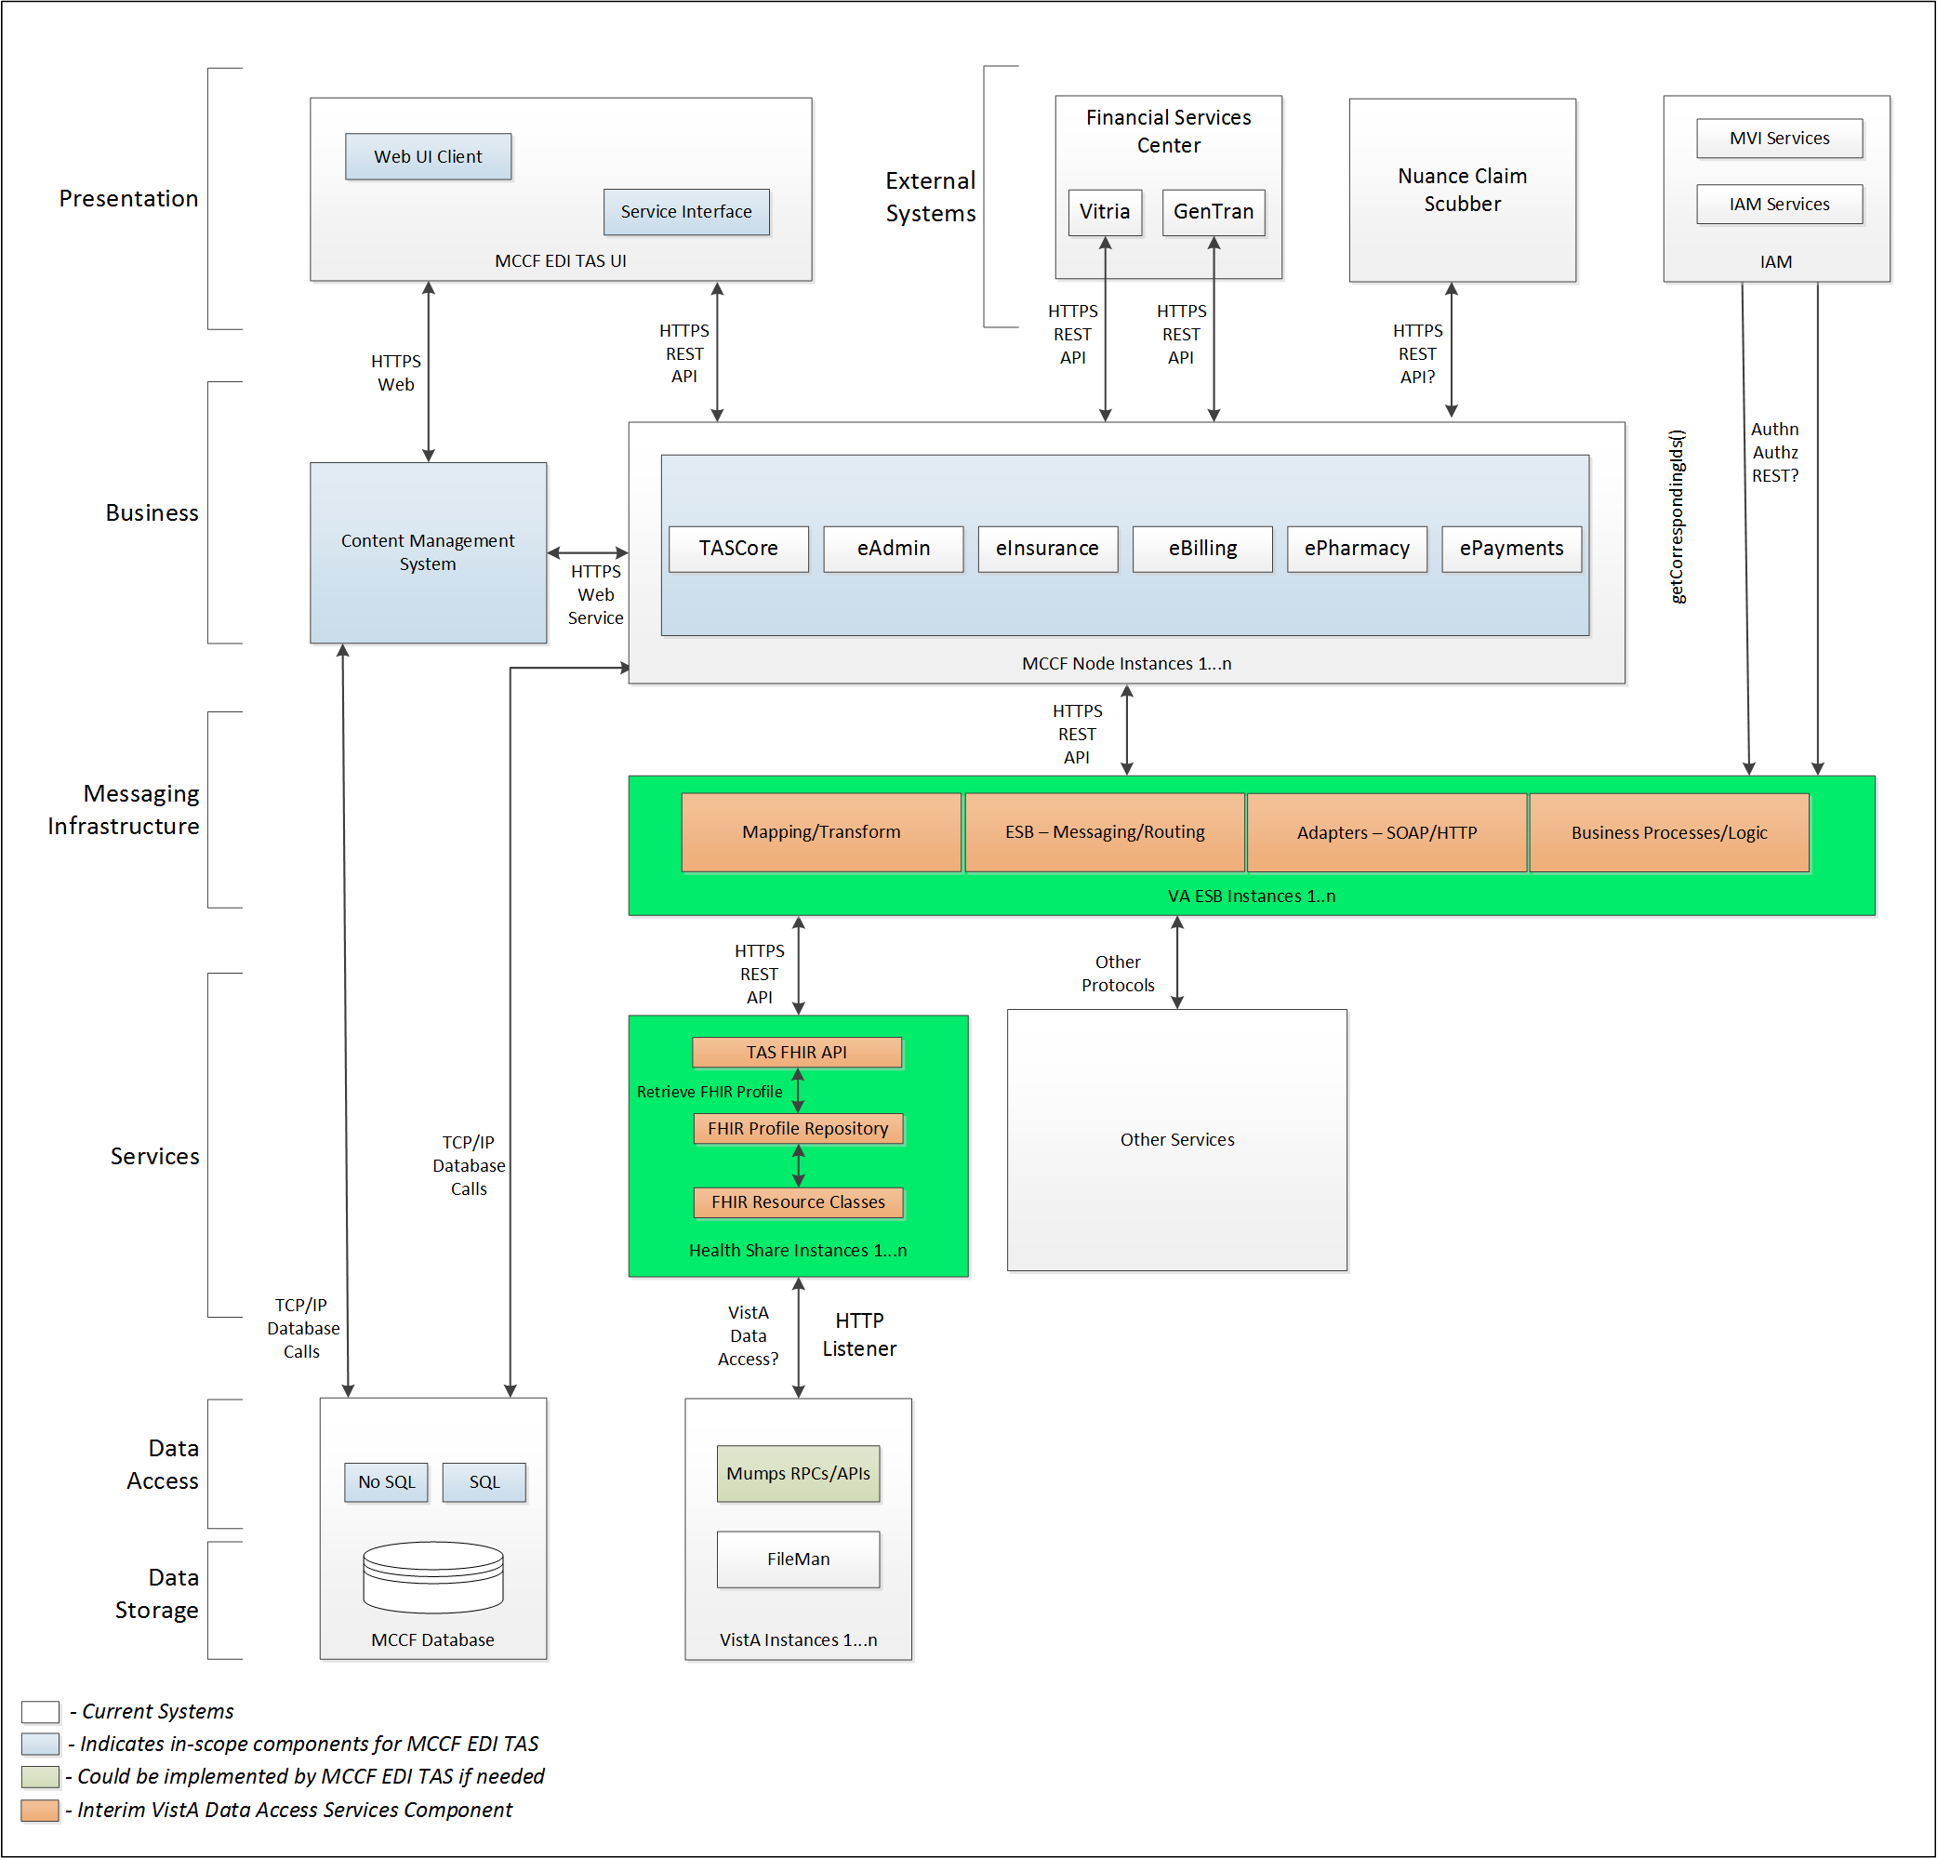

Figure - To Be Solution

## Interface Overview

Exchanging messages between MCCF EDI TAS eBilling and FSC can be done in real time or via message queuing.

### Connectivity between the systems

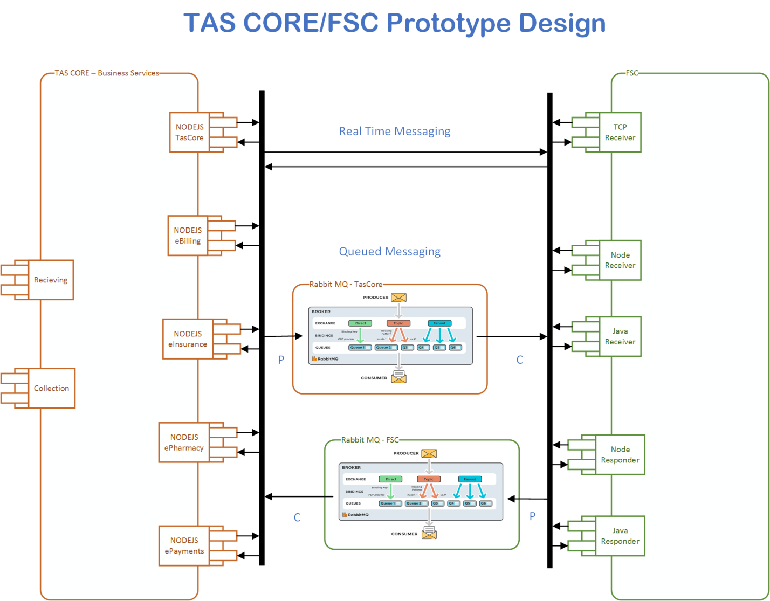

Figure - Connectivity

## Operations

Tbd

### Data Extraction

Data being sent to FSC will be extracted from the VistA databases using a FHIR server.

### Data Transformation

Tbd

### Sending/Receiving

MCCF EDI TAS sends 276 claim status requests to FSC and receives 277 responses from FSC.

## Data Transfer

Data is transferred between the FSC and the TASCore Application Stack**.**

## Transaction Types

MCCF EDI TAS transmits FHIR bundles consisting of different FHIR resources needed to construct a 276 Claim Status Request. The content is modeled on the ASC X12 5010 standard and contains the data elements necessary for FSC to create valid 276 request transactions to then be sent to payers.

FSC receives 277 responses from payers and transmits that data in FHIR resources inside FHIR bundles to MCCF EDI TAS.

## Data Exchanges

MCCF EDI TAS sends a 276 Request FHIR bundle to FSC and receives a 277 Response FHIR bundle from FSC. Refer to Section Appendix A.

### FHIR Based Resources

The following FHIR resources are needed to assemble a 276 Request FHIR bundle

* Basic
* ChargeItem
* Claim
* Group
* MedicationDispense
* MessageHeader
* Organization
* Patient
* Practitioner
* RelatedPerson

The following FHIR resources are needed to assemble a 277 Response FHIR bundle

* Basic
* ChargeItem
* Claim
* Group
* MedicationDispense
* MessageHeader
* Organization
* Patient
* Practitioner
* RelatedPerson

### JSON Format

Messages are formatted using the JSON format and implement a Bundle FHIR Resource.

Refer to <https://www.hl7.org/fhir/json.html> for JSON representation of FHIR Resources.

#### 276 Request FHIR bundle

A bundle implementing a 276 request sent to FSC will have the following structure:

See Appendix A.

#### 277 Response FHIR bundle

A bundle implementing a 277 response received from FSC will have the following structure:

See Appendix A.

### Bundle Definition

A Bundle is a top-level container in FHIR that contains all the FHIR resources desired for a transaction between MCCF EDI TAS and FSC.

A Bundle is a container for resources, enabling you to group and transmit resources altogether at once. Resources such as Claim, Patient, etc. will be transmitted inside multiple entries (see entry list inside Bundle) as a resource type.

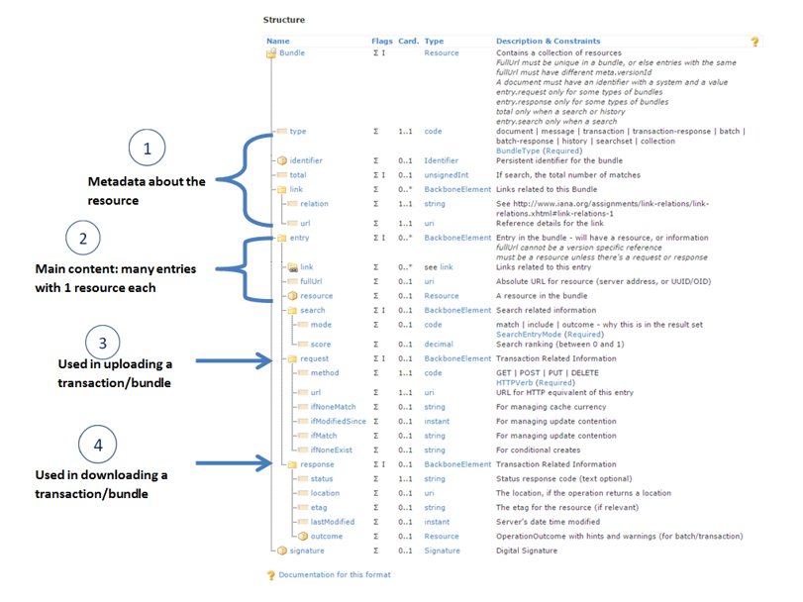

Figure - FHIR Bundle

Source https://fhir-drills.github.io/bundle.html

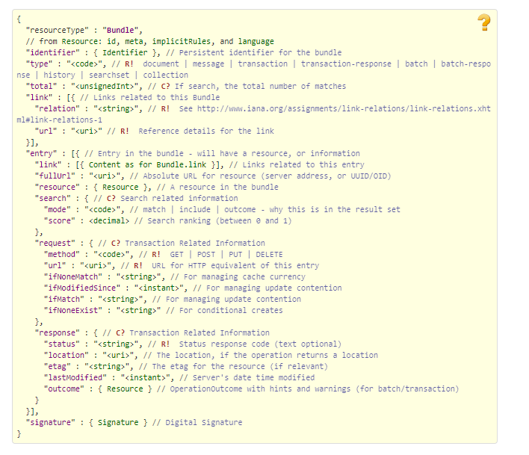

Figure - FHIR Bundle JSON

Source https://www.hl7.org/fhir/bundle.html

## Communications Methods

### Ports and Protocols

#### HTTP(S)

Can be used for real time communication.

#### Advanced Message Queuing Protocol (AMQP)

AMQP offers reliable messaging via queues.

### ESB Configuration(s)

Tbd

### System Configuration

Tbd

## Performance Requirements

Refer to MCCD EDI TAS SDD <https://vaww.oed.portal.va.gov/pm/hape/ipt_5010/EDI_Portfolio/TASCore/MCCF_EDI_TAS_System_Design_Document_v0.7.pdf>

## Security

Refer to MCCD EDI TAS SDD <https://vaww.oed.portal.va.gov/pm/hape/ipt_5010/EDI_Portfolio/TASCore/MCCF_EDI_TAS_System_Design_Document_v0.7.pdf>

## Testing Requirements

### Comparison of Data

Testing the FHIR conformance will be based on https://www.hl7.org/fhir/validation.html.

Business Rules will have to be specifically defined in user stories by the product team.

* Which fields are mandatory from a business perspective?
* Data integrity.

### Completeness

Tests defined in section 2.10.1 must cover all the FHIR resources that are defined in section 2.6.1 in consideration of any functional user story.

### Load Testing

Bench mark tests must be performed based on individual use case requirements.

## Policies and Constraints

### HIPAA Compliance

FSC receives transactions and then translates them into standard ASC X12N/005010 276/277 Health Care Claim Status Requests, validates whether the data complies with HIPAA standards, and then forwards the claim data to the VA Healthcare Clearing House (HCCH).

# Appendix A

## Data Elements

Data being exchanged between TAS and FSC will be formatted in FHIR using the JSON notation. Data elements are mapped into fields in FHIR resources. FHIR resources will be located inside a FHIR bundle.

## Bundle

Repeating fields within a segment need context definition so they can be differentiated within a segment.

Also, repeating fields across multiple segments need to be differentiated. Following steps have been used to assign context to fields.

1. Identify the segment where the resource is located (Bundle.entry.extension.url="segment" and Bundle.entry.extension.valueString=" 276-NM1-2100A") [MessageType-Segment]
2. Where elements repeat within a segment use extension.valueString to identify field (Basic.extension.url="sequence" and Basic.extension.valueString=" 276-NM1-2100A-1") [MessageType-Segment-Field]
3. Repeating segments will include an incrementing id (276-REF-2200D-1, 276-REF-2200D-2, ...)

Following JSON files describe the 276 request and 277 response bundles. The JSON bundle files are auto-generated using the mapping sheets. They may not be accurate and there are issues that we are aware of. We are continuing to fix the issues that we've identified.



## Resource Sections

### 276 Request FHIR Bundle Resources

#### Basic

See Basic resource in 276 Bundle included in section 3.2

#### ChargeItem

See ChargeItem resource in 276 Bundle included in section 3.2

#### Claim

See Claim resource in 276 Bundle included in section 3.2

#### Group

See Group resource in 276 Bundle included in section 3.2

#### MedicationDispense

See MedicationDispense resource in 276 Bundle included in section 3.2

#### MessageHeader

See MessageHeader resource in 276 Bundle included in section 3.2

#### Organization

See Organization resource in 276 Bundle included in section 3.2

#### Patient

See Patient resource in 276 Bundle included in section 3.2

#### Practitioner

See Practitioner resource in 276 Bundle included in section 3.2

#### RelatedPerson

See RelatedPerson resource in 276 Bundle included in section 3.2

### 277 Response FHIR Bundle Resources

#### Basic

See Basic resource in 277 Bundle included in section 3.2

#### ChargeItem

See ChargeItem resource in 277 Bundle included in section 3.2

#### Claim

See Claim resource in 277 Bundle included in section 3.2

#### Group

See Group resource in 277 Bundle included in section 3.2

#### MedicationDispense

See MedicationDispense resource in 277 Bundle included in section 3.2

#### MessageHeader

See MessageHeader resource in 277 Bundle included in section 3.2

#### Organization

See Organization resource in 277 Bundle included in section 3.2

#### Patient

See Patient resource in 277 Bundle included in section 3.2

#### Practitioner

See Practitioner resource in 277 Bundle included in section 3.2

#### RelatedPerson

See RelatedPerson resource in 277 Bundle included in section 3.2

### Mapping Sheet



# Appendix B - TASCore Mapping Rules

Tbd

# Appendix C – TASCore Default Values

Tbd

# Appendix D – FSC Mapping Rules

Tbd

# Appendix E – FSC Default Values

Tbd

# Appendix F - Glossary

| **Term** | **Meaning** |
| --- | --- |
| AMQP - Advanced Message Queuing Protocol | The *Advanced Message Queuing Protocol* (*AMQP*) is an open standard for passing business messages between applications or organizations using queues. |
| HCCH | Health Care Clearing House |
| REST - REpresentational State Transfer | REpresentational State Transfer, or RESTful web services provide interoperability between computer systems on the Internet or other network. Sometimes spelled ReST. |

# Attachment A – Approval Signatures

This section is used to document the approval of the ICD. The review should be conducted face to face where signatures can be obtained ‘live’ during the review. If unable to conduct a face-to-face meeting then it should be held via Lync and concurrence captured during the meeting. The Scribe should add /es/name by each position cited.

By signing below, I agree that I have reviewed and agree the document is approved.



## Signature page continued

