Medical Care Collections Fund (MCCF)

Electronic Data Interchange (EDI)

Transactions Applications Suite (TAS)

Electronic Insurance Verification (eIV)

Interface Control Document

ASC X12N/005010 270 Health Care Eligibility Benefits Inquiry

and

ASC X12N/005010 271 Health Care Eligibility Benefits Response

Logo for the Department of Veterans Affairs, Office of Information and Technology, Product Development, including the official seal of the Department of Veterans Affairs


Department of Veterans Affairs

May 2018

Version 2.2

Revision History

|  |  |  |  |
| --- | --- | --- | --- |
| Date | Version | Description | Author |
| 2/22/18 | 0.0.1 | Initial creation of document | Steffen Maerdian - Halfaker |
| 2/26/18 | 0.0.2 | Formatting | Steffen Maerdian - Halfaker |
| 2/28/18 | 1.0 | Finalization of draft | Steffen Maerdian - Halfaker |
| 3/22/18 | 1.1 | Incorporating review remarks FSC and product team | Steffen Maerdian - Halfaker |
| 3/26/18 | 2.0 | Review Final Draft | Keith Oulson – Halfaker & Associates |
| 4/19/18 | 2.1 | Adding latest mapping sheets | Steffen Maerdian - Halfaker |
| 4/27/18 | 2.11 | Corrected signature page according to Frank Annecchini | Keith Oulson – Halfaker & Associates |
| 5/11/2018 | 2.2 | Corrected JSON reference files | Keith Oulson – Halfaker & Associates |
|  |  |  |  |
|  |  |  |  |
|  |  |  |  |
|  |  |  |  |
|  |  |  |  |
|  |  |  |  |
|  |  |  |  |
|  |  |  |  |
|  |  |  |  |
|  |  |  |  |
|  |  |  |  |
|  |  |  |  |

Table of Contents

1 Introduction 1

1.1 Purpose 1

1.2 Scope 1

1.3 System Identification 1

1.3.1 MCCF EDI TAS eInsurance 1

1.3.2 FSC 2

1.4 Operational Agreement 2

2 Interface Definition 3

2.1 System Overview 3

2.1.1 Overview Diagram 4

2.2 Interface Overview 6

2.2.1 Connectivity between the systems 6

2.3 Operations 6

2.3.1 Data Extraction 6

2.3.2 Data Transformation 7

2.3.3 Sending/Receiving 7

2.4 Data Transfer 7

2.5 Transaction Types 7

2.6 Data Exchanges 7

2.6.1 FHIR Based Resources 7

2.6.2 JSON Format 8

2.6.3 Bundle Definition 9

2.7 Communications Methods 12

2.7.1 Ports and Protocols 12

2.7.2 ESB Configuration(s) 12

2.7.3 System Configuration 12

2.8 Performance Requirements 12

2.9 Security 12

2.10 Testing Requirements 12

2.10.1 Comparison of Data 12

2.10.2 Completeness 12

2.10.3 Load Testing 12

2.11 Policies and Constraints 13

2.11.1 HIPAA Compliance 13

3 Appendix A 1

3.1 Data Elements 1

3.2 Bundle 1

3.3 Resource Sections 2

3.3.1 270 Request FHIR Bundle Resources 2

3.3.2 271 Response FHIR Bundle Resources 3

3.3.3 Mapping Sheets 4

4 Appendix B - TASCore Mapping Rules 4

5 Appendix C – TASCore Default Values 4

6 Appendix D – FSC Mapping Rules 5

7 Appendix E – FSC Default Values 5

8 Appendix F - Glossary 5

9 Attachment A – Approval Signatures 6

Table of Figures

Figure 1 - Interim Solution 4

Figure 2 - To Be Solution 5

Figure 3 - Connectivity 6

Figure 4 - FHIR Bundle 10

Figure 5 - FHIR Bundle JSON 11

# Introduction

This document describes the eIV interface between the MCCF EDI TAS eInsurance application and the VA Financial Services Center in Austin, TX (FSC) for ASC X12N/005010 270 Health Care Eligibility Benefits Inquiry and ASC X12N/005010 271 Health Care Eligibility Benefits response transactions.

## Purpose

The purpose of this eIV TAS/FSC Interface Control Document (ICD) is to define the message structure and protocols which govern the interchange of insurance eligibility data between eInsurance within MCCF EDI TAS and the FSC related to the electronic processing of

* ASC X12N/005010 270 Health Care Eligibility Benefits Inquiry
* and
* ASC X12N/005010 271 Health Care Eligibility Benefits Response

messages.

## Scope

This ICD specifies the eIV interface between FSC and MCCF EDI TAS eInsurance. This document provides details on the functional, performance, operational, and design requirements for the interface. This document defines the layouts for the data that the FSC receives from MCCF EDI TAS eInsurance (Inquiries) and the layout for the data that MCCF EDI TAS eInsurance receives from the FSC (Reponses). This document is intended for all parties requiring such information, including business stakeholders, end-users, software developers, system designers, testers, and anyone else responsible for implementing this interface.

## System Identification

This ICD describes the eIV interface between the MCCF EDI TAS Platform and the system(s) at the FSC.

### MCCF EDI TAS eInsurance

The MCCF EDI TAS Platform will modernize and automate the business processes used currently as part of the VA revenue cycle. This includes insurance verification, billing and claims processing, payment, and remittance.

This interface supports the eIV process which involves the electronic transmission of ASC X12N/005010 270 Health Care Eligibility Benefits Inquiry messages to VA’s clearinghouse(s), where insurance data are transmitted to the payers. It also supports receiving ASC X12N/005010 271 Health Care Eligibility Benefits Responses sent from clearinghouse(s) to the FSC and back to TAS.

|  |  |
| --- | --- |
| System | Details |
| Title | tbd |
| Abbreviation | tbd |
| Version number | tbd |
| Release number | tbd |
| Point of Contact | tbd |
| Vendor [optional] | tbd |

### 

### FSC

The system(s) at FSC, receive(s) the data from the MCCF EDI TAS Platform, translate(s) the data into a standard ASC X12N/005010 270 Health Care Eligibility Benefits transmission, validates that the data complies with HIPAA standards, and then forward(s) the eIV data to VA’s clearinghouse(s). The system(s) at FSC also receive(s) ASC X12N/005010 271 Health Care Eligibility Benefits Responses from VA’s clearinghouse(s) and forward(s) it/them to the MCCF EDI TAS Platform.

|  |  |
| --- | --- |
| System | Details |
| Title | tbd |
| Abbreviation | tbd |
| Version number | tbd |
| Point of Contact | tbd |
| Vendor [optional] | tbd |

## Operational Agreement

This ICD provides the specification for an interface between FSC and MCCF EDI TAS eInsurance regarding Health Care Eligibility Benefits data. The VHA Office of Community Care (VHA CC) eBusiness Solutions Team – eInsurance is responsible for notifying FSC personnel of any potential or planned changes to data feeds once these changes are known in order to minimize adverse impacts.

# Interface Definition

Health Care Eligibility Benefits data is transmitted between MCCF EDI TAS eInsurance and the FSC in FHIR bundles. One bundle will be used for each 270/271 message.

## System Overview

The MCCF EDI TAS eInsurance system is designed to facilitate transmission of Health Care Eligibility Benefits Inquiries to the FSC and Health Care Eligibility Benefits Responses from the FSC.

FSC is designed to receive FHIR data from MCCF EDI TAS eInsurance and to translate that data into an ASC X12N/005010 270 Health Care Eligibility Benefits Inquiry message. FSC is also designed to receive an ASC X12N/005010 271 Health Care Eligibility Benefits Response from payers, to translate it to FHIR data and to send it to MCCD EDI TAS eInsurance.

### Overview Diagram

Interim solution

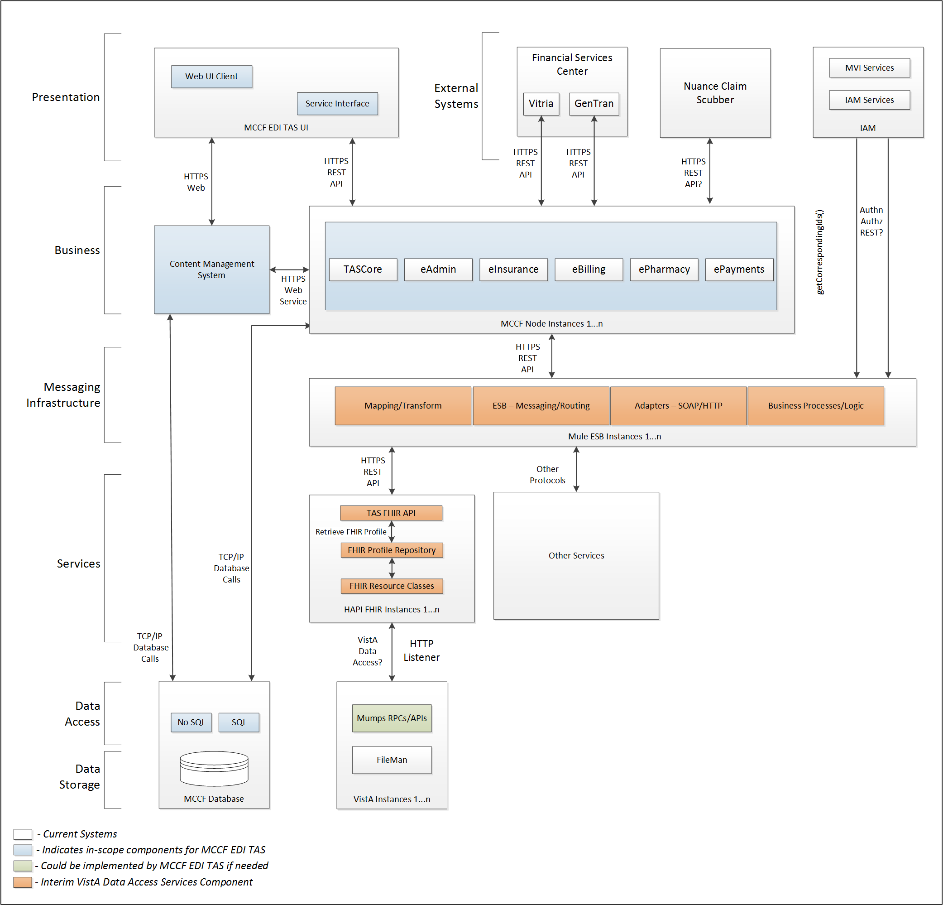

Figure 1 - Interim Solution

To be solution

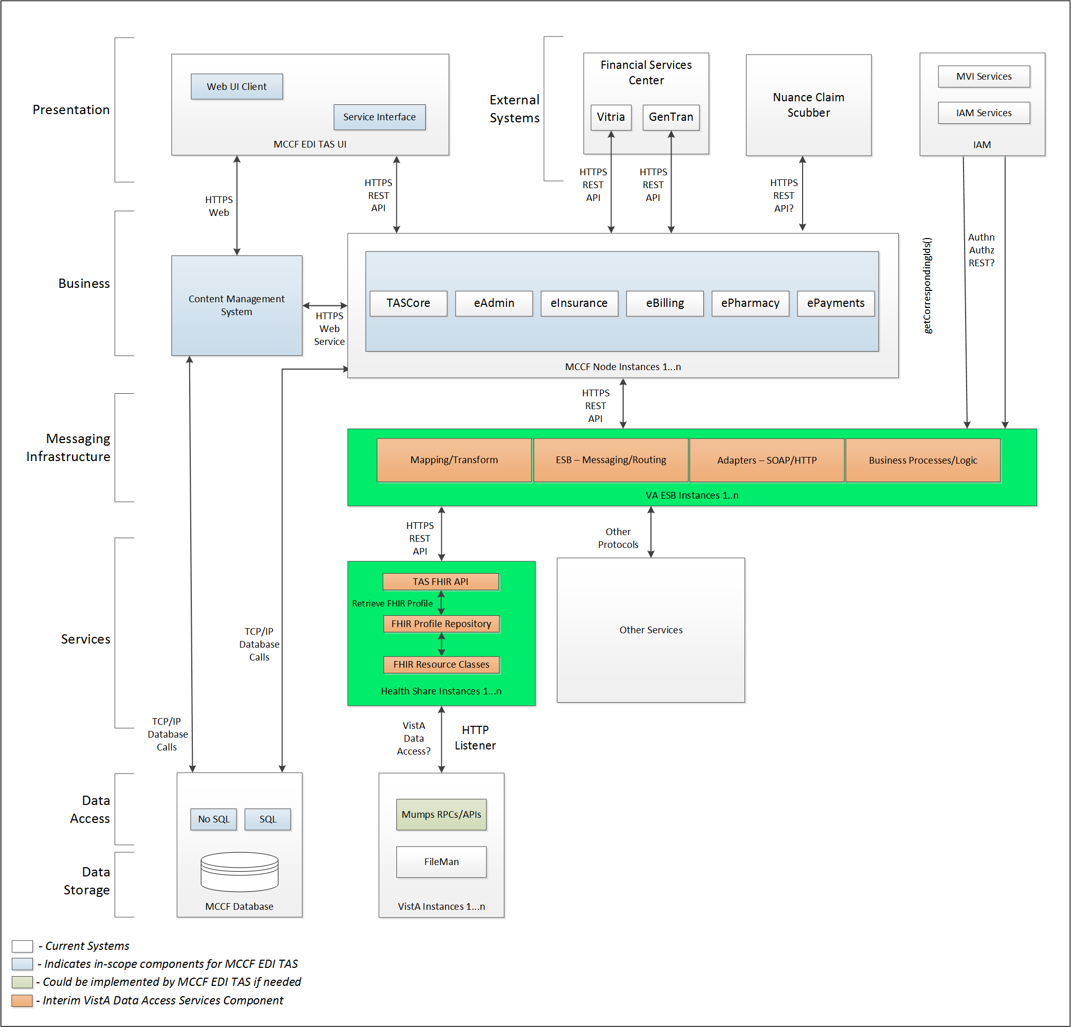

Figure 2 - To Be Solution

## Interface Overview

Exchanging messages between FSC and MCCF EDI TAS eInsurance can be done in real time or as queued messaging.

### Connectivity between the systems

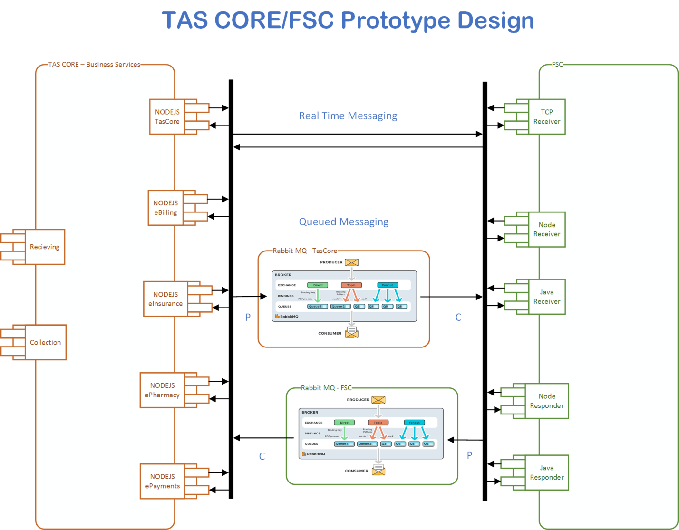

Figure 3 - Connectivity

## Operations

### Data Extraction

Data being sent to FSC will be extracted from the VistA databases using a FHIR server.

### Data Transformation

Tbd

### Sending/Receiving

MCCF EDI TAS sends ASC X12N/005010 270 Health Care Eligibility Benefits Inquiries in FHIR Bundles to FSC and receives ASC X12N/005010 271 Health Care Eligibility Benefits Responses in FHIR Bundles from FSC.

## Data Transfer

Data is transferred between the FSC and the TASCore Application Stack.

## Transaction Types

MCCF EDI TAS eInsurance transmits FHIR bundles consisting of different FHIR resources needed to construct a 270 inquiry type message. The content is modeled on the ASC X12 5010 standard and contains the data elements necessary for FSC to create valid 270 inquiry transactions to send to payers.

FSC receives 271 response types from payers and transmits that data in FHIR resources inside FHIR bundles to MCCF EDI TAS eInsurance.

## Data Exchanges

MCCF EDI TAS eInsurance sends a 270 Inquiry FHIR bundle to FSC and receives a 271 Response FHIR bundle from FSC. Refer to Appendix A.

### FHIR Based Resources

The following FHIR resources are needed to assemble a 270 Request FHIR bundle

* Appointment
* Basic
* Communication
* Coverage
* Encounter
* Location
* MessageHeader
* Organization
* Patient
* RelatedPerson
* PractitionerRole
* ProcessRequest

The following FHIR resources are needed to assemble a 271 Response FHIR bundle

* Appointment
* Basic
* CarePlan
* Communication
* Condition
* Coverage
* EligibilityRequest
* EligibilityResponse
* Location
* MessageHeader
* OperationOutcome
* Organization
* RelatedPerson
* Person
* Practitioner
* PractitionerRole
* Procedure
* ProcessRequest
* ProcessResponse
* Task

### JSON Format

Messages are formatted using the JSON format and implement a Bundle FHIR Resource.

Refer to <https://www.hl7.org/fhir/json.html> for JSON representation of FHIR Resources.

#### 270 Request FHIR bundle

A bundle implementing a 270 request sent to FSC will have the following structure:

See section 3.3.1.

#### 271 Response FHIR bundle

A bundle implementing a 271 request sent from FSC will have the following structure:

See section 3.3.2.

### Bundle Definition

A Bundle is a top-level container in FHIR that contains all the FHIR resources desired for a transaction between MCCF EDI TAS and FSC.

A Bundle is a container for resources, enabling grouping and transmitting resources altogether at once. Resources such as Claim, Patient, etc., will be transmitted inside multiple entries (see entry list inside Bundle) as a resource type.

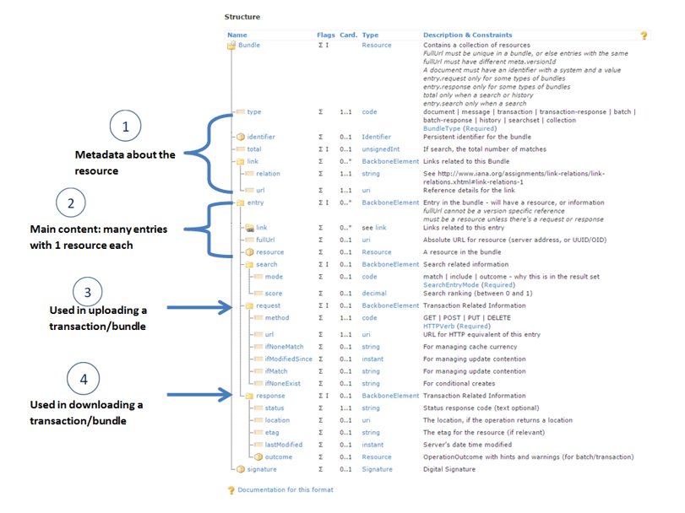

Figure - FHIR Bundle

Source https://fhir-drills.github.io/bundle.html

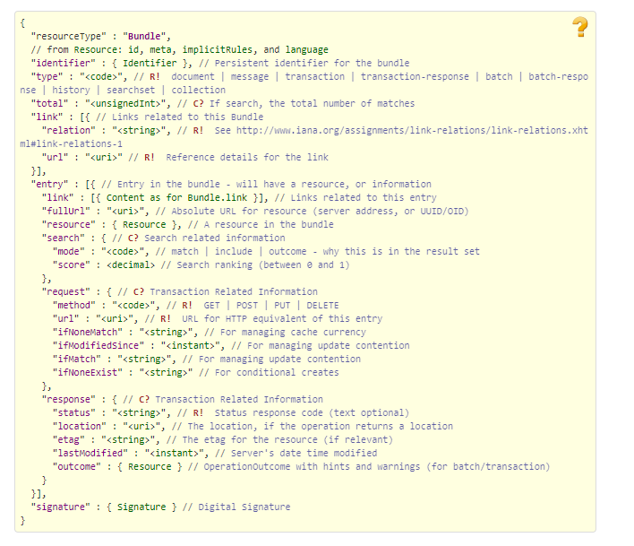

Figure 5 - FHIR Bundle JSON

Source https://www.hl7.org/fhir/bundle.html

## Communications Methods

### Ports and Protocols

#### HTTP(S)

Can be used for real time communication.

#### Advanced Message Queuing Protocol (AMQP)

AMQP offers reliable messaging via queues.

### ESB Configuration(s)

Tbd

### System Configuration

Tbd

## Performance Requirements

Refer to MCCD EDI TAS SDD <https://vaww.oed.portal.va.gov/pm/hape/ipt_5010/EDI_Portfolio/TASCore/MCCF_EDI_TAS_System_Design_Document_v0.7.pdf>

## Security

Refer to MCCD EDI TAS SDD <https://vaww.oed.portal.va.gov/pm/hape/ipt_5010/EDI_Portfolio/TASCore/MCCF_EDI_TAS_System_Design_Document_v0.7.pdf>

## Testing Requirements

### Comparison of Data

Testing the FHIR conformance will be based on <https://www.hl7.org/fhir/validation.html>.

Business Rules will have to be specifically defined in user stories by the product team.

* Which fields are mandatory from a business perspective?
* Data integrity.

### Completeness

Tests defined in section 2.10.1 must cover all the FHIR resources that are defined in section 2.6.1 in consideration of any functional user story.

### Load Testing

Bench mark tests must be performed based on individual use case requirements.

## Policies and Constraints

### HIPAA Compliance

FSC receives transactions and then translates them into standard ASC X12N/005010 270 Health Care Eligibility Benefits Inquiry, validates whether the data complies with HIPAA standards, and then forwards the eIV data to the VA Healthcare Clearing House (HCCH).

# Appendix A

## Data Elements

Data being exchanged between TAS and FSC will be formatted in FHIR using the JSON notation. Data elements are mapped into fields in FHIR resources. FHIR resources will be located inside a FHIR bundle.

## Bundle

Repeating fields within a segment need context definition so they can be differentiated within a segment.

Also, repeating fields across multiple segments need to be differentiated. Following steps have been used to assign context to fields.

1. Identify the segment where the resource is located (Bundle.entry.extension.url="segment" and Bundle.entry.extension.valueString=" 270-MSH") [MessageType-Segment]
2. Where elements repeat within a segment use extension.valueString to identify field (Location.identifier.extension.url="sequence", Location.identifier.extension.valueString="270-MSH-4") [MessageType-Segment-Field]
3. Repeating segments will include an incrementing id (MSA1, MSA2, ...)

Following JSON files describe the 270 request and 271 response bundles.





## Resource Sections

### 270 Request FHIR Bundle Resources

#### Appointment

See Appointment resource in Bundle included in section 3.2

See Basic resource in Bundle included in section 3.2

#### Communication

See Communication resource in Bundle included in section 3.2

#### Coverage

See Coverage resource in Bundle included in section 3.2

#### Encounter

See Encounter resource in Bundle included in section 3.2

#### Location

See Location resource in Bundle included in section 3.2

#### MessageHeader

See MessageHeader resource in Bundle included in section 3.2

#### Organization

See Organization resource in Bundle included in section 3.2

#### Patient

See Patient resource in Bundle included in section 3.2

#### RelatedPerson

See RelatedPerson resource in Bundle included in section 3.2

#### PractitionerRole

See PractitionerRole resource in Bundle included in section 3.2

#### ProcessRequest

See Appointment resource in ProcessRequest included in section 3.2

### 271 Response FHIR Bundle Resources

#### Appointment

See Appointment resource in Bundle included in section 3.2

See Basic resource in Bundle included in section 3.2

#### CarePlan

See CarePlan resource in Bundle included in section 3.2

#### Communication

See Communication resource in Bundle included in section 3.2

#### Condition

See Condition resource in Bundle included in section 3.2

#### Coverage

See Coverage resource in Bundle included in section 3.2

#### EligibilityRequest

See EligibilityRequest resource in Bundle included in section 3.2

#### EligibilityResponse

See EligibilityResponse resource in Bundle included in section 3.2

#### Location

See Location resource in Bundle included in section 3.2

#### MessageHeader

See MessageHeader resource in Bundle included in section 3.2

#### OperationOutcome

See OperationOutcome resource in Bundle included in section 3.2

#### Organization

See Organization resource in Bundle included in section 3.2

#### RelatedPerson

See RelatedPerson resource in Bundle included in section 3.2

#### Person

See Person resource in Bundle included in section 3.2

#### Practitioner

See Practitioner resource in Bundle included in section 3.2

#### PractitionerRole

See PractitionerRole resource in Bundle included in section 3.2

#### Procedure

See Procedure resource in Bundle included in section 3.2

#### ProcessRequest

See ProcessRequest resource in Bundle included in section 3.2

#### ProcessResponse

See ProcessResponse resource in Bundle included in section 3.2

#### Task

See Task resource in Bundle included in section 3.2

### Mapping Sheets



# Appendix B - TASCore Mapping Rules

# Appendix C – TASCore Default Values

# Appendix D – FSC Mapping Rules

# Appendix E – FSC Default Values

See mapping sheets section 3.3.3

# Appendix F - Glossary

| **Term** | **Meaning** |
| --- | --- |
| AMQP - Advanced Message Queuing Protocol | The *Advanced Message Queuing Protocol* (*AMQP*) is an open standard for passing business messages between applications or organizations using queues. |
| HCCH | Health Care Clearing House |
| REST - REpresentational State Transfer | REpresentational State Transfer, or RESTful web services provide interoperability between computer systems on the Internet or other network. Sometimes spelled ReST. |
| RabbitMQ | RabbitMQ is the most widely deployed open source message broker. With more than 35,000 production deployments of RabbitMQ world-wide at small startups and large enterprises, RabbitMQ is the most popular open source message broker. RabbitMQ is lightweight and easy to deploy on premises and in the cloud. |

# Attachment A – Approval Signatures

This section is used to document the approval of the ICD. The review should be conducted face to face where signatures can be obtained ‘live’ during the review. If unable to conduct a face-to-face meeting then it should be held via Lync and concurrence captured during the meeting. The Scribe should add /es/name by each position cited.

By signing below, I agree that I have reviewed and agree the document is approved.

