Medical Care Collections Fund (MCCF) eBilling

Electronic Data Interchange (EDI)

Transactions Applications Suite (TAS)

Interface Control Document

ASC X12N/005010 275 Additional Information to Support a

Health Care Claim or Encounter

Logo for the Department of Veterans Affairs, Office of Information and Technology, Product Development, including the official seal of the Department of Veterans Affairs


Department of Veterans Affairs

March 2018

Version 2.0

Revision History

|  |  |  |  |
| --- | --- | --- | --- |
| Date | Version | Description | Author |
| 2/20/18 | 0.0.1 | Initial creation of document | Steffen Maerdian - Halfaker |
| 2/21/2018 | 0.0.2 | Creation of the specific 275 transaction document with formatting and content updates for initial draft | Keith Oulson – Halfaker and Associates |
| 3/2/18 | 1.0 | Reviewing for initial draft | Steffen Maerdian - Halfaker |
| 3/19/18 | 1.5 | Incorporation of review comments from eBilling and Technical Writer – FSC did not deliver review on due date. | Keith Oulson – Halfaker & Associates |
| 3/26/18 | 2.0 | Review | Steffen Maerdian - Halfaker |
|  |  |  |  |
|  |  |  |  |
|  |  |  |  |
|  |  |  |  |
|  |  |  |  |
|  |  |  |  |
|  |  |  |  |
|  |  |  |  |
|  |  |  |  |
|  |  |  |  |
|  |  |  |  |
|  |  |  |  |
|  |  |  |  |
|  |  |  |  |
|  |  |  |  |

Table of Contents

1 Introduction 1

1.1 Purpose 1

1.2 Scope 1

1.3 System Identification 1

1.3.1 MCCF EDI TAS eBilling 2

1.3.2 FSC 2

1.4 Operational Agreement 2

2 Interface Definition 3

2.1 System Overview 3

2.1.1 Overview Diagram 3

2.2 Interface Overview 5

2.2.1 Connectivity between the systems 5

2.3 Operations 6

2.3.1 Data Extraction 6

2.3.2 Data Transformation 6

2.3.3 Sending/Receiving 6

2.4 Data Transfer 6

2.5 Transaction Types 6

2.6 Data Exchanges 6

2.6.1 FHIR Based Resources 7

2.6.2 JSON Format 7

2.6.3 Bundle Definition 7

2.7 Communications Methods 9

2.7.1 Ports and Protocols 9

2.7.2 ESB Configuration(s) 9

2.7.3 System Configuration 9

2.8 Performance Requirements 10

2.9 Security 10

2.10 Testing Requirements 10

2.10.1 Comparison of Data 10

2.10.2 Completeness 10

2.10.3 Load Testing 10

2.11 Policies and Constraints 11

2.11.1 HIPAA Compliance 11

3 Appendix A 12

3.1 Data Elements 12

3.2 Bundle (275) 12

3.2.1 275 Additional Information to Support a Claim or Encounter Bundle 12

3.3 Resource Sections 13

3.3.1 275 Transaction FHIR Bundle Resources 13

3.4 Mapping Sheet 13

4 Appendix B - TASCore Mapping Rules 13

5 Appendix C – TASCore Default Values 13

6 Appendix D – FSC Mapping Rules 13

7 Appendix E – FSC Default Values 13

8 Glossary 14

9 Attachment A – Approval Signatures 15

9.1 Signature page continued 16

**Table of Figures**

Figure 1- Interim Solution 3

Figure 2 - Future (To Be) Solution 4

Figure 3 - TASCore / FSC Connectivity 5

Figure 4 – Example FHIR Bundle content 8

Figure 5 – Example FHIR Bundle layout 9

# Introduction

This document describes the interface between an MCCF EDI TAS application and the VA Financial Services Center in Austin, TX (FSC) related to the electronic processing of ASC X12N/005010 275 Additional Information to Support a Health Care Claim or Encounter message.

## Purpose

The purpose of this Interface Control Document (ICD) is to define the message structure and protocols which govern the interchange of data between eBilling within MCCF EDI TAS and the VA Financial Services Center (FSC) related to the electronic processing of

* ASC X12N/005010 275 Additional Information to Support a Health Care Claim or Encounter

## Scope

This ICD specifies the interface between MCCF EDI TAS eBilling and FSC. This document provides details on the functional, performance, operational and design requirements for the interface. This document defines the layouts for the data that the FSC receives from MCCF EDI TAS eBilling. This document is intended for all parties requiring such information, including business stakeholders, end-users, software developers, system designers, testers and anyone else responsible for implementing this interface.

## System Identification

MCCF EDI TAS eBilling is software designed to support the processing of claims, request/inquiries and responses related to health care services, claims and encounter reviews. This interface supports the electronic transmission of ASC X12N/005010 275 Additional Information to Support a Health Care Claim or Encounter messages between MCCF EDI TAS eBilling and FSC.

The messages are initially mapped by MCCF EDI TAS eBilling to FHIR resources inside a FHIR bundle and transmitted to FSC where they are translated into ASC X12N/005010 275 Additional Information to Support a Health Care Claim or Encounter messages and sent to the respective payer.

### MCCF EDI TAS eBilling

|  |  |
| --- | --- |
| System | Details |
| Title | TBD |
| Abbreviation | TBD |
| Version number | TBD |
| Release number | TBD |
| Point of Contact | TBD |
| Vendor [optional] | TBD |

The TAS Platform will modernize and automate the business processes used currently as part of the VA revenue cycle. This includes insurance verification, billing, and claims processing, payment, and remittance. These processes are tied to other processes that are out of scope, including documenting the care provided, coding treatment and encounters, and sending claims and receiving remittance to and from the clearinghouse.

This interface supports the electronic third-party billing process which involves the electronic transmission of ASC X12N/005010 275 Additional Information to Support a Health Care Claim or Encounter messages to the insurance company or payer requesting the additional information.

### FSC

|  |  |
| --- | --- |
| System | Details |
| Title | TBD |
| Abbreviation | TBD |
| Version number | TBD |
| Point of Contact | TBD |
| Vendor [optional] | TBD |

The system(s) at FSC, receive(s) the data from the TAS Platform, translate(s) the data into a standard ASC X12N/005010 275 Additional Information to Support a Health Care Claim or Encounter messages, validate(s) the data complies with HIPAA standards and then forward(s) the claim data to the payer.

## Operational Agreement

This ICD provides the specification for an interface between MCCF EDI TAS eBilling and FSC regarding Health Care Services Review data. The Chief Business Office (CBO) is responsible for notifying FSC personnel of any potential or planned changes to data feeds once these changes are known to minimize adverse impacts.

# Interface Definition

ASC X12N/005010 275 Additional Information to Support a Health Care Claim or Encounter data is transmitted between MCCF EDI TAS eBilling and the FSC in FHIR bundles.

## System Overview

FSC is designed to receive FHIR data from MCCF EDI TAS and to translate that data into an ASC X12N/005010 275 Additional Information to Support a Health Care Claim or Encounter message which is then forwarded on to payers seeking the additional information the message contains.

### Overview Diagram

Interim solution

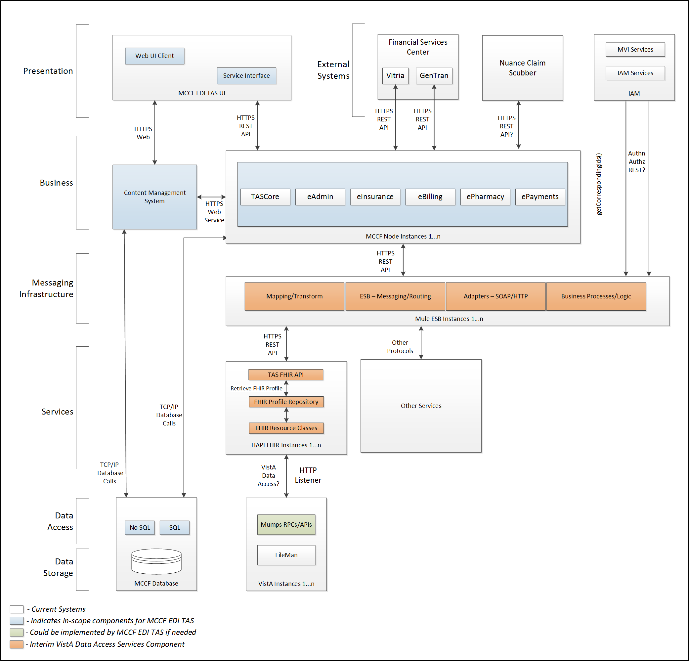

Figure 1- Interim Solution

To be solution

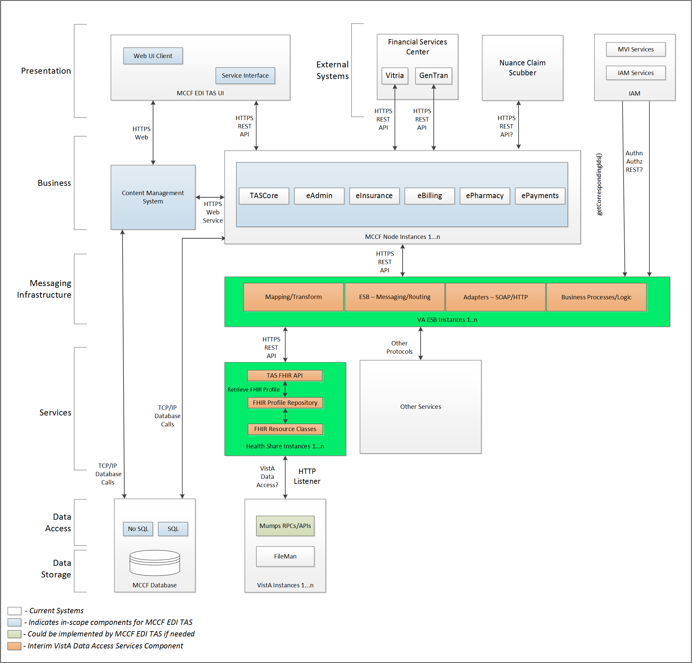

Figure 2 - Future (To Be) Solution

## Interface Overview

The messages exchanged between MCCF EDI TAS eBilling and FSC can be done in real time or as queued messaging.

### Connectivity between the systems

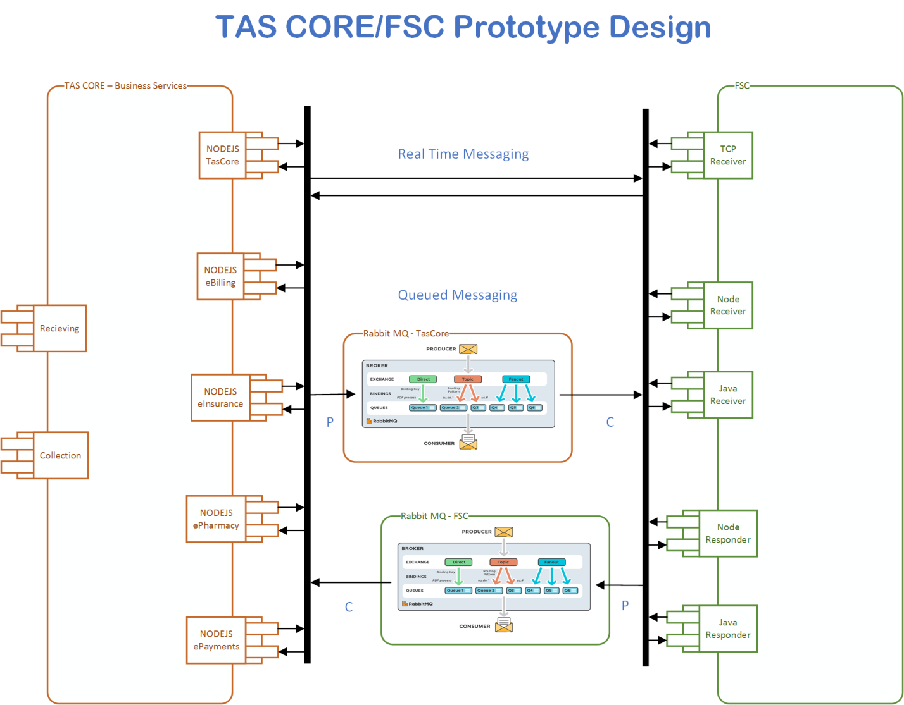

Figure 3 - TASCore / FSC Connectivity

## Operations

TBD

### Data Extraction

Data being sent to FSC will be extracted from the VistA databases using a FHIR server.

### Data Transformation

MCCF EDI TAS doesn’t transform data for 275 transactions going to FSC.

### Sending/Receiving

MCCF EDI TAS eBilling sends FHIR messages to FSC.

## Data Transfer

Data is transferred between the FSC and the TASCore Application Stack.

## Transaction Types

MCCF EDI TAS eBilling transmits FHIR bundles consisting of different FHIR resources needed to construct a 275 transaction. The content is modeled on the ASC X12N/005010 275 Additional Information to Support a Health Care Claim or Encounter standard and contains the data elements necessary for FSC to create valid ASC X12N/005010 275 Additional Information to Support a Health Care Claim or Encounter transaction to send to payers. The ASC X12N/005010 275 Additional Information to Support a Health Care Claim or Encounter is a response message caused by receipt of a 277 message – a request for additional health care claim information. (See 277RFAI ICD)

FSC receives 277 Health Care Claim Request for Additional Information from Payers and forwards that to MCCF EDI TAS eBilling as a Bundle containing necessary FHIR resources. The ASC X12N/005010 275 Additional Information to Support a Health Care Claim or Encounter message is the response and will transfer that data in FHIR resources inside FHIR bundles to FSC.

## Data Exchanges

MCCF EDI TAS sends a 275 FHIR bundle to FSC in response to having received a 277 Health Care Claim Request for Additional Information as a FHIR bundle from FSC. The 275 FHIR bundle sent to FSC contains the necessary FHIR resources so FSC can construct a 275 transaction in ASC X12N/005010 format which then forwards the ASC X12N/005010 275 Additional Information to Support a Health Care Claim or Encounter transaction on to the payer.

Refer to Section Appendix A section 3.3.1.

### FHIR Based Resources

The following FHIR resources are needed to assemble a 275 transaction FHIR bundle

* Basic
* Claim
* Consent
* MessageHeader

### JSON Format

Messages are formatted using the JSON format and implement a Bundle FHIR Resource.

Refer to <https://www.hl7.org/fhir/json.html> for JSON representation of FHIR Resources.

#### 275 Response FHIR bundle

A bundle implementing a 275 response sent to FSC will have the following structure:

See appendix A section 3.2.

### Bundle Definition

A Bundle is a container for resources, enabling the grouping and transmitting resources altogether. Resources such as Claim, Patient, etc. will be transmitted inside multiple entries (see entry list inside Bundle) as a resource type.

A Bundle is a top level container in FHIR that contains all the FHIR resources desired for a transaction between MCCF EDI TAS and FSC.

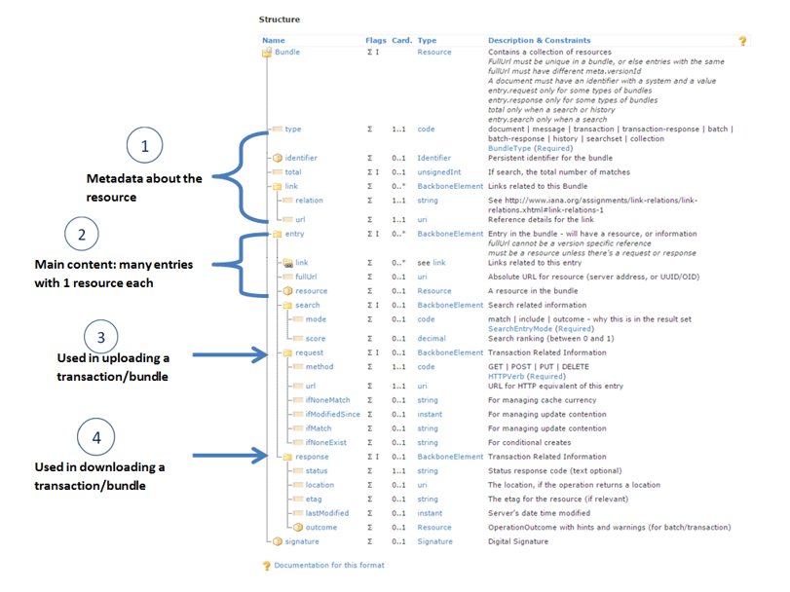

Figure 4 – Example FHIR Bundle content

Source https://fhir-drills.github.io/bundle.html

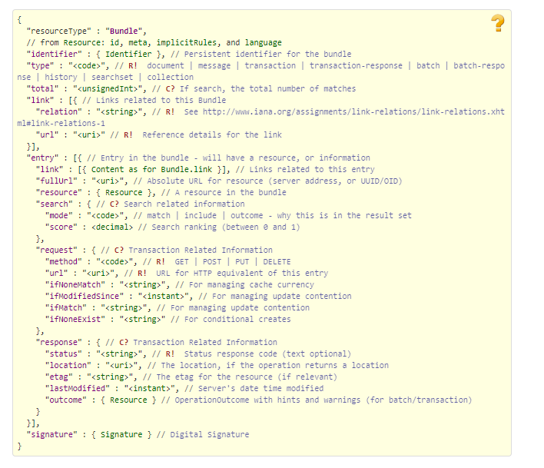

Figure 5 – Example FHIR Bundle layout

Source https://www.hl7.org/fhir/bundle.html

## Communications Methods

### Ports and Protocols

#### HTTP(S)

Used for real time communication.

#### Advanced Message Queuing Protocol (AMQP)

AMQP offers reliable messaging via queues.

### ESB Configuration(s)

TBD

### System Configuration

TBD

## Performance Requirements

System Design Document (SDD); Medical Care Collections Fund (MCCF) - Electronic Data Interchange Transaction Application Suite (EDI TAS) <https://vaww.oed.portal.va.gov/pm/hape/ipt_5010/EDI_Portfolio/TASCore/MCCF_EDI_TAS_System_Design_Document_v0.7.pdf>

if needed.

## Security

System Design Document (SDD); Medical Care Collections Fund (MCCF) - Electronic Data Interchange Transaction Application Suite (EDI TAS) <https://vaww.oed.portal.va.gov/pm/hape/ipt_5010/EDI_Portfolio/TASCore/MCCF_EDI_TAS_System_Design_Document_v0.7.pdf>

if needed.

## Testing Requirements

### Comparison of Data

Testing the FHIR conformance will be based on HTTPS://www.hl7.org/fhir/validation.html.

Business Rules will have to be specifically defined in user stories by the eBilling team.

* Which fields are mandatory from a business perspective?
* Data integrity

### Completeness

Tests defined in section 2.10.1 must cover all the FHIR resources that are defined in section 2.6.1 in consideration of any functional user story.

### Load Testing

Bench mark tests must be performed based on individual use case requirements.

## Policies and Constraints

### HIPAA Compliance

FSC receives transactions and then translates them into standard ASC X12N/005010 275 Additional Information to Support a Health Care Claim or Encounter message, validates whether the data complies with HIPAA standards, and then forwards the claim data to the VA Healthcare Clearing House (HCCH).

# Appendix A

## Data Elements

Data being exchanged between TAS and FSC will be formatted in FHIR using the JSON notation. Data elements are mapped into fields in FHIR resources. FHIR resources will be located inside a FHIR bundle.

## Bundle (275)

Repeating fields within a segment need context definition so they can be differentiated within a segment. Also, repeating fields across multiple segments need to be differentiated. Following steps have been used to assign context to fields.

1. Identify the segment where the resource is located (Bundle.entry.extension.url="segment" and Bundle.entry.extension.valueString="275-EVN") [MessageType-Segment]
2. Where elements repeat within a segment use extension.valueString to identify field (Basic.extension.url="sequence" and Basic.extension.valueString="275-MSH-16" or Location.identifier.extension.url="sequence" and Location.identifier.extension.valueString="275-MSH-3") [MessageType-Segment-Field]
3. Repeating segments will include an incrementing id (MSA1, MSA2, ...)

### 275 Additional Information to Support a Claim or Encounter Bundle

NOTE: The JSON bundle files are auto-generated using the mapping sheets. They may not be accurate and there are issues that we are aware of. We are continuing to fix the issues that we've identified.



## Resource Sections

### 275 Transaction FHIR Bundle Resources

#### Basic

See Basic resource in Bundle located in section 3.2.1

#### Claim

See Claim resource in Bundle located in section 3.2.1

#### Consent

See Consent resource in Bundle located in section 3.2.1

#### MessageHeader

See MessageHeader resource in Bundle located in section 3.2.1

## Mapping Sheet

The following mapping sheet is for the 275 Addtl Info to Support a Claim or Encounter

Note that at time of document prep, FSC review of the mapping is not complete so this may undergo change in the future.



# Appendix B - TASCore Mapping Rules

TBD

# Appendix C – TASCore Default Values

TBD

# Appendix D – FSC Mapping Rules

TBD

# Appendix E – FSC Default Values

TBD

# Glossary

|  |  |
| --- | --- |
| AMQP – Advanced Message Queuing Protocol | The Advanced Message Queuing Protocol (AMQP) is an open standard for passing business messages between applications or organizations using queues. |
| HCCH | Health Care Clearing House |
| REST – Representational State Transfer | REpresentational State Transfer, or RESTful web services provide interoperability between computer systems on the Internet or other network. Sometimes spelled ReST. |

# 

# Attachment A – Approval Signatures

This section is used to document the approval of the ICD. The review should be conducted face to face where signatures can be obtained ‘live’ during the review. If unable to conduct a face-to-face meeting then it should be held via Lync and concurrence captured during the meeting. The Scribe should add /es/name by each position cited.

By signing below, I agree that I have reviewed and agree the document is approved.



## Signature page continued

