Medical Care Collections Fund (MCCF) eBilling

Electronic Data Interchange (EDI)

Transactions Applications Suite (TAS)

Interface Control Document

ASC X12N/005010 277CA Health Care

Claim Acknowledgement

Logo for the Department of Veterans Affairs, Office of Information and Technology, Product Development, including the official seal of the Department of Veterans Affairs


Department of Veterans Affairs

March 2018

Version 2.0

Revision History

|  |  |  |  |
| --- | --- | --- | --- |
| Date | Version | Description | Author |
| 2/20/18 | 0.0.1 | Initial creation of document | Steffen Maerdian - Halfaker |
| 2/21/18 | 0.0.2 | Creation of the specific 277CA transaction document with formatting and content updates for initial draft | Keith Oulson – Halfaker and Associates |
| 3/2/18 | 1 | Finalizing draft | Steffen Maerdian - Halfaker |
| 3/19/18 | 1.1 | Incorporating review remarks from product team (FSC team didn’t deliver review remarks on due date) | Steffen Maerdian - Halfaker |
| 3/26/18 | 2 | Final Draft Review | Keith Oulson – Halfaker & Associates |
|  |  |  |  |
|  |  |  |  |
|  |  |  |  |
|  |  |  |  |
|  |  |  |  |
|  |  |  |  |
|  |  |  |  |
|  |  |  |  |
|  |  |  |  |
|  |  |  |  |
|  |  |  |  |
|  |  |  |  |
|  |  |  |  |
|  |  |  |  |
|  |  |  |  |

Table of Contents

1 Introduction 1

1.1 Purpose 1

1.2 Scope 1

1.3 System Identification 1

1.3.1 MCCF EDI TAS eBilling 1

1.3.2 FSC 2

1.4 Operational Agreement 2

2 Interface Definition 2

2.1 System Overview 3

2.1.1 Overview Diagram 3

2.2 Interface Overview 4

2.2.1 Connectivity between the systems 5

2.3 Operations 5

2.3.1 Data Extraction 5

2.3.2 Data Transformation 5

2.3.3 Sending/Receiving 5

2.4 Data Transfer 6

2.5 Transaction Types 6

2.6 Data Exchanges 6

2.6.1 FHIR Based Resources 6

2.6.2 JSON Format 6

2.6.3 Bundle Definition 7

2.7 Communications Methods 8

2.7.1 Ports and Protocols 8

2.7.2 ESB Configuration(s) 9

2.7.3 System Configuration 9

2.8 Performance Requirements 9

2.9 Security 9

2.10 Testing Requirements 9

2.10.1 Comparison of Data 9

2.10.2 Completeness 9

2.10.3 Load Testing 9

2.11 Policies and Constraints 9

2.11.1 HIPAA Compliance 10

3 Appendix A 11

3.1 Data Elements 11

3.2 Bundle 11

3.3 Resource Sections 11

3.3.1 Basic 11

3.3.2 Claim 12

3.3.3 ClaimResponse 12

3.3.4 CommunicationRequest 12

3.3.5 EpisodeOfCare 12

3.3.6 MessageHeader 12

3.3.7 OperationOutcome 12

3.3.8 Organization 12

3.3.9 Patient 12

3.3.10 RelatedPerson 12

3.4 Mapping Sheet 12

4 Appendix B - TASCore Mapping Rules 12

5 Appendix C – TASCore Default Values 12

6 Appendix D – FSC Mapping Rules 12

7 Appendix E – FSC Default Values 12

8 Appendix F – Glossary 13

9 Attachment A – Approval Signatures 14

9.1 Signature page continued 15

Table of Figures

Figure 1 - Interim Solution 3

Figure 2 - To Be Solution 4

Figure 3 - Connectivity 5

Figure 4 - FHIR Bundle 7

Figure 5 - FHIR Bundle JSON 8

# Introduction

This document describes the interface between a MCCF EDI TAS application and the VA Financial Services Center in Austin, TX (FSC) related to the electronic processing of ASC X12N/005010 277CA Health Care Claim Acknowledgement messages.

## Purpose

The purpose of this Interface Control Document (ICD) is to define the message structure and protocols which govern the interchange of data between eBilling within MCCF EDI TAS and the VA Financial Services Center (FSC) related to the electronic processing of

* ASC X12N/005010 277CA Health Care Claim Acknowledgement transactions.

## Scope

This ICD specifies the interface between MCCF EDI TAS eBilling and FSC. This document provides details on the functional, performance, operational and design requirements for the interface. This document defines the layouts for the data that the FSC receives from MCCF EDI TAS eBilling. This document is intended for all parties requiring such information, including business stakeholders, end-users, software developers, system designers, testers and anyone else responsible for implementing this interface.

## System Identification

MCCF EDI TAS eBilling is a software stack designed to support the processing of claim requests/inquiries and responses related to health care services claims and encounter reviews. This interface supports the electronic transmission and reception of various EDI transactions including the ASC X12N/005010 277CA Health Care Claim Acknowledgement between MCCF EDI TAS eBilling and FSC.

The 277CA messages are initially received from payers and mapped by FSC where they are translated from ASC X12N/005010 Health Care Claim Acknowledgement 277CA to FHIR resources inside a FHIR bundle and transmitted to MCCF EDI TAS eBilling.

### MCCF EDI TAS eBilling

The TAS Platform will modernize and automate the business processes used currently as part of the VA revenue cycle. This includes insurance verification, billing, and claims processing, payment, and remittance. These processes are tied to other processes that are out of scope, including documenting the care provided, coding treatment and encounters, and sending claims and receiving remittance to and from the clearinghouse.

This interface supports the electronic third-party billing process which involves the electronic transmission of ASC X12N/005010 277CA Health Care Claim Acknowledgement from the insurance company or payer.

|  |  |
| --- | --- |
| System | Details |
| Title | tbd |
| Abbreviation | tbd |
| Version number | tbd |
| Release number | tbd |
| Point of Contact | tbd |
| Vendor [optional] | tbd |

### FSC

The system(s) at FSC receive(s) the data from the insurance company or payer, translate(s) the standard ASC X12N/005010 277CA Health Care Claim Acknowledgement message(s) into a FHIR bundle with the FHIR resources representing the 277CA data, and send(s) that bundle to the MCCF EDI TAS eBilling system to update the claim record(s).

|  |  |
| --- | --- |
| System | Details |
| Title | tbd |
| Abbreviation | tbd |
| Version number | tbd |
| Point of Contact | tbd |
| Vendor [optional] | tbd |

## Operational Agreement

This ICD provides the specification for an interface between MCCF EDI TAS eBilling and FSC regarding ASC X12N/005010 277CA Health Care Claim Acknowledgement data. The Chief Business Office (CBO) is responsible for notifying FSC personnel of any potential or planned changes to data feeds once these changes are known in order to minimize adverse impacts.

# Interface Definition

Health Care Claim Acknowledgement (277CA) data is transmitted between the FSC and MCCF EDI TAS IB in FHIR bundles

## System Overview

The MCCF EDI TAS eBilling module is designed to receive Health Care Claim Acknowledgement 277CA transactions from the FSC.

FSC is designed to receive ASC X12N/005010 277CA Health Care Claim Acknowledgement transactions from payers and to translate that data into FHIR resources for processing in MCCF EDI TAS eBilling.

### Overview Diagram

Interim solution

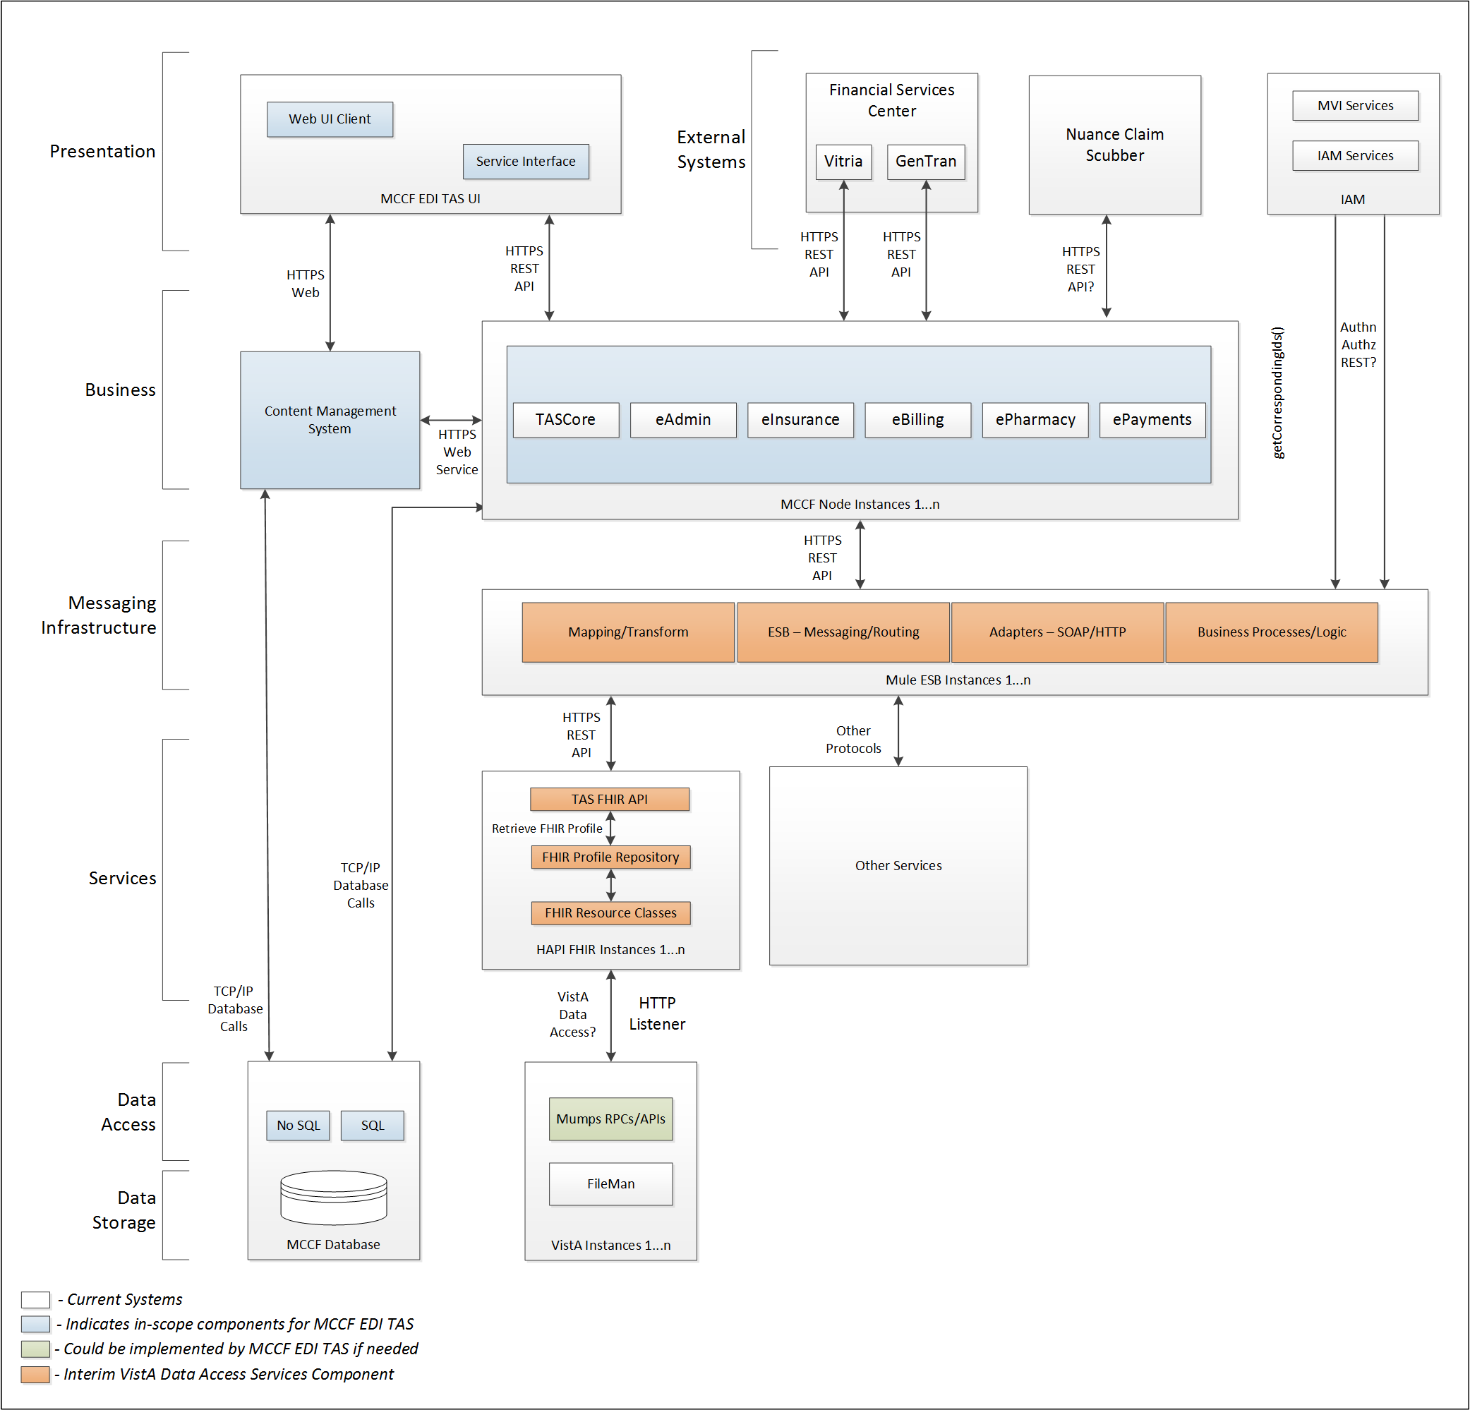

Figure - Interim Solution

To be solution

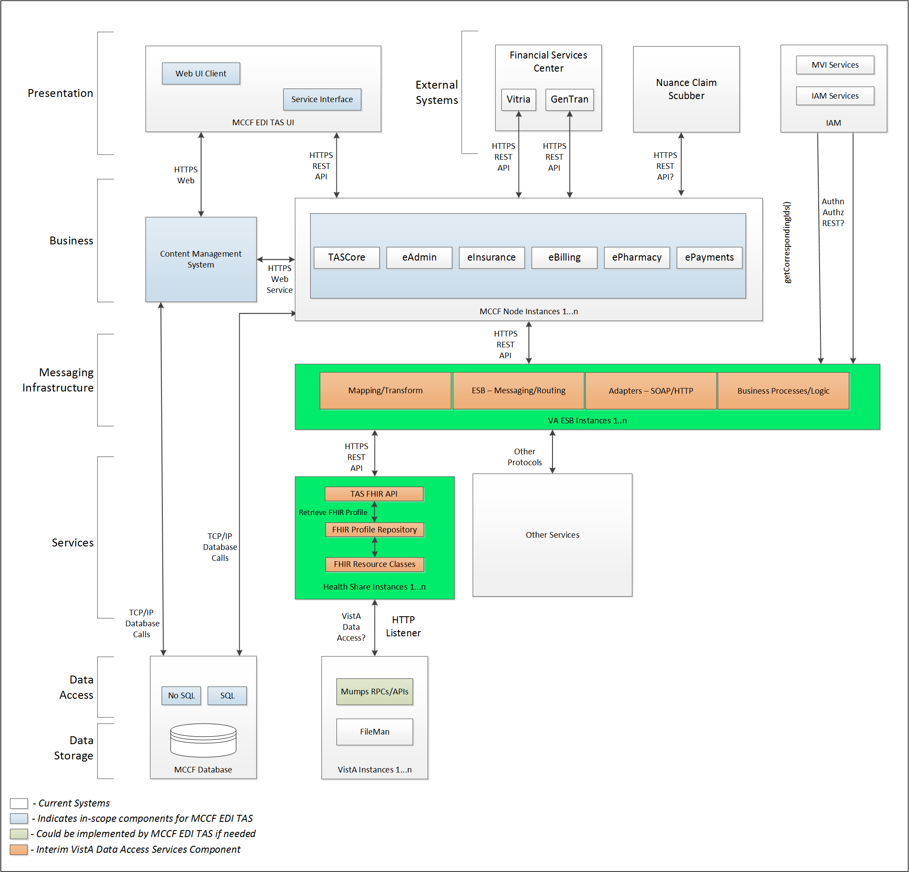

Figure - To Be Solution

## Interface Overview

The messages exchanged between the FSC and MCCF EDI TAS eBilling can be done in real time or as queued messaging.

### Connectivity between the systems

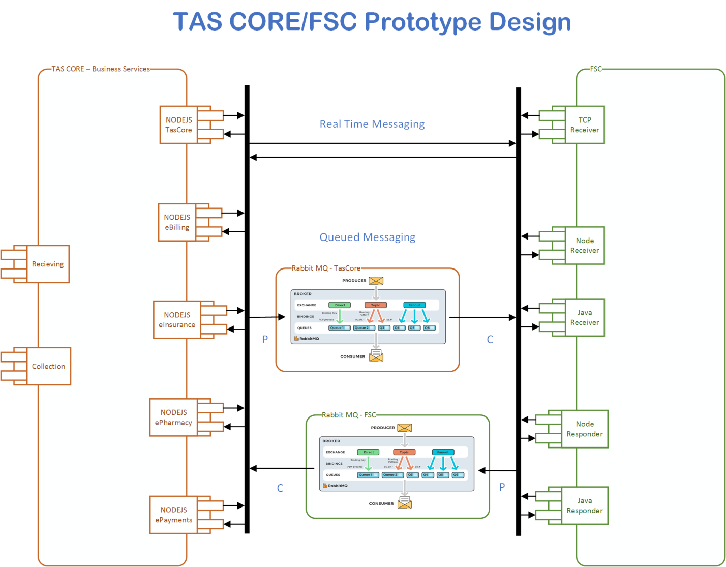

Figure - Connectivity

## Operations

### Data Extraction

Tbd

### Data Transformation

Tbd

### Sending/Receiving

MCCF EDI TAS receives FHIR resources in a bundle from FSC that were derived from receipt of a ASC X12N/005010 277CA Health Care Claim Acknowledgement from a payer.

## Data Transfer

Data is transferred between the FSC and the TASCore Application Stack.

## Transaction Types

FSC receives ASC X12N/005010 277CA Health Care Claim Acknowledgement from Payers and forwards that to MCCF EDI TAS eBilling as a translated FHIR Bundle containing necessary FHIR resources.

## Data Exchanges

MCCF EDI TAS receives a FHIR bundle from FSC, representing the ASC X12N/005010 277CA Health Care Claim Acknowledgement from a payer. Refer to Appendix.

### FHIR Based Resources

The following FHIR resources in a Bundle are expected from FSC to respond to the 277CA

* Basic
* Claim
* ClaimResponse
* CommunicationRequest
* EpisodeOfCare
* MessageHeader
* OperationOutcome
* Organization
* Patient
* RelatedPerson

### JSON Format

Messages are formatted using the JSON format and implement a Bundle FHIR Resource.

Refer to <https://www.hl7.org/fhir/json.html> for JSON representation of FHIR Resources.

#### 277CA FHIR bundle

A bundle implementing a 277CA sent by FSC to MCCF EDI TAS eBilling will have the following structure:

See appendix A.

### Bundle Definition

A Bundle is a container for resources, enabling grouping and transmitting resources altogether at once. Resources such as Claim, Patient, etc., will be transmitted inside multiple entries (see entry list inside Bundle) as a resource type.

A Bundle is a top-level container in FHIR that contains all the FHIR resources desired for a transaction between MCCF EDI TAS and FSC.

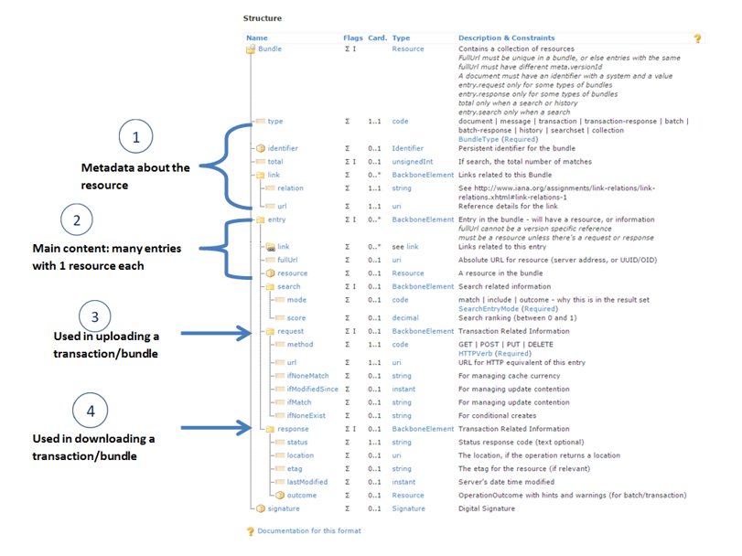

Figure - FHIR Bundle

Source https://fhir-drills.github.io/bundle.html

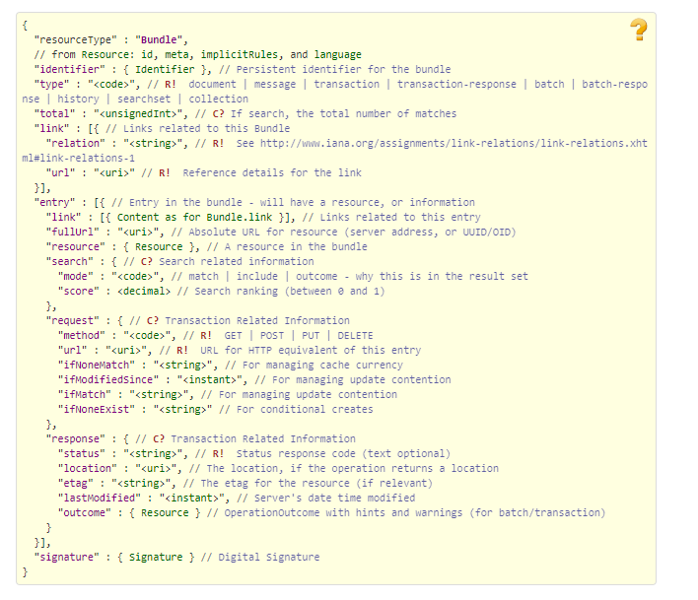

Figure - FHIR Bundle JSON

Source https://www.hl7.org/fhir/bundle.html

## Communications Methods

### Ports and Protocols

#### HTTP(S)

Used for real time communication.

#### Advanced Message Queuing Protocol (AMQP)

AMQP offers reliable messaging via queues.

### ESB Configuration(s)

Tbd

### System Configuration

Tbd

## Performance Requirements

Refer to MCCD EDI TAS SDD <https://vaww.oed.portal.va.gov/pm/hape/ipt_5010/EDI_Portfolio/TASCore/MCCF_EDI_TAS_System_Design_Document_v0.7.pdf>

## Security

Refer to MCCD EDI TAS SDD <https://vaww.oed.portal.va.gov/pm/hape/ipt_5010/EDI_Portfolio/TASCore/MCCF_EDI_TAS_System_Design_Document_v0.7.pdf>

## Testing Requirements

### Comparison of Data

Testing the FHIR conformance will be based on <https://www.hl7.org/fhir/validation.html>.

Business Rules will have to be specifically defined in user stories by the product team.

* Which fields are mandatory from a business perspective?
* Data integrity.

### Completeness

Tests defined in section 2.10.1 must cover all the FHIR resources that are defined in section 2.6.1 in consideration of any functional user story.

### Load Testing

Bench mark tests must be performed based on individual use case requirements.

## Policies and Constraints

### HIPAA Compliance

FSC receives standard ASC X12N/005010 277CA Health Care Claim Acknowledgement transactions from payers and translates them into a FHIR Bundle with FHIR resources and transmits that to MCCF EDI TAS eBilling. It is assumed that those messages are HIPPA compliant.

# Appendix A

## Data Elements

Data being exchanged between TAS and FSC will be formatted in FHIR using the JSON notation. Data elements are mapped into fields in FHIR resources. FHIR resources will be located inside a FHIR bundle.

## Bundle

Repeating fields within a segment need context definition so they can be differentiated within a segment. Also, repeating fields across multiple segments need to be differentiated. Following steps have been used to assign context to fields.

1. Identify the segment where the resource is located (Bundle.entry.extension.url="segment" and Bundle.entry.extension.valueString=" 277CA-Segment1") [MessageType-Segment]
2. Where elements repeat within a segment use extension.valueString to identify field (MessageHeader.extension.url="sequence", MessageHeader.extension.valueString="277CA-Segment1-BHT04") [MessageType-Segment-Field]
3. Repeating segments will include an incrementing id.

Following JSON file describes the 277CA bundle. The JSON bundle files are auto-generated using the mapping sheets. They may not be accurate and there are issues that we are aware of. We are continuing to fix the issues that we've identified.



## Resource Sections

### Basic

See Basic resource in Bundle included in section 3.2

### Claim

See Claim resource in Bundle included in section 3.2

### ClaimResponse

See ClaimResponse resource in Bundle included in section 3.2

### CommunicationRequest

See CommunicationRequest resource in Bundle included in section 3.2

### EpisodeOfCare

See EpisodeOfCare resource in Bundle included in section 3.2

### MessageHeader

See MessageHeader resource in Bundle included in section 3.2

### OperationOutcome

See OperationOutcome resource in Bundle included in section 3.2

### Organization

See Organization resource in Bundle included in section 3.2

### Patient

See Patient resource in Bundle included in section 3.2

### RelatedPerson

See RelatedPerson resource in Bundle included in section 3.2

## Mapping Sheet



# Appendix B - TASCore Mapping Rules

Tbd

# Appendix C – TASCore Default Values

Tbd

# Appendix D – FSC Mapping Rules

Tbd

# Appendix E – FSC Default Values

See mapping sheet section 3.4

# Appendix F – Glossary

| **Term** | **Meaning** |
| --- | --- |
| AMQP - Advanced Message Queuing Protocol | The *Advanced Message Queuing Protocol* (*AMQP*) is an open standard for passing business messages between applications or organizations using queues. |
| HCCH | Health Care Clearing House |
| REST - REpresentational State Transfer | REpresentational State Transfer, or RESTful web services provide interoperability between computer systems on the Internet or other network. Sometimes spelled ReST. |

# Attachment A – Approval Signatures

This section is used to document the approval of the ICD. The review should be conducted face to face where signatures can be obtained ‘live’ during the review. If unable to conduct a face-to-face meeting then it should be held via Lync and concurrence captured during the meeting. The Scribe should add /es/name by each position cited.

By signing below, I agree that I have reviewed and agree the document is approved.



## Signature page continued

