Medical Care Collections Fund (MCCF) eBilling

Electronic Data Interchange (EDI)

Transactions Applications Suite (TAS)

Interface Control Document

ASC X12N/005010 277RFAI Health Care Claim Request

for Additional Information

Logo for the Department of Veterans Affairs, Office of Information and Technology, Product Development, including the official seal of the Department of Veterans Affairs


Department of Veterans Affairs

March 2018

Version 1

Revision History

|  |  |  |  |
| --- | --- | --- | --- |
| Date | Version | Description | Author |
| 2/20/18 | 0.0.1 | Initial creation of document | Steffen Maerdian - Halfaker |
| 2/21/18 | 0.0.2 | Creation of the specific 277RFAI transaction document with formatting and content updates for initial draft | Keith Oulson – Halfaker and Associates |
| 3/2/18 | 1 | Creating initial draft | Steffen Maerdian - Halfaker |
|  |  |  |  |
|  |  |  |  |
|  |  |  |  |
|  |  |  |  |
|  |  |  |  |
|  |  |  |  |
|  |  |  |  |
|  |  |  |  |
|  |  |  |  |
|  |  |  |  |
|  |  |  |  |
|  |  |  |  |
|  |  |  |  |
|  |  |  |  |
|  |  |  |  |
|  |  |  |  |
|  |  |  |  |

Table of Contents

1 Introduction 1

1.1 Purpose 1

1.2 Scope 1

1.3 System Identification 1

1.3.1 MCCF EDI TAS eBilling 1

1.3.2 FSC 2

The system(s) at FSC, receive(s) the data from payers as a standard ASC X12N/005010 277RFAI Health Care Claim Request for Additional Information transmissionand send(s) that data as FHIR data to MCCF EDI TAS. 2

1.4 Operational Agreement 2

2 Interface Definition 2

1.5 System Overview 2

1.5.1 Overview Diagram 3

1.6 Interface Overview 4

1.6.1 Connectivity between the systems 5

1.7 Operations 5

1.7.1 Data Extraction 5

1.7.2 Data Transformation 5

1.7.3 Sending/Receiving 5

1.8 Data Transfer 6

1.9 Transaction Types 6

1.10 Data Exchanges 6

1.10.1 FHIR Based Resources 6

1.10.2 JSON Format 6

1.10.3 Bundle Definition 6

1.11 Communications Methods 8

1.11.1 Ports and Protocols 8

1.11.2 ESB Configuration(s) 9

1.11.3 System Configuration 9

1.12 Performance Requirements 9

1.13 Security 9

1.13.1 Is within the VA firewall 9

1.14 Testing Requirements 9

1.14.1 Comparison of Data 9

1.14.2 Completeness 9

1.15 Policies and Constraints 9

1.15.1 HIPAA Compliance 9

3 Appendix A 1

1.16 Data Elements 1

1.17 Bundle 1

1.18 Resource Sections 1..N 3

1.18.1 Basic 3

1.18.2 Claim 4

1.18.3 CommunicationRequest 8

1.18.4 Location 9

1.18.5 MessageHeader 10

1.18.6 Organization 11

1.18.7 Person 12

1.18.8 Practitioner 13

1.18.9 Patient 14

1.19 Embedded following columns: 15

4 Appendix B - TASCore Mapping Rules 15

5 Appendix C – TASCore Default Values 15

6 Appendix D – FSC Mapping Rules 15

7 Appendix E – FSC Default Values 15

# Introduction

This document describes the interface between an MCCF EDI TAS application and the VA Financial Services Center in Austin, TX (FSC) related to the electronic processing of ASC X12N/005010 277RFAI Health Care Claim Request for Additional Information message.

## Purpose

The purpose of this Interface Control Document (ICD) is to define the message structure and protocols which govern the interchange of data between VA Financial Services Center (FSC) and eBilling within MCCF EDI TAS related to the electronic processing of ASC X12N/005010 277RFAI Health Care Claim Request for Additional Information transactions.

## Scope

This ICD specifies the interface between FSC and MCCF EDI TAS eBilling. This document provides details on the functional, performance, operational and design requirements for the interface. This document defines the layouts for the data that MCCF EDI TAS eBilling receives from FSC. This document is intended for all parties requiring such information, including business stakeholders, end-users, software developers, system designers, testers and anyone else responsible for implementing this interface.

## System Identification

MCCF EDI TAS eBilling is a software stack designed to support the request/inquiries and responses related to health care services claims and encounter reviews. This interface supports the electronic transmission of ASC X12N/005010 277RFAI Health Care Claim Request for Additional Information between FSC and MCCF EDI TAS eBilling.

### MCCF EDI TAS eBilling

|  |  |
| --- | --- |
| System | Details |
| Title |  |
| Abbreviation |  |
| Version number |  |
| Release number |  |
| Point of Contact |  |
| Vendor [optional] |  |

The TAS Platform will modernize and automate the business processes used currently as part of the VA revenue cycle. This includes insurance verification, billing, and claims processing, payment, and remittance. These processes are tied to other processes that are out of scope, including documenting the care provided, coding treatment and encounters, and sending claims and receiving remittance to and from the clearinghouse.

### FSC

|  |  |
| --- | --- |
| System | Details |
| Title |  |
| Abbreviation |  |
| Version number |  |
| Point of Contact |  |
| Vendor [optional] |  |

## The system(s) at FSC, receive(s) the data from payers as a standard ASC X12N/005010 277RFAI Health Care Claim Request for Additional Information transmissionand send(s) that data as FHIR data to MCCF EDI TAS.

## Operational Agreement

This ICD provides the specification for an interface between FSC and MCCF EDI TAS eBilling ASC X12N/005010 277RFAI Health Care Claim Request for Additional Information data. The Chief Business Office (CBO) is responsible for notifying FSC personnel of any potential or planned changes to data feeds once these changes are known in order to minimize adverse impacts.

# Interface Definition

277RFAI Health Care Claim Request for Additional Information data is transmitted between FSC and MCCF EDI TAS eBilling in FHIR bundles.

## System Overview

MCCF EDI TAS eBilling is designed to facilitate transmission of Health Care Claim Request for Additional Information from the FSC.

### Overview Diagram

Interim solution

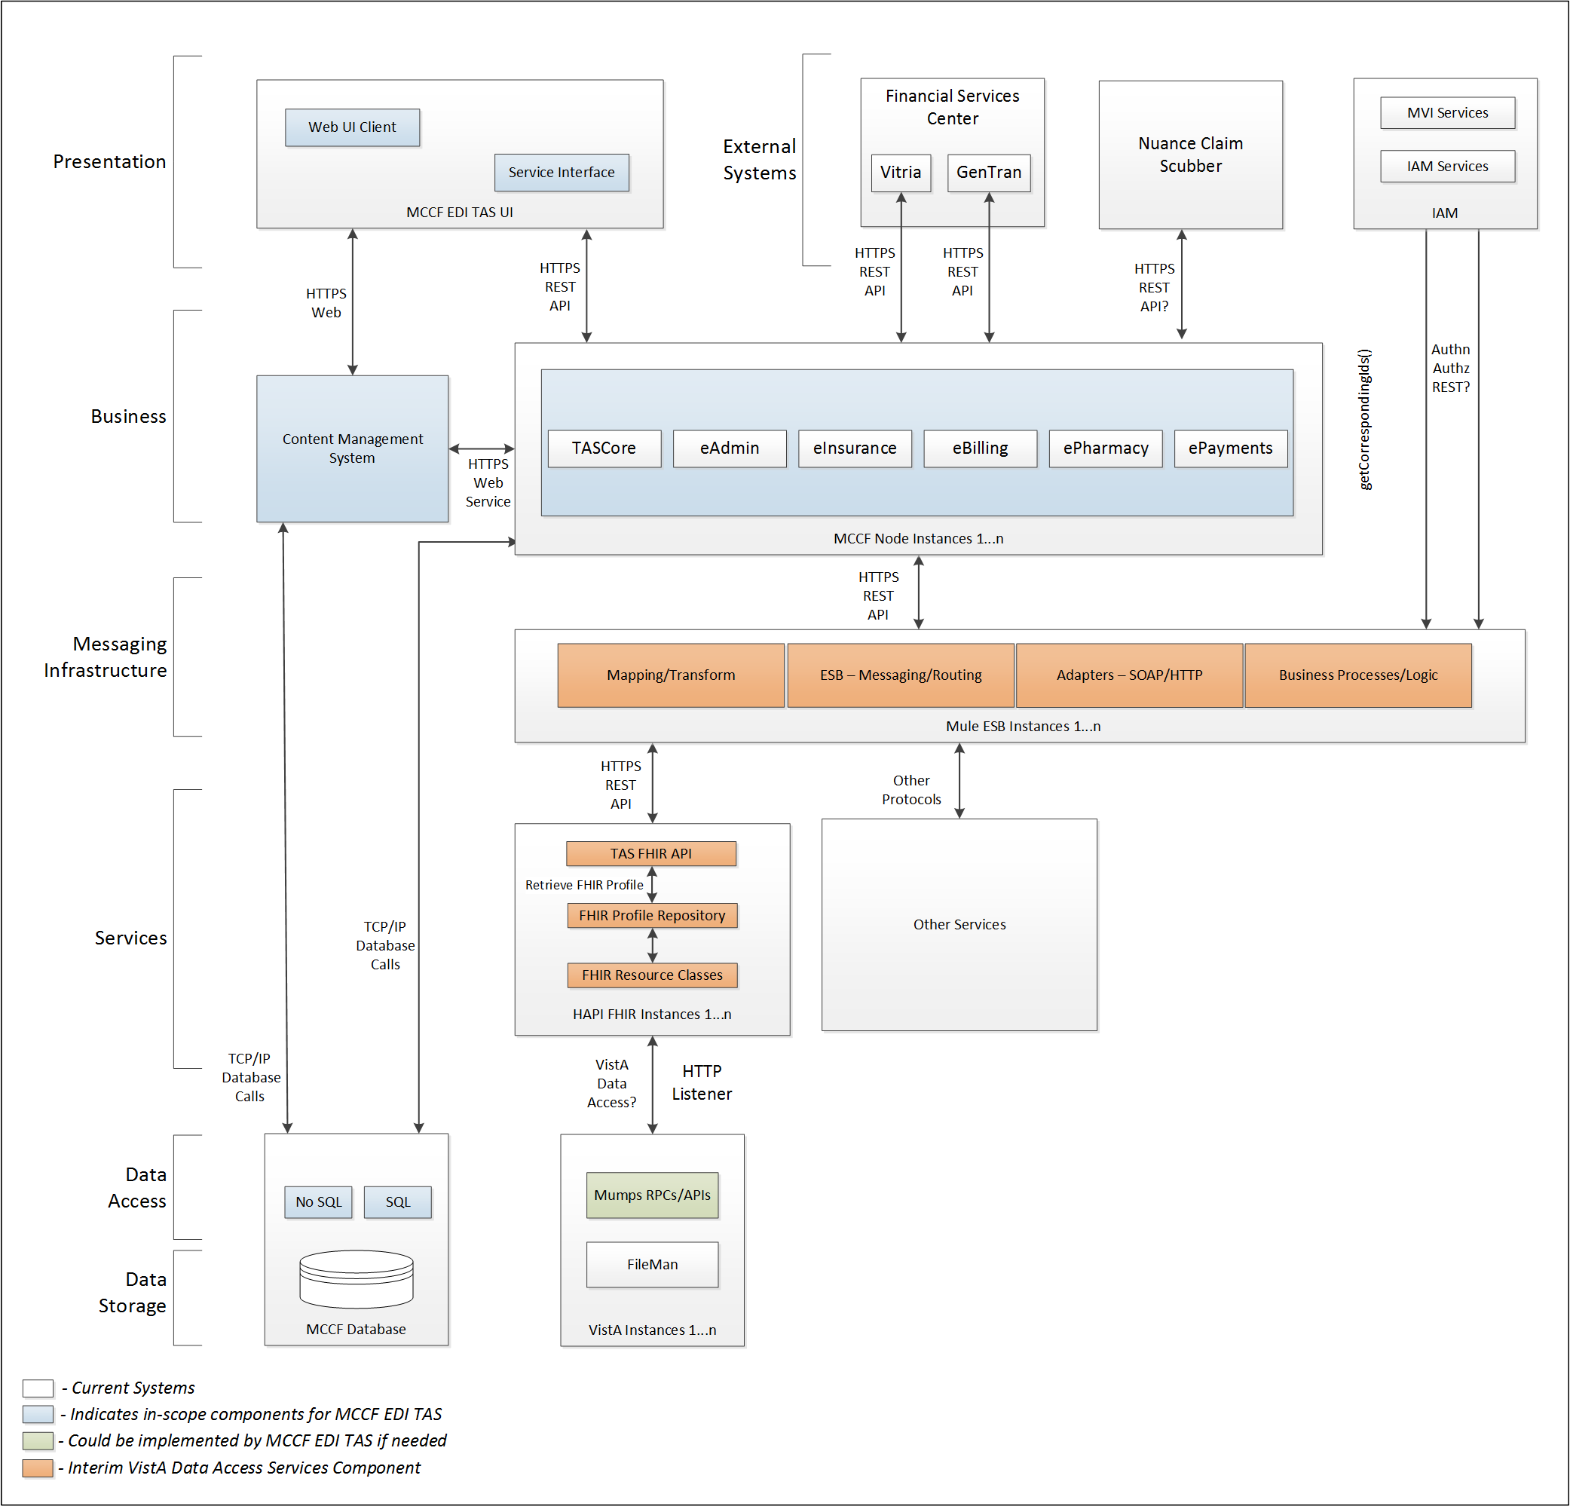

To be solution

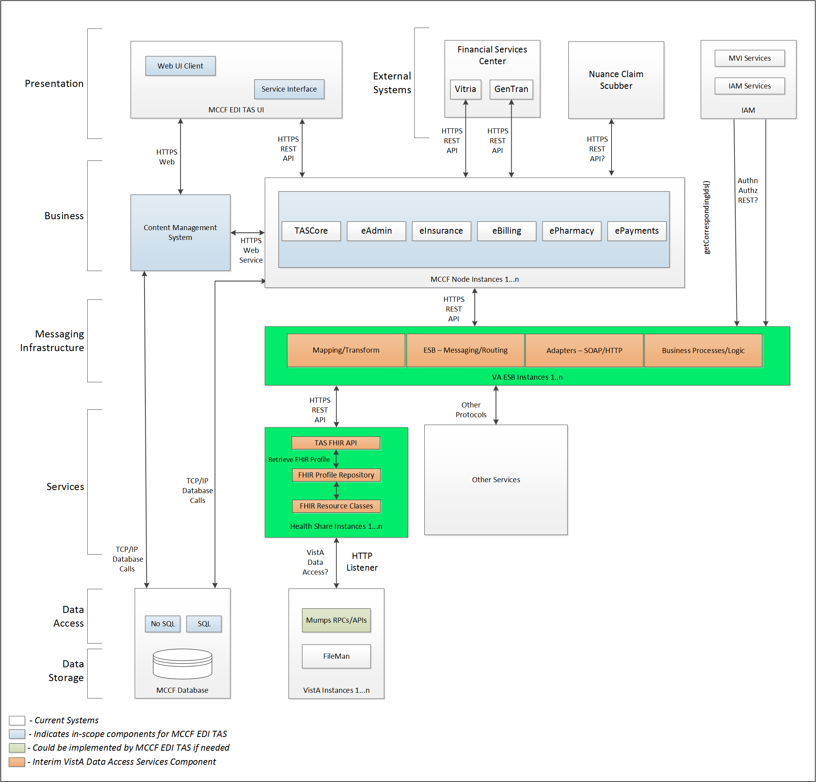

## Interface Overview

The messages exchanged between FSC and MCCF EDI TAS eBilling can be done in real time or as queued messaging.

### Connectivity between the systems

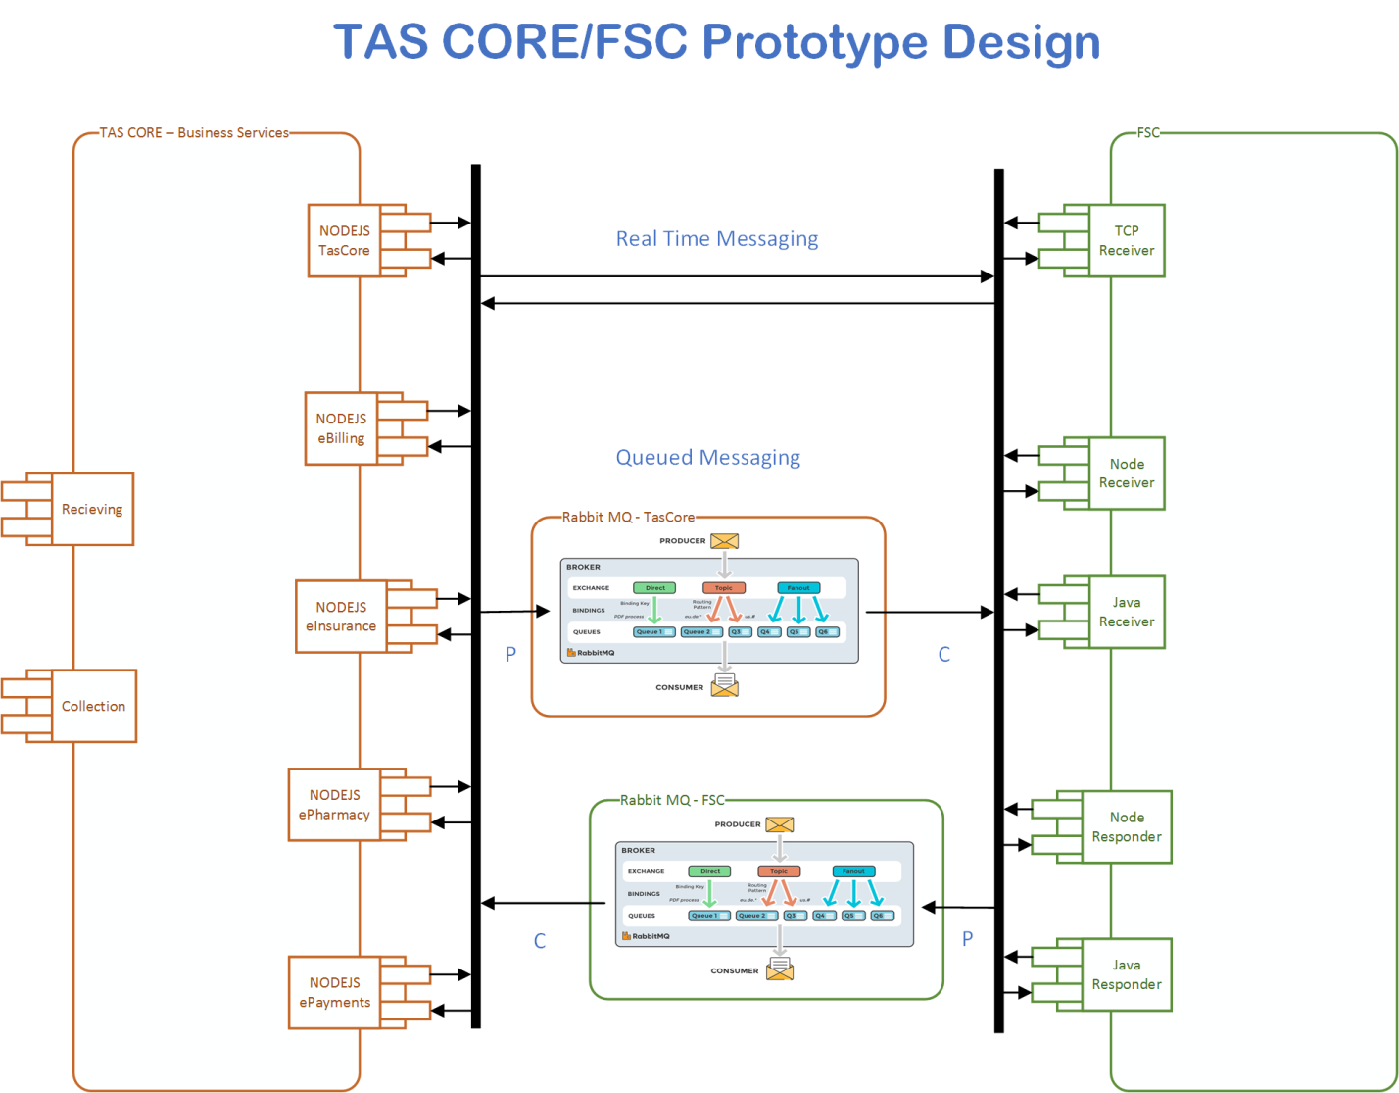

## Operations

Tbd

### Data Extraction

Tbd

### Data Transformation

Tbd

### Sending/Receiving

FSC sends FHIR data to MCCF EDI TAS.

## Data Transfer

Data is transferred between the FSC and the TASCore Application Stack.

## Transaction Types

FSC receives ASC X12N/005010 277RFAI Health Care Claim Request for Additional Information from payers and forwards that data to MCCF EDI TAS as a FHIR Bundle containing necessary FHIR resources.

## Data Exchanges

### FHIR Based Resources

The following FHIR resources in a Bundle are expected from FSC for the 277RFAI transaction

* Basic
* Claim
* CommunicationRequest
* Location
* MessageHeader
* Organization
* Person
* Practitioner
* Patient

Refer to Appendix A.

### JSON Format

Messages are formatted using the JSON format and implement a Bundle FHIR Resource.

Refer to <https://www.hl7.org/fhir/json.html> for JSON representation of FHIR Resources.

### Bundle Definition

A Bundle is a top level container in FHIR that contains all the FHIR resources desired for a transaction between MCCF EDI TAS and FSC.

A Bundle is a container for resources, enabling you to group and transmit resources altogether at once. Resources such as Claim, Patient, etc. will be transmitted inside multiple entries (see entry list inside Bundle) as a resource type.

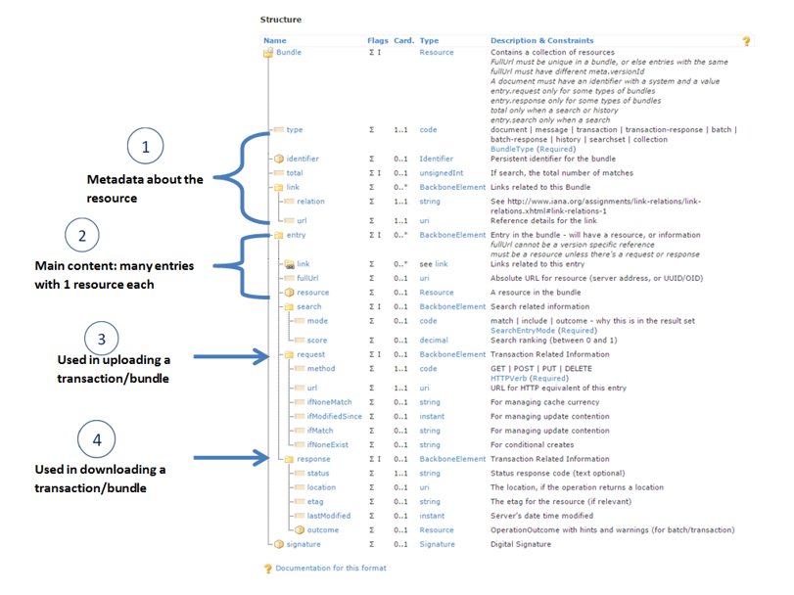

Figure - Source https://fhir-drills.github.io/bundle.html

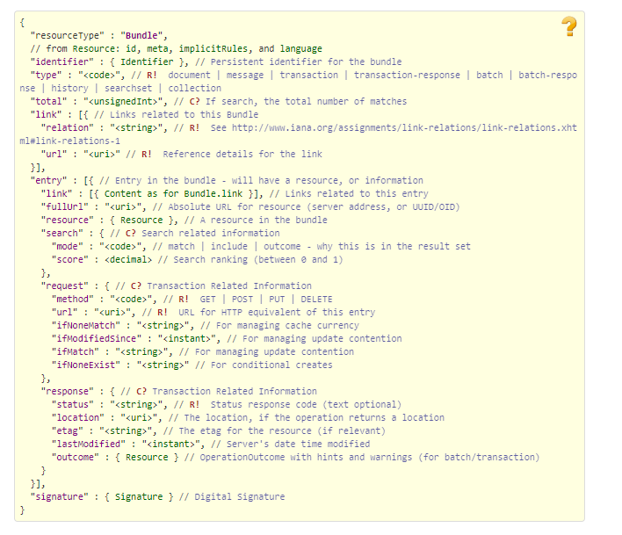

Figure - Source <https://www.hl7.org/fhir/bundle.html>

## Communications Methods

### Ports and Protocols

#### HTTP(S)

Used for real time communication.

#### AMQP

AMQP offers reliable messaging via queues.

### ESB Configuration(s)

Tbd

### System Configuration

Tbd

## Performance Requirements

System Design Document (SDD); Medical Care Collection Fund (MCCF) - Electronic Data Interchange Transaction Application Suite (EDI TAS) Section and Page or Paragraph if needed.

## Security

System Design Document (SDD); Medical Care Collection Fund (MCCF) - Electronic Data Interchange Transaction Application Suite (EDI TAS) Section and Page or Paragraph if needed.

### Is within the VA firewall

Tbd

## Testing Requirements

System Design Document (SDD); Medical Care Collection Fund (MCCF) - Electronic Data Interchange Transaction Application Suite (EDI TAS) Section and Page or Paragraph if needed.

### Comparison of Data

Tbd

### Completeness

Tbd

## Policies and Constraints

Tbd

### HIPAA Compliance

FSC receives transactions in standard ASC X12N/005010 Request for Additional Information (277RFAI) messages from outside sources.

It is assumed that those messages are HIPPA compliant.

# Appendix A

## Data Elements

## Bundle

Repeating fields within a segment need context definition so they can be differentiated within a segment. Also, repeating fields across multiple segments need to be differentiated. Following steps have been used to assign context to fields.

1. Identify the segment where the resource is located (Bundle.entry.extension.url="segment" and Bundle.entry.extension.valueString="278-EVN") [MessageType-Segment]

2. Where elements repeat within a segment use extension.valueString to identify field (Basic.extension.url="sequence" and Basic.extension.valueString="278-MSH-16" or Location.identifier.extension.url="sequence" and Location.identifier.extension.valueString="278-MSH-3") [MessageType-Segment-Field]

3. Repeating segments will include an incrementing id (MSA1, MSA2, ...)

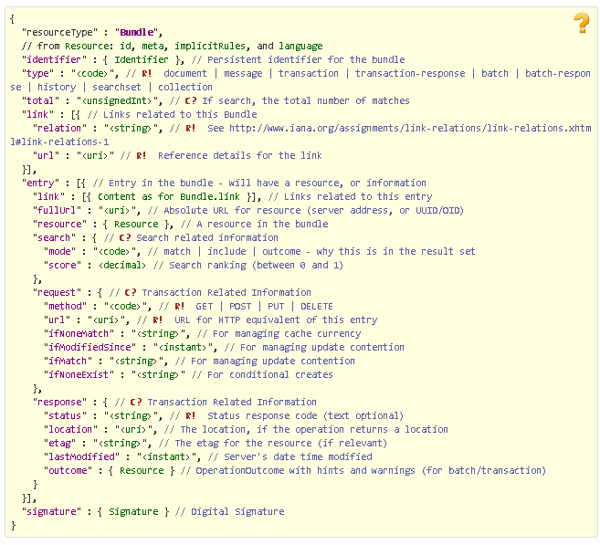

Figure Source: <http://www.hl7.org/fhir/bundle.html>

## Resource Sections 1..N

The following FHIR resources in a Bundle are expected for a 277RFAI transaction from FSC to MCCF EDI TAS

### Basic

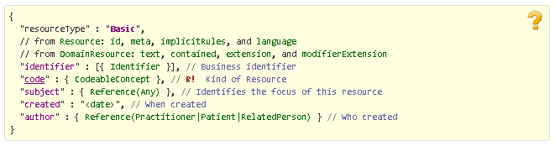

Figure Source http://www.hl7.org/fhir/basic.html

### Claim

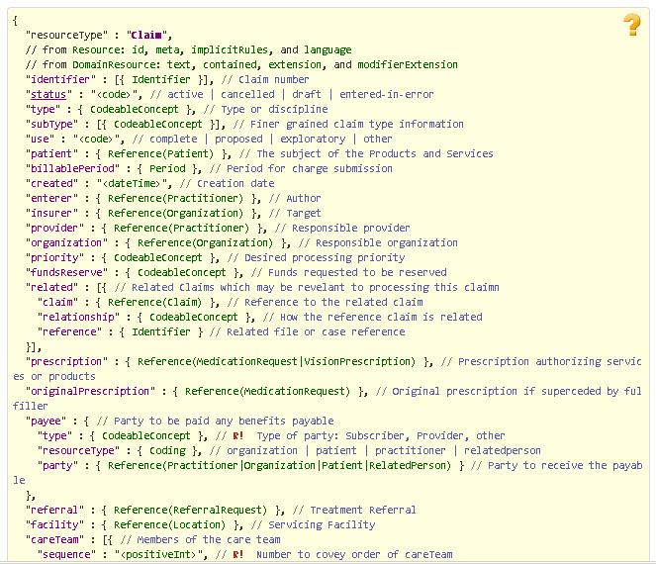

Figure Source http://www.hl7.org/fhir/claim.html

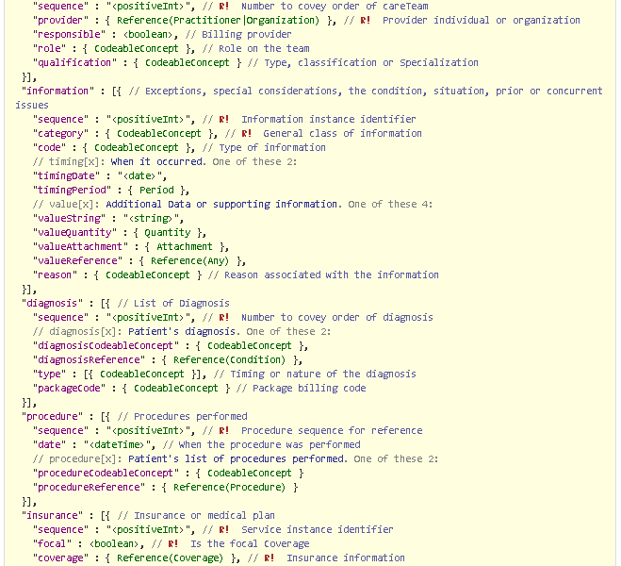

Figure Source http://www.hl7.org/fhir/claim.html

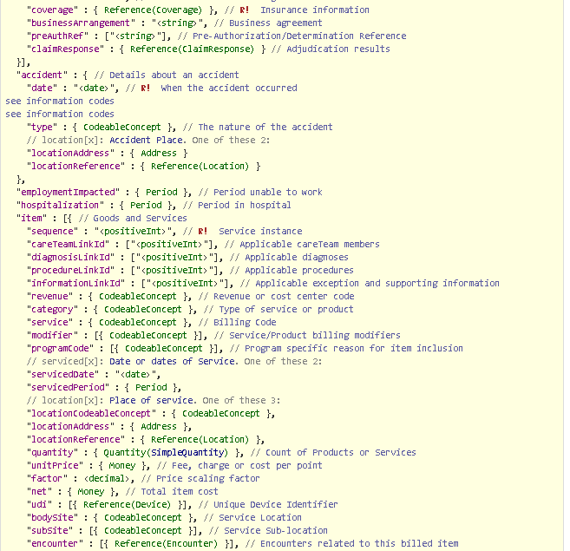

Figure Source http://www.hl7.org/fhir/claim.html

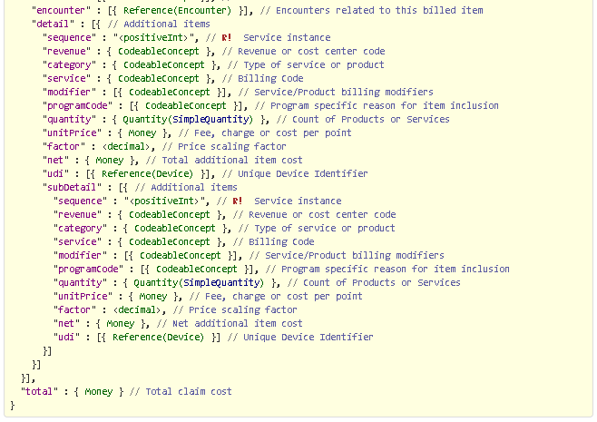

Figure Source http://www.hl7.org/fhir/claim.html

### CommunicationRequest

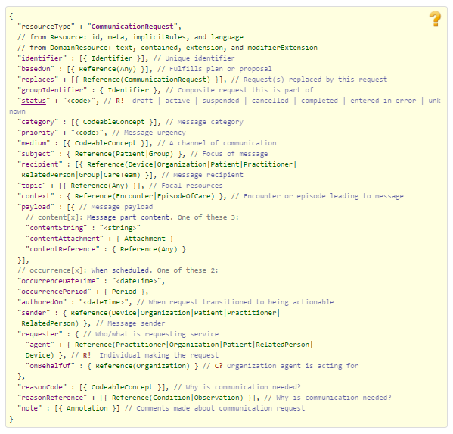

Figure Source http://www.hl7.org/fhir/communicationrequest.html

### Location

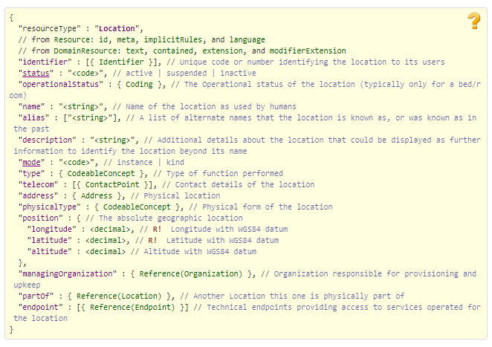

Figure Source http://www.hl7.org/fhir/location.html

### MessageHeader

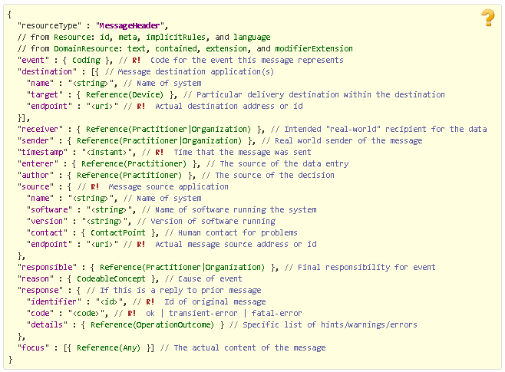

Figure Source http://www.hl7.org/fhir/messageheader.html

### Organization

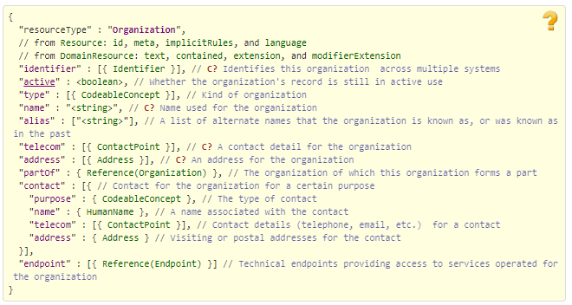

Figure Source http://www.hl7.org/fhir/organization.html

### Person

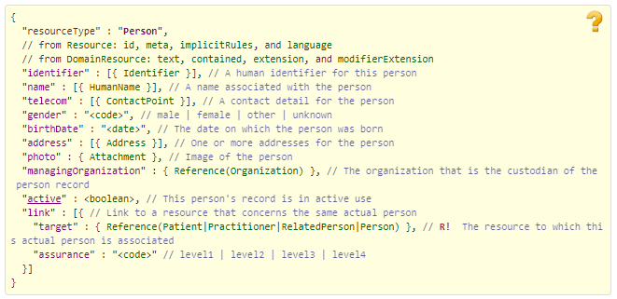

Figure Source http://www.hl7.org/fhir/person.html

### Practitioner

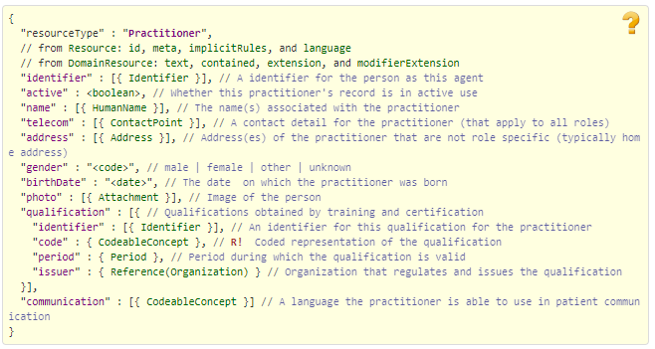

Figure Source http://www.hl7.org/fhir/practitioner.html

### Patient

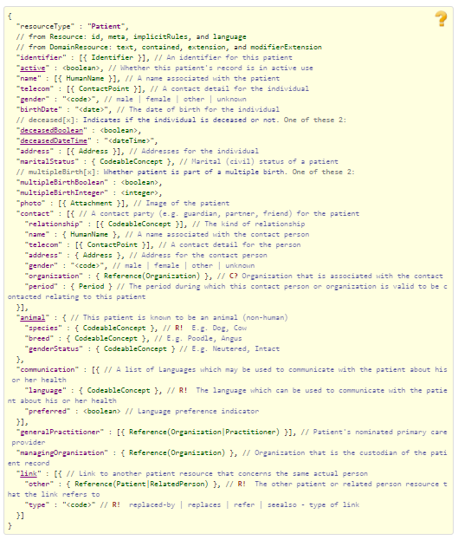

Figure Source http://www.hl7.org/fhir/patient.html

## Embedded following columns:

#### Element #

#### Max Length

#### FSC Transaction Location

* FSC Comments
* FHIR Resource
* TASCore Comments

# Appendix B - TASCore Mapping Rules

# Appendix C – TASCore Default Values

# Appendix D – FSC Mapping Rules

# Appendix E – FSC Default Values