Medical Care Collections Fund (MCCF) eBilling

Electronic Data Interchange (EDI)

Transactions Applications Suite (TAS)

Interface Control Document

ASC X12N/005010 277STAT Health Care Claim Status

Logo for the Department of Veterans Affairs, Office of Information and Technology, Product Development, including the official seal of the Department of Veterans Affairs


Department of Veterans Affairs

March 2018

Version 2.0

Revision History

|  |  |  |  |
| --- | --- | --- | --- |
| Date | Version | Description | Author |
| 2/20/18 | 0.0.1 | Initial creation of document | Steffen Maerdian - Halfaker |
| 2/23/2018 | 0.0.2 | Creation of the specific 277RFAI transaction document with formatting and content updates for initial draft | Keith Oulson – Halfaker and Associates |
| 3/1/18 | 1 | Finalizing the draft | Keith Oulson – Halfaker & Associates |
| 3/19/18 | 1.1 | Incorporation of review remarks | Steffen Maerdian - Halfaker |
| 3/26/18 | 2.0 | Final Draft Review | Keith Oulson – Halfaker & Associates |
|  |  |  |  |
|  |  |  |  |
|  |  |  |  |
|  |  |  |  |
|  |  |  |  |
|  |  |  |  |
|  |  |  |  |
|  |  |  |  |
|  |  |  |  |
|  |  |  |  |
|  |  |  |  |
|  |  |  |  |
|  |  |  |  |
|  |  |  |  |
|  |  |  |  |

Table of Contents

1 Introduction 1

1.1 Purpose 1

1.2 Scope 1

1.3 System Identification 1

1.3.1 MCCF EDI TAS eBilling 1

1.3.2 FSC 2

1.4 Operational Agreement 2

2 Interface Definition 2

2.1 System Overview 3

2.1.1 Overview Diagram 3

2.2 Interface Overview 5

2.2.1 Connectivity between the systems 5

2.3 Operations 5

2.3.1 Data Extraction 5

2.3.2 Data Transformation 6

2.3.3 Sending/Receiving 6

2.4 Data Transfer 6

2.5 Transaction Types 6

2.6 Data Exchanges 6

2.6.1 FHIR Based Resources 6

2.6.2 JSON Format 7

2.6.3 Bundle Definition 7

2.7 Communications Methods 8

2.7.1 Ports and Protocols 8

2.7.2 ESB Configuration(s) 9

2.7.3 System Configuration 9

2.8 Performance Requirements 9

2.9 Security 9

2.10 Testing Requirements 9

2.10.1 Comparison of Data 9

2.10.2 Completeness 9

2.10.3 Load Testing 9

2.11 Policies and Constraints 10

2.11.1 HIPAA Compliance 10

3 Appendix A 0

3.1 Data Elements 0

3.2 Bundle 0

3.3 Resource Sections 1

3.3.1 Basic 1

3.3.2 Claim 1

3.3.3 ClaimResponse 1

3.3.4 CommunicationRequest 1

3.3.5 EpisodeOfCare 1

3.3.6 MessageHeader 1

3.3.7 OperationOutcome 1

3.3.8 Organization 1

3.3.9 Patient 1

3.3.10 RelatedPerson 1

3.4 Mapping Sheets 1

4 Appendix B - TASCore Mapping Rules 1

5 Appendix C – TASCore Default Values 1

6 Appendix D – FSC Mapping Rules 1

7 Appendix E – FSC Default Values 1

8 Appendix F - Glossary 2

9 Attachment A – Approval Signatures 3

9.1 Signature page continued 4

Table of Figures

Figure 1 - Interim Solution 3

Figure 2 - To Be Solution 4

Figure 3 - Connectivity 5

Figure 4 - FHIR Bundle 7

Figure 5 - FHIR Bundle JSON 8

# Introduction

This document describes the interface between a MCCF EDI TAS application and the VA Financial Services Center in Austin, TX (FSC) related to the electronic processing of ASC X12N/005010 277STAT Health Care Claim Status messages.

## Purpose

The purpose of this Interface Control Document (ICD) is to define the message structure and protocols which govern the interchange of data between the FSC and eBilling within MCCF EDI TAS related to the electronic processing of ASC X12N/005010 277STAT Health Care Claim Status transactions.

## Scope

This ICD specifies the interface between FSC and MCCF EDI TAS eBilling. This document provides details on the functional, performance, operational, and design requirements for the interface. This document defines the layouts for the data that MCCF EDI TAS eBilling receives from FSC. This document is intended for all parties requiring such information, including business stakeholders, end-users, software developers, system designers, testers, and anyone else responsible for implementing this interface.

## System Identification

This ICD describes the interface between FSC and MCCF EDI TAS eBilling, a software stack designed to support the request/inquiries and responses related to health care services claims and encounter reviews.

This interface supports the electronic transmission and reception of various EDI transactions including the ASC X12N/005010 277STAT Health Care Claim Status between MCCF EDI TAS eBilling and FSC / Payers.

MCCF EDI TAS eBilling receives FHIR resources inside a FHIR bundle from FSC representing ASC X12N/005010 Health Care Claim Status 277STAT transaction data.

### MCCF EDI TAS eBilling

The TAS Platform will modernize and automate the business processes used currently as part of the VA revenue cycle. This includes insurance verification, billing and claims processing, payment, and remittance. These processes are tied to other processes that are out of scope, including documenting the care provided, coding treatment and encounters, and sending claims and receiving remittance to and from the clearinghouse.

|  |  |
| --- | --- |
| System | Details |
| Title | tbd |
| Abbreviation | tbd |
| Version number | tbd |
| Release number | tbd |
| Point of Contact | tbd |
| Vendor [optional] | tbd |

### FSC

The system(s) at FSC, receive(s) ASC X12N/005010 277STAT Health Care Claim Status data from payer(s), translate(s) the data into FHIR resources, and send(s) it/them to MCCF EDI TAS.

|  |  |  |
| --- | --- | --- |
| System |  | Details |
| Title | tbd |  |
| Abbreviation | tbd |  |
| Version number | tbd |  |
| Point of Contact | tbd |  |
| Vendor [optional] | tbd |  |

The system(s) at FSC, receive(s) ASC X12N/005010 277STAT Health Care Claim Status data from payer(s), translate(s) the data into FHIR resources, and send(s) it/them to MCCF EDI TAS.

## Operational Agreement

This ICD provides the specification for an interface between MCCF EDI TAS eBilling and the FSC regarding ASC X12N/005010 277STAT Health Care Claim Status data. The Chief Business Office (CBO) is responsible for notifying FSC personnel of any potential or planned changes to data feeds once these changes are known to minimize adverse impacts.

# Interface Definition

Health Care Claim Status (277STAT) data is transmitted between FSC and MCCF EDI TAS eBilling.

## System Overview

The MCCF EDI TAS eBilling is designed to receive Health Care Claim Status 277STAT transactions from the FSC.

FSC is designed to send a FHIR bundle containing the resources derived from their receipt of an ASC X12N/005010 277STAT Health Care Claim Status transaction from a payer to MCCF EDI TAS.

### Overview Diagram

Interim solution

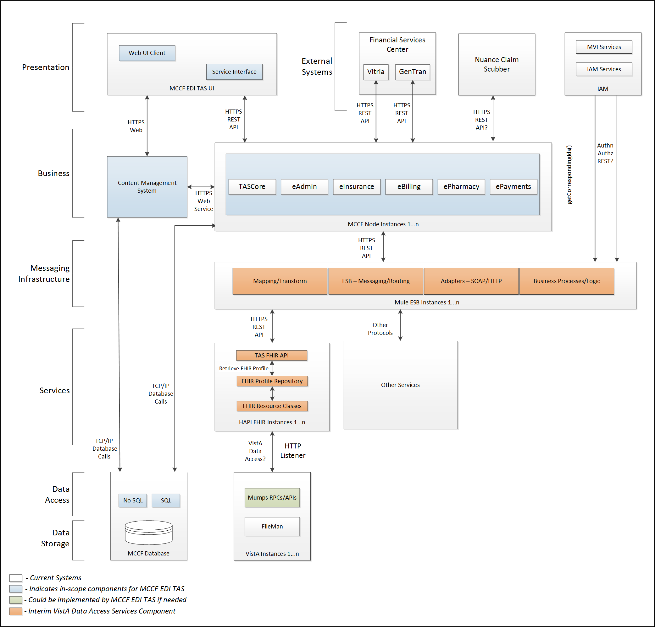

Figure 1 - Interim Solution

To be solution

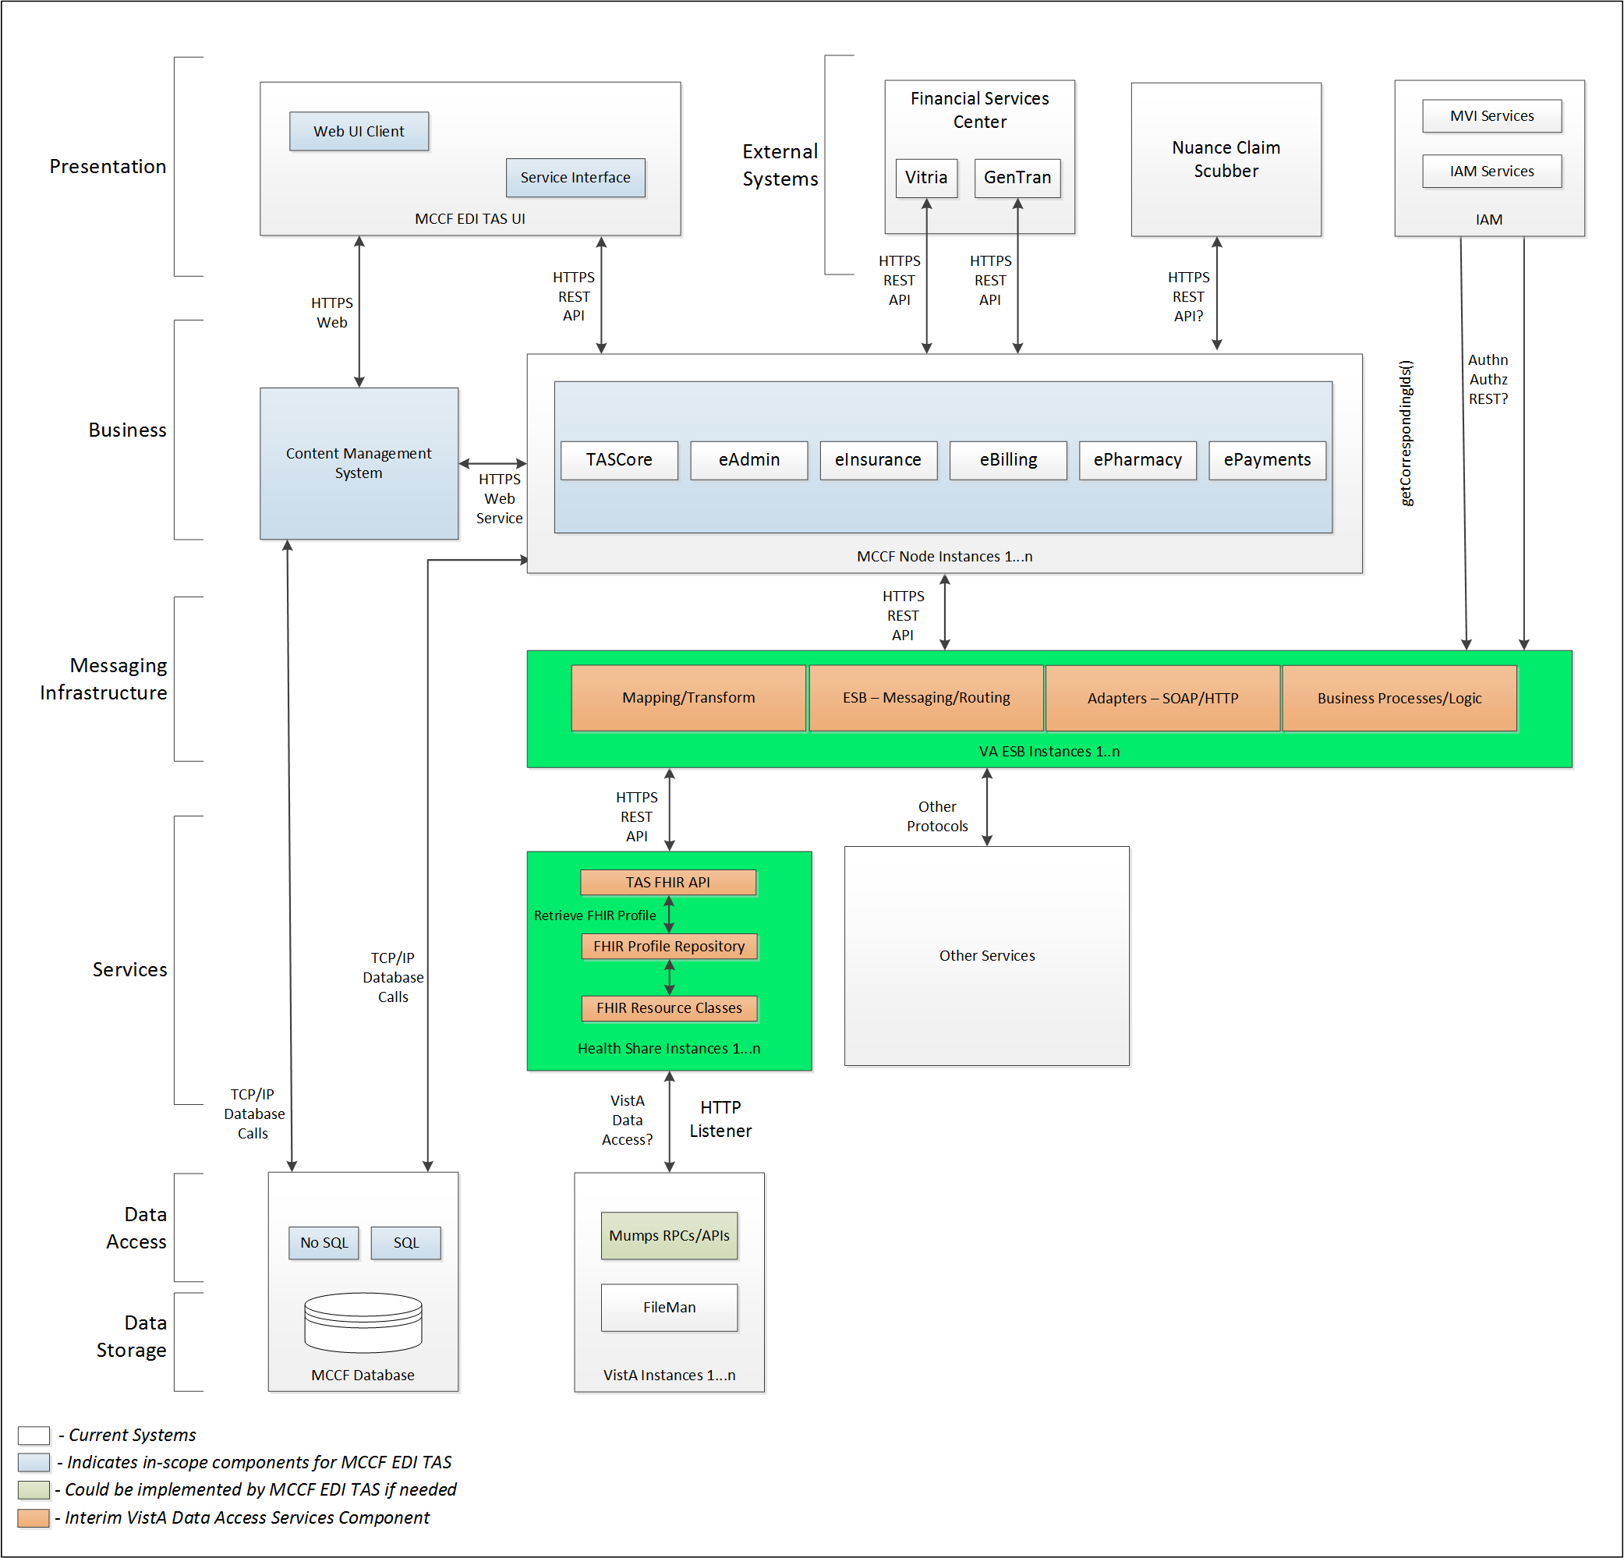

Figure 2 - To Be Solution

## Interface Overview

The messages exchanged between FSC and MCCF EDI TAS eBilling can be done in real time or as queued messaging.

### Connectivity between the systems

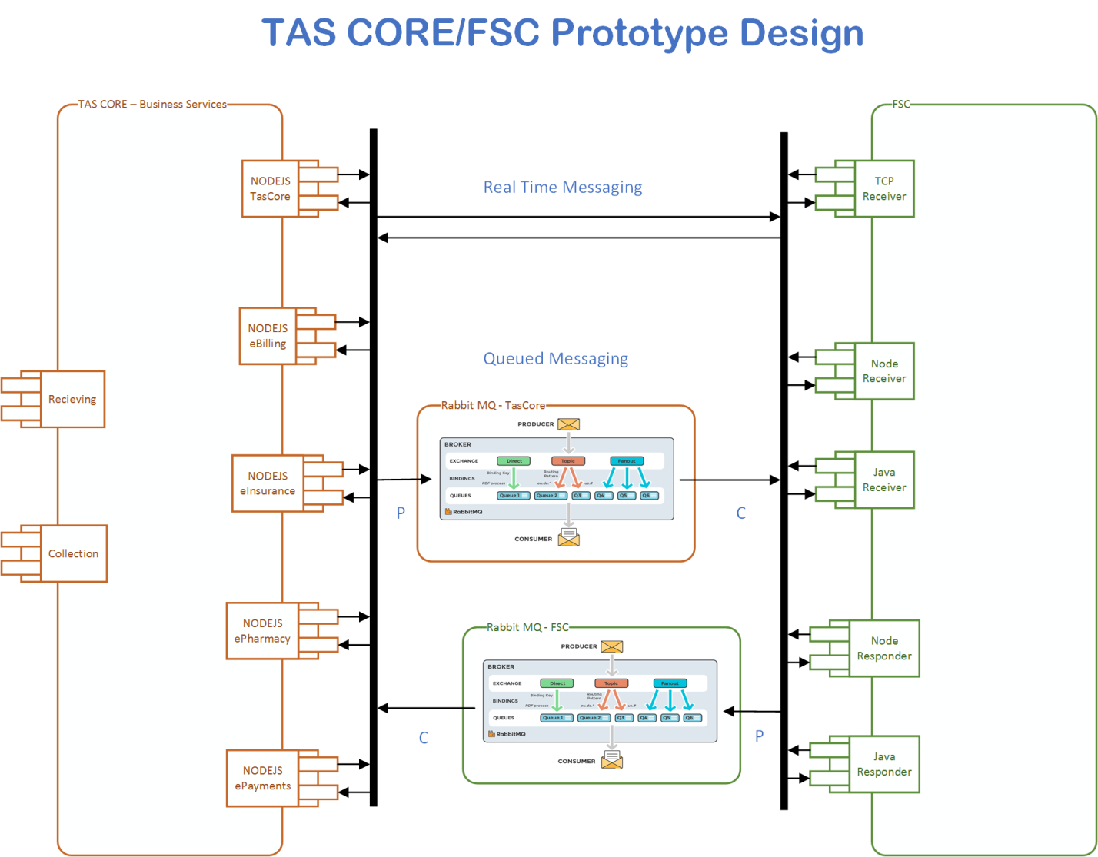

Figure 3 - Connectivity

## Operations

### Data Extraction

No Data is being extracted from the VistA databases for this transaction, it may be inserted however as a claim status update.

### Data Transformation

Tbd

### Sending/Receiving

MCCF EDI TAS receives FHIR resources in a FHIR bundle from FSC so that a 277STAT can be processed from a payer and the relevant claim information can be updated in eBilling.

## Data Transfer

Data is transferred between the FSC and the TASCore Application Stack

## Transaction Types

MCCF EDI TAS receives a FHIR bundle consisting of different FHIR resources representing a Health Care Claim Status message (277STAT) from FSC. FSC receives the ASC X12N/005010 Health Care Claim Status (277STAT) transaction from payers.

## Data Exchanges

MCCF EDI TAS receives a FHIR bundle, representing the 277STAT transaction FSC received from a payer. The payer sends a 277STAT transaction to the FSC to provide claim status updates as directed or when desired. Refer to Section Appendix A.

### FHIR Based Resources

The following FHIR resources in a Bundle are expected from FSC for the 277STAT transaction

* Basic
* Claim
* ClaimResponse
* CommunicationRequest
* EpisodeOfCare
* MessageHeader
* OperationOutcome
* Organization
* Patient
* RelatedPerson

### JSON Format

Messages are formatted using the JSON format and implement a Bundle FHIR Resource.

Refer to <https://www.hl7.org/fhir/json.html> for JSON representation of FHIR Resources.

### Bundle Definition

A Bundle is a top-level container in FHIR that contains all the FHIR resources desired for a transaction between FSC and MCCF EDI TAS.

It is a container for resources, enabling one to group and transmit resources altogether at once. Resources such as Claim, Patient, etc., will be transmitted inside multiple entries (see entry list inside Bundle) as a resource type.

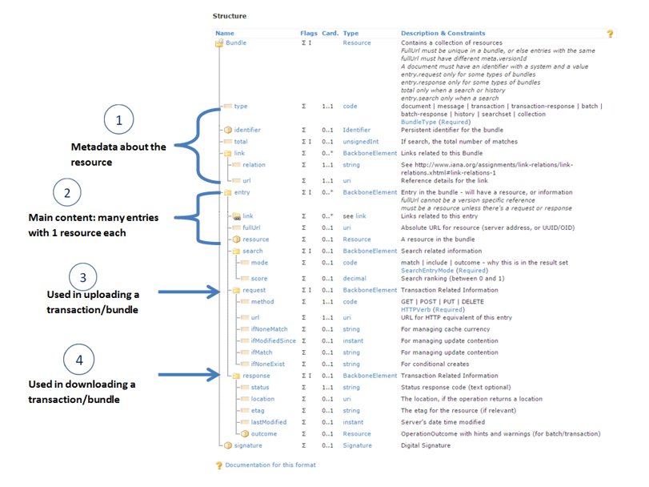

Figure 4 - FHIR Bundle

Source https://fhir-drills.github.io/bundle.html

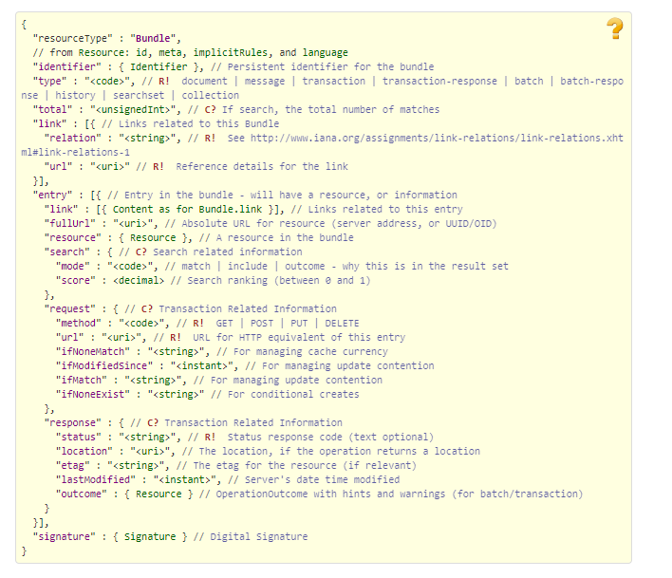

Figure 5 - FHIR Bundle JSON

Source https://www.hl7.org/fhir/bundle.html

## Communications Methods

### Ports and Protocols

#### HTTP(S)

Used for real time communication.

#### Advanced Message Queuing Protocol (AMQP)

AMQP offers reliable messaging via queues.

### ESB Configuration(s)

Tbd

### System Configuration

Tbd

## Performance Requirements

Refer to MCCD EDI TAS SDD <https://vaww.oed.portal.va.gov/pm/hape/ipt_5010/EDI_Portfolio/TASCore/MCCF_EDI_TAS_System_Design_Document_v0.7.pdf>

## Security

Refer to MCCD EDI TAS SDD <https://vaww.oed.portal.va.gov/pm/hape/ipt_5010/EDI_Portfolio/TASCore/MCCF_EDI_TAS_System_Design_Document_v0.7.pdf>

## Testing Requirements

### Comparison of Data

Testing the FHIR conformance will be based on https://www.hl7.org/fhir/validation.html.

Business Rules will have to be specifically defined in user stories by the product team.

* Which fields are mandatory from a business perspective?
* Data integrity.

### Completeness

Tests defined in section 2.10.1 must cover all the FHIR resources that are defined in section 2.6.1 in consideration of any functional user story.

### Load Testing

Bench mark tests must be performed based on individual use case requirements.

## Policies and Constraints

### HIPAA Compliance

FSC receives standard ASC X12N/005010 Health Care Claim Status (277STAT) transactions from payers.

# Appendix A

## Data Elements

Data being exchanged between TAS and FSC will be formatted in FHIR using the JSON notation. Data elements are mapped into fields in FHIR resources. FHIR resources will be located inside a FHIR bundle.

## Bundle

Repeating fields within a segment need context definition so they can be differentiated within a segment. Also, repeating fields across multiple segments need to be differentiated. Following steps have been used to assign context to fields.

1. Identify the segment where the resource is located (Bundle.entry.extension.url="segment" and Bundle.entry.extension.valueString=" 277STAT-Header") [MessageType-Segment]
2. Where elements repeat within a segment use extension.valueString to identify field (MessageHeader.extension.url="sequence", MessageHeader.extension.valueString="277STAT-Header-3") [MessageType-Segment-Field]
3. Repeating segments will include an incrementing id (MSA1, MSA2, ...)

Following JSON file describes the 277STAT bundle. The JSON bundle files are auto-generated using the mapping sheets. They may not be accurate and there are issues that we are aware of. We are continuing to fix the issues that we've identified.



## Resource Sections

### Basic

See Basic resource in 277STAT FHIR Bundle Resources section 3.2

### Claim

See Claim resource in 277STAT FHIR Bundle Resources section 3.2

### ClaimResponse

See ClaimResponse resource in 277STAT FHIR Bundle Resources section 3.2

### CommunicationRequest

See CommunicationRequest resource in 277STAT FHIR Bundle Resources section 3.2

### EpisodeOfCare

See EpisodeOfCare resource in 277STAT FHIR Bundle Resources section 3.2

### MessageHeader

See MessageHeader resource in 277STAT FHIR Bundle Resources section 3.2

### OperationOutcome

See OperationOutcome resource in 277STAT FHIR Bundle Resources section 3.2

### Organization

See Organization resource in 277STAT FHIR Bundle Resources section 3.2

### Patient

See Patient resource in 277STAT FHIR Bundle Resources section 3.2

### RelatedPerson

See RelatedPerson resource in 277STAT FHIR Bundle Resources section 3.2

## Mapping Sheets



# Appendix B - TASCore Mapping Rules

Tbd

# Appendix C – TASCore Default Values

Tbd

# Appendix D – FSC Mapping Rules

Tbd

# Appendix E – FSC Default Values

See mapping sheet section 3.4

# Appendix F - Glossary

| **Term** | **Meaning** |
| --- | --- |
| AMQP - Advanced Message Queuing Protocol | The *Advanced Message Queuing Protocol* (*AMQP*) is an open standard for passing business messages between applications or organizations using queues. |
| HCCH | Health Care Clearing House |
| REST - REpresentational State Transfer | REpresentational State Transfer, or RESTful web services provide interoperability between computer systems on the Internet or other network. Sometimes spelled ReST. |

# Attachment A – Approval Signatures

This section is used to document the approval of the ICD. The review should be conducted face to face where signatures can be obtained ‘live’ during the review. If unable to conduct a face-to-face meeting then it should be held via Lync and concurrence captured during the meeting. The Scribe should add /es/name by each position cited.

By signing below, I agree that I have reviewed and agree the document is approved.



## Signature page continued

